**3.scorecalculatorapp**

**Step-1: created a react app with name scorecalculatorapp**

**>npx create-react-app scorecalculatorapp**

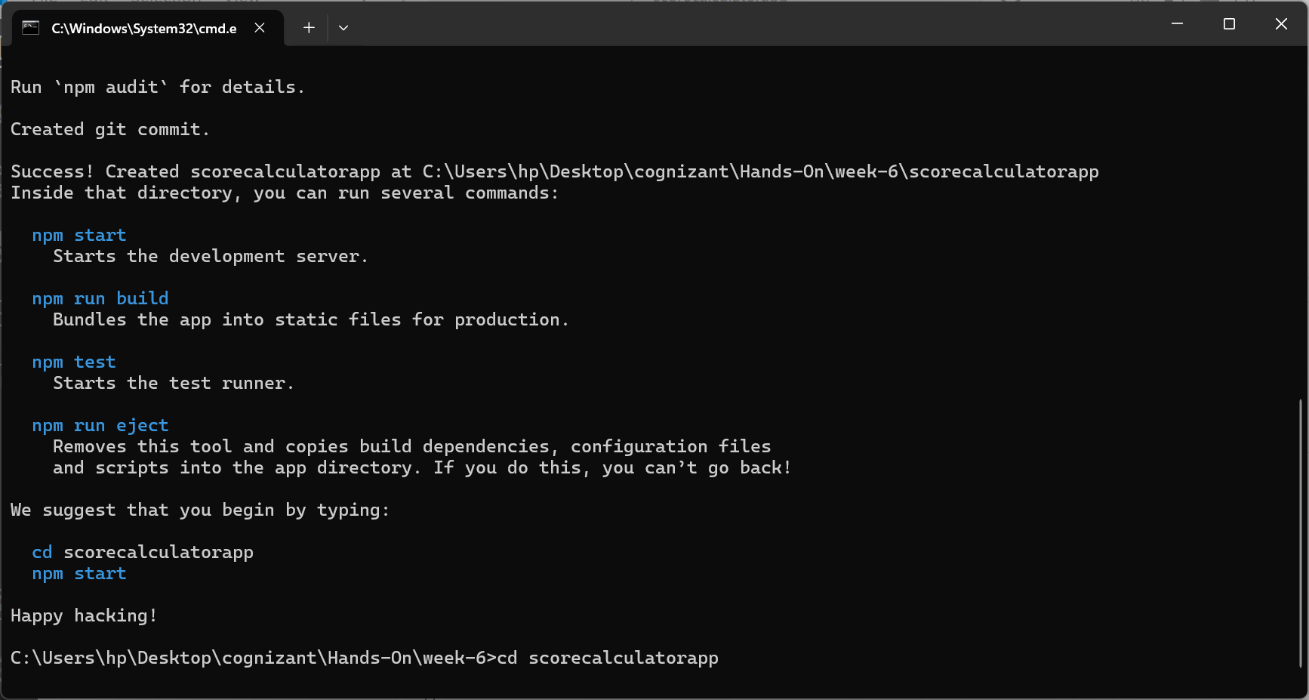

**Step-2:Created a component folder and added CalculatorScore functional component with props -> Name,School,Total,goal**

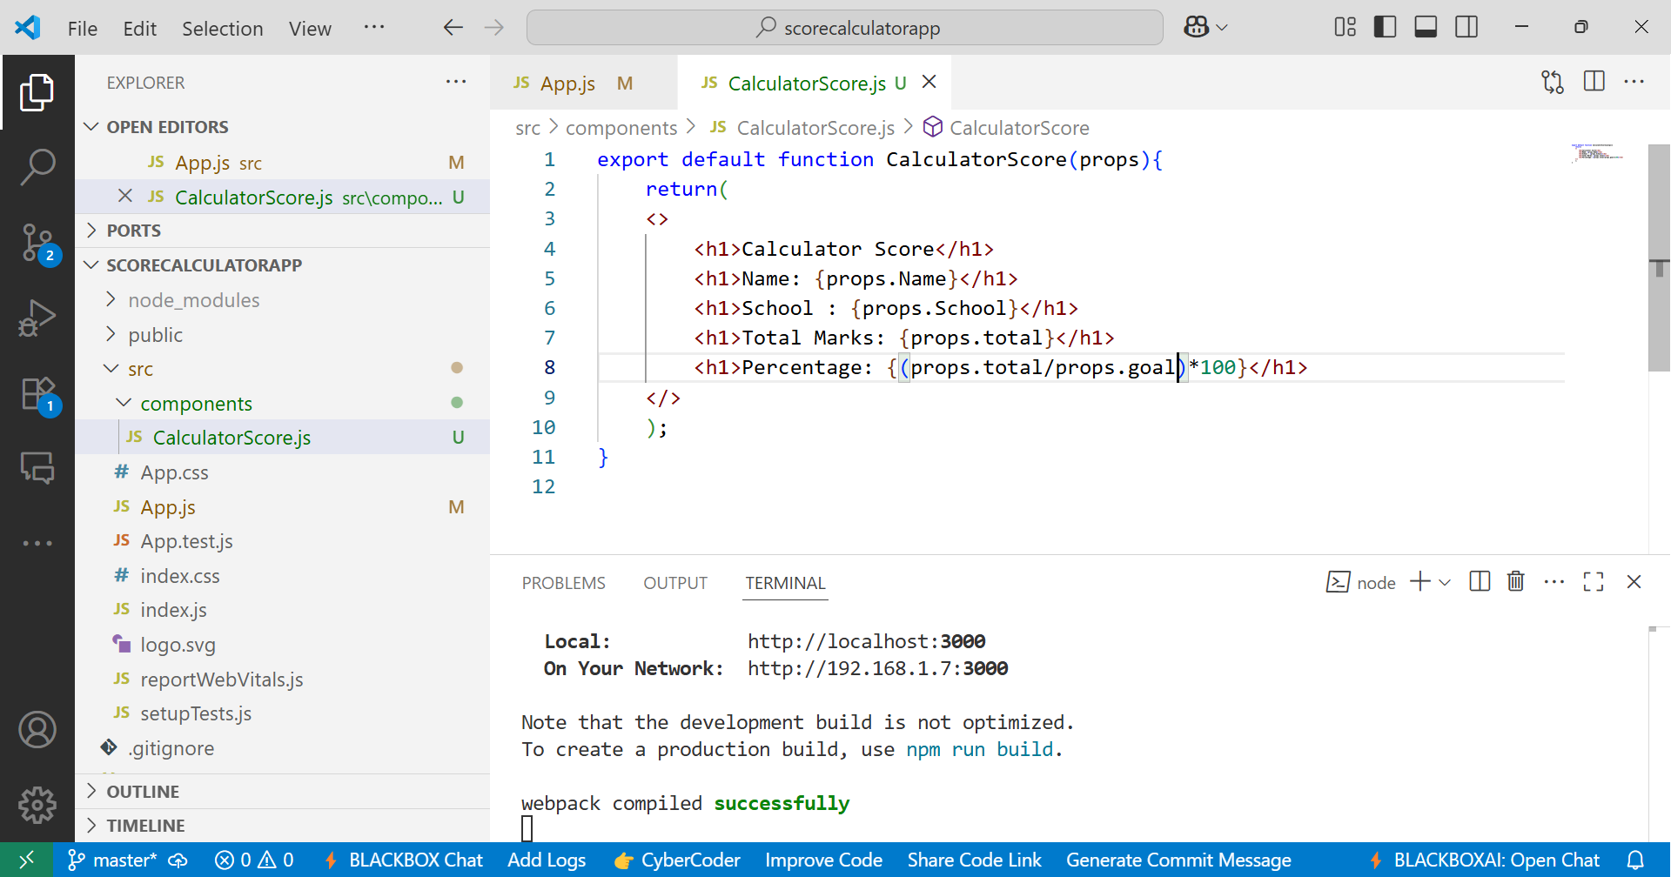

**Step-3: Called the functional component from the App.js**

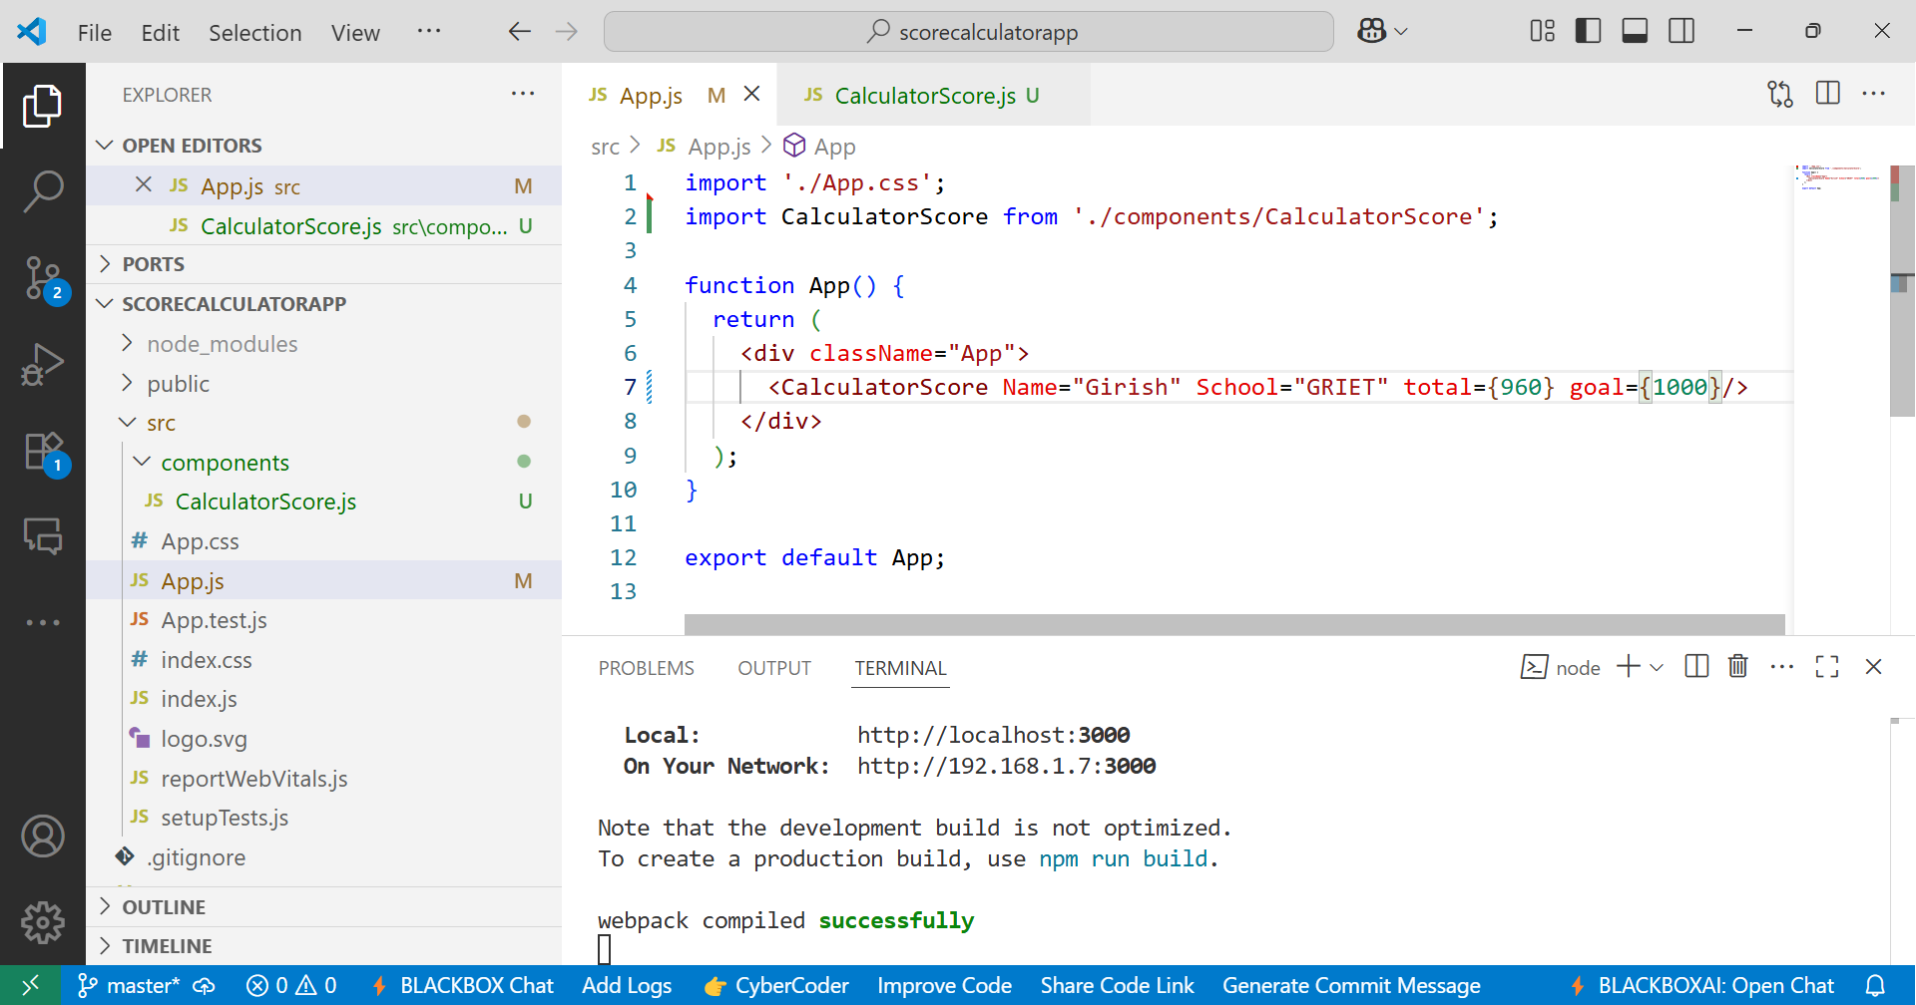

**Step-4:**

**Output:**

**>npm start**

