**4.BlogApp**

**Step-1:Created a blogapp with command**

**>npx create-react -app blogapp**

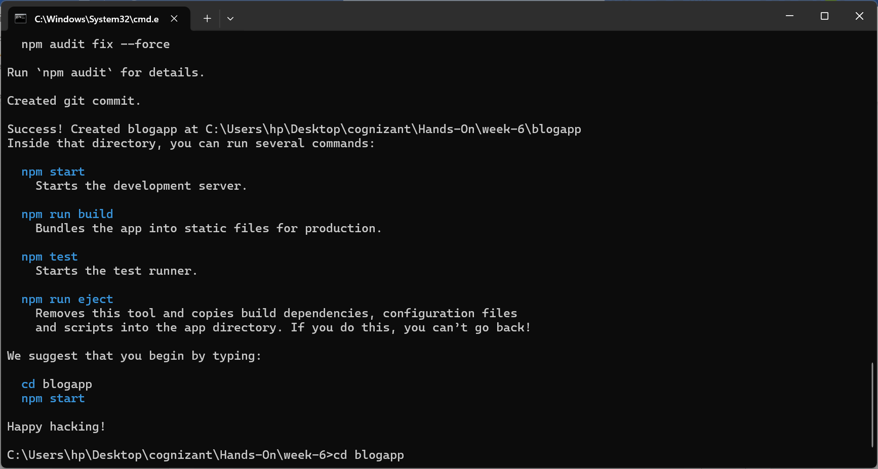

**Step-2: Created two js files Post.js and Posts.js**

1. **Posts.js for fetching details from api:** <https://jsonplaceholder.typicode.com/posts>
2. **And load them into a var data and use it to save in Post and render into web page**

**Post.js**

class post{

    constructor(id,title,body){

        this.id=id;

        this.title=title;

        this.body=body;

    }

}

export default post;

**Posts.js**

import post from './post';

import React from 'react';

class Posts extends React.Component{

    constructor(props){

        super(props);

        this.state = {

        posts: [],

        error: null

        };

    }

loadPosts = async () => {

        try {

        const response = await fetch("https://jsonplaceholder.typicode.com/posts");

        const data = await response.json();

        const posts = data.map(p => new post(p.id, p.title, p.body));

        this.setState({ posts });

        } catch (err) {

        this.setState({ error: err });

        }

    };

    componentDidMount() {

        this.loadPosts();

    }

    render() {

        return (

        <div>

            <h1>All Blog Posts</h1>

            {this.state.posts.map((post) => (

            <div key={post.id}>

                <h3>{post.title}</h3>

                <p>{post.body}</p>

            </div>

            ))}

        </div>

        );

    }

    componentDidCatch(error,info){

        alert("An error occurred: " + error.toString());

    }

}

export default Posts;

**App.js**

import './App.css';

import Posts from './Posts.js'

function App() {

  return (

    <div className="App">

      <Posts/>

    </div>

  );

}

export default App;

**Step-3:**

**Output**

