**5.CohertTracker**

**Step-1: Installed the zip file and extracted to local folder.**

**Installed all the dependencies with the command**

**>npm install**

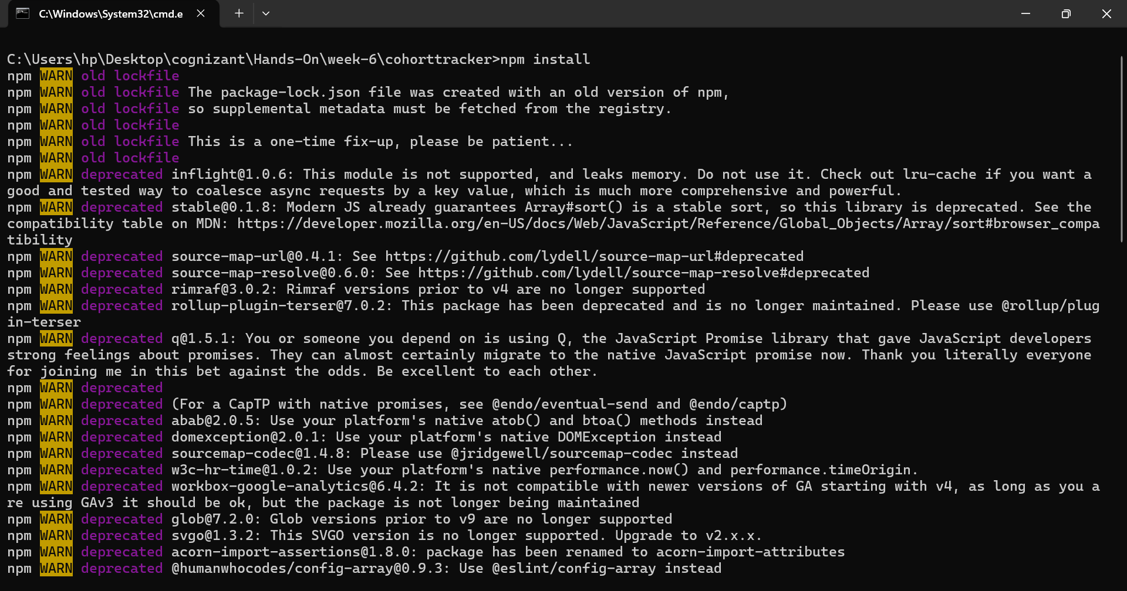

**Step-2:Created a CohertDetails.module.css in src/**

**Styled .box class in css**

.box{

 width: 300px;

 display:inline-block;

 margin : 10px;

 padding-top: 10px;

 padding-bottom: 10px;

 padding-right: 20px;

 padding-left: 20px;

 border-width: 1px;

 border-radius: 10px;

 border-color: black ;

}

**Styled dt tag**

dt{

 font-weight :500px;

}

**Coloring h3 based on ongoing status:**

h3.ongoing {

    color: green;

}

h3:not(.ongoing) {

    color: blue;

}

**Step-3: imported the css module into cohertDetails.js**

**Step-4: Given ClassName to div and h3 tags**

import styles from './CohertDetails.module.css';

function CohortDetails(props) {

    return (

        <div className={styles.box}>

            <h3 className={props.cohort.currentStatus.toLowerCase() === styles.ongoing ? 'ongoing' : ''}>

                {props.cohort.cohortCode} -

                <span>{props.cohort.technology}</span>

            </h3>

            <dl>

                <dt>Started On</dt>

                <dd>{props.cohort.startDate}</dd>

                <dt>Current Status</dt>

                <dd>{props.cohort.currentStatus}</dd>

                <dt>Coach</dt>

                <dd>{props.cohort.coachName}</dd>

                <dt>Trainer</dt>

                <dd>{props.cohort.trainerName}</dd>

            </dl>

        </div>

    );

}

export default CohortDetails;

**Step-5:**

**Output:**

