**10.officespacerentalapp**

**Step-1: created a react app named officespacerentalapp**

**>npx create-react-app officespacerentalapp**

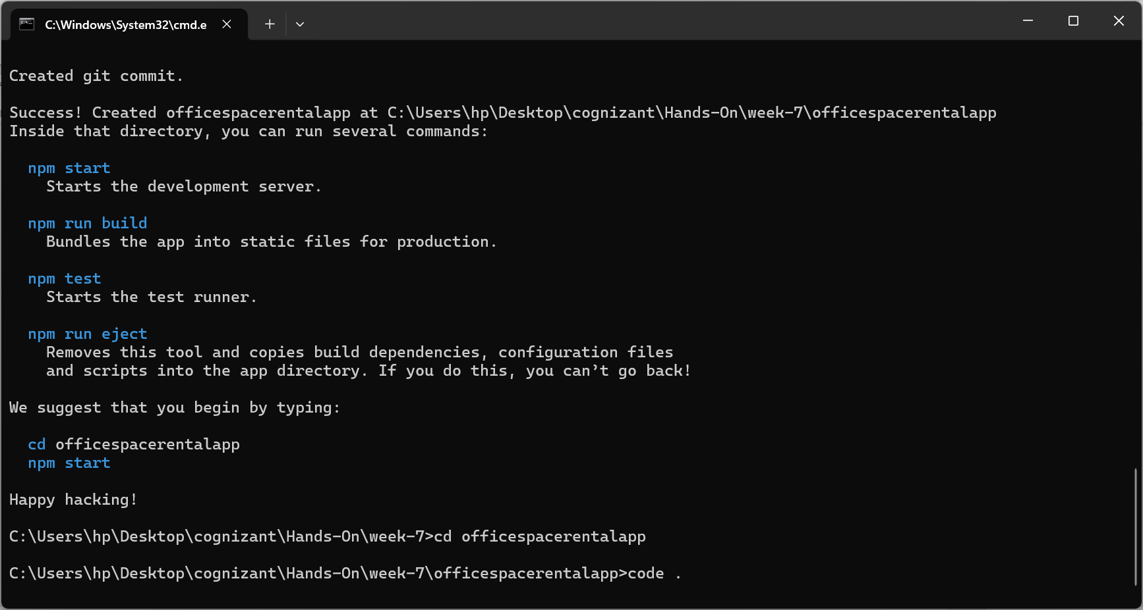

**Step-2: Created element with office name and rent and loc details**

**Styled the rent tag to display in red if less then 60000**

**App.js**

function App() {

  const offices = [

    {

      id: 1,

      name: 'office Space',

      rent: 50000,

      Name: "DBS",

      address: 'Chennai',

      image: "https://gustavconcept.com/cdn/shop/articles/QIC_SYD_Unispace_QIC_resized_2_copy.jpg?v=1691409476&width=1600"

    }

  ];

  return (

    <div className="App">

      <header className="App-header">

        <h1>{offices[0].name} at affordable price</h1>

        <img src={offices[0].image} className="App-logo" alt="logo"style={{ width: "20%" ,height:"20%" }}/>

        <h3>Name : {offices[0].Name}</h3>

        <h3 style={{ color: offices[0].rent > 60000 ? 'green' : 'red' }}>Rent : {offices[0].rent}</h3>

        <h3>Address : {offices[0].address}</h3>

      </header>

    </div>

  );

}

export default App;

**Step-3:Output**

