**11.eventexamplesapp**

**Step-1: created a react app named eventexamplesapp**

**>npx create-react-app eventexamplesapp** 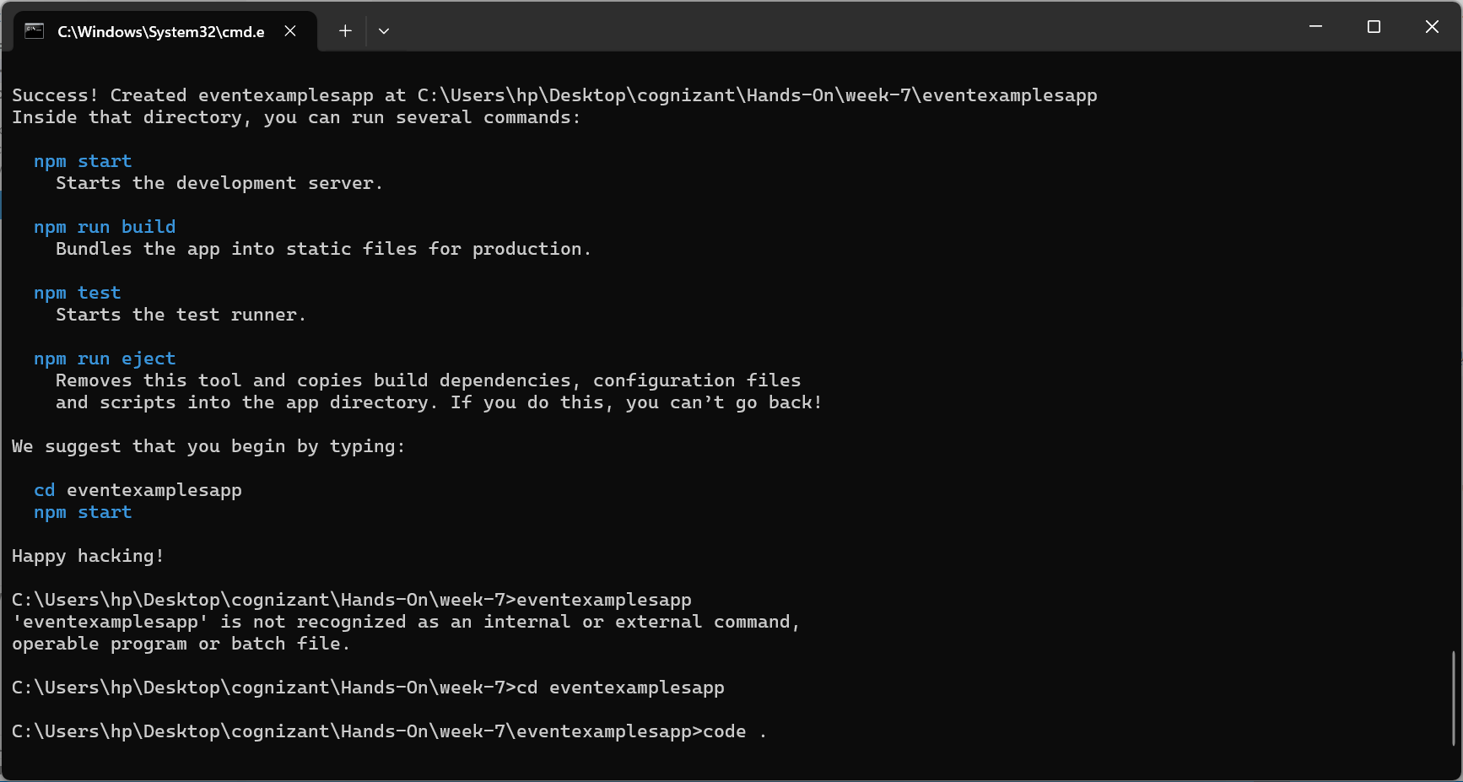

**Step-2:**

**Created buttons with name increase , decrease ,welcome , click and used useState hooks to change the value of num based on increment and decrement.**

**Step-3:**

**Created a currency calculator from dollar to Indian rupee fetched value from amount input tag and converted value is visibled with currency tag using useState hook**

**App.js**

import React, { useState } from 'react';

import './App.css';

function App() {

  const [num, setNum] = useState(0);

  const [amount, setAmount] = useState('');

  const [converted, setConverted] = useState('');

  function inc() {

    setNum(num + 1);

  }

  function dec() {

    setNum(num - 1);

  }

  function click() {

    alert("You have clicked Me!");

  }

  function wel() {

    alert("Welcome");

  }

  function cal() {

    const usd = parseFloat(amount);

    if (!isNaN(usd)) {

      const inr = usd * 83;

      setConverted(inr.toFixed(2));

    } else {

      alert("Please enter a valid amount");

    }

  }

  return (

    <div className="App">

      <h2>{num}</h2>

      <button onClick={inc}>Increment</button>

      <button onClick={dec}>Decrement</button>

      <button onClick={wel}>Welcome</button>

      <button onClick={click}>Click Me</button>

      <h1 style={{ color: "green" }}>Currency Converter!</h1>

      <label>Amount (USD): </label>

      <input

        type="number"

        value={amount}

        onChange={(e) => setAmount(e.target.value)}

      />

      <br /><br />

      <label>Converted (INR): </label>

      <input

        type="text"

        value={converted}

        readOnly

      />

      <br /><br />

      <button onClick={cal}>Convert</button>

    </div>

  );

}

export default App;

**Step-4:Output**

