**12.ticketbookingapp**

**Step-1: created a react app named ticketbookingapp**

**>npx create-react-app ticketbookingapp**

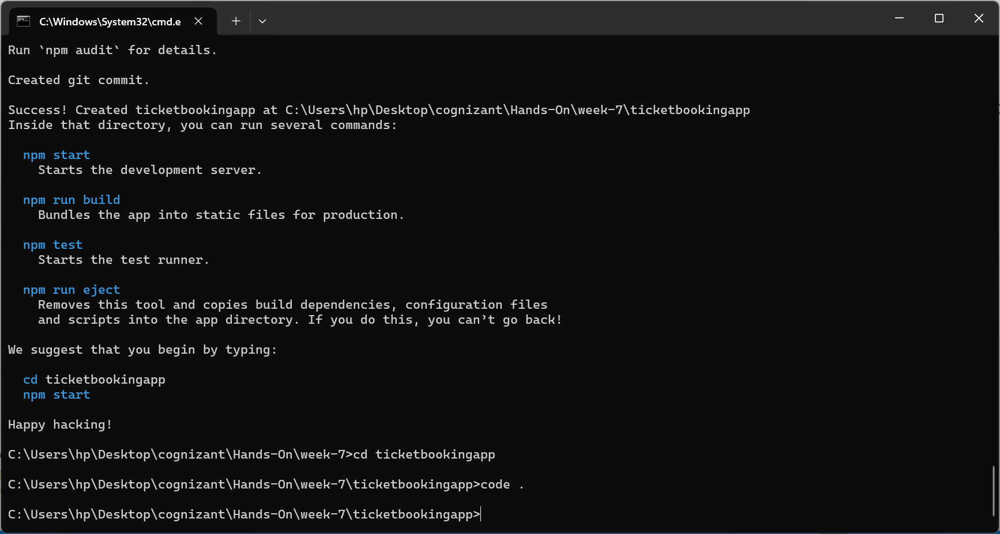

**Step-2:**

**Created buttons with name Login , Logout and used useState hooks to change the value of** setUserStatus **based on onclick of login and logout button click.**

**Step-3:**

**App.js**

import React, { useState } from 'react';

function App() {

  const [UserStatus,setUserStatus]=useState(false);

  if (UserStatus===true){

    return (

      <div>

        <h1>Welcome User</h1>

        <button onClick={() => setUserStatus(false)}>Logout</button>

      </div>

    )

  }

  else {

     return (

      <div>

        <h1>Welcome Guest</h1>

        <h1>Please Login</h1>

        <button onClick={() => setUserStatus(true)}>Login</button>

      </div>

    )

  }

}

export default App;

**Step-4:**

**Output**

