**13.bloggerapp**

**Step-1: Created a react app with name bloggerapp**

**>npx create-react-app bloggerapp**

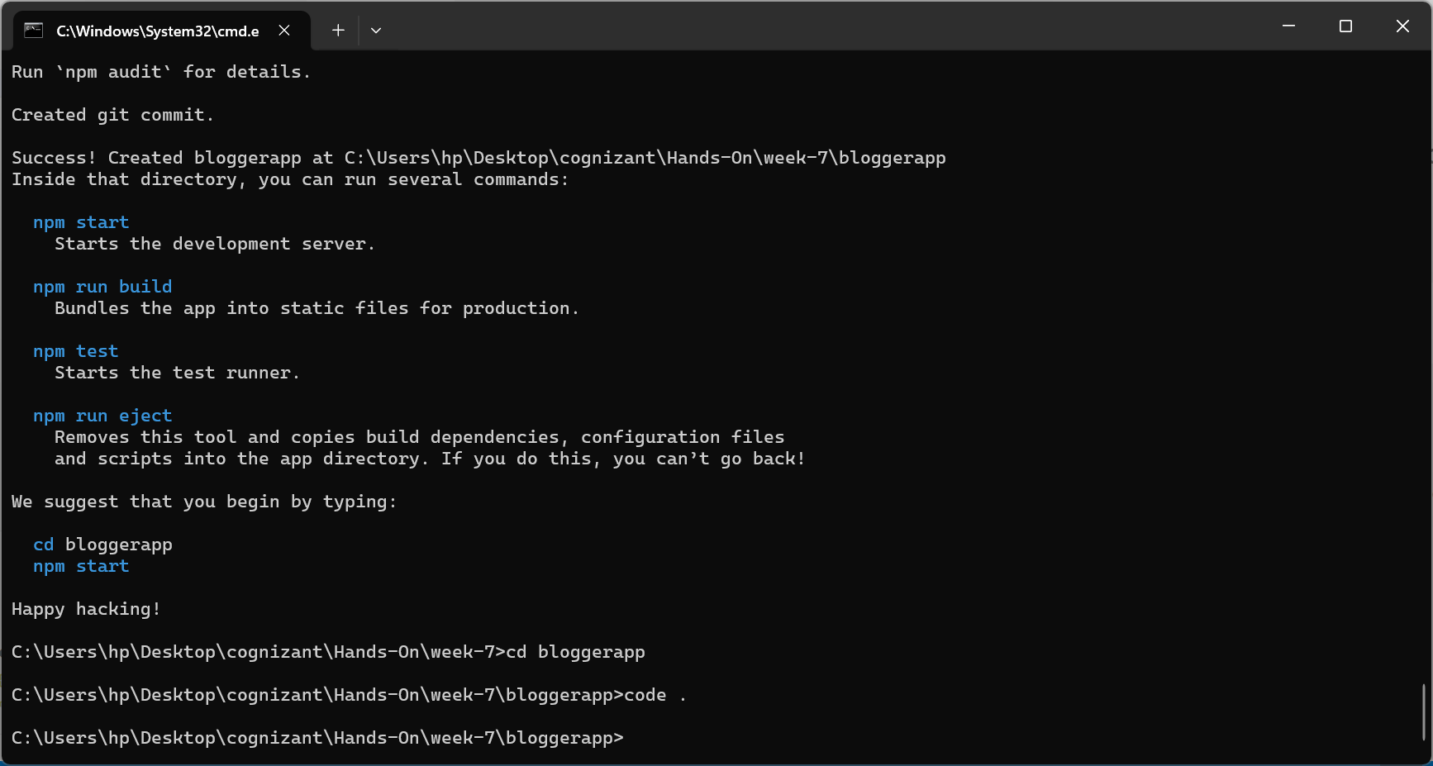

**Step-2:**

**Created 3 elemnts books,blogs,course with some details**

**Step-3:**

**Rendered all the 3 elements with 3 conditional rendering ways**

**>books with ternery rendering**

**>blogs with &&**

**>course with if and else**

**App.js**

import React from 'react';

import './App.css';

function App() {

  const books = [

    { id: 1, title: "React ", pages: 270 },

    { id: 2, title: "Deepdive into angular", pages: 800 },

    { id: 3, title: "Mongodb essentials", pages: 450}

  ];

  const blogs = [

    { id: 1, title: "React Learing", writer: "Stephen Biz", content:"Welcome to react" },

    { id: 2, title: "Installation", writer: "Schewendiezwer" ,content:"Install react from npm"}

  ];

  const courses = [{name:"Angular", date: "4/5/21"},

    {name:"React", date: "6/3/22"},

  ];

  return (

    <div className="App" >

      <div style={{ display: "flex", justifyContent: "space-around" }}>

        <div >

          <h2>Book Details</h2>

          {

            books.length > 0

              ? books.map((book) => (

                  <div key={book.id}>

                    <p><strong>{book.title}</strong></p>

                    <p>{book.pages}</p>

                  </div>

                ))

              : <p>No books available</p> // Conditional rendering using ternary

          }

        </div>

        <div>

          <h2>Blog Details</h2>

          {

            blogs.length && blogs.map((blog) => ( // Using `&&` for conditional rendering

              <div key={blog.id}>

                <p><strong>{blog.title}</strong></p>

                <p>{blog.writer}</p>

                <p> {blog.content}</p>

              </div>

            ))

          }

        </div>

        <div >

          <h2>Course Details</h2>

          {

            (() => {         //can't write directly if else stmts without function in return

              if (courses.length === 0) {

                return <p>No courses available</p>;

              } else {

                return courses.map(course => (      //conditional rendering using if else

                  <div >

                    <p><strong>{course.name}</strong></p>

                    <p>{course.date}</p>

                  </div>

                ));

              }

            })()

          }

        </div>

      </div>

    </div>

  );

}

export default App;

**Step-4:**

**OUTPUT**

