**9.Cricketapp**

**Step-1: Created a react app with name cricketapp**

**>npx create-react-app cricketapp**

**Step-2: created a players array with 11 playersnames and scores.**

**Displayed all players.names with scores**

**App.js**

import Players70 from './Players70';

import IndianPlayers from './IndianPlayers';

function App() {

  const players = [

    { name: "jack", score: 50 },

    { name: "Micheal", score: 70 },

    { name: "john", score: 40 },

    { name: "ann", score: 61 },

    { name: "elisebeth", score: 61 },

    { name: "sachin", score: 95 },

    { name: "dhoni", score: 100 },

    { name: "virat", score: 84 },

    { name: "jadeja", score: 64 },

    { name: "yuvaraj", score: 75 },

    { name: "rohit", score: 80 }

  ];

  var flag=false;

  if(flag===true){

    return (

      <>

      <div className="App">

        <h2>List of Players</h2>

        <ul>

          {players.map((player, index) => (

            <li key={index}>Mr. {player.name} : {player.score}</li>

          ))}

        </ul>

      </div>

      <div>

        <h2>Players with Score below 70</h2>

        <Players70 players={players} />

      </div>

      </>

    );

  }

  else{

    return(

      <IndianPlayers/>

    )

  }

}

export default App;

**Step-3: Created players70 component and displayed only players names who scored less than or equal to 70**

**Players70.js**

function Players70({ players }) {

  return (

    <ul>

      {players.map((item, index) => {

        if (item.score <= 70) {

          return <li key={index}>Mr. {item.name} : {item.score}</li>;

        }

        return null;

      })}

    </ul>

  );

}

**Step-4: Created Indianplayers component to create to arrays with oddteam and even team names and then merged t20players array and ranjitrophyplayers array using ES6 merge feature and displayed result**

**IndianPlayers.js**

export default Players70;

import React from 'react';

function IndianPlayers() {

  const oddTeam = ["Sachin","Virat", "yuvaraj"];

  const evenTeam = ["Dhoni", "Rohit", "raina"];

  const [firstOdd, secondOdd, ...remainingOdd] = oddTeam;

  const [firstEven, secondEven, ...remainingEven] = evenTeam;

  // Merge feature of ES6

  const T20Players = ["firstPlayer", 'secondPlayer', 'thirdPlayer'];

  const RanjiTrophyPlayers = ['fourthPlayer', 'fifthPlayer','sixthPlayer'];

  const allPlayers = [...T20Players, ...RanjiTrophyPlayers];

  return (

    <div>

      <h2>Odd Team</h2>

      <ul>

        <li>{firstOdd}</li>

        <li>{secondOdd}</li>

        {remainingOdd.map((player, idx) => <li key={idx}>{player}</li>)}

      </ul>

      <h2>Even Team</h2>

      <ul>

        <li>{firstEven}</li>

        <li>{secondEven}</li>

        {remainingEven.map((player, idx) => <li key={idx}>{player}</li>)}

      </ul>

      <h2>List of Indian Players Merged</h2>

      <ul>

        {allPlayers.map((player, idx) => <li key={idx}>{player}</li>)}

      </ul>

    </div>

  );

}

export default IndianPlayers;

**Step-5: OUTPUT:**

**Flag===true**

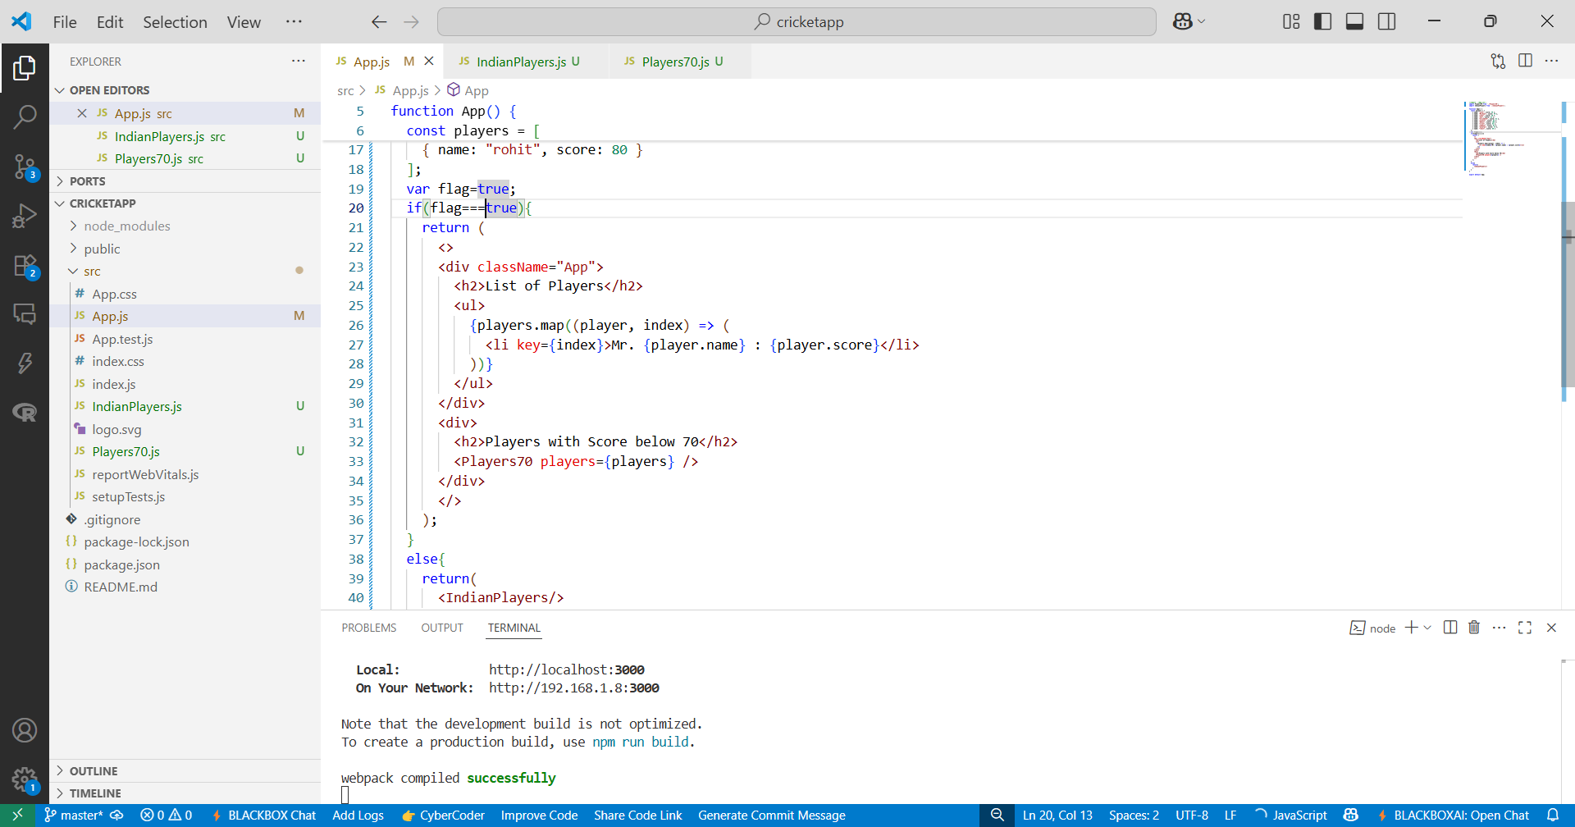

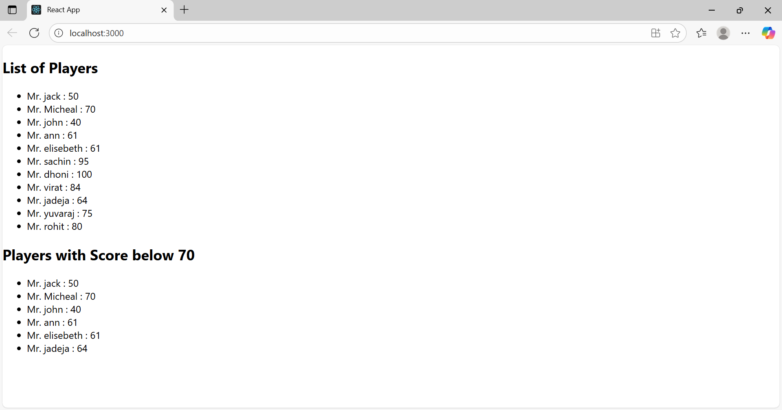

**Flag===false**

