**2.Git-HOL**

**Objective:** Create a **“.log”** file and a **log folder** in the working directory of Git. Update the **.gitignore** file in such a way that on committing, these files (.log extensions and log folders) are ignored.

**Step-1:** Created a log folder and added 2 .log files into it

**Step-2:**Created a new gitignore folder in local repository and ignored log folder and log files

**gitignore**

*.log

#ignores all log files

log/

#ignores log folder

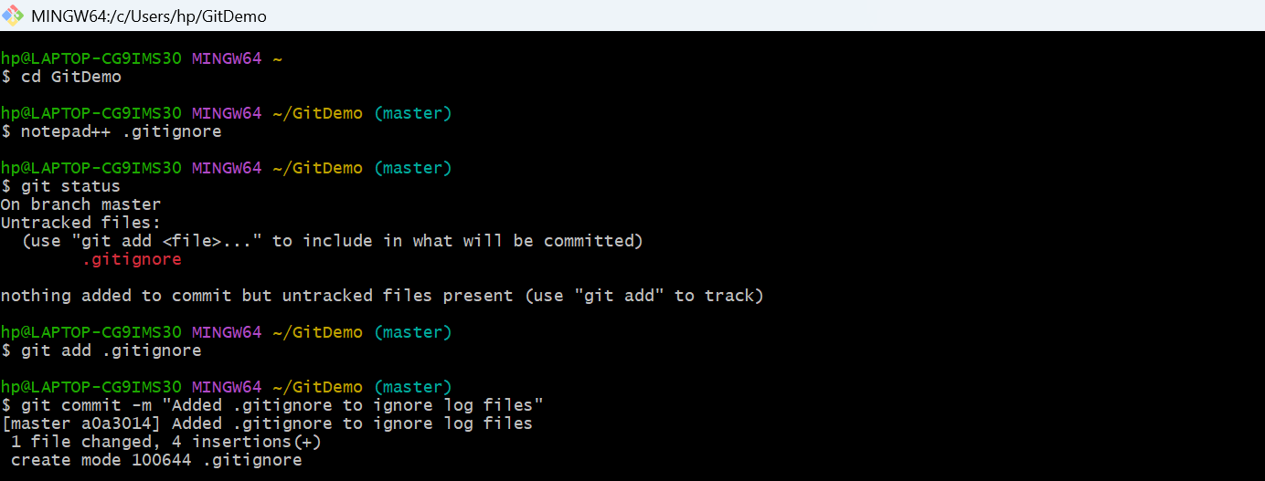

**Step-3:** added to remote repo using

**>git add gitignore**

**>git status**

**>git commit -m “Added gitignore to ignore log files”**

**Step-4**: pushed into remote repo

**>git push origin master**

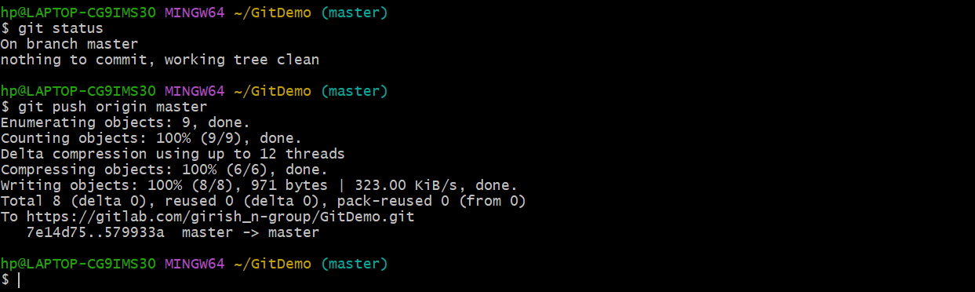

**Step-5: OUTPUT:**

**Local repository/working directory**

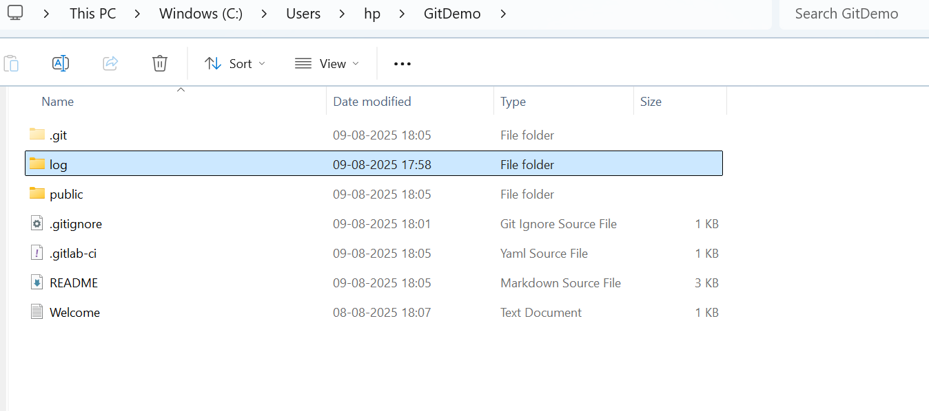

**Remote Repository with no log folder**

