**3.Git-HOL**

**Objective:** Create a new gitbranch , add files to it, merge it with master, delete it , and push.

**Step-1:** create new gitbranch

**>git branch GitNewBranch**

**>git checkout GitNewBranch** //to move to branch from master

**Step-2;** created new branchfile.txt

**Step-3:** added new file

**>git add branchfile.txt**

**>git commit -m “Add branchfile.txt in GitNewBranch”**

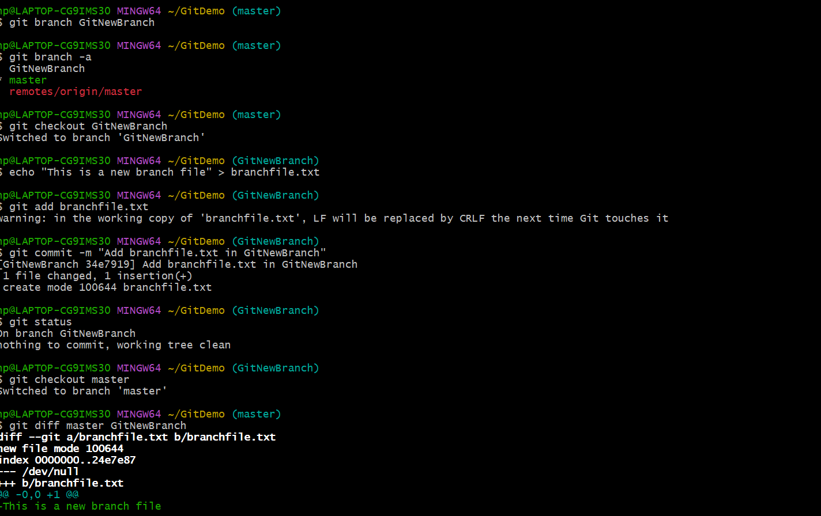

**Step-4:** Move to master

**>git checkout master**

**Step-5:** merge the branch

**>git merge GitNewBranch**

**Step-6:** deleted the branch and pushed into remote

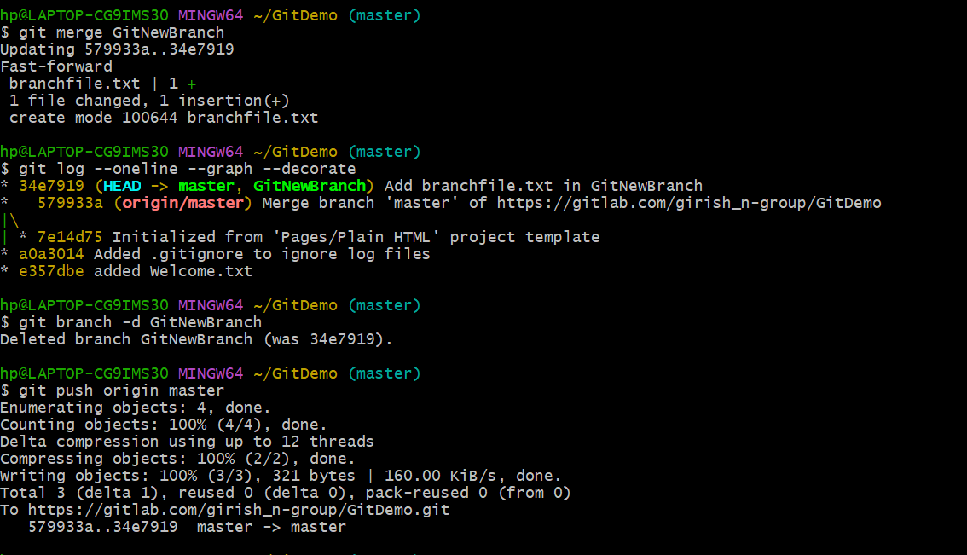

**OUTPUT;**

