**5. Git-HOL**

**Objective:** Verify the repository status and make clean, pull latest changes, and push to the remote repo.

**Step-1:** see master is clean

**>git status**

**Step-2:** List all branches

**>git branch -a**

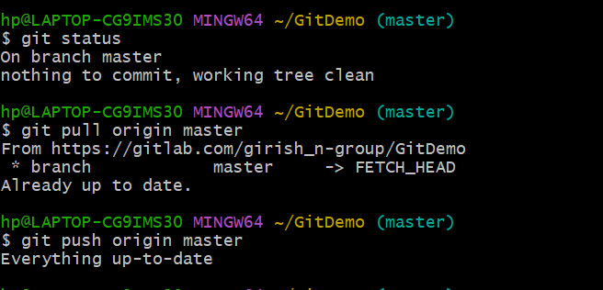

**Step-3:** Pull changes from remote

**>git pull origin master**

**Step-4**: Push pending changes to remote

**>git push origin master**

**Step-5:**

**OUTPUT:**

