INTERNSHIP REPORT
Submitted in partial fulfilment of the requirements for the degree of
Bachelor of Technology
In
Electronics And Communication Engineering
Submitted by
Udaya sri



Department of Electronics And Communication
Engineering
JNTUH UNIVERSITY COLLEGE OF ENGINEERING SULTANPUR

ACKNOWLEDGEMENT

I would like to express my sincere gratitude to all those who supported me in completing this codec technology project. Their guidance and encouragement were invaluable throughout this journey.
I am deeply thankful to the open-source community and online educational platforms for providing documentation, tools, and tutorials that facilitated my research on codec technologies. The resources available online made it possible to explore complex codec algorithms and implement them effectively.
I also appreciate the technical communities and forums where I found answers to challenging questions during the coding, testing, and debugging phases of this project.

INDEX

ACKNOWLEDGEMENT 2
LIST OF FIGURES 5
ABSTRACT 6
CHAPTER 1: INTRODUCTION
  - Introduction 7
  - State Diagram 8
CHAPTER 2: SYSTEM OVERVIEW
  - Objectives 9
  - System Requirements 9
  - Classical vs Adaptive System 9
CHAPTER 3: DESIGN AND WORKING
  - Verilog Overview 10
  - Working Principle 10
  - Adaptive Timing 10
  - Emergency Handling 10
CHAPTER 4: IMPLEMENTATION
  - Implementation 11
CHAPTER 5: WORKING CODE
  - Design Module 12
  - Test Bench Module 17
  - Explanation of Design Logic 21
  - Experiment Procedure 22
CHAPTER 6: SIMULATION AND OUTPUTS
  - Schematic Diagram 26
  - Device 26
  - Output Graph 27

  - Result 27
CHAPTER 7: ADVANTAGES AND APPLICATIONS
  - Advantages 28
  - Applications 28
CHAPTER 8: CONCLUSION AND FUTURE SCOPE
  - Conclusion 29
  - Future Scope 29
REFERENCES 30

LIST OF FIGURES

Figure 1.1 State Diagram of Adaptive Traffic Signal System 8
Figure 5.1 Vivado Project Creation (Step 1 & Step 2) 22
Figure 5.2 Board Selection and Tool Interface (Step 3 & Step 4) 23
Figure 5.3 Adding Design Sources (Step 5 & Step 6) 24
Figure 5.4 Source Window and Code Writing (Step 7) 25
Figure 6.1 Schematic Diagram of Traffic Controller 26
Figure 6.2 Device Layout (FPGA Implementation) 26
Figure 6.3 Simulation Output Waveform 27

ABSTRACT
Traffic congestion at road intersections is a common problem due to the increasing number of vehicles.Conventional traffic signal systems work on fixed timing and do not respond to real-time traffic conditions, which leads to unnecessary delays. In this mini project, an adaptive traffic signal control system for a four - way intersection is designed using Verilog Hardware Description Language (HDL).

The system controls traffic in the North, South, East, and West directions by allowing only one direction to receive a green signal at a time. A Finite State Machine (FSM) is used to represent different signal states such as green, yellow, and red. Based on simulated traffic density inputs, the controller adjusts the green signal duration to reduce waiting time.

Emergency vehicle priority and pedestrian crossing signals are also considered to improve safety at the intersection. The complete design is implemented using hardware - based logic without using any microcontroller or software delay. The functionality of the system is verified using Verilog simulation and testbench results.

This project helps in understanding the application of digital logic design and FSM concepts using Verilog HDL and shows how adaptive traffic control can be implemented using hardware description languages.

CHAPTER 1 INTRODUCTION

INTRODUCTION

Traffic congestion is a major issue in urban areas due to the rapid increase in the number of vehicles. Conventional traffic signal systems operate on fixed timing intervals and do not consider real-time traffic conditions. This leads to unnecessary waiting time, fuel wastage, and inefficient traffic flow.
To overcome these limitations, adaptive traffic control systems are introduced. These systems dynamically adjust signal timing based on traffic density, thereby improving efficiency and reducing congestion.
In this project, an adaptive traffic light controller is designed using Verilog Hardware Description Language (HDL). The system uses a Finite State Machine (FSM) to control traffic signals in four directions: North, East, South, and West.
The system ensures that only one direction receives a green signal at a time while others remain red. The signal timing is adjusted dynamically based on traffic density inputs.
Additional features such as emergency vehicle priority and pedestrian crossing control are also implemented. Emergency vehicles are given priority by immediately switching the signal to green in the required direction. Pedestrian crossing ensures all signals turn red for safe movement.
The design is simulated using Verilog tools, and the results are verified through waveform outputs and schematic diagrams.

STATE DIAGRAM :
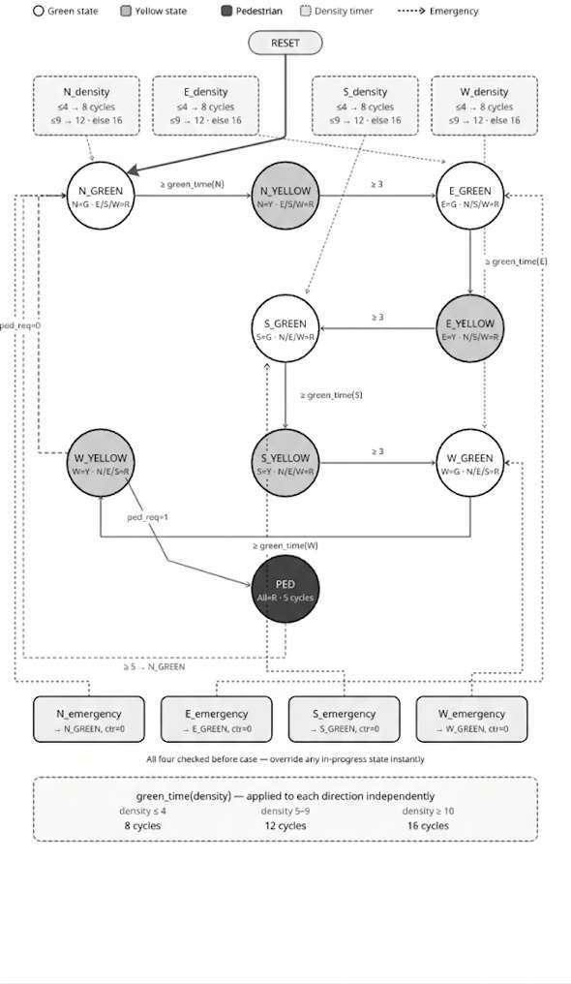

Figure 1.1 State Diagram of Adaptive Traffic Signal System

CHAPTER 2: SYSTEM OVERVIEW

OBJECTIVES
    - The main objectives of this project are:
    - To design a traffic light controller using Verilog HDL
    - To implement Finite State Machine (FSM) for signal control
    - To adjust signal timing based on traffic density
    - To provide priority for emergency vehicles
    - To ensure safe pedestrian crossing

SYSTEM REQUIREMENTS
Inputs:
    - Clock and Reset signals
    - Traffic density inputs (North, East, South, West)
    - Emergency signals
    - Pedestrian request Outputs:
    - Traffic signals for each direction:
    - Red
    - Yellow
    - Green

CLASSICAL VS ADAPTIVE SYSTEM

Classical Traffic System:
    - Fixed timing
    - No real-time control
    - Higher waiting time
    - No emergency support Adaptive Traffic System:
    - Dynamic timing
    - Uses traffic density inputs
    - Reduces waiting time
    - Supports emergency vehicles
    - Improves traffic efficiency

CHAPTER 3: DESIGN AND WORKING

VERILOG OVERVIEW

Verilog HDL is used to design and simulate digital systems. In this project, Verilog is used to implement the traffic controller using FSM concepts.
The design includes adaptive timing, emergency handling, and pedestrian control. Simulation is used to verify the correct behaviour of the system.

WORKING PRINCIPLE

The system operates based on a Finite State Machine (FSM).
    - Initial state is N_GREEN
    - Traffic flows in sequence: North → East → South → West
Each direction follows:
    - GREEN → YELLOW → Next direction Only one direction is active at a time.
The system transitions between states based on:
    - Counter (timing control)
    - Traffic density
    - Emergency signals
    - Pedestrian request

ADAPTIVE TIMING

    - The green signal duration is adjusted based on traffic density:
      - Low traffic(<=4) → 8 seconds
      - Medium traffic (<=9)→ 12 seconds
      - High traffic (>10)→ 16 seconds
This reduces unnecessary waiting time and improves traffic flow.

EMERGENCY HANDLING

The system detects emergency vehicles such as ambulances and fire trucks.
    - Priority is given to emergency direction
    - Signal immediately turns GREEN
    - Normal sequence is overridden Priority order:
North > East > South > West

CHAPTER 4: IMPLEMENTATION
The adaptive traffic signal controller is implemented using Verilog HDL.
    - FSM is used for controlling traffic states
    - Counter is used for timing control
    - Function is used for adaptive green time calculation
    - Emergency and pedestrian inputs modify state transitions
The design is simulated using a testbench that includes:
    - Low traffic condition
    - Medium traffic condition
    - High traffic condition
    - Mixed traffic scenario
    - Emergency cases
    - Pedestrian request
Simulation results verify the correctness of the design.

CHAPTER 5:WORKING CODE

DESIGN MODULE :
module smart_traffic_controller( input clk,
input reset,
input [3:0] N_density,
input [3:0] E_density,
input [3:0] S_density,
input [3:0] W_density, input N_emergency, input E_emergency, input S_emergency, input W_emergency, input pedestrian,
output reg N_red,N_yellow,N_green, output reg E_red,E_yellow,E_green, output reg S_red,S_yellow,S_green, output reg W_red,W_yellow,W_green
);

parameter N_GREEN=0, N_YELLOW=1, E_GREEN=2, E_YELLOW=3, S_GREEN=4, S_YELLOW=5, W_GREEN=6, W_YELLOW=7, PED=8;
reg [3:0] state,next_state;
reg [4:0] counter; reg ped_req;
// TIMING

parameter YELLOW_TIME=3; parameter PED_TIME=5;
// ADAPTIVE GREEN TIME
function [4:0] green_time;
input [3:0] density; begin
if(density <=4)
green_time = 8;
else if(density <=9)
green_time = 12; else
green_time = 16;
end endfunction
// STATE REGISTER
always @(posedge clk or posedge reset) begin
if(reset) begin
state <= N_GREEN; counter <= 0;
end else begin
state <= next_state; if(state != next_state)
counter <= 0; else
counter <= counter + 1;
end end

always @(posedge clk or posedge reset) begin

if(reset)
ped_req <= 0; else if(pedestrian) ped_req <= 1;
else if(state == PED) ped_req <= 0;
end
always @(*) begin
next_state = state;
if(N_emergency) next_state = N_GREEN; else if(E_emergency) next_state = E_GREEN; else if(S_emergency) next_state = S_GREEN;
else if(W_emergency) next_state = W_GREEN; else
case(state) N_GREEN:
if(counter >= green_time(N_density)) next_state = N_YELLOW; N_YELLOW:
if(counter >= YELLOW_TIME) next_state = E_GREEN; E_GREEN:
if(counter >= green_time(E_density)) next_state = E_YELLOW; E_YELLOW:
if(counter >= YELLOW_TIME) next_state = S_GREEN; S_GREEN:
if(counter >= green_time(S_density)) next_state = S_YELLOW; S_YELLOW:
if(counter >= YELLOW_TIME) next_state = W_GREEN;

W_GREEN:
if(counter >= green_time(W_density)) next_state = W_YELLOW; W_YELLOW:
if(counter >= YELLOW_TIME) begin
if(ped_req) next_state = PED;
else
next_state = N_GREEN;
end PED:
if(counter >= PED_TIME) next_state = N_GREEN; default:
next_state = N_GREEN; endcase
end
always @(*) begin
N_red=0;N_yellow=0;N_green=0; E_red=0;E_yellow=0;E_green=0; S_red=0;S_yellow=0;S_green=0; W_red=0;W_yellow=0;W_green=0; if(state==PED)
begin
N_red=1; E_red=1; S_red=1; W_red=1;
end else
case(state)
N_GREEN : begin N_green=1; E_red=1; S_red=1; W_red=1; end

N_YELLOW : begin N_yellow=1; E_red=1; S_red=1; W_red=1; end E_GREEN : begin E_green=1; N_red=1; S_red=1; W_red=1; end E_YELLOW : begin E_yellow=1; N_red=1; S_red=1; W_red=1; end S_GREEN : begin S_green=1; N_red=1; E_red=1; W_red=1; end S_YELLOW : begin S_yellow=1; N_red=1; E_red=1; W_red=1; end W_GREEN : begin W_green=1; N_red=1; E_red=1; S_red=1; end W_YELLOW : begin W_yellow=1; N_red=1; E_red=1; S_red=1; end default:
begin
N_red=1; E_red=1; S_red=1; W_red=1;
end endcase end endmodul

TEST BENCH MODULE :
`timescale 1ns/1ps module smart_traffic_tb; reg clk;
reg reset;
reg pedestrian; reg N_emergency; reg E_emergency; reg S_emergency;
reg W_emergency; reg [3:0] N_density;
reg [3:0] E_density;
reg [3:0] S_density;
reg [3:0] W_density;
wire N_red,N_yellow,N_green; wire E_red,E_yellow,E_green; wire S_red,S_yellow,S_green; wire W_red,W_yellow,W_green; smart_traffic_controller uut(
.clk(clk), .reset(reset),
.N_density(N_density), .E_density(E_density),
.S_density(S_density), .W_density(W_density),
.N_emergency(N_emergency), .E_emergency(E_emergency),
.S_emergency(S_emergency), .W_emergency(W_emergency),
.pedestrian(pedestrian),
.N_red(N_red),.N_yellow(N_yellow),.N_green(N_green),
.E_red(E_red),.E_yellow(E_yellow),.E_green(E_green),
.S_red(S_red),.S_yellow(S_yellow),.S_green(S_green),
.W_red(W_red),.W_yellow(W_yellow),.W_green(W_green)
);
// CLOCK (10ns period) always #5 clk = ~clk; initial
begin

// WAVEFORM GENERATION
$dumpfile("traffic_wave.vcd");
$dumpvars(0, smart_traffic_tb);
// MONITOR OUTPUT
$monitor("TIME=%0t | N(G=%b Y=%b R=%b) E(G=%b Y=%b R=%b) S(G=%b Y=%b R=%b) W(G=%b Y=%b R=%b)",
$time, N_green,N_yellow,N_red, E_green,E_yellow,E_red, S_green,S_yellow,S_red, W_green,W_yellow,W_red);
//INITIAL VALUES
clk = 0;
reset = 1;
pedestrian = 0;
N_emergency = 0;
E_emergency = 0;
S_emergency = 0;
W_emergency = 0;
// INITIAL DENSITY
N_density = 2;
E_density = 2;
S_density = 2;
W_density = 2;
// RESET RELEASE
#10 reset = 0;
#5;
// LOW TRAFFIC #40
$display("LOW TRAFFIC"); N_density = 2;
E_density = 3;
S_density = 1;
W_density = 4;

// MEDIUM TRAFFIC #80
$display("MEDIUM TRAFFIC"); N_density = 6;
E_density = 7;
S_density = 5;
W_density = 8;
// HIGH TRAFFIC #80
$display("HIGH TRAFFIC"); N_density = 12;
E_density = 10;
S_density = 15;
W_density = 11;
// MIXED TRAFFIC (REAL SCENARIO) #80
$display("MIXED TRAFFIC"); N_density = 12; // HIGH E_density = 2; // LOW S_density = 7; // MEDIUM W_density = 3; // LOW
// PEDESTRIAN MODE #200
$display("PEDESTRIAN MODE");
pedestrian = 1;
#200 pedestrian = 0;
// EMERGENCY NORTH #80
$display("EMERGENCY NORTH");
N_emergency = 1;
#40 N_emergency = 0;
// EMERGENCY EAST #80
$display("EMERGENCY EAST");

E_emergency = 1;
#40 E_emergency = 0;
// END SIMULATION #200
$display("SIMULATION FINISHED");
$finish; End endmodule

EXPLANATION OF DESIGN LOGIC:

The adaptive traffic signal controller is designed using Verilog HDL based on the concept of a Finite State Machine (FSM). The system controls traffic flow at a four-way intersection by managing signals for North, East, South, and West directions.
The design is divided into different functional stages, which work together to ensure efficient traffic management. Initially, the design specification is defined, including inputs such as traffic density, emergency signals, and pedestrian requests, and outputs such as red, yellow, and green signals for each direction. Based on this specification, the Register Transfer Level (RTL) description is written using Verilog HDL.
The FSM forms the core of the system. It consists of multiple states representing traffic conditions, namely: N_GREEN, N_YELLOW, E_GREEN, E_YELLOW, S_GREEN, S_YELLOW, W_GREEN, W_YELLOW,
and PED (pedestrian state).
The system starts from the N_GREEN state and transitions sequentially through all directions in the order North → East → South → West. Each direction follows a sequence of GREEN → YELLOW → next direction GREEN.
A counter is used to control the timing of each state. The green signal duration is dynamically adjusted using an adaptive timing function based on traffic density inputs.
- Low density → shorter duration
- Medium density → moderate duration
- High density → longer duration

This adaptive mechanism improves traffic flow by reducing unnecessary waiting time.
Emergency handling is also incorporated into the design. When an emergency signal is detected in any direction, the system immediately gives priority to that direction by switching the signal to green. This overrides the normal traffic sequence and ensures quick passage for emergency vehicles.
Pedestrian control is implemented using a request signal. When activated, the system enters a pedestrian state where all traffic signals turn red for a fixed duration. This ensures safe crossing for pedestrians. After completion, the system resumes normal operation.
The output logic ensures that at any given time, only one direction has a green signal while all other directions remain in red, maintaining safe traffic conditions.
The overall design follows standard digital design methodology, including RTL design, simulation using testbench, and verification through waveform analysis. The modular structure of the design ensures flexibility, scalability, and efficient implementation in real-world traffic systems.

EXPERIMENT PROCEDURE :

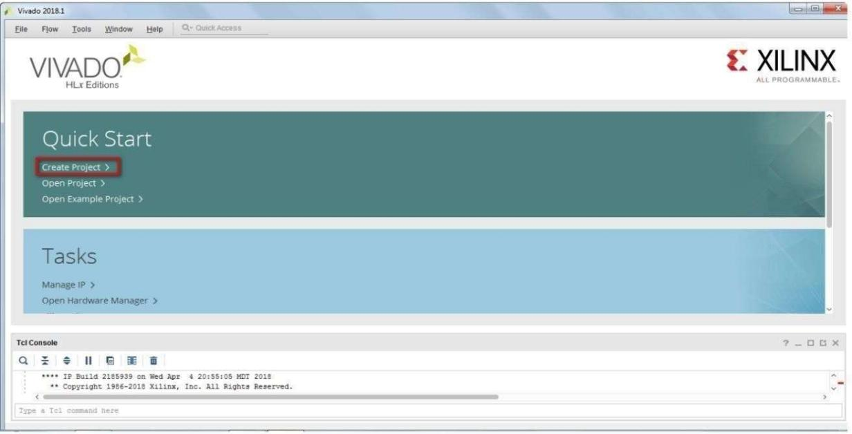
Step 1: Open Vivado click on create project design Suite by selecting.

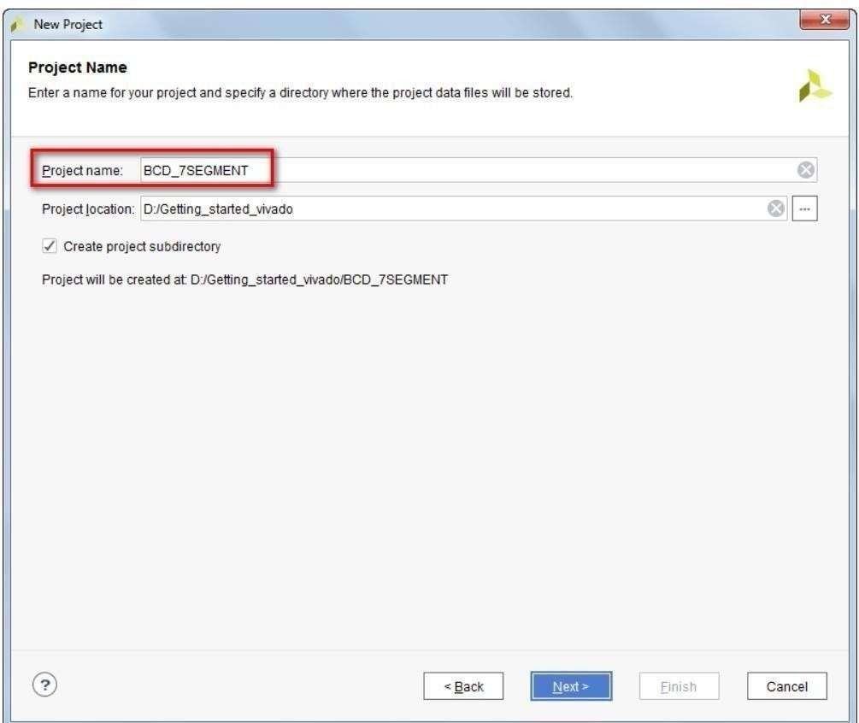
Step 2: Select Project directory and mention new project name.
Figure 5.1 Vivado Project Creation

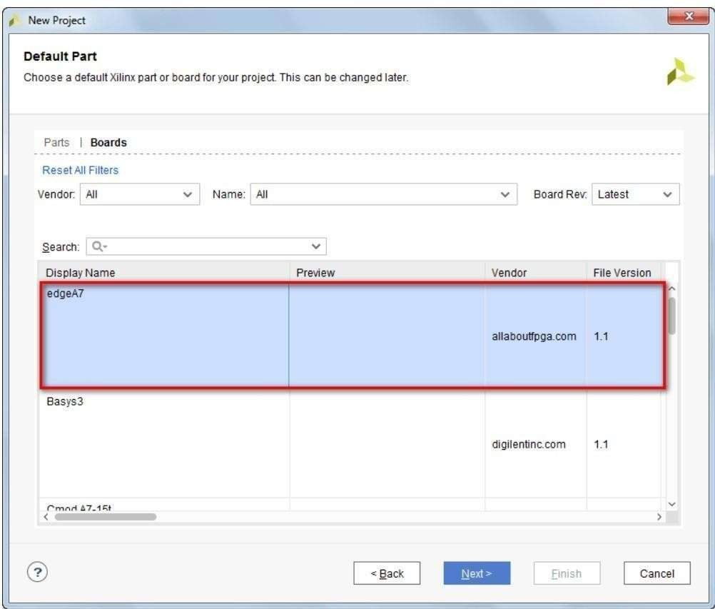
Step 3: Click Boards and and select the evaluation board (zedboard).

Step 4: Now the Vivado tool opens with Flow Navigator on left and Project Manager on right. Flow Navigator display the list of process involved from HDL input creation to bit file output generation. Project manager consist of Source, Workspace and Report Window.
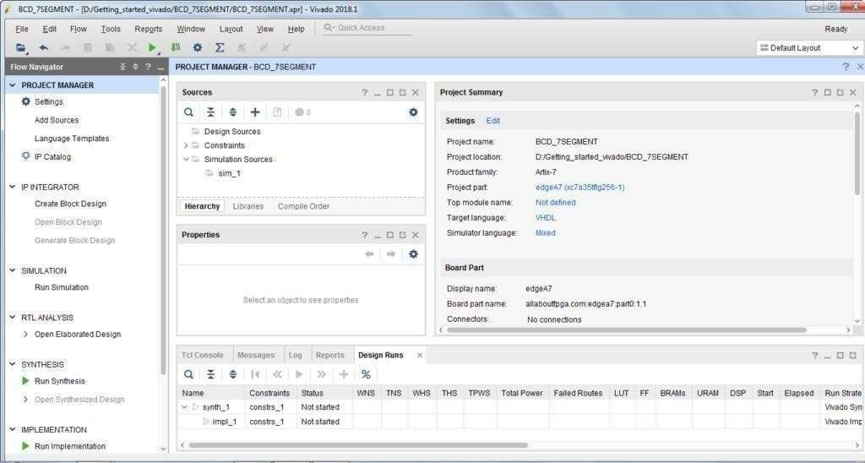
Figure 5.2 Board Selection and Tool Interface

Source Window displays Design Sources (VHDL, Verilog), Constraints (XDC) and Simulation sources. Workspace Window is used to create and view HDL/XDC files. Report Window consist of TCL console, Messages, Logs, Reports and Design Rules

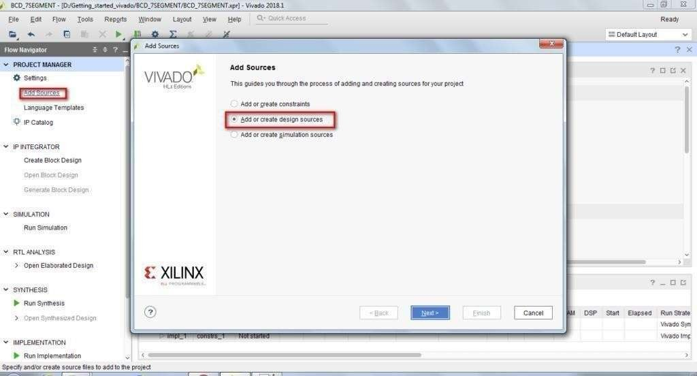
Step 5: Now click Add source and select Add create design sources

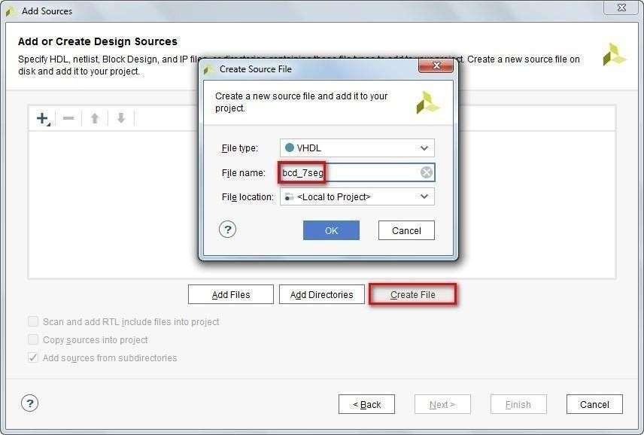
Step 6: Click create file and select file type and file name as bcd_7seg

Figure 5.3 Adding Design Sources (Step 5 & Step 6)

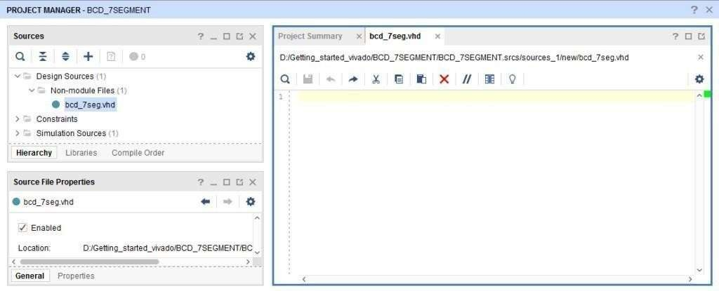
Step 7: Double click on the bcd_7seg.vhd at source window to open on the right side.
Figure 5.4 Source Window and Code Writing
And after this write the code on this file.

CHAPTER 6: SCHEMATIC DIAGRAM :
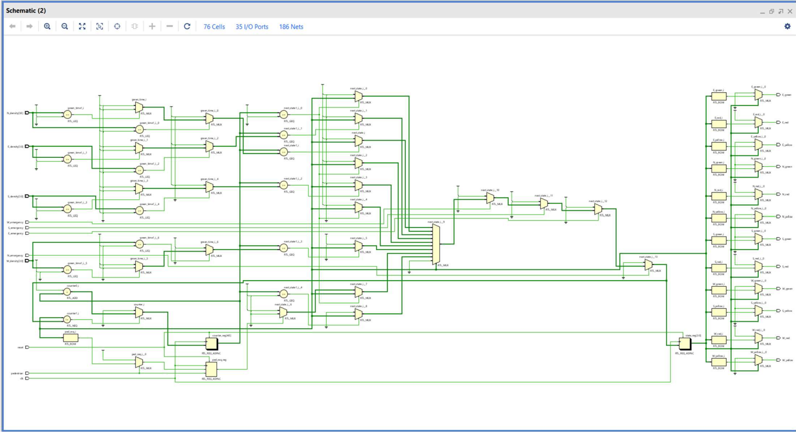
Figure 6.1 Schematic Diagram of Traffic Controller

DEVICE :

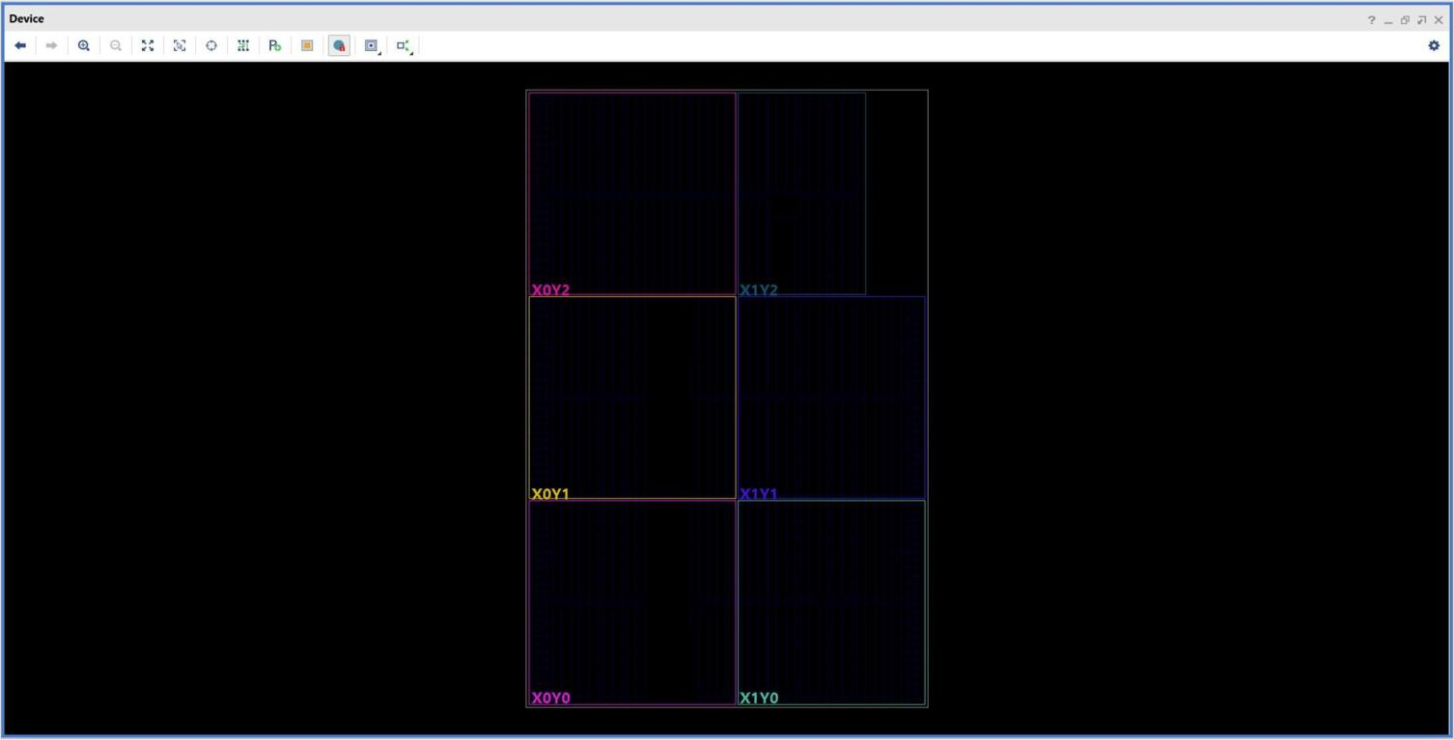
Figure 6.2 Device Layout (FPGA Implementation)

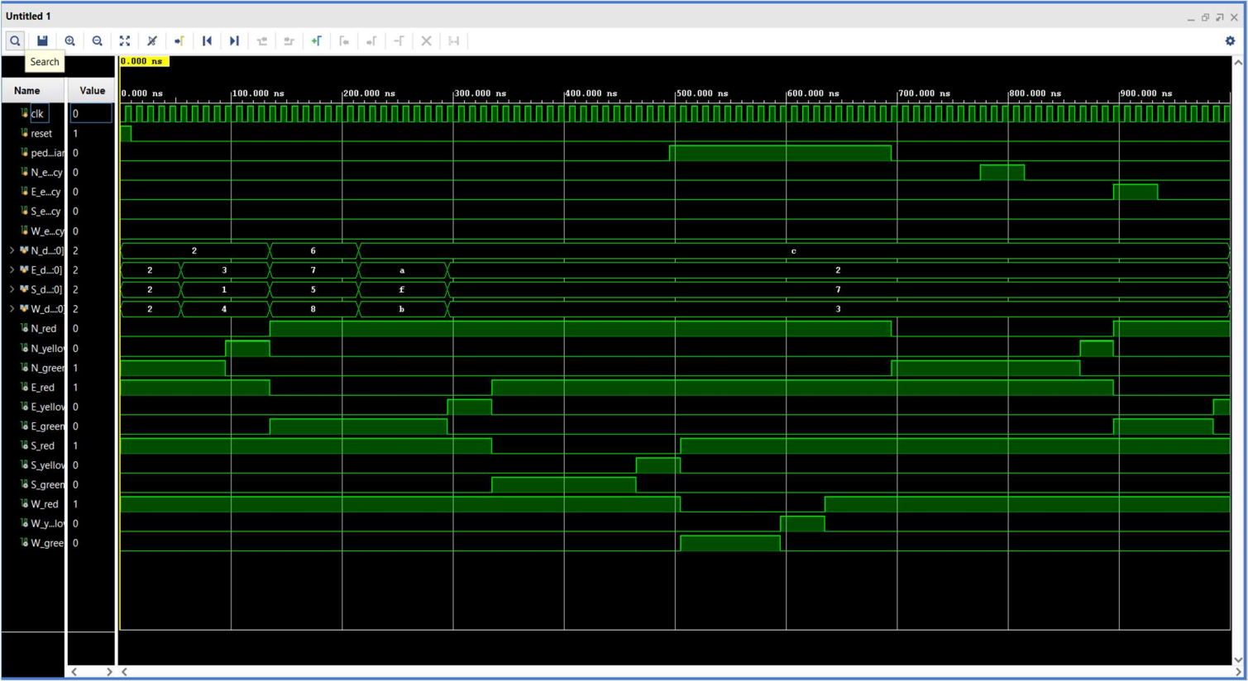
GRAPH (OUTPUT):
Figure 6.3 Simulation Output Waveform

RESULT:
The simulation results show:
- Proper state transitions
- Correct signal timing
- Successful handling of emergency and pedestrian inputs
- Efficient traffic flow
Waveforms and schematic diagrams confirm the working of the system.

CHAPTER 7: ADVANTAGES AND APPLICATIONS

Advantages:
- Reduces traffic congestion
- Minimizes waiting time
- Saves fuel and energy
- Improves road safety
- Supports emergency vehicles

Applications:
- Smart city traffic systems
- Urban intersections
- Highways
- Emergency corridors
- IoT-based traffic systems

CHAPTER 8 CONCLUSION AND FUTURE SCOPE

CONCLUSION :
- The adaptive traffic signal controller using Verilog provides an efficient solution for modern traffic management.
- The system dynamically adjusts signal timing based on traffic density and supports emergency and pedestrian features.
- The use of FSM and Verilog ensures reliable design and accurate simulation. Compared to traditional systems, this approach significantly improves traffic flow and reduces congestion.

FUTURE SCOPE:
- Integration with IoT sensors
- AI-based traffic prediction
- Camera-based vehicle detection
- Cloud-based traffic monitoring
- FPGA-based real-time implementation

REFERENCES :

    - https://www.fpga4student.com/2017/08/verilog-code-for-traffic-light-system.html

    - https://www.geeksforgeeks.org/traffic-light-controller-using-verilog/

    - M. H. Rashid, Digital Design with HDL, Cengage Learning.

    - Stephen Brown and Zvonko Vranesic, Fundamentals of Digital Logic with Verilog Design, McGraw-Hill.

    - Wayne Wolf, FPGA-Based System Design, Pearson Education.

    - Xilinx Inc., Vivado Design Suite User Guide, 2021.

    - IEEE Paper: “Design of Adaptive Traffic Signal Control System using FPGA”, IEEE Conference Proceedings.

    - K. V. S. Reddy et al., “Smart Traffic Light Control System Using FPGA”, International Journal of Engineering

    - From Wikipedia, the free encyclopedia, the web page on
https://en.wikipedia.org/wiki/Traffic_light_control_and_coordination

