1. **Go to**[**https://github.com/join**](https://github.com/join)**in a web browser.** You can use any web browser on your computer, phone, or tablet to join.

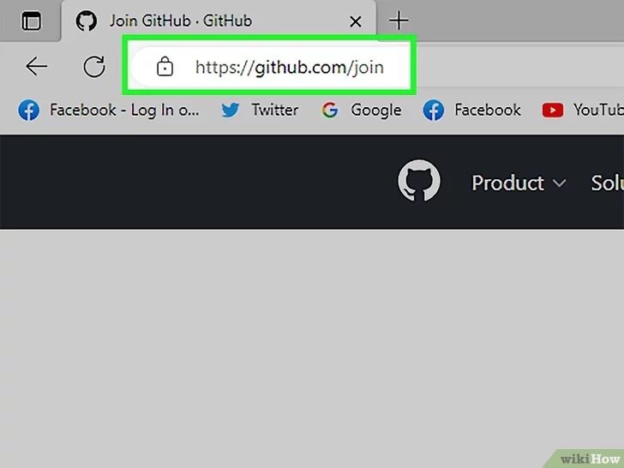

1. **Enter your personal details.** In addition to creating a username and entering an email address, you'll also have to create a password. Your password must be at least 15 characters in length *or* at least 8 characters with at least one number and lowercase.letter.

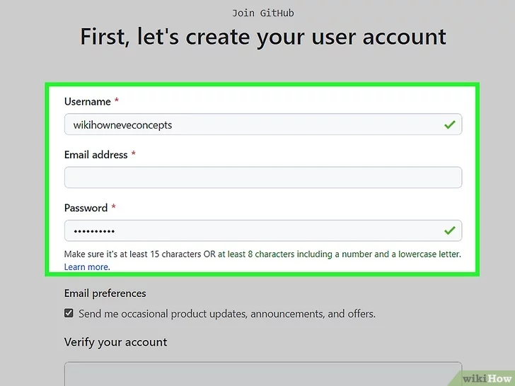

**3.Click Verify to start the verification puzzle.** The instructions vary by puzzle, so just follow the on-screen instructions to confirm that you are a human. A green checkmark will appear after completing the puzzle.

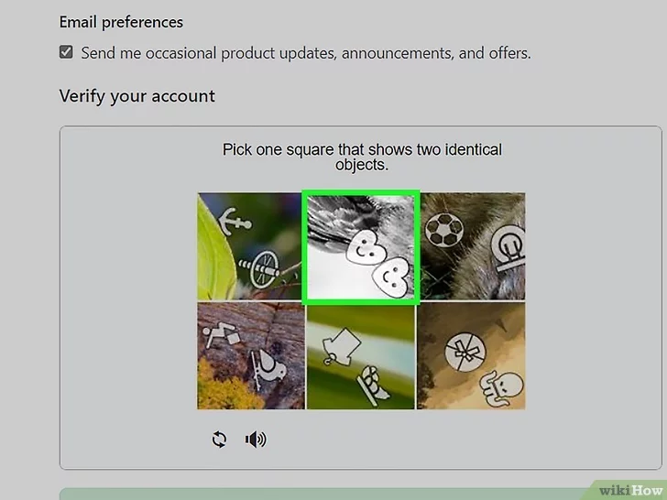

**4.Click the green Create account button.** It's below the form, at the bottom of the page. This will take you to an email verification page.

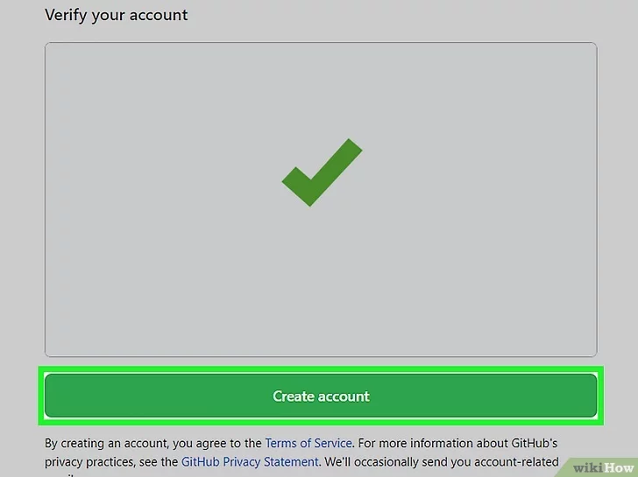

**5.verify your email by entering the code.** After clicking **Create account**, you’ll receive an email with a code. Enter this code on the verification page. Entering the code will automatically take you to the welcome page.

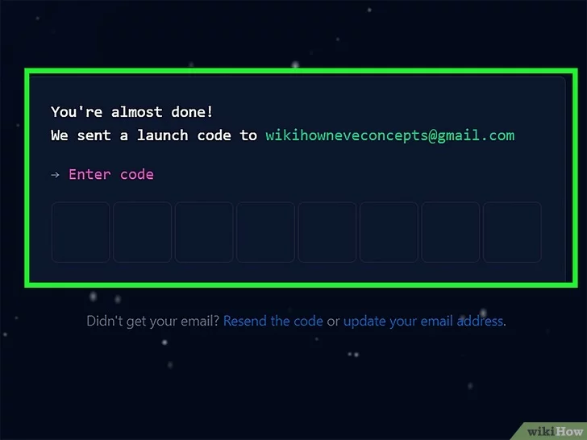

**6.Select your preferences and click Continue.** GitHub displays a quick survey that can help you tailor your experience to match what you're looking for. You’ll be sent to the plan selection page after completing the survey.

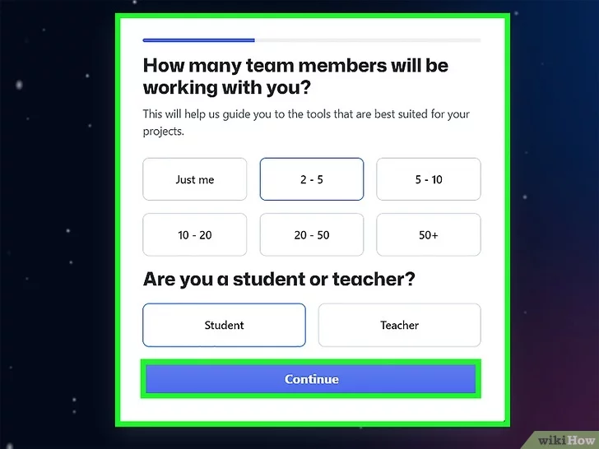

7. **Note the types of plans offered by GitHub.** There are a few different plans to choose from, varying in the amount of features provided.[[2]](https://www.wikihow.com/Create-an-Account-on-GitHub#_note-2)

* **Free:** Unlimited public and private repositories, up to 3 collaborators, issues and bug tracking, and project management tools.
* **Pro:** Unlimited access to all repositories, unlimited collaborators, GitHub email support, and advanced insight tools.

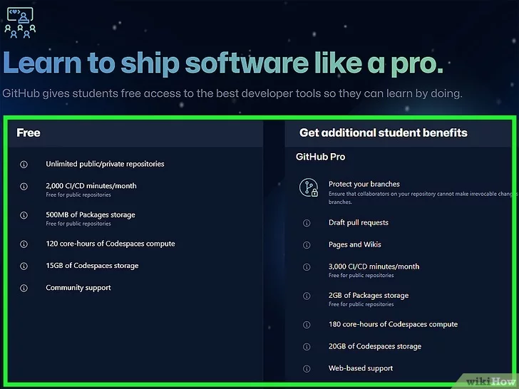

**8. Select the free plan.** On the plan selection page, scroll down to click the button for choosing a free plan. This will immediately take you to your GitHub dashboard. You’re ready to [download some directories and repositories](https://www.wikihow.com/Download-a-GitHub-Folder), or [download a file](https://www.wikihow.com/Download-a-File-from-GitHub).

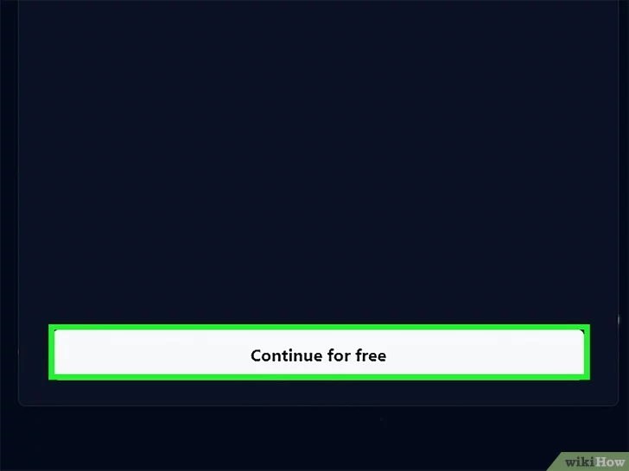

9. create repository:-

