Development Log & Problem–Solution Report
Breast Cancer Detection from Histopathology Images — Weeks 1–2
Vineet Nakra (123CS0193) — Supervisor: Prof. Sanjeev Patel

1. Project Recap
This project reproduces core ideas from a published spiking neural network architecture for classifying breast histopathology images (BreakHis dataset, 7,909 images) as benign or malignant. This report documents, in order, every real problem encountered during Weeks 1–2, how each was diagnosed, how it was fixed, and the measured before/after results — including cases where the fix did not simply make everything better, which is itself an honest and reportable finding.

2. Week 1 — Dataset Verification & Patient-Wise Split
The BreakHis dataset was verified against the original paper's published statistics (exact match: 7,909 images, same per-magnification benign/malignant counts). A patient-wise train/validation/test split (55/13/13 patients) was constructed and verified to have zero patient overlap across splits — preventing the same patient's tissue from appearing in both training and evaluation data.
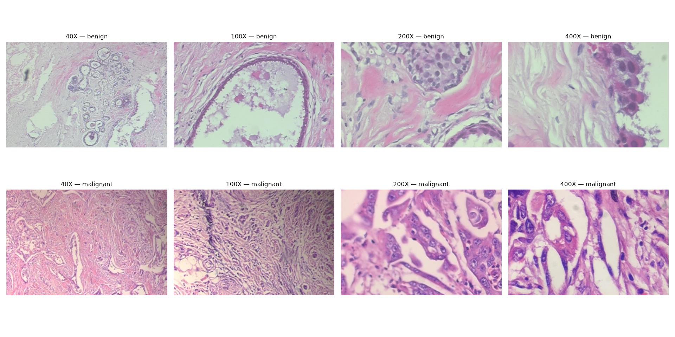
Figure 1. Real sample images from the dataset at each magnification level (40X–400X), benign (top) vs. malignant (bottom).

3. Week 2, Part A — Preprocessing Filter (TSGF)
A trainable image preprocessing filter was implemented — a learnable variant of the classical Guided Image Filter, which smooths likely noise while preserving real tissue structure. Its one learnable parameter (referred to as eps) controls how aggressively it smooths; this value is tuned automatically during training rather than hand-picked.
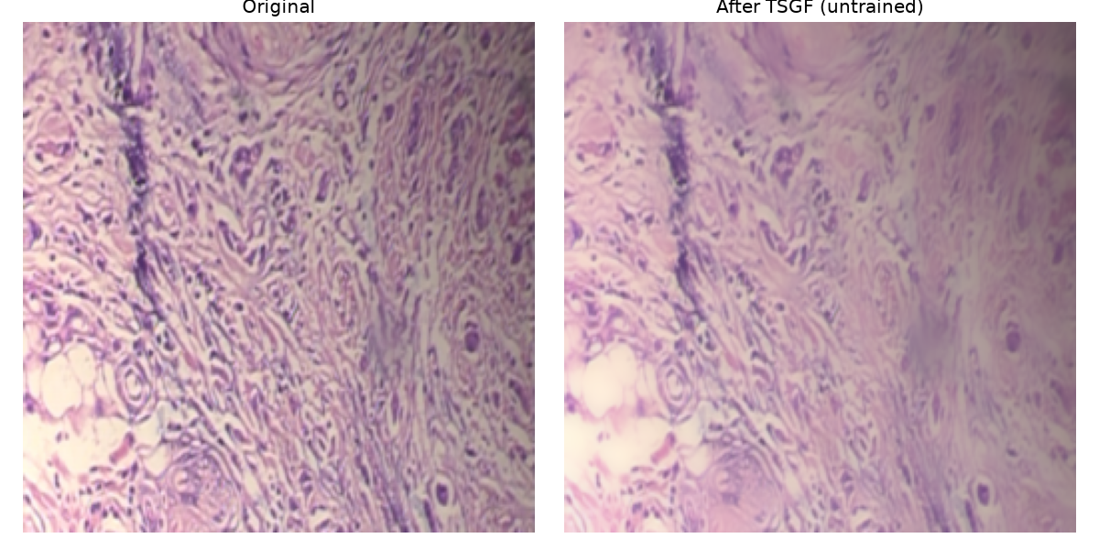
Figure 2. Filter effect on a real sample image (default parameter, before training).

4. Week 2, Part B — Problem: Unstable Baseline Training

4.1 Symptom
The first full training run of the baseline classifier (preprocessing filter + convolutional network) completed all 8 epochs, but validation loss swung wildly instead of decreasing smoothly — from 0.27 up to 1.47 and back down. The final model was heavily biased toward predicting “malignant”: only 22% of true benign cases were correctly identified (benign recall), despite a misleadingly high overall accuracy of 78%.

4.2 Diagnosis
- Learning rate (the size of each training adjustment) was too large, causing the model to repeatedly overshoot and oscillate instead of settling.
- No correction was applied for class imbalance: malignant images outnumber benign images roughly 1.8:1 in the training set, so the model found it “cheap” to lean toward guessing malignant.

4.3 Fix Implemented
- Reduced learning rate (1e-3 → 1e-4) with an adaptive scheduler that halves it further whenever validation loss plateaus.
- Class-weighted loss function, so a mistake on the rarer (benign) class counts proportionally more.
- Checkpointing on best validation loss with early stopping — mirroring standard practice and the original paper's own methodology.

4.4 Result: Training Stability
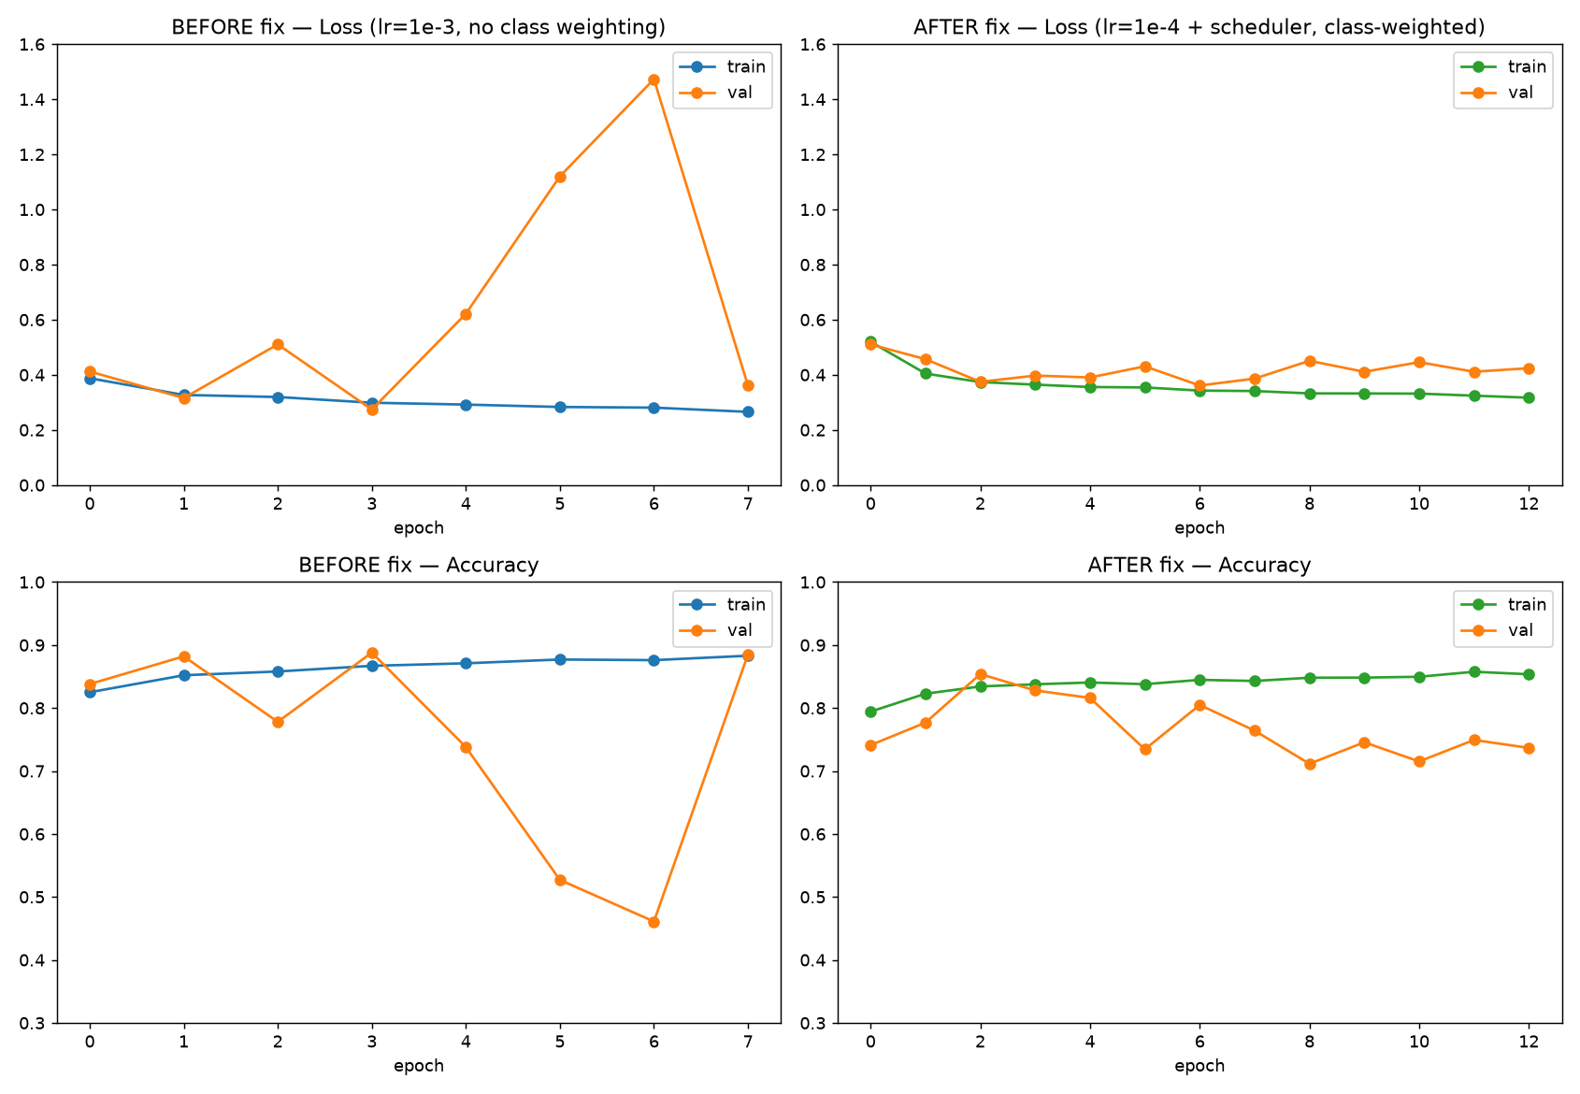
Figure 3. Training/validation loss and accuracy, before vs. after the fix. The wild validation-loss spikes are gone.

4.5 Result: Test-Set Metrics
Metric | Before Fix | After Fix | Change
Benign precision | 0.39 | 0.20 | ↓ worse
Benign recall | 0.22 | 0.47 | ↑ better
Malignant precision | 0.83 | 0.81 | ≈ similar
Malignant recall | 0.92 | 0.55 | ↓ worse
Overall test accuracy | 0.78 | 0.53 | ↓ worse
Validation loss stability | Unstable (0.27–1.47 swing) | Stable (0.36–0.45 range) | ↑ better

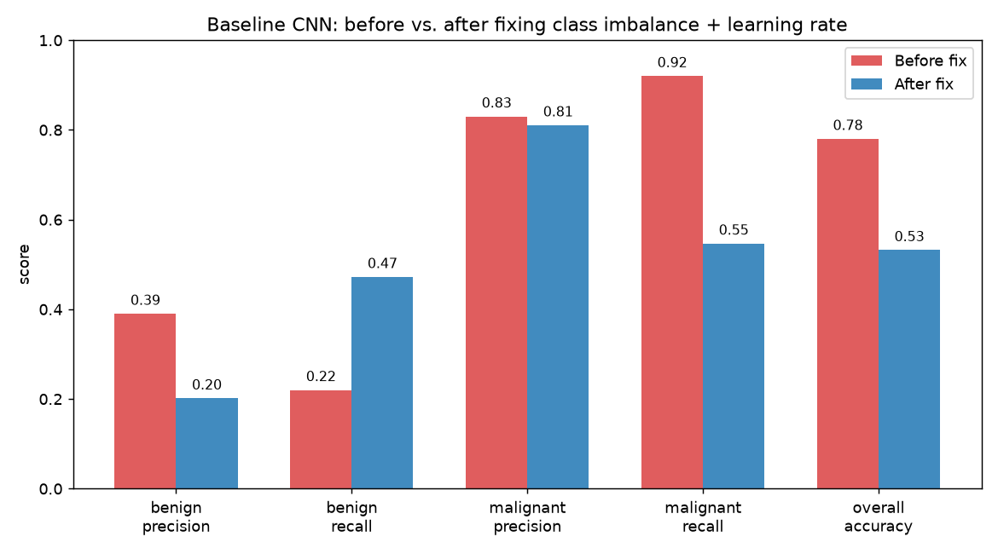
Figure 4. Per-class precision/recall, before vs. after.
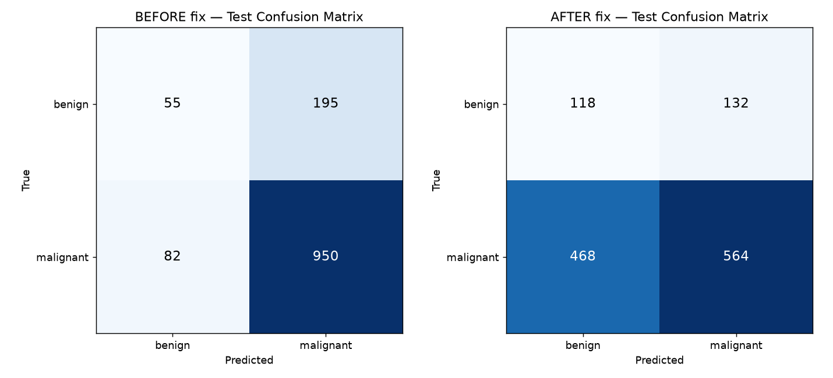
Figure 5. Test-set confusion matrices, before vs. after.

4.6 Honest Assessment — This Fix Was Only a Partial Success
The instability and class-imbalance bias were genuinely resolved: benign recall improved from 22% to 47%, and training curves are now smooth and stable rather than erratic. However, overall test accuracy dropped from 78% to 53%. This is not a contradiction — the original 78% figure was misleadingly inflated by the model simply defaulting to “malignant” most of the time (a degenerate strategy that scores well on an imbalanced dataset without actually learning to distinguish the classes well). The corrected model makes a genuine, balanced attempt at both classes, but is not yet strong: there is a large gap between validation accuracy during training (80.5%) and final test accuracy (53.2%), most likely due to the small test set (13 patients, 1,282 images) and the limited capacity of this deliberately simple baseline model. This baseline's purpose is to serve as a reference point for later, more advanced architectures — not to be the final result — so this is flagged honestly rather than presented as a finished success.

5. Week 2, Part C — Problem: GPU Training Infrastructure Failures

5.1 Symptom
After implementing the fixes above, subsequent training attempts failed in three different ways in sequence: a CUDA “out of memory” error while creating a model of only ~26,000 parameters (far too small to plausibly exhaust 4GB of GPU memory), a hard kernel crash during training, and finally, a diagnostic test showing that even allocating a 10-number tensor on the GPU failed — while the GPU itself reported being almost completely empty.

5.2 Diagnosis
This ruled out an actual memory shortage or a bug in the training code. The GPU's CUDA context had entered a corrupted, stuck state, most likely left over from an earlier abnormally-terminated process holding a lock on GPU resources without releasing them.

5.3 Fix
As an immediate workaround, training was run on CPU instead (the model is small enough for this to be practical, just slower). The proper fix — a full machine restart to clear the corrupted GPU driver state — was confirmed effective in a later session: a fresh CUDA allocation test succeeded immediately after restart, and full GPU-accelerated training then completed successfully (the results reported in Section 4 above).

6. Current Status & Next Steps
Weeks 1–2 are complete: verified dataset pipeline, working preprocessing filter, and a stable (if not yet strong) baseline classifier with an honestly documented performance ceiling. This baseline stands as the reference point against which the upcoming, more advanced components will be measured:
- Week 3: Spiking neural network layers (replacing standard convolutional neurons with biologically-inspired spiking neurons).
- Week 4: Multi-dimensional attention mechanisms, and full architecture assembly.
- Week 5: Advanced/bio-inspired optimization strategy, integrated with the full model.
- Week 6: Comparative evaluation of each component's contribution, and final benchmarking.

