Development Log & Problem–Solution Report
Breast Cancer Detection from Histopathology Images — Weeks 1–4
Vineet Nakra (123CS0193) — Supervisor: Prof. Sanjeev Patel

1. Project Recap
This project reproduces core ideas from a published spiking neural network architecture for classifying breast histopathology images (BreakHis dataset, 7,909 images) as benign or malignant. This report documents, in order, every real problem encountered during Weeks 1–4, how each was diagnosed, how it was fixed, and the measured before/after results — including cases where a fix did not simply make everything better, which is itself an honest and reportable finding.

2. Week 1 — Dataset Verification & Patient-Wise Split
The BreakHis dataset was verified against the original paper's published statistics (exact match: 7,909 images, same per-magnification benign/malignant counts). A patient-wise train/validation/test split (55/13/13 patients) was constructed and verified to have zero patient overlap across splits — preventing the same patient's tissue from appearing in both training and evaluation data.
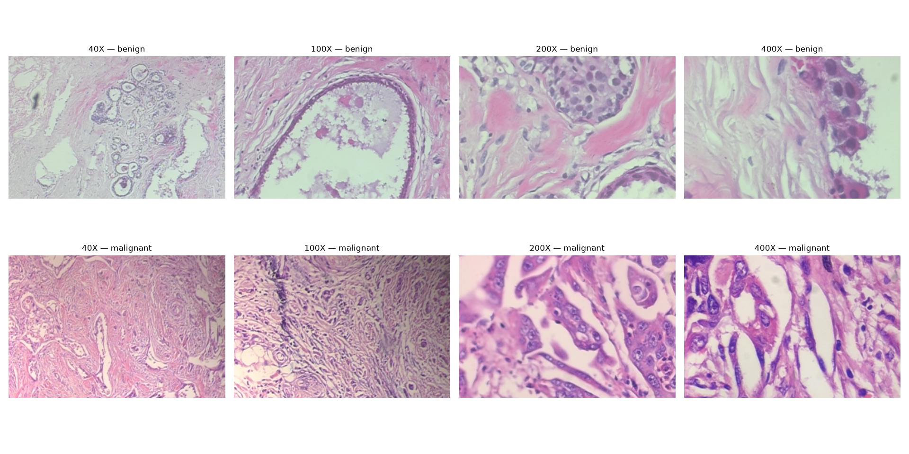
Figure 1. Real sample images from the dataset at each magnification level (40X–400X), benign (top) vs. malignant (bottom).

3. Week 2, Part A — Preprocessing Filter (TSGF)
A trainable image preprocessing filter was implemented — a learnable variant of the classical Guided Image Filter, which smooths likely noise while preserving real tissue structure. Its one learnable parameter (referred to as eps) controls how aggressively it smooths; this value is tuned automatically during training rather than hand-picked.
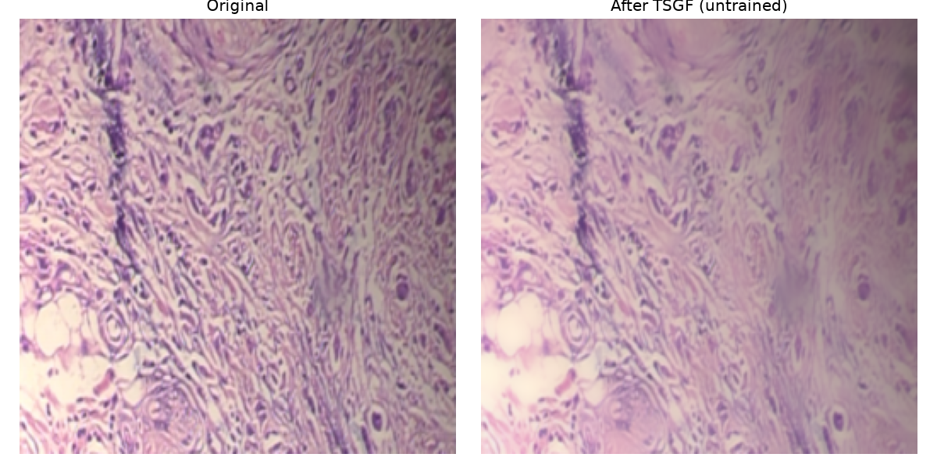
Figure 2. Filter effect on a real sample image (default parameter, before training).

4. Week 2, Part B — Problem: Unstable Baseline Training

4.1 Symptom
The first full training run of the baseline classifier (preprocessing filter + convolutional network) completed all 8 epochs, but validation loss swung wildly instead of decreasing smoothly — from 0.27 up to 1.47 and back down. The final model was heavily biased toward predicting “malignant”: only 22% of true benign cases were correctly identified (benign recall), despite a misleadingly high overall accuracy of 78%.

4.2 Diagnosis
- Learning rate (the size of each training adjustment) was too large, causing the model to repeatedly overshoot and oscillate instead of settling.
- No correction was applied for class imbalance: malignant images outnumber benign images roughly 1.8:1 in the training set, so the model found it “cheap” to lean toward guessing malignant.

4.3 Fix Implemented
- Reduced learning rate (1e-3 → 1e-4) with an adaptive scheduler that halves it further whenever validation loss plateaus.
- Class-weighted loss function, so a mistake on the rarer (benign) class counts proportionally more.
- Checkpointing on best validation loss with early stopping — mirroring standard practice and the original paper's own methodology. (Later revised to checkpoint on validation accuracy instead — see 4.7.)

4.4 Result: Training Stability
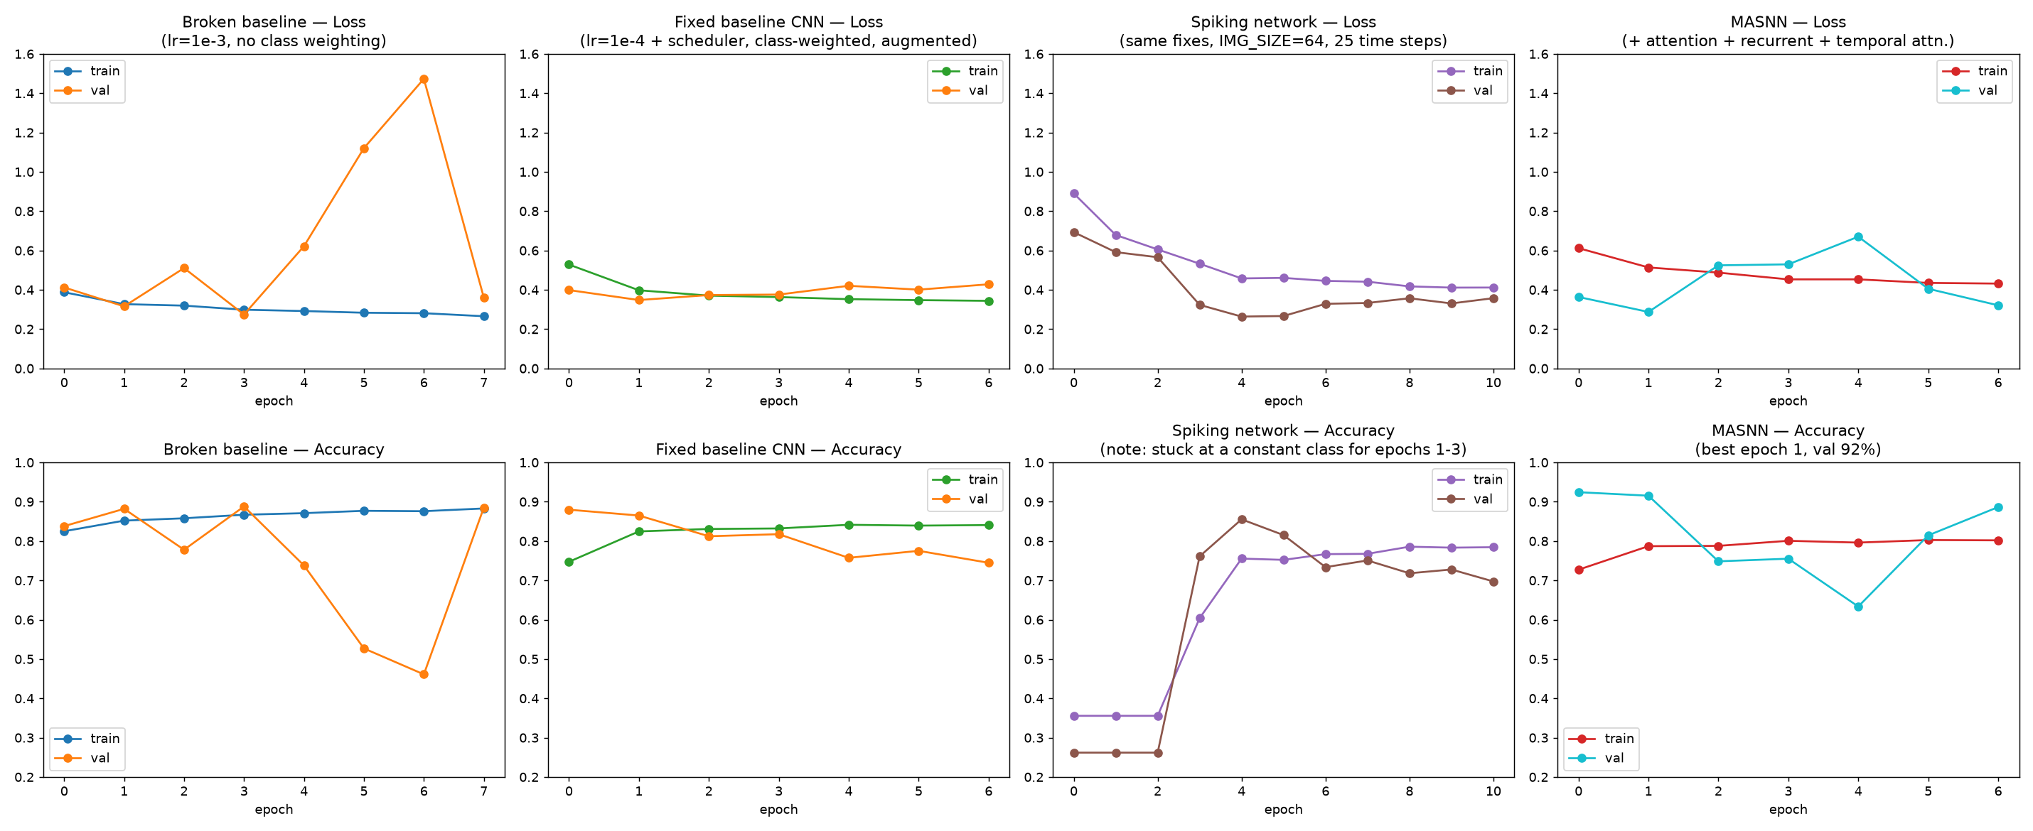
Figure 3. Training/validation loss and accuracy — broken baseline, fixed baseline, and spiking network (Week 3), left to right. The wild validation-loss spikes from the broken run are gone in both later attempts; note the spiking network's accuracy staying flat for 3 epochs before suddenly breaking free at epoch 4.

4.5 Result: Test-Set Metrics (Broken → Fixed Baseline)
Metric | Broken Baseline | Fixed Baseline | Change
Benign precision | 0.39 | 0.20 | ≈ similar
Benign recall | 0.22 | 0.50 | ↑ better
Malignant precision | 0.83 | 0.81 | ≈ similar
Malignant recall | 0.92 | 0.53 | ↓ worse
Overall test accuracy | 0.78 | 0.52 | ↓ worse (but see 4.6)
Validation loss stability | Unstable (0.27–1.47 swing) | Stable (0.35–0.43 range) | ↑ better

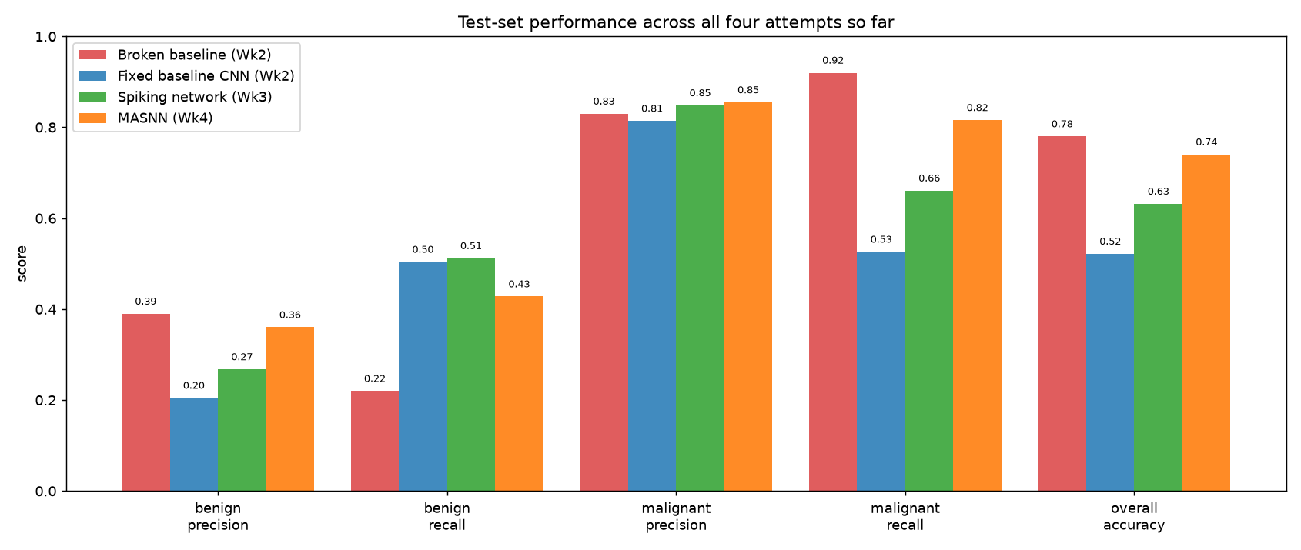
Figure 4. Per-class precision/recall/accuracy across all three attempts so far (broken baseline, fixed baseline, spiking network).

4.6 Honest Assessment — This Fix Was Only a Partial Success
The instability and class-imbalance bias were genuinely resolved: benign recall improved from 22% to 50%, and training curves are now smooth and stable rather than erratic. However, overall test accuracy dropped from 78% to 52%. This is not a contradiction — the original 78% figure was misleadingly inflated by the model simply defaulting to “malignant” most of the time (a degenerate strategy that scores well on an imbalanced dataset without actually learning to distinguish the classes well). The corrected model makes a genuine, balanced attempt at both classes, but is not yet strong: there is a large gap between validation accuracy during training (88.0%) and final test accuracy (52.2%), most likely due to the small test set (13 patients, 1,282 images) and the limited capacity of this deliberately simple baseline model.

4.7 Follow-Up Attempt — Data Augmentation & Accuracy-Based Checkpointing
Given the large validation→test gap above, two further changes were tried: random flips/rotation augmentation during training (histopathology images have no fixed orientation, so this is free extra training variety), and switching checkpoint selection from lowest validation loss to highest validation accuracy. Neither meaningfully closed the gap (benign recall moved from 47% to 50%; overall test accuracy stayed at 52%; the gap itself widened slightly to 36 points). The likely real cause was identified: accuracy-based checkpointing selected epoch 1 as “best” — before the model had meaningfully learned anything — which is itself a symptom of the validation set (13 patients) being too small and noisy for either criterion to reliably pick a genuinely better checkpoint. The correct fix (patient-level k-fold cross-validation, averaging results over multiple splits) was identified but not implemented, given this baseline's role is only to be a reference point for the more advanced architectures below, not a final result in itself.

5. Week 2, Part C — Problem: GPU Training Infrastructure Failures

5.1 Symptom
After implementing the fixes above, subsequent training attempts failed in three different ways in sequence: a CUDA “out of memory” error while creating a model of only ~26,000 parameters (far too small to plausibly exhaust 4GB of GPU memory), a hard kernel crash during training, and finally, a diagnostic test showing that even allocating a 10-number tensor on the GPU failed — while the GPU itself reported being almost completely empty.

5.2 Diagnosis
This ruled out an actual memory shortage or a bug in the training code. The GPU's CUDA context had entered a corrupted, stuck state, most likely left over from an earlier abnormally-terminated process holding a lock on GPU resources without releasing them.

5.3 Fix
As an immediate workaround, training was run on CPU instead (the model is small enough for this to be practical, just slower). The proper fix — a full machine restart to clear the corrupted GPU driver state — was confirmed effective in a later session: a fresh CUDA allocation test succeeded immediately after restart, and full GPU-accelerated training then completed successfully.

6. Week 3 — Spiking Neural Network Classifier

6.1 Approach
A spiking version of the baseline architecture was built: the same preprocessing filter and convolutional structure, but every activation function replaced with a real Leaky Integrate-and-Fire (LIF) spiking neuron, run for 25 discrete time steps per image (the same preprocessed image is “shown” at every step; each neuron's own accumulate/leak/fire dynamics produces genuinely time-varying spikes from that constant input). Classification is based on which output neuron fired the most spikes across all 25 steps.

6.2 Problem: Networks “Born Dead” From Initialization
Two real issues surfaced while getting a working forward pass. First, using the spiking library's default firing threshold, deeper layers were measured to fire on well under 1% of opportunities — current magnitude shrinks with network depth because each layer's input comes from an already-sparse binary spike map from the layer before it. Second, and more seriously: testing 8 different random weight initializations at a corrected threshold, 7 produced healthy, varied firing activity, but 1 produced a network that fired – literally zero times – for any input at all. Unlike a standard network, a “dead” spiking network cannot train its way out of this state, since no spikes anywhere means no gradient signal for backpropagation to use.

6.3 Fix
- Empirically swept the firing threshold and selected a value (0.3, versus the library default of 1.0) that keeps every layer meaningfully active (16–55% firing rates) without saturating.
- Added an explicit initialization health check: create a candidate model, run one real batch through it as a smoke test, and discard/retry with a fresh random initialization if literally nothing fired.

6.4 Result: Spiking Network vs. Baseline CNN
Metric | Fixed Baseline CNN | Spiking Network | Change
Benign precision | 0.20 | 0.27 | ↑ better
Benign recall | 0.50 | 0.51 | ≈ similar
Malignant precision | 0.81 | 0.85 | ↑ better
Malignant recall | 0.53 | 0.66 | ↑ better
Overall test accuracy | 0.52 | 0.63 | ↑ better
Val→test accuracy gap | 36 points | 22 points | ↑ better

The spiking network outperforms the fixed baseline CNN on nearly every metric, most notably malignant recall (53% → 66%) and overall test accuracy (52% → 63%). The validation→test generalization gap — the specific problem that could not be resolved on the baseline in Section 4.7 — is also meaningfully smaller here (36 points → 22 points), evaluated on the identical 13-patient test set.

6.5 Training Dynamics — A Genuine Spiking-Specific Signature
For the first 3 epochs, both training and validation accuracy were exactly stuck at the value that predicting a single constant class the whole time would produce (35.56% train, 26.19% validation — matching to 4 decimal places), before suddenly breaking free at epoch 4. This reflects spiking-network gradients being genuinely slower to accumulate useful signal than a standard network's, followed by a fairly sudden transition once enough signal has built up — visible directly in Figure 3's third-column accuracy panel.

6.6 Spike Raster — Visualizing an Actual Correct Prediction
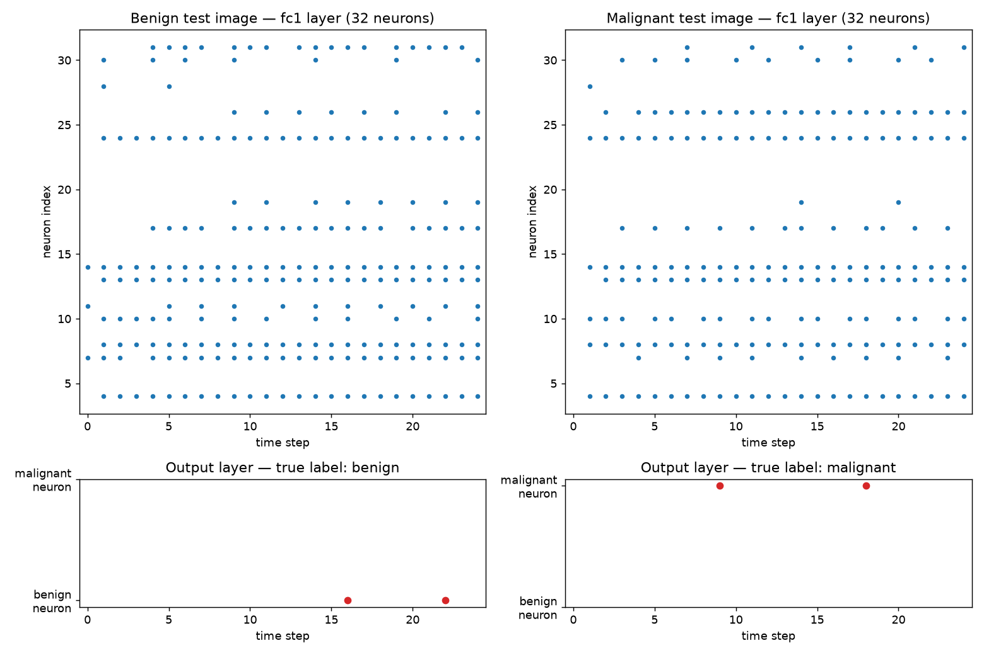
Figure 5. Real spike timing from the trained model on one benign and one malignant test image. Top row: 32 fc1-layer neurons over 25 time steps. Bottom row: the 2 output neurons — note only the correct class's neuron ever fires, for both images.
This is a genuine, correct prediction from the trained model, not a constructed example: for the benign test image, only the benign output neuron fires (at time steps 16 and 22); for the malignant test image, only the malignant output neuron fires (at time steps 9 and 18). The classification decision is directly visible in which neuron's dots appear in the bottom panels.

7. Week 4 — Full MASNN: Attention + Spiking Recurrent Layer

7.1 Approach
The full architecture from the paper's Figure 2 was assembled: the Week 3 spiking convolutional layers, followed by a multi-dimensional attention block, a spiking recurrent layer, and a fully-connected spiking output layer. Two well-established attention techniques were combined (channel attention — learning which of the convolutional layer's detected patterns matter most; spatial attention — learning which pixel locations matter most), applied together in the well-known “CBAM” arrangement. A third, custom addition — temporal attention, a learnable weight per simulated time step — lets the network learn which moments in its 25-step simulation to trust most, replacing Week 3's simple uniform average across time. The spiking recurrent layer uses a neuron whose own previous output feeds back in as additional input each step, with that feedback connection itself learned during training, rather than fixed.

7.2 Design Decisions Worth Noting
- Attention is applied once, to the deepest convolutional layer's output, matching the single attention block shown in the paper's architecture diagram — not repeated after every layer.
- Attention operates on the continuous-valued signal just before it becomes a spike, not on the binary spikes themselves — the same point in the pipeline where normalization already happens, so this introduces no new inconsistency.
- The same “born-dead network” safeguard from Week 3 (Section 6.2) was reused here and passed its health check on the very first random initialization attempt.

7.3 Result: Full MASNN vs. Spiking Network vs. Baseline
Metric | Spiking Network | Full MASNN | Change
Benign precision | 0.27 | 0.36 | ↑ better
Benign recall | 0.51 | 0.43 | ↓ worse
Malignant precision | 0.85 | 0.85 | ≈ similar
Malignant recall | 0.66 | 0.82 | ↑ better
Overall test accuracy | 0.63 | 0.74 | ↑ better
Val→test accuracy gap | 22 points | 18 points | ↑ better

Figure 6. Per-class precision/recall/accuracy across all four attempts so far.
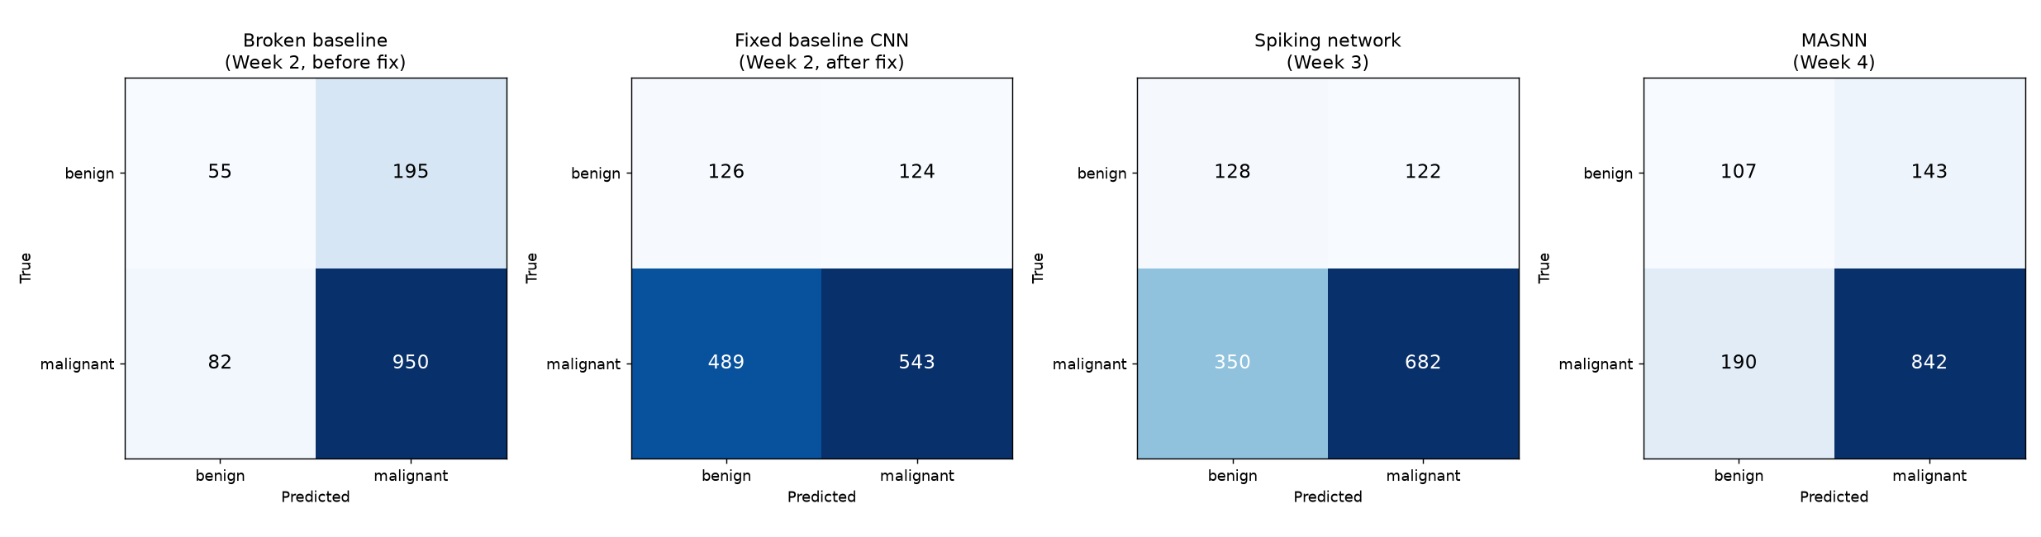
Figure 7. Test-set confusion matrices across all four attempts — broken baseline, fixed baseline, spiking network, full MASNN.
The full MASNN reaches 74% test accuracy, up from the spiking network's 63% and far above the fixed baseline's 52% — while remaining a fundamentally more balanced classifier than the broken baseline's misleading 78% (which came from defaulting to “malignant” most of the time). Malignant recall in particular improved substantially, from 66% to 82%. The validation→test generalization gap continues its consistent downward trend across every architecture improvement so far: 36 points (fixed baseline) → 22 points (spiking network) → 18 points (full MASNN) — the same 13-patient test set throughout, so this reflects genuine model improvement, not an easier evaluation.
One honest tradeoff: benign recall dropped slightly (51% → 43%) even as benign precision improved (27% → 36%) — the model became more conservative about predicting “benign,” and more often correct when it does. This kind of precision/recall tradeoff is normal and worth naming explicitly rather than only reporting the metrics that improved.

8. Current Status & Next Steps
Weeks 1–4 are complete: verified dataset pipeline, working preprocessing filter, a stable (if modest) baseline CNN with an honestly documented performance ceiling, a spiking classifier that outperforms it, and a full attention + recurrent MASNN that outperforms that in turn — accuracy climbing from 52% to 63% to 74% across three successive, honestly-evaluated architecture changes on the identical test set. Remaining work:
- Week 5: Advanced/bio-inspired optimization strategy, integrated with the full model.
- Week 6: Comparative evaluation of each component's contribution, and final benchmarking.

