For the OpenChargeMap app registration (they want to know what you're doing with their data):

The problem it solves
The Netherlands has roughly 15,000 public EV charging points. OpenChargeMap publishes data about all of them: where they are, who operates them, what power they deliver, and whether they're currently reported as working.
But that API only tells you what is true right now. If you ask it today, you get today's picture. Ask tomorrow, you get tomorrow's picture. Yesterday is gone — nobody stored it.
So there are questions nobody can answer from the source alone:
- Has this charger in Utrecht been broken for two days, or two months?
- Which operator has the worst reliability record?
- Did forty chargers quietly disappear from Amsterdam last month?
- Is the network growing or shrinking in my province?
Your project answers those questions by doing one simple thing the source doesn't do: it remembers. Create API for this.
Api : "https://api.openchargemap.io/v3/poi"

The core idea
A snapshot tells you the state. A sequence of snapshots tells you the story.
Every hour, your system takes a picture of the whole Dutch network and compares it to the previous picture. Anything that changed gets written to a permanent log — a new station appeared, a station's status flipped from "operational" to "out of service", a station vanished from the feed entirely. Over weeks, that log becomes a history nobody else has.
That's the whole product. Everything else is engineering around it.
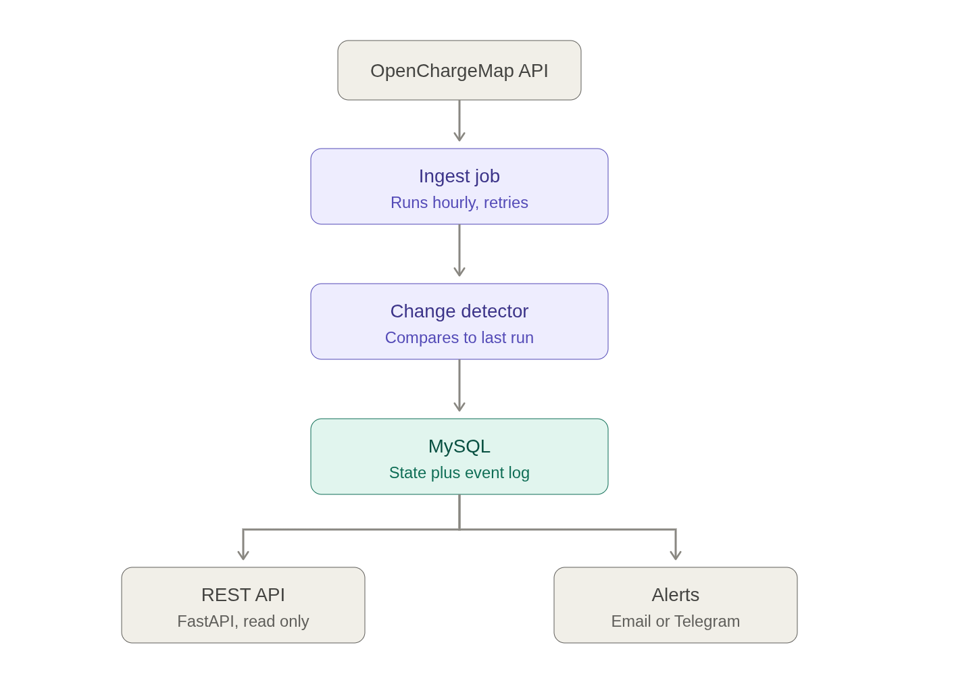

Each part, in detail
The ingest job. Wakes up on a schedule, pulls all Dutch stations from OpenChargeMap, page by page. The interesting engineering is in what happens when things go wrong: the API times out, returns a 503, or rate-limits you. Junior code crashes here. Your code retries with exponential backoff, gives up gracefully after N attempts, and records the failure in ingest_runs so you know a gap in your history exists and why.
The change detector. This is the brain, and it's the reason the order of operations I gave you matters. Before writing anything, it reads the previous state out of the database — that's the "before" picture. Then it compares, station by station:
- In the feed, not in the database → new
- In both, but status_title differs → status_change
- In the database, missing from this run's feed → delisted
- Was delisted, now back → relisted
Each difference becomes a row in status_events. This table is append-only — you never update or delete a row in it. That's a deliberate architectural choice, and it's the one worth explaining in your README: a mutable table can only ever tell you the present, while an immutable event log lets you reconstruct any past moment. It's the same reason banks store transactions instead of just a balance.
MySQL. Two tables doing two different jobs. stations is fast to query — "show me all broken chargers in Rotterdam" hits one indexed table. status_events is the history — "show me everything that happened to station 12345" walks the log. Splitting them means neither query is slow. ingest_runs is the third table and the one beginners skip; it's your operational record, and it's what turns a script into a service.
The REST API. FastAPI, read-only. Something like: list stations with filters, get one station with its full event history, list recent changes, show ingest health. Read-only is intentional — clients consume the data, only the pipeline writes it. FastAPI gives you Swagger docs for free, which means your README can link to a live, clickable API. That's a strong thing for a reviewer to land on.
Alerts. The last mile that makes it a product rather than a database. When change detection produces events matching a rule ("any station in my postcode went offline"), send a message. Telegram is the easiest to implement and the most fun to demo.
And it has a property most portfolio projects lack: it gets more valuable while you sleep. After a month of running, you have a dataset nobody else has. You can write a short post — "what I learned running a monitor on the Dutch charging network for 30 days" — with a real chart.

===========================================================

