FINANCIAL TRANSACTIONS
AND LOANS DASHBOARD
POWER BI PROJECT REPORT

Student Name | NAKSHATHRA S
Register Number | E25FA030
Department / Course | B.Com FinTech and AI
Project Topic | Financial Transactions and Loans Dashboard using Microsoft Power BI

Submitted as part of the Power BI project work

1. Introduction
Microsoft Power BI is a business intelligence and data visualisation tool that converts raw data into meaningful information through interactive reports, dashboards, charts and tables. This project uses a Financial Transactions and Loans dataset to present a clear overview of customer accounts, loan status and transaction activity.
The dashboard combines key performance indicator (KPI) cards, bar charts, a line chart, a doughnut chart, a summary table and slicers. These visuals help users compare account categories, review loan statuses and explore transaction patterns by year, account type and transaction type.

2. Objectives of the Project
- To create an interactive financial dashboard using Microsoft Power BI.
- To display key indicators such as total customers, active accounts, active loans and total transaction value.
- To compare account counts across Youth, Business, Savings, Payroll and Checking account types.
- To analyse the distribution of loans by status, including Active, Paid Off and Overdue.
- To compare transaction counts and transaction values for Deposit, Payment, Transfer and Withdrawal.
- To study transaction trends over time and allow filtering through slicers.

3. Dataset Description
The dataset contains information about customers, accounts, loans and financial transactions. Account type, transaction type, transaction value, date and loan status are used to group, calculate and filter the information displayed in the report.
Field | Purpose
Customer | Identifies customers represented in the dataset.
Account / TypeName | Groups accounts by Youth, Business, Savings, Payroll and Checking.
Transaction Type | Identifies Deposit, Payment, Transfer or Withdrawal.
Transaction Value | Records the monetary value of each transaction.
Loan / StatusName | Classifies loans as Active, Paid Off or Overdue.
Date / Year | Supports month-wise and year-wise trend analysis.

4. Data Preparation
Before creating the visuals, the required dataset was imported into Power BI Desktop. The fields and data types were reviewed, date fields were prepared for time-based analysis, and relationships between relevant tables were checked so that filters could work across the report.
- Checked customer, account, loan, transaction and date fields.
- Reviewed blank or missing values and considered how they should be handled.
- Checked table relationships and the consistency of category names.
- Created measures for the headline financial indicators.
- Tested slicers and visuals to ensure they responded to filters.

5. Dashboard Overview
The main dashboard provides a single-screen summary of the financial dataset. It includes account counts, loan status, transaction activity and filters for exploring different segments. The first image shows the main overview dashboard used as the basis for this report.
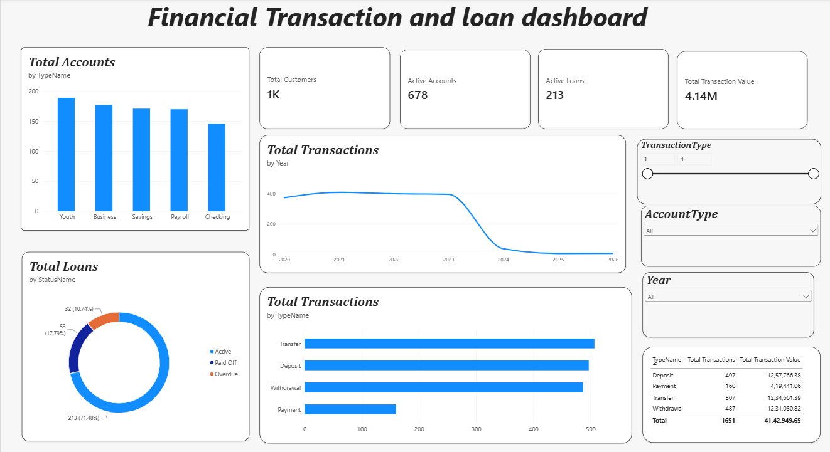
Figure 1: Financial Transaction and Loan Dashboard — overview

6. KPI Cards
KPI cards display the most important figures at a glance. The dashboard includes cards for Total Customers, Active Accounts, Active Loans and Total Transaction Value. These indicators help users understand the scale of customer activity, the number of active accounts and loans, and the amount of money moving through the accounts.
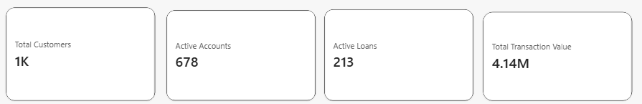
Figure 3: KPI cards showing headline financial indicators
- Total Customers — number of customers represented in the dataset.
- Active Accounts — accounts currently marked as active.
- Active Loans — loans currently marked with Active status.
- Total Transaction Value — sum of the monetary values of transactions.

7. Total Accounts by Account Type
The column chart compares the number of accounts across the available account types: Youth, Business, Savings, Payroll and Checking. It makes it easier to identify which account categories have more or fewer accounts and compare their relative size.
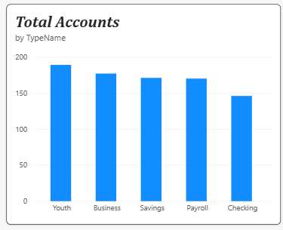
Figure 4: Total accounts by account type
- Purpose: compare account counts across categories and identify the most and least common types.

8. Total Loans by Status
The doughnut chart divides the loan portfolio into Active, Paid Off and Overdue loans. This visual helps the viewer understand the composition of the loan book and identify overdue loans that may require follow-up.
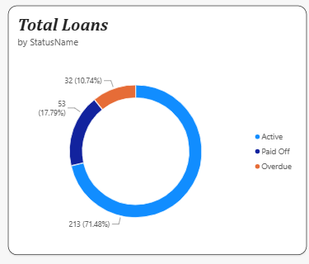
Figure 5: Total loans by status
- Purpose: monitor loan status distribution and highlight areas that may need attention.

9. Total Transactions by Type
The transaction chart compares the number of Deposit, Payment, Transfer and Withdrawal transactions. It allows users to see which transaction types occur most often and which occur less frequently.
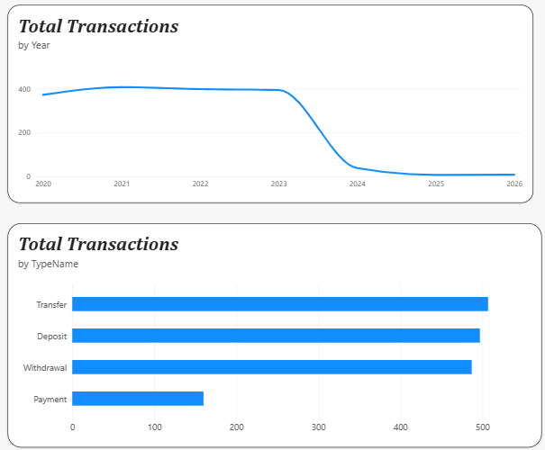
Figure 6: Transaction trend and transaction-type charts
- Purpose: compare transaction volume by type and understand how customers use their accounts.

10. Transaction Trends and Filters
The line chart presents transaction activity over time. Trend visuals can help reveal increases, decreases or unusual changes in activity. Slicers such as Year, Account Type and Transaction Type allow the user to focus on a selected period or category. The second supplied image shows a filtered-card view, illustrating how a selected transaction type can be highlighted.
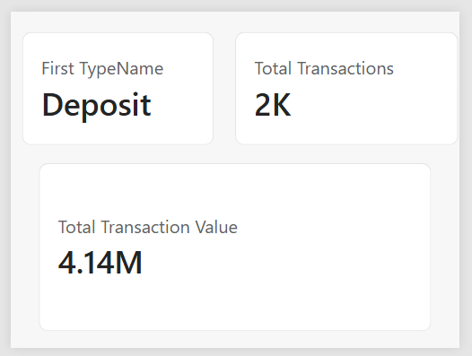
Figure 2: Filtered KPI view for a selected transaction type
Note: displayed figures may change when filters are applied. The values shown in a filtered view should therefore be interpreted in the context of the current selections.

11. Transaction Summary Table
A summary table lists transaction types alongside transaction counts and transaction values. Tables are useful when exact figures are needed in addition to the visual comparison provided by charts. Totals help the user compare categories and check the overall scale of transaction activity.

12. Key Points
- KPI cards summarise the main financial indicators in one place.
- The account-type chart makes category comparisons easy.
- The loan-status doughnut chart helps monitor active, paid-off and overdue loans.
- Transaction charts compare the frequency of different transaction types.
- Trend charts support time-based analysis and can reveal changes in activity.
- Slicers make the report interactive by filtering data by year, account type and transaction type.
- The summary table provides exact counts and values for detailed comparison.

13. Conclusion
The Financial Transactions and Loans Dashboard demonstrates how Microsoft Power BI can turn financial data into an interactive and understandable report. By combining KPI cards, charts, a summary table and filters, the dashboard supports quick comparison of account categories, loan status and transaction activity. The project also provides practical experience in preparing data, creating measures and designing visuals for financial analysis. Overall, the dashboard can help users explore the dataset more efficiently and make better-informed observations about the financial activity shown.

