CPI Inflation Analysis - Month-on-Month Change Heatmaps
Generated on: 2026-02-13 10:39:58
Data Source: All India - Combined Sector
Date Range: January 2025 to January 2026

Division Level
Shows aggregate MoM change for each division across all commodities.
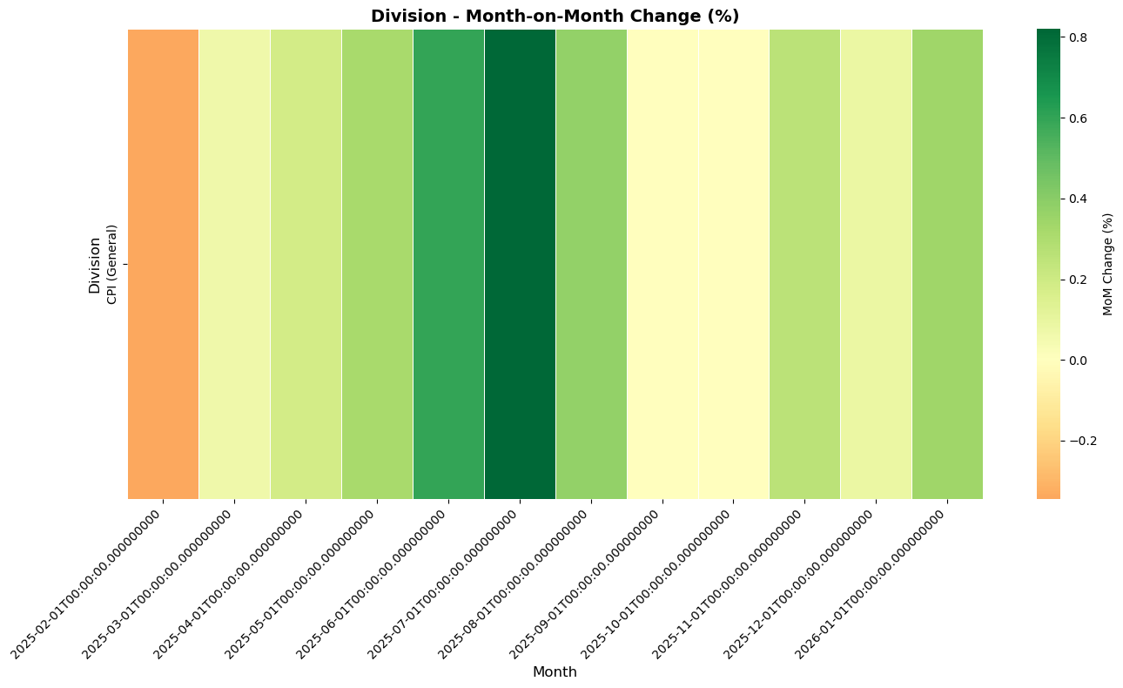

Code Level
Total item-code combinations: 668
Note: Showing first 10 item-code combinations for brevity.

Codes: *
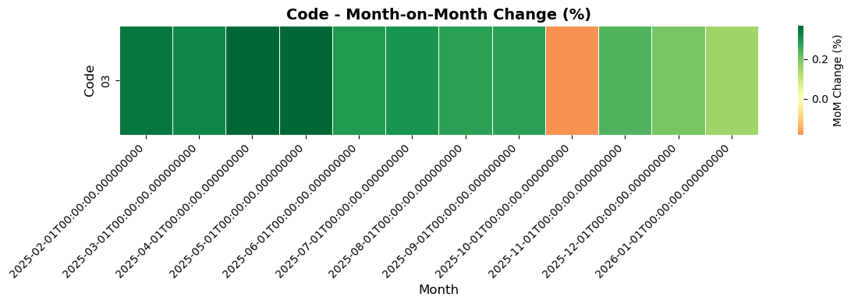

Codes: *
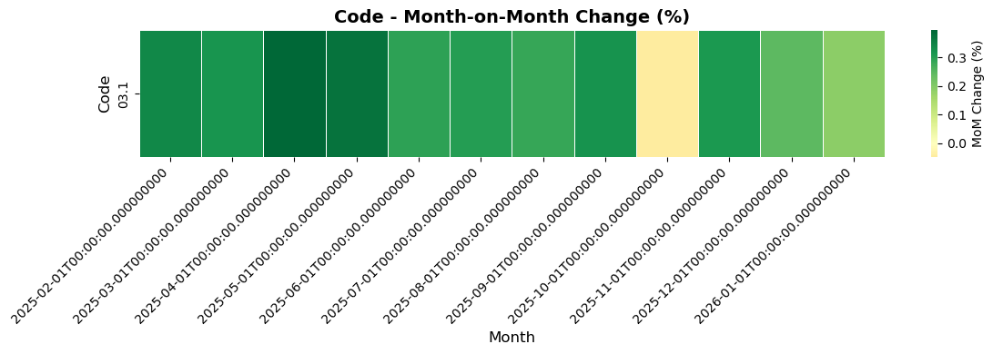

Codes: *
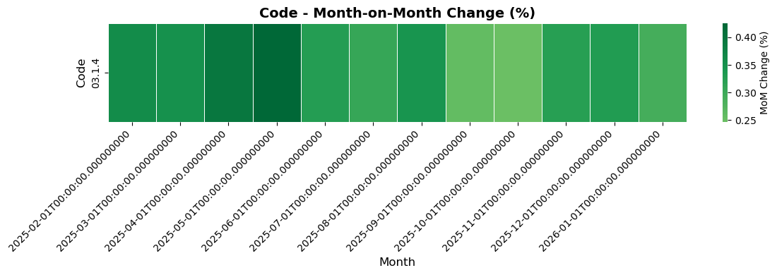

Codes: *
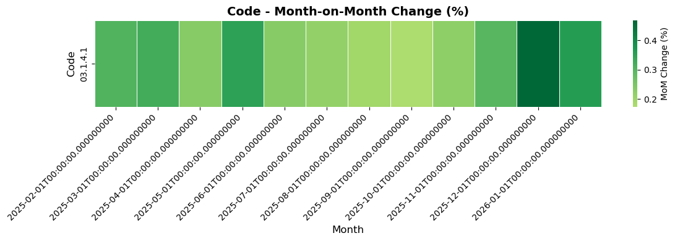

Codes: Washerman, laundry, ironing, dry cleaning and dyeing
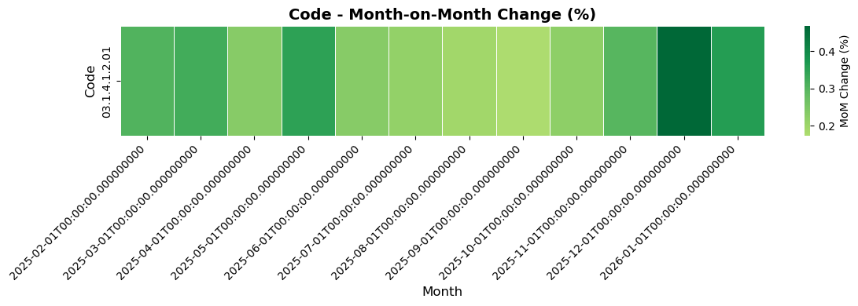

Codes: *
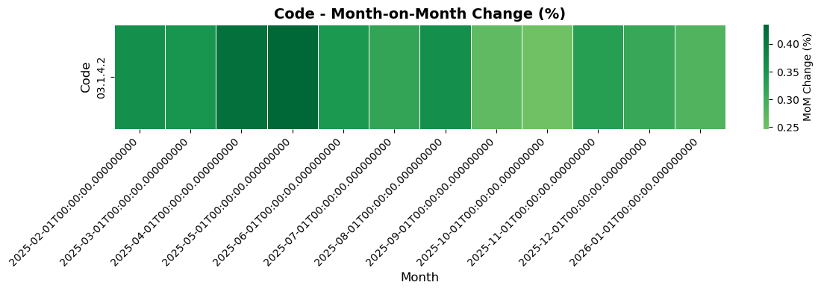

Codes: Tailor
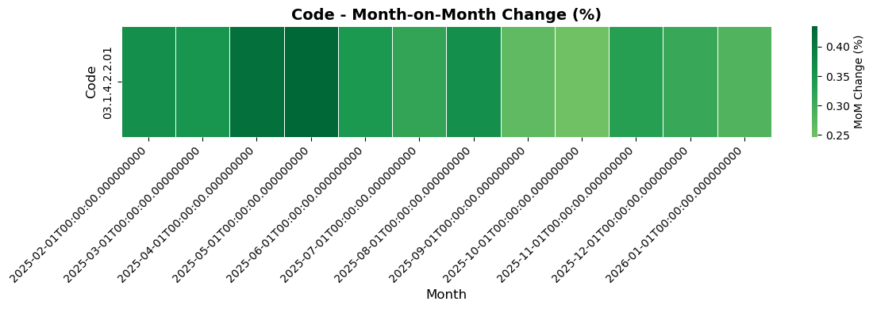

Codes: *
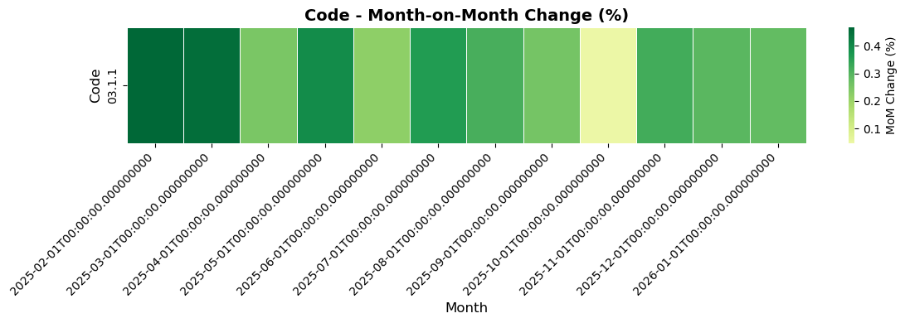

Codes: *
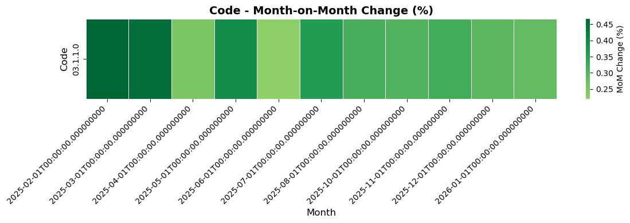

Codes: Clothing materials
