McDONALD'S

Sales Analysis
Dashboard Report
Performance review, KPI assessment and business insights

Reporting period: 2021–2022
Source: MacDonald Sales Analysis Dashboard.xlsx

1. Executive Summary
This report evaluates the sales dashboard workbook supplied for McDonald's. The workbook presents annual monthly sales for 2021 and 2022, 2022 country-level sales, three headline KPIs (sales, profit and customers), and five customer-satisfaction measures. Based on the monthly figures, sales increased from $2,387.0M in 2021 to $2,543.9M in 2022, a year-over-year increase of 6.6%.
Headline measure | Actual | Target | Achievement | Gap to target
Sales | $2,543.9M | $3,000.0M | 84.8% | $456.1M
Profit | $890.4M | $1,000.0M | 89.0% | $109.6M
Customers | 87 | 100 | 87.0% | 13

All three headline KPIs are below target. Sales achieved 84.8% of target, profit achieved 89.0%, and customers achieved 87.0%. The dashboard's profit-to-sales ratio is approximately 35.0%. The average of the five satisfaction scores is 76.2%; the highest score is 95% (Availability (95%)) and the lowest is 53% (Service (53%)).

2. Scope and Data Overview
The analysis uses the Inputs and Contacts worksheets in the supplied workbook. The Dashboard worksheet is visually constructed with Excel drawing objects; the report therefore uses the underlying input tables and KPI values rather than attempting to reproduce the dashboard layout.
Workbook component | Information used | Purpose
KPI summary | Sales, profit and customer actuals and targets | Assess performance against plan
Monthly sales | 2021 and 2022 values for January–December | Compare annual sales trends
Country sales | Seven country values for 2022 | Review geographic contribution
Customer satisfaction | Speed, Quality, Hygiene, Service and Availability | Identify service strengths and gaps
Contacts | Country manager names and email addresses | Operational reference for follow-up

Unless otherwise stated, monetary figures are shown in millions of dollars ($M), as labelled in the workbook.

3. Sales Performance Analysis
Total monthly sales rose by $156.9M from 2021 to 2022, representing 6.6% growth. The monthly 2022 series is higher than the corresponding 2021 value in 11 of the 12 months.
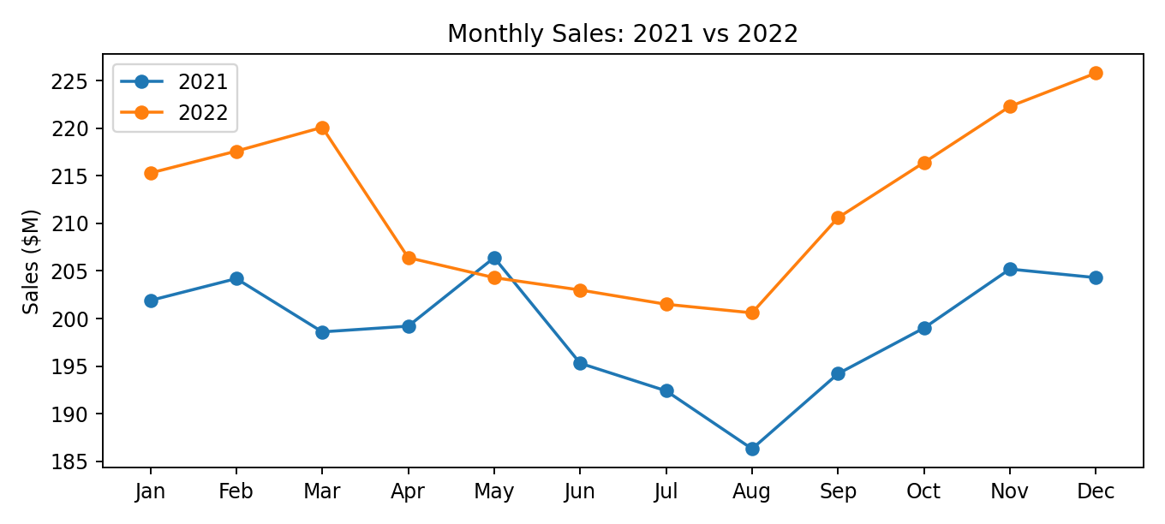
Metric | 2021 | 2022 | Change
Annual total | $2,387.0M | $2,543.9M | $156.9M
Year-over-year growth | — | — | 6.6%
Highest month | May: $206.4M | Dec: $225.8M
Lowest month | Aug: $186.3M | Aug: $200.6M

In 2022, Dec recorded the highest monthly sales at $225.8M, while Aug was the lowest at $200.6M. The overall pattern is relatively stable, with a modest uplift in the second half of the year.

4. KPI Performance Against Targets
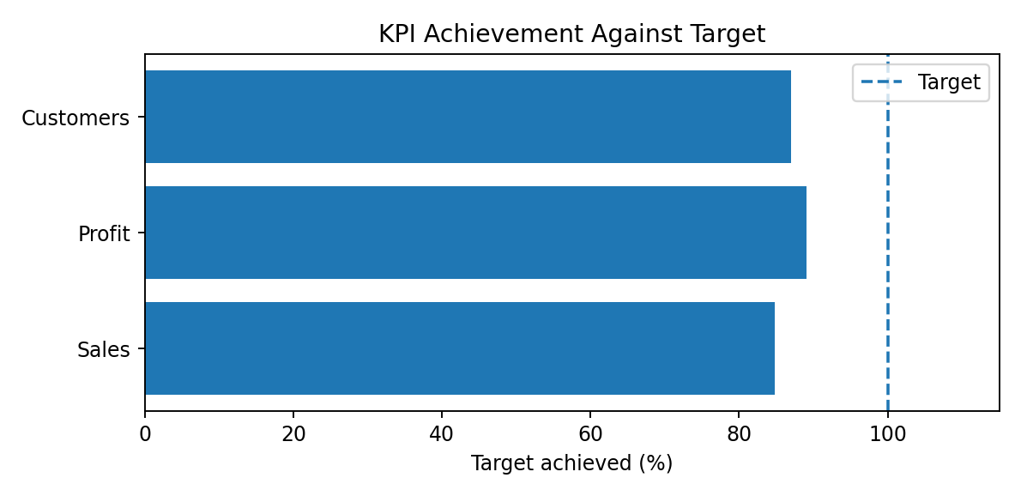
Sales are $456.1M below the stated target. Profit is $109.6M below target, and the customer count is 13 below target. The closest KPI to target is profit at 89.0%, while sales has the largest percentage shortfall at 15.2 percentage points.
Management should review the sales conversion funnel, average transaction value, product mix, promotional effectiveness and store-level performance. For profit, review food and packaging costs, labour scheduling, waste, discounting and contribution margin. Customer growth should be supported through repeat-visit initiatives, loyalty engagement and local marketing.

5. Geographic Sales Analysis
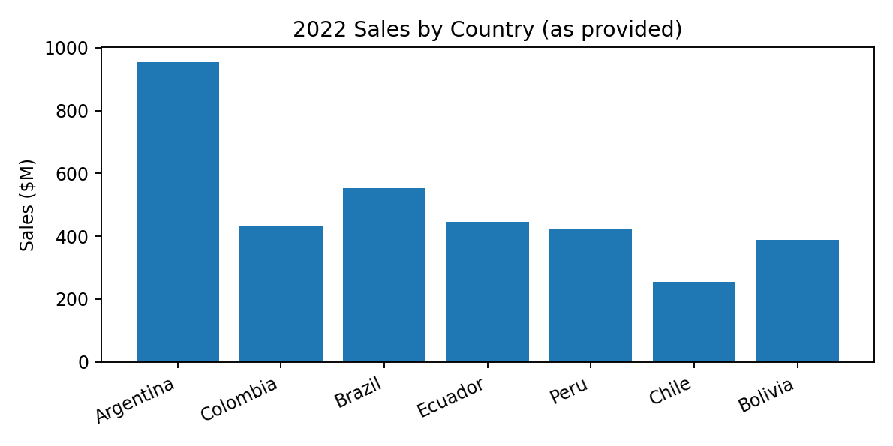
Country | Reported sales | Share of listed country total
Argentina | $953.3M | 27.6%
Brazil | $553.2M | 16.0%
Ecuador | $445.1M | 12.9%
Colombia | $432.4M | 12.5%
Peru | $425.1M | 12.3%
Bolivia | $387.5M | 11.2%
Chile | $253.6M | 7.4%

Argentina is the largest contributor among the listed countries at $953.3M (27.6% of the country-list total). Chile is the smallest at $253.6M. The geographic table can help prioritize country-level reviews, but its figures require reconciliation with the headline sales KPI before being used for consolidated reporting.

6. Customer Satisfaction
Dimension | Score
Speed (54%) | 54%
Quality (86%) | 86%
Hygene (93%) | 93%
Service (53%) | 53%
Availability (95%) | 95%

The average score across the five listed dimensions is 76.2%. Availability (95%) and Quality (86%) are comparatively strong. Service (53%) and Speed (54%) are the two lowest results and should be priority improvement areas. Potential actions include monitoring order-to-handover time, staffing peak periods, simplifying service workflows, and tracking customer feedback by location and daypart.

7. Key Findings
- Sales grew by 6.6% between 2021 and 2022 based on the monthly series.
- All three headline KPIs remain below their stated targets.
- Profit is closest to target at 89.0% achievement.
- Argentina leads the listed country sales table, while Chile is the smallest contributor.
- Availability and Quality are the strongest satisfaction dimensions; Service and Speed are weakest.
- A material reconciliation issue exists between the country-level sales total and the headline sales KPI.

8. Data Quality Notes and Limitations
The seven country values sum to $3,450.2M, whereas the headline sales actual is $2,543.9M. This creates a difference of $906.3M. The workbook does not explain whether the country table uses a different scope, period, currency basis, or a different sales definition. These figures should not be combined until the discrepancy is resolved.
The monthly sales values sum to the stated headline sales actual for 2022. The 2021 monthly values sum to $2,387.0M. The dashboard does not provide definitions for profit, customer counting methodology, satisfaction sample size, survey dates, or target-setting assumptions. The satisfaction labels and values are treated as percentages as displayed in the workbook.
The source workbook contains a contact list for seven country managers. The contact details are retained in the workbook's Contacts worksheet and are not reproduced in this report because they are not required for the performance analysis.

9. Recommendations and Action Plan
Priority | Recommended action | Suggested measure
1 — Data governance | Reconcile country sales to the consolidated sales KPI; confirm period, currency and scope. | Country total matches approved consolidated definition
2 — Sales growth | Analyze store, product and daypart performance; test targeted offers and local campaigns. | Monthly sales growth; sales target achievement
3 — Profitability | Review cost of goods, labour, waste, discounts and product contribution. | Profit margin; cost percentage; waste rate
4 — Customer growth | Strengthen loyalty, repeat-visit and customer acquisition initiatives. | Active customers; repeat-visit rate
5 — Service speed | Measure order-to-handover time and improve peak-hour staffing/workflows. | Average service time; Speed score
6 — Service quality | Track complaints and customer feedback by location and issue category. | Service score; complaint resolution time
7 — Dashboard governance | Add reporting dates, metric definitions, variance indicators and refresh controls. | Data freshness; documented KPI definitions

A monthly management review should assign an owner to each action, set a measurable target and track progress against the prior month and the same month in the previous year.

10. Conclusion
The dashboard indicates positive year-over-year sales growth of 6.6%, but sales, profit and customer performance have not yet reached their targets. Customer satisfaction is mixed: availability and quality are stronger, while speed and service require focused attention. The most important immediate reporting action is to reconcile the country-level sales table with the headline sales KPI. Once the data definitions are confirmed, management can use the dashboard more confidently to prioritize growth, profitability and customer experience.

Appendix: Source Workbook
Source file: MacDonald Sales Analysis Dashboard.xlsx
Worksheets reviewed: Dashboard, Inputs and Contacts.
Analysis calculations: annual totals are summed from the 12 monthly values; growth is calculated as (2022 total − 2021 total) ÷ 2021 total; KPI achievement is actual ÷ target; country shares are calculated against the sum of the seven listed country values.

