A Project Report
on
BLOCKCHAIN-BASED ORGANIC FARMING TRACEABILITY AND SUPPLY CHAIN TRANSPARENCY PLATFORM
B.Tech Major Project Report
VII Semester | Session 2026–2027
by
Nakshatra 23CSU207
Under the supervision of
Dr Poonam & Dr Sneha Kandacharam
Assistant Professor
Department of Computer Science and Engineering

Department of Computer Science and Engineering
School of Engineering and Technology
The NorthCap University, Gurugram – 122001, India
November 2026

A Project Report
on
BLOCKCHAIN-BASED ORGANIC FARMING TRACEABILITY AND SUPPLY CHAIN TRANSPARENCY PLATFORM
submitted in partial fulfillment of the requirement for the award of the degree
of
Bachelor of Technology
in
Computer Science and Engineering
by
Nakshatra 23CSU207
Under supervision of
Dr Poonam & Dr Sneha Kandacharam
Assistant Professor
Department of CSE & IT
The NorthCap University, Gurgaon
November 2026

CERTIFICATE
This is to certify that the Project Report entitled, “Blockchain-Based Organic Farming Traceability and Supply Chain Transparency Platform” submitted by “Nakshatra (23CSU207)” to The NorthCap University, Gurgaon, India, is a record of bonafide Project work carried out by him/her under my/our supervision and guidance and is worthy of consideration for the award of the degree of Bachelor of Technology in Computer Science and Engineering of the University.

Dr Poonam Dr Sneha Kandacharam
Assistant Professor Assistant Professor
Department of CSE Department of CSE
Date: ………………

ACKNOWLEDGEMENT
I would like to express my sincere gratitude to my supervisors, Dr Poonam and Dr Sneha Kandacharam, Assistant Professors in the Department of Computer Science and Engineering, for their continuous guidance, constructive feedback and encouragement throughout this project. Their suggestions at every evaluation helped me to refine the scope of the work and to present it as a practical, implementation-oriented system.
I am thankful to the Head of the Department and the faculty members of the Department of Computer Science and Engineering, School of Engineering and Technology, The NorthCap University, Gurugram, for providing the laboratory facilities and the academic environment needed to complete this work.
I also acknowledge the open-source communities behind Solidity, Hardhat, ethers.js, Node.js, React, PostgreSQL and Prisma, whose freely available tools and documentation made it possible to build and test the complete platform without any licensing cost.
Finally, I thank my family and friends for their patience and moral support during the development of this project.
Nakshatra (23CSU207)

ABSTRACT
Organic food sells at a premium, yet buyers cannot easily check where a product came from or whether its organic certificate is genuine, and farmers who follow organic practice seldom capture the premium. Product information is also scattered across independent stakeholders, so no single trusted history of a batch exists. This project presents Organic Trace, a web-based traceability platform that records the journey of an organic batch from farm to retail and lets a consumer verify it by scanning a QR code.
The system combines a React front end, a Node.js and Express back end with PostgreSQL for application data, and a Solidity smart contract on a local Hardhat Ethereum network for tamper-evident records. Only SHA-256 digests of batch metadata, certificates and supply-chain events are anchored on the blockchain; documents and personal data stay off-chain. Custody events are validated against a 15-stage directed acyclic graph using Kahn’s topological sort, and the presence of any event in a batch history can be proved with a Merkle tree in O(log N) steps. A native C11/C++20 add-on using x86-64 SHA-NI and SIMD assembly accelerates hashing, with a JavaScript fallback on other processors. The platform also offers a curated hub of Indian government agricultural schemes ranked with a min-heap, and multilingual voice navigation covering 27 languages.
The smart-contract, algorithm, security and voice-parser test suites pass, and the native hashing path reached about 1,490 MB/s on the development machine, roughly 6.7 times the JavaScript fallback. The report also states clearly that blockchain protects the integrity of recorded data, not the physical authenticity of the produce.
Keywords: Blockchain, Traceability, Organic Farming, Smart Contracts, SHA-256, Merkle Tree, Directed Acyclic Graph, QR Code, Government Schemes, Voice Navigation

TABLE OF CONTENTS
Certificate ii
Acknowledgements iii
Abstract iv
List of Tables viii
List of Figures ix
List of Symbols and Abbreviations x
1. Introduction 1
1.1 Background and Overview 1
1.2 Motivation and Need for the Project 3
1.3 Objectives 4
1.4 Scope of the Project 5
1.5 Target Users and Applications 5
1.6 Organization of the Report 6
2. Literature Review 7
2.1 Blockchain Traceability in Agri-Food Research 7
2.2 Existing Solutions and Their Limitations 9
2.3 Technologies and Theoretical Concepts 10
2.3.1 Ethereum Virtual Machine and Solidity Smart Contracts 10
2.3.2 SHA-256 and Hash Commitments 10
2.3.3 Merkle Trees 11
2.3.4 Directed Acyclic Graph and Kahn’s Topological Sort 11
2.3.5 SIMD, SHA-NI and Native Add-ons 11
2.3.6 Priority Queues, Tries and Inverted Indexes 12
2.4 Gap Analysis 12
3. Problem Definition and Requirement Analysis 14
3.1 Problem Statement 14
3.2 Functional Requirements 14
3.3 Non-Functional Requirements 15
3.4 Hardware Requirements 16
3.5 Software Requirements 16
3.6 Feasibility Study 17
3.6.1 Technical Feasibility 17
3.6.2 Economic Feasibility 17
3.6.3 Operational Feasibility 17
3.6.4 Schedule Feasibility 18
3.7 Actors and Use Cases 18
3.8 Mapping of the Synopsis Plan to the Implementation 19
4. Design and Implementation 20
4.1 System Architecture 20
4.2 Data Flow Diagrams 22
4.2.1 Level 0 Context Diagram 22
4.2.2 Level 1 Diagram 22
4.3 UML Diagrams 23
4.3.1 Use Case Diagram 23
4.3.2 Class Diagram 24
4.3.3 Sequence Diagrams 25
4.4 Database Design 27
4.5 Project Structure 29
4.6 Module-Wise Implementation 30
4.6.1 Smart Contract Module 30
4.6.2 Back-End API and Authentication Module 30
4.6.3 Native Cryptographic Engine 31
4.6.4 Algorithms Engine 32
4.6.5 Government Schemes Module 34
4.6.6 Localization and Voice Module 35
4.6.7 Optional AI Assistant 36
4.6.8 Front-End Module 36
4.7 Algorithms Used 36
4.7.1 Min-Heap Top-K Selection 36
4.7.2 Inverted Index and Prefix Trie Search 37
4.7.3 Custody Validation and Proof Generation 37
4.8 API Endpoints 37
4.9 User Interface and User Flow 39
4.10 Security, Validation and Error Handling 39
5. Testing and Deployment 41
5.1 Testing Strategy 41
5.2 Test Cases 41
5.3 Defects Found and Fixed 42
5.4 Deployment and Installation 43
5.4.1 Prerequisites 43
5.4.2 Environment Configuration 43
5.4.3 Running and Stopping the Stack 44
5.4.4 Containers and Continuous Integration 44
6. Analysis and Results 45
6.1 Working Output of the Features 45
6.1.1 Tamper Detection 49
6.2 Performance Observations 49
6.3 Algorithmic Efficiency 50
6.4 Results and Discussion 50
6.5 Advantages 51
6.6 Limitations 51
7. Conclusion and Future Enhancements 53
7.1 Conclusion 53
7.2 Future Enhancements 54
Proof of Broader Impact 55
8. References 56
Appendix A: Smart Contract Source Code 58
Appendix B: Docker Multi-Stage Build Definition 59

LIST OF TABLES
1.1 Key project modules and capabilities 3
2.1 Summary of the literature reviewed and its relevance to this project 8
2.2 Qualitative comparison of existing approaches with Organic Trace 9
3.1 Functional requirements specification 14
3.2 Non-functional requirements 15
3.3 Hardware requirements 16
3.4 Software technology stack and versions 16
3.5 System actors and permissions 18
3.6 Synopsis outcomes and their implementation status 19
4.1 Relational schema, keys and constraints 28
4.2 Directory layout and file roles 29
4.3 Supply-chain stages, ranks and permitted transitions 33
4.4 Representative supported languages and voice codes 35
4.5 REST API endpoint specification 38
5.1 Automated test suites 41
5.2 Representative test cases 41
5.3 Defects, root causes and fixes 42
6.1 Native accelerator benchmark results (development machine) 49
6.2 Complexity of the data structures and algorithms used 50

LIST OF FIGURES
1.1 Conceptual overview of the Organic Trace platform 2
4.1 High-level system architecture 21
4.2 Level 0 context data flow diagram 22
4.3 Level 1 data flow diagram 23
4.4 Use case diagram of the platform 24
4.5 Class diagram of the contract and engine classes 25
4.6 Sequence diagram: batch creation and anchoring 26
4.7 Sequence diagram: consumer QR trace and verification 27
4.8 Entity-relationship diagram of the database 28
4.9 Merkle tree and inclusion proof for one event 32
4.10 Supply-chain stage DAG (transitions between consecutive ranks) 34
6.1 Landing page with the public batch search 45
6.2 Farmer dashboard listing batches with on-chain status 46
6.3 Batch details with QR code and certificate hash upload 46
6.4 Partner view listing all batches 47
6.5 Partner form for recording a supply-chain event 47
6.6 Supply-chain timeline with blockchain transaction hashes 48
6.7 Public product traceability page seen by a consumer 48

LIST OF SYMBOLS AND ABBREVIATIONS
ABI | Application Binary Interface
API | Application Programming Interface
ASM | Assembly Language (x86-64, GNU Assembler)
BCP-47 | IETF Best Current Practice 47 (language tags)
BOLA | Broken Object-Level Authorization
C11 / C++20 | ISO C (2011) / ISO C++ (2020) standards
CI/CD | Continuous Integration / Continuous Deployment
CORS | Cross-Origin Resource Sharing
CRC | Cyclic Redundancy Check
DAG | Directed Acyclic Graph
DFD | Data Flow Diagram
DSA | Data Structures and Algorithms
ER | Entity-Relationship
EVM | Ethereum Virtual Machine
FPO | Farmer Producer Organization
IDOR | Insecure Direct Object Reference
JSON | JavaScript Object Notation
JWT | JSON Web Token
LLM | Large Language Model
LRU | Least Recently Used
N-API | Node-API (stable native addon interface of Node.js)
NFR / FRS | Non-Functional Requirement / Functional Requirement Specification
NPOP | National Programme for Organic Production
ORM | Object-Relational Mapping
PGS-India | Participatory Guarantee System for India
PKVY | Paramparagat Krishi Vikas Yojana
QR | Quick Response (code)
RBAC | Role-Based Access Control
REST | Representational State Transfer
SHA / SHA-NI | Secure Hash Algorithm / SHA New Instructions (Intel, AMD)
SIMD | Single Instruction, Multiple Data
SSRF | Server-Side Request Forgery
SSE / SSSE3 | Streaming SIMD Extensions / Supplemental SSE3
TTL | Time To Live
UI / UX | User Interface / User Experience
UML | Unified Modeling Language
XSS | Cross-Site Scripting

CHAPTER 1
INTRODUCTION

1.1 Background and Overview
Organic farming has gained importance because consumers are increasingly concerned about food quality, agricultural practices, product origin and authenticity. An organic product, however, looks the same as a conventionally grown one. Whether it is organic depends on how it was grown and on the certification that backs the claim, and neither can be seen on the shelf. The product also passes through several stages before it reaches the consumer: farming, harvesting, processing, packaging, transportation, distribution and retail. The information produced at each stage is normally held in separate records by separate organizations, so a consumer who wants the complete history of a product usually cannot obtain a trustworthy one.
Traceability is the ability to follow the movement and history of a product through the stages of its supply chain. Traditional traceability systems rely on a centralized database controlled by one organization. Such a database is useful for record keeping, but the party that controls it can alter or delete entries, and independent stakeholders have no way of detecting that. Blockchain technology offers a different approach. A blockchain is a distributed ledger in which records are linked using cryptographic hashes, so changing an earlier record without detection is extremely difficult [1]. Smart contracts, introduced by the Ethereum platform, add programmable rules that run on the ledger itself [2]. Recent reviews identify blockchain-based food traceability as an active research area, while also reporting that practical adoption is still held back by technical and organizational challenges [3], [4].
This project, titled Blockchain-Based Organic Farming Traceability and Supply Chain Transparency Platform and named Organic Trace, is an implementation-oriented answer to that problem. It is a complete web application in which a farmer registers a product batch, supply-chain partners record each custody hand-over, and a consumer scans a QR code to see the verified journey of the batch without logging in or installing anything. A conventional PostgreSQL database holds the application data, while a Solidity smart contract running on an Ethereum-compatible network holds only cryptographic digests of the important records. Figure 1.1 shows the concept of the system at a glance.
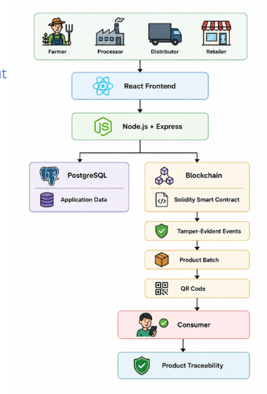
Figure 1.1: Conceptual overview of the Organic Trace platform
Beyond basic traceability, the final implementation adds several features that were not part of the initial synopsis but make the platform more useful and more rigorous: Merkle-tree inclusion proofs, validation of custody order using a directed acyclic graph, a native hardware-accelerated hashing engine, a curated hub of Indian government agricultural schemes, and voice navigation in 27 languages for farmers who are not comfortable with English-only interfaces. Table 1.1 summarises the main modules of the system.
Table 1.1: Key project modules and capabilities
Subsystem | Implementation | Primary capability
Blockchain anchor | Solidity ^0.8.24, Hardhat EVM (chain ID 31337) | Tamper-evident registry of batches, certificate hashes and events
Native accelerator | C11, C++20 and x86-64 assembly (Node-API add-on) | SHA-NI hashing, SIMD hex encoding, off-heap cache
Relational storage | PostgreSQL 16 with Prisma ORM (8 models) | Users, batches, events, schemes, preferences
Algorithms engine | JavaScript with native fallbacks | Merkle tree, stage DAG, min-heap Top-K, trie, inverted index
Government schemes hub | Express.js with a curated dataset (17+ programmes) | Browsing, filtering, ranking and batch linking of schemes
Localization and voice | React 18, Vite, Web Speech API, 27 locales | Voice commands and native-language text
AI assistant (optional) | Local Ollama server with Llama 3.2 | Grounded question answering about schemes and the app

1.2 Motivation and Need for the Project
Two practical problems motivated the project. The first is a lack of trust in organic claims. Smallholder farmers carry the cost of organic cultivation but often receive the same price as conventional producers because buyers doubt their claims, while consumers pay a premium for a label that they cannot verify. Centralized certification databases and paper certificates are open to tampering, re-use across batches and single points of failure. Studies of consumer behaviour report that blockchain-enabled traceability can raise trust in organic products and the intention to buy them [5], [6], which supports the idea of giving consumers a direct and simple way of checking a batch.
The second problem is information access. India has many central and state schemes that support irrigation, organic inputs, cold storage and farmer producer organizations, yet small and marginal farmers often cannot use them because the information is scattered across portals, written in administrative language and available mostly in English or Hindi. A platform that already knows a farmer’s crop, location and batches is well placed to surface the relevant schemes in the farmer’s own language. Combining traceability with scheme discovery in one application is the distinctive idea of this project.

1.3 Objectives
The objectives of the project are as follows.
- To design and develop a blockchain-based platform for tracing organic agricultural products across the farm, processing, distribution and retail stages.
- To implement a smart contract that records product batches, metadata digests, certificate hashes and supply-chain events with trusted timestamps.
- To provide a tamper-evident and auditable history of a batch, including Merkle-tree inclusion proofs and validation of the order of custody events.
- To implement SHA-256 based verification of certificate documents so that any later modification can be detected, without storing the document or personal data on the blockchain.
- To provide QR-code based public access to the provenance of a batch with no login and no installation.
- To implement role-based access for farmers, supply-chain partners and administrators, with protection against common web attacks.
- To accelerate cryptographic hashing using a native C/C++/assembly engine while keeping a portable JavaScript fallback.
- To help farmers discover relevant government schemes, with multilingual voice-driven navigation in 27 Indian languages.
- To evaluate the platform in terms of functionality, security, data integrity and performance.

1.4 Scope of the Project
The work covers the development, deployment and testing of the smart contract on an Ethereum-compatible node; relational persistence with PostgreSQL and Prisma; the native hashing engine; Merkle-tree, DAG and min-heap algorithms; a curated repository of Indian government schemes with domain-safe link validation; the public QR traceability page; the multilingual voice interface; and container-based deployment with Docker Compose and a Python launcher.
The following items are outside the scope of the project. Deployment to the live Ethereum main network is excluded, because gas fees would be prohibitive; the project targets a local Hardhat network and notes Layer-2 networks as future work. Physical IoT sensors are not manufactured, although the data model can accept sensor-derived values. Payment processing for consumer purchases is not included. Finally, the platform records and protects the integrity of submitted information; it does not claim to prove that the produce is physically organic. This limitation is discussed in Section 6.6.

1.5 Target Users and Applications
- Organic farmers register batches, upload certificate hashes, generate QR codes and link their batches to government schemes.
- Supply-chain partners (processors, laboratories, cold-storage operators, distributors and retailers) record timestamped custody events.
- Retail consumers scan the QR code on a package with any smartphone camera to see the verified lifecycle of the product.
- Administrators and extension officers monitor the platform, synchronise the blockchain and database, and review scheme usage.

1.6 Organization of the Report
The report is organized into seven chapters followed by references and appendices. Chapter 1 introduces the project. Chapter 2 reviews the literature, compares existing approaches and explains the theoretical concepts used. Chapter 3 defines the problem and lists the functional and non-functional requirements. Chapter 4 describes the design and implementation, including architecture, diagrams, database, algorithms, API and security. Chapter 5 presents testing and deployment. Chapter 6 analyses the results and performance. Chapter 7 concludes the report and suggests future enhancements. The appendices contain the smart-contract source, the container definition and the configuration template.

CHAPTER 2
LITERATURE REVIEW

2.1 Blockchain Traceability in Agri-Food Research
Blockchain-based agricultural traceability has become an active research area. This section summarises ten studies that shaped the design of the project, and Table 2.1 lists the relevance of each to this work.
Feng et al. reviewed the use of blockchain to improve agri-food traceability and explained how centralized systems limit access to transaction information and make it hard for consumers to follow product origins. They identify transparency and security as the main benefits and discuss the challenges of implementation [3]. Prashar et al. proposed a smart-contract based traceability and visibility system for agricultural products in the Indian context, showing how blockchain can provide traceability and integrity for food safety [7]. Mirabelli and Solina analysed the research literature and concluded that blockchain for agricultural traceability was still at an early stage and needed more practical work [8].
Rana et al. reviewed blockchain in sustainable agri-food supply chains and reported benefits in traceability and transparency together with challenges such as scalability, privacy leakage, cost and connectivity [9]. These challenges explain two design choices in this project: large files are never stored on the blockchain, and PostgreSQL is used for ordinary application data. Hasan et al. proposed a peer-to-peer blockchain architecture with self-sovereign identity for agricultural product traceability and compared transaction and verification timing on different networks [10]. Pakseresht et al. identified transparency, immutability, redundancy, versatility, automation and remittance as the characteristics of blockchain relevant to the agri-food sector, with immutability and automation most prominent in traceability [4].
Studies of consumers are equally relevant. Tao and Chao surveyed Chinese consumers and found that a blockchain-based traceability system increased perceived quality, product trust and willingness to buy organic agricultural products [5]. Pan et al. examined how well blockchain traceability fits the tasks of agri-food stakeholders and highlighted that the clarity and integrity of the information shown to consumers matter, and that consumers can still doubt whether blockchain data is reliable [6]. More recent systematic reviews report growing interest in combining blockchain with IoT and artificial intelligence and identify food safety, authenticity and security as dominant themes [11], [12].
Table 2.1: Summary of the literature reviewed and its relevance to this project
Reference | Focus of the study | Relevance to Organic Trace
Feng et al. (2020) | Review of blockchain for agri-food traceability | Supports transparent, tamper-evident supply-chain records
Prashar et al. (2020) | Smart-contract traceability for Indian agriculture | Closest Indian context; validates smart-contract approach
Mirabelli and Solina (2020) | Research trends in agricultural traceability | Shows need for implementation-oriented work
Rana et al. (2021) | Blockchain for sustainable agri-food chains | Scalability and privacy; motivates hybrid storage
Hasan et al. (2023) | Peer-to-peer architecture with identity management | Trusted participants; simpler B.Tech-scale alternative adopted
Pakseresht et al. (2024) | Characteristics of blockchain for agri-food | Transparency, immutability and automation are the focus
Tao and Chao (2024) | Blockchain traceability and organic purchase intention | Supports consumer-facing QR traceability
Pan et al. (2024) | Consumer view of blockchain traceability | Integrity of records versus truth of inputs
Vasileiou et al. (2025) | Systematic review on food safety and traceability | Confirms active research area and open challenges
Rejeb et al. (2026) | Systematic review and co-word analysis | Integration with IoT and AI as future extensions

2.2 Existing Solutions and Their Limitations
Traceability systems in the agricultural sector can be grouped into four categories. Centralized enterprise systems keep records in an internal relational database. They scale well, but the database administrator can edit or delete records, which makes the history difficult to defend when stakeholders disagree. QR-based product portals give consumers quick access to information, but the authenticity of what is displayed depends entirely on the database behind the code. Government and certification portals, such as the portals operated for the National Programme for Organic Production [13] and the Participatory Guarantee System [14], record certification data but do not provide a consumer-facing, cryptographically verifiable farm-to-shelf history. Enterprise permissioned blockchains offer strong auditability, but they require heavy infrastructure, membership management and licensing, which puts them out of reach of individual farmers and small farmer producer organizations.
Table 2.2 compares these approaches with Organic Trace on the features that matter for this project. The comparison is qualitative and is based on publicly described features of each category, not on a measured benchmark.
Table 2.2: Qualitative comparison of existing approaches with Organic Trace
Feature | Centralized ERP | Government portal | Enterprise blockchain | Organic Trace
Tamper evidence | Weak; admin can edit | Weak; central database | Strong | Strong; on-chain digests
Public inclusion proof | No | No | Limited | Merkle proof, O(log N)
Custody-order validation | Basic status flags | Basic status flags | Custom rules | Kahn DAG, O(V + E)
Hardware-accelerated hashing | No | No | No | Yes (SHA-NI, SIMD)
Regional languages | One or two | English / Hindi | Major global languages | 27 Indian languages
Voice navigation | No | No | No | Yes (Web Speech API)
Government schemes hub | No | Separate portals | No | Integrated, 17+ programmes
Consumer access | Vendor application | Web link | Web link | Zero-install QR page
Deployment weight | Heavy | Government servers | Heavy | Lightweight Docker Compose

2.3 Technologies and Theoretical Concepts

2.3.1 Ethereum Virtual Machine and Solidity Smart Contracts
The Ethereum Virtual Machine (EVM) is a deterministic state machine whose state changes are agreed by the network [2]. Solidity is the main language for writing contracts for the EVM [15]. A contract stores data in persistent storage slots, exposes functions and emits events that off-chain programs can read. In this project, the contract SupplyChain.sol stores batches, metadata digests, event records and certificate digests, and uses a few lines of inline assembly to read the block timestamp and to set the owner, which avoids some compiler-generated checks. Hardhat provides a local EVM network with instant block production, which allows development and testing without paying for gas [16]. The Node.js back end communicates with the contract through the ethers.js library [17].

2.3.2 SHA-256 and Hash Commitments
SHA-256 is a cryptographic hash function that maps any input to a 256-bit digest and is specified in the Secure Hash Standard [18]. It is deterministic, one-way and collision resistant, and a change of a single bit of input changes the digest completely. The project uses SHA-256 as a commitment: the digest of a certificate or of a canonical form of batch metadata is stored on the blockchain, and the original content stays off-chain. Anyone who later holds the content can recompute the digest and compare it with the stored value. This keeps personal data and large files off the public ledger and gives privacy by design. It should be noted that this is a hash commitment scheme and not a zero-knowledge proof.

2.3.3 Merkle Trees
A Merkle tree is a binary tree in which each leaf holds the hash of a data item and each internal node holds the hash of the concatenation of its two children [19]. The root summarises all leaves. To prove that one item belongs to the set, a prover supplies the sibling hashes along the path from the leaf to the root, and the verifier recomputes the root. For N events this needs only about log₂ N hashes, as shown in Figure 4.9. In this project the leaves are the hashes of the events of a batch, and the proof is shown on the public trace page.

2.3.4 Directed Acyclic Graph and Kahn’s Topological Sort
A directed acyclic graph (DAG) is a directed graph without cycles. Kahn’s algorithm produces a topological ordering by repeatedly removing vertices of in-degree zero, in O(V + E) time [20]. Supply-chain custody is strictly forward-moving: a batch cannot be harvested after it has been dispatched. The project models the 15 supply-chain stages as a DAG, checks that the graph itself is acyclic with Kahn’s algorithm, and then uses stage ranks to detect events that move backwards or skip an illegal transition.

2.3.5 SIMD, SHA-NI and Native Add-ons
Single Instruction Multiple Data (SIMD) instructions operate on several data elements held in one wide register. Modern Intel and AMD processors also provide SHA extensions (SHA-NI) that compute SHA-256 rounds in hardware [21]. Interpreted JavaScript cannot use these instructions directly, so the project places the heavy hashing path in a native add-on written in C11, C++20 and x86-64 assembly and loads it through Node-API [22]. The add-on decodes Base64 in small stack chunks and feeds them to the hardware hash, so large certificates are processed without large heap allocations. A pure JavaScript path is used automatically if the add-on or the instruction set is not available.

2.3.6 Priority Queues, Tries and Inverted Indexes
Selecting the best K items out of N is done with a min-heap of size K, which costs O(N log K) time and O(K) space, instead of sorting all N items. A prefix trie supports fast prefix lookup, and an inverted index maps each word to the documents that contain it so that a search touches only the relevant entries. These three structures together drive the ranking and search of government schemes.

2.4 Gap Analysis
The literature shows that blockchain has real potential for agricultural traceability, but several gaps remain.
- Fragmented information. Stakeholders keep separate records, so no complete product history exists.
- Limited consumer-level access. Many systems focus on communication between organizations and give consumers little to see.
- Certification integration. Organic certificates are rarely linked to the full supply-chain history, and a stored certificate offers no strong way of detecting later changes.
- Conceptual rather than complete systems. Much of the literature proposes frameworks; there is value in a complete prototype with front end, back end, database, smart contract and QR access [8], [4].
- Accessibility of rural users. Existing prototypes ignore language and literacy barriers and rarely connect traceability to the welfare schemes that farmers need.
- Integrity versus authenticity. Blockchain protects recorded data but cannot tell whether the original input was true [6].
Organic Trace addresses these gaps by combining farmer-level provenance, multi-stage event recording, certificate hash verification, Merkle-based auditability, QR-based consumer access, a government schemes hub and multilingual voice navigation in a single application, while stating clearly that it verifies the integrity of submitted records and not the physical nature of the produce.

CHAPTER 3
PROBLEM DEFINITION AND REQUIREMENT ANALYSIS

3.1 Problem Statement
Organic agricultural products pass through multiple stages before reaching consumers, and information on origin, harvesting, processing, certification, transportation and retail is recorded separately by different stakeholders. This fragmentation makes it difficult for consumers to obtain a complete and verifiable product history. Centralized systems depend on the organization that maintains the database, and QR-based systems can show information without giving strong evidence that it has not been altered. At the same time, small farmers find it hard to discover and use the government schemes meant to support them.
The problem addressed by this project is therefore to design, implement and validate an integrated web platform that (a) anchors the provenance, certificate digests and custody hand-overs of organic batches on a blockchain without exposing private data, (b) lets any consumer verify a batch through a QR code using Merkle proofs and custody-order checks, and (c) helps farmers discover relevant government schemes through multilingual, voice-driven navigation.

3.2 Functional Requirements
Table 3.1 lists the functional requirements. Each requirement was traced to an implemented module and to at least one automated test or manual check.
Table 3.1: Functional requirements specification
ID | Module | Requirement
FR-01 | Authentication and RBAC | Register and log in as farmer, partner or administrator with bcrypt password hashing and JWT sessions
FR-02 | Batch creation | Farmer creates a batch; the system computes a canonical SHA-256 metadata hash and anchors it on the blockchain
FR-03 | Certificate ingestion | Farmer uploads a Base64 PGS-India or NPOP certificate; the native engine hashes it and the digest is anchored
FR-04 | Certificate verification | Any party submits a certificate and the system compares its hash with the anchored hash in constant time
FR-05 | Custody event logging | Partner appends events such as PACKAGED or DISPATCHED; each event data hash is computed and anchored
FR-06 | Public traceability | Consumer opens /trace/:batchId without login and sees on-chain status, timeline and DAG progress
FR-07 | Merkle proof | System builds a Merkle tree over the batch events and returns an inclusion proof
FR-08 | Custody DAG | Event history is validated against the 15-stage DAG; regressions and illegal skips are reported
FR-09 | Schemes hub | Browse, filter and paginate 17+ verified government schemes by category, state and level
FR-10 | Scheme ranking | Return Top-K schemes scored on land holding, state and farmer category
FR-11 | Batch–scheme linking | Link a scheme to a batch to record subsidy utilization
FR-12 | Voice control | Voice bar parses commands in 27 languages with input sanitization
FR-13 | AI assistant | Optional local Ollama assistant answers questions grounded in scheme data
FR-14 | Benchmark telemetry | Expose a live native microbenchmark at /api/health/benchmark
FR-15 | Self-healing sync | Re-synchronise the database and the blockchain when they drift apart

3.3 Non-Functional Requirements
Table 3.2: Non-functional requirements
ID | Category | Criterion
NFR-01 | Performance | Native SHA-256 throughput above 1,000 MB/s; cache lookup latency of a few microseconds
NFR-02 | API latency | Read endpoints (trace, batches, schemes) respond in under 50 ms under typical load
NFR-03 | Security: authentication | JWT expiry enforced; bcrypt hashing; constant-time hash comparison
NFR-04 | Security: network | SSRF defence: only HTTPS links on approved .gov.in, .nic.in and listed official domains
NFR-05 | Security: access | Object-level authorization: a farmer can modify only his or her own batches
NFR-06 | Usability | Keyboard navigation, light and dark mode, zero-install QR access, native-language text
NFR-07 | Reliability | Automatic fallback from the native add-on to pure JavaScript on unsupported CPUs
NFR-08 | Scalability | Containerized services; indexes on all foreign keys and filter columns

3.4 Hardware Requirements
Table 3.3: Hardware requirements
Component | Minimum (development / test) | Recommended (benchmark / production)
Processor | x86-64 dual-core CPU | Intel Core i7 or AMD Ryzen 7 with AVX2 and SHA-NI
Memory | 4 GB RAM | 16 GB RAM
Storage | 5 GB free disk | 20 GB NVMe SSD
Network | Ethernet or 802.11n Wi-Fi | Gigabit Ethernet
Audio input | Built-in or USB microphone | Noise-cancelling microphone for voice tests

3.5 Software Requirements
Table 3.4 lists the software stack. The versions shown are the ones declared in the project’s package manifests and container files.
Table 3.4: Software technology stack and versions
Layer | Technology | Version | Purpose
Smart contract | Solidity | ^0.8.24 | Contract logic with inline assembly [15]
Blockchain tooling | Hardhat | ^2.22.10 | Local Ethereum network and tests [16]
Web3 client | ethers.js | ^6.13.2 | Contract calls, signing, ABI encoding [17]
Runtime | Node.js | 20+ | Event-driven server runtime
Back-end framework | Express.js | ^4.19.2 | REST routing and middleware [23]
ORM | Prisma | ^5.19.0 | Schema, migrations and typed queries [24]
Database | PostgreSQL | 16 | Relational persistence [25]
Native toolchain | GCC / G++ (C11, C++20) | 12.2+ | Build of the Node-API add-on
Assembly | GNU Assembler | 2.40+ | x86-64 vector routines
Authentication | jsonwebtoken, bcryptjs | ^9.0.2, ^2.4.3 | Signed tokens and salted hashes [26]
Hardening | helmet, express-rate-limit | ^7.1.0, ^7.4.0 | Security headers and rate limits
Validation | zod | ^3.23.8 | Request-body schema validation
Front end | React, react-router-dom | ^18.3.1, ^6.26.2 | Component UI and routing [27]
Build tool | Vite | ^5.4.3 | Development server and bundler
Styling | Tailwind CSS | ^3.4.10 | Responsive, dark / light themes
QR codes | qrcode.react | ^3.1.0 | QR generation for batches
HTTP client | axios | ^1.7.7 | REST client with interceptors
Containers | Docker, Docker Compose | Engine 29+ | Multi-service deployment [28]
Orchestration | Python | 3.10+ | Launcher script run.py

3.6 Feasibility Study

3.6.1 Technical Feasibility
The platform uses open standards and widely available open-source tools: Solidity, the Ethereum JSON-RPC interface, REST, Node-API and the Web Speech API [29]. The first version runs on a local Ethereum-compatible network, which removes the dependence on public blockchain infrastructure during development. The native engine is compiled automatically inside the Docker build, and the JavaScript fallback keeps the system usable on any machine.

3.6.2 Economic Feasibility
The entire stack is open source. Because the contract runs on a local Hardhat network, no paid blockchain transactions are needed for development and testing. A later move to a low-fee Layer-2 network would keep running costs small.

3.6.3 Operational Feasibility
Each participant receives an interface suited to the role. The consumer interface is deliberately simple: the consumer needs no knowledge of blockchain and no wallet, only a phone camera. Farmers can operate the application by voice in their own language.

3.6.4 Schedule Feasibility
The work was planned in phases: literature survey and requirements first, then database, back end, front end and smart contract, followed by integration, testing and documentation. This matches the milestones of the university’s major-project calendar, from the synopsis submission to the end-term evaluation.

3.7 Actors and Use Cases
Table 3.5 lists the actors. The synopsis proposed separate processor, distributor, retailer and certifier roles. In the implementation, these supply-chain roles share the single PARTNER account type, and the stage that a partner records is determined by the event type chosen (for example RECEIVED_BY_PROCESSOR, DISPATCHED or RECEIVED_BY_RETAILER). Certificate verification is open to any party, because it only compares hashes. This keeps role management simple while preserving accountability, since every event is stored with the participant who recorded it. The use cases are shown in Figure 4.4.
Table 3.5: System actors and permissions
Actor | Identifier | Authorized operations
Organic farmer | FARMER | Register, create batches, upload certificate hash, link schemes, view own batches
Supply-chain partner | PARTNER | Log custody events (processing, packaging, dispatch, delivery); view all batches
System administrator | ADMIN | Monitor the platform, synchronise blockchain and database, run benchmarks
Retail consumer | Public (no login) | Scan QR code, view provenance, verify Merkle proof and custody progress

3.8 Mapping of the Synopsis Plan to the Implementation
The final system follows the plan in the synopsis and extends it. Table 3.6 shows how each planned outcome was realised.
Table 3.6: Synopsis outcomes and their implementation status
Planned outcome (synopsis) | Status | Implementation note
Web-based traceability platform | Completed | React front end with Express back end
Smart contract for supply-chain events | Completed | SupplyChain.sol on Hardhat
PostgreSQL for application data | Completed | Prisma schema with 8 models
Role-based dashboards | Completed (merged roles) | Farmer, Partner and Admin; partner covers processor to retailer
Batch creation and tracking | Completed | Batch registry with on-chain status
QR code generation and public trace page | Completed | QR download and /trace/:batchId
Certificate hash generation and verification | Completed | Native SHA-NI hashing; constant-time comparison
Blockchain transaction records | Completed | Transaction hash stored with each batch and event
Administrative monitoring | Completed (basic) | Health, benchmark and synchronisation endpoints
Experimental evaluation | Completed | Automated tests and benchmarks (Chapters 5 and 6)
Not in synopsis: Merkle proofs, DAG, native engine, schemes hub, voice | Added | Extensions described in Chapter 4

CHAPTER 4
DESIGN AND IMPLEMENTATION

4.1 System Architecture
The platform follows a layered architecture with four tiers, shown in Figure 4.1. The presentation tier is a React 18 single-page application built with Vite and styled with Tailwind CSS; it provides the dashboards, the public trace page, the QR generator and the voice bar. The application tier is a Node.js and Express.js server that enforces JWT authentication, Zod validation and role checks and hosts the algorithms engine and the scheme service. The native acceleration tier is a Node-API add-on, organic_native.node, containing the SHA-NI engine, the SIMD assembly routines and an off-heap cache. The persistence tier combines PostgreSQL for relational data, the Hardhat EVM running the SupplyChain contract, and a local hash-chain ledger file that cross-checks the on-chain data.
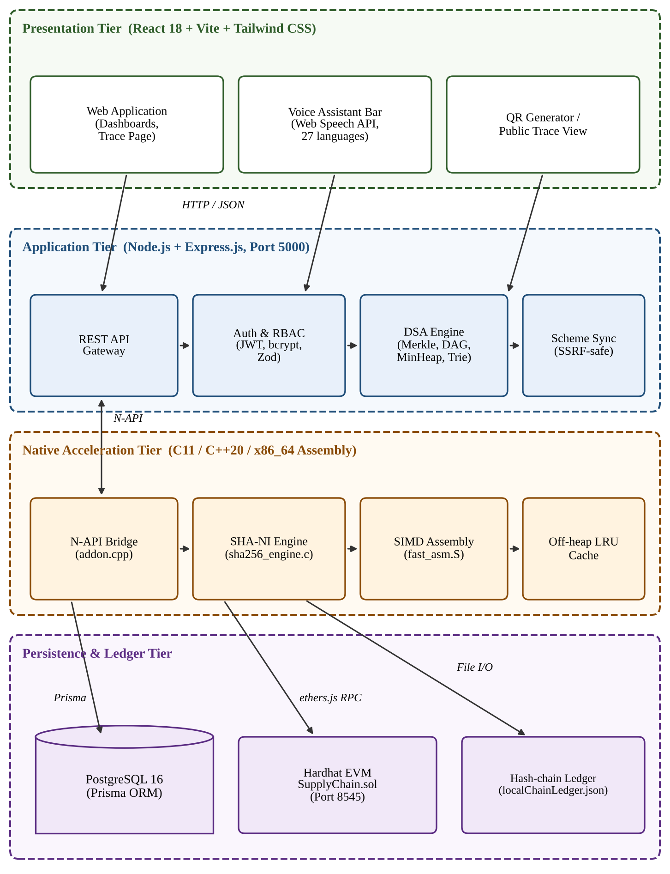
Figure 4.1: High-level system architecture
The key design decision is a hybrid storage model. PostgreSQL keeps all ordinary application data because it is fast and supports rich queries. The blockchain keeps only 32-byte digests, identifiers and timestamps. When a batch is displayed to a consumer, the server recomputes the digest from the database record and compares it, in constant time, with the digest stored on-chain. Any mismatch means the database record was changed after it was anchored, and the page shows a tamper alert.

4.2 Data Flow Diagrams

4.2.1 Level 0 Context Diagram
The context diagram in Figure 4.2 shows the platform as one process exchanging data with four external entities: farmers supply batch data and certificates and receive QR codes and scheme recommendations; partners supply custody events and receive transaction confirmations; consumers send trace requests and receive provenance and proofs; and official government portals are contacted only for HTTPS health and metadata checks.
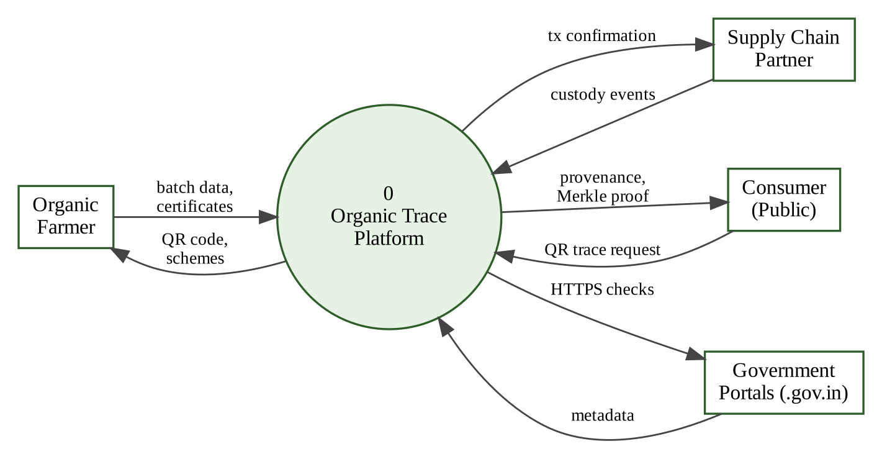
Figure 4.2: Level 0 context data flow diagram

4.2.2 Level 1 Diagram
Figure 4.3 decomposes the platform into six processes: authentication and session management, batch registration, hashing and anchoring, custody event processing, traceability and verification, and the scheme matcher. Two data stores are used: the PostgreSQL database (D1) and the blockchain with its local ledger (D2).
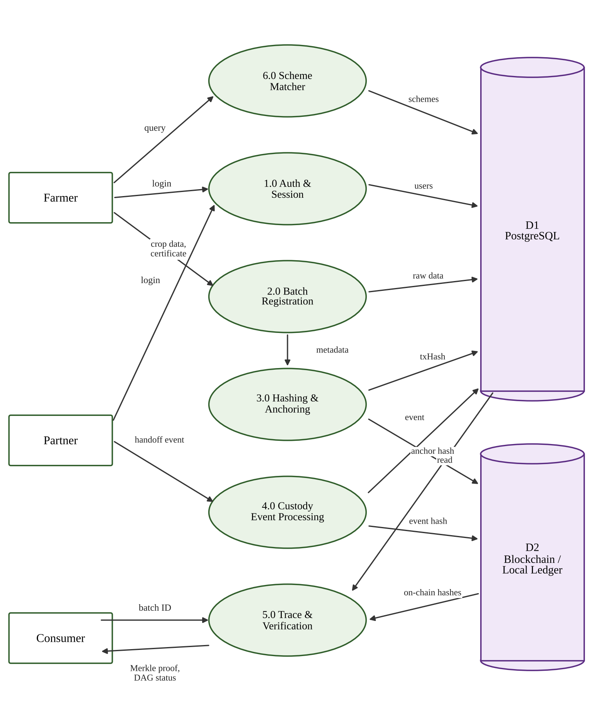
Figure 4.3: Level 1 data flow diagram

4.3 UML Diagrams

4.3.1 Use Case Diagram
Figure 4.4 shows the use cases of the four actors defined in Section 3.7. Farmers create and certify batches and use the schemes hub; partners log custody events and verify certificates; consumers trace batches and verify proofs; administrators synchronise the ledger and run benchmarks.
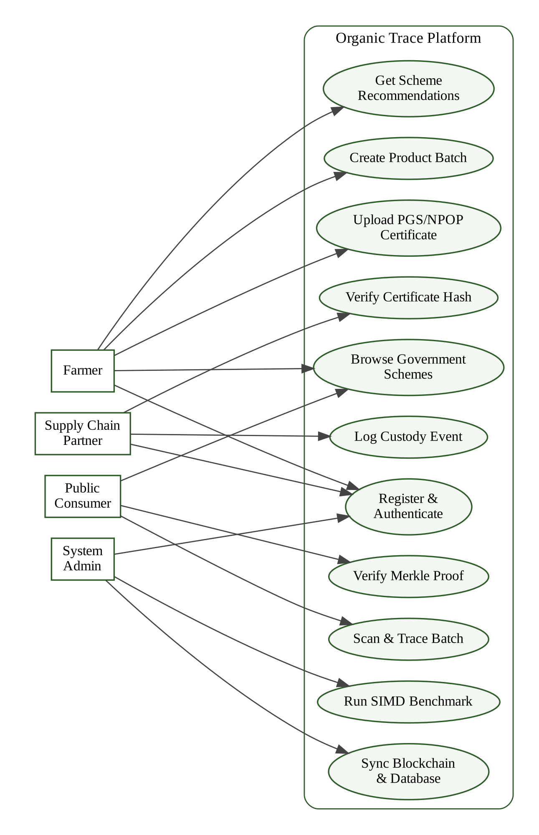
Figure 4.4: Use case diagram of the platform

4.3.2 Class Diagram
Figure 4.5 shows the main classes: the smart contract, the native engine facade, and the algorithmic classes MerkleTree, SupplyChainStageDAG and MinHeap. The native engine supplies hardware SHA-256 to the Merkle tree and the contract digests are cross-validated against it.
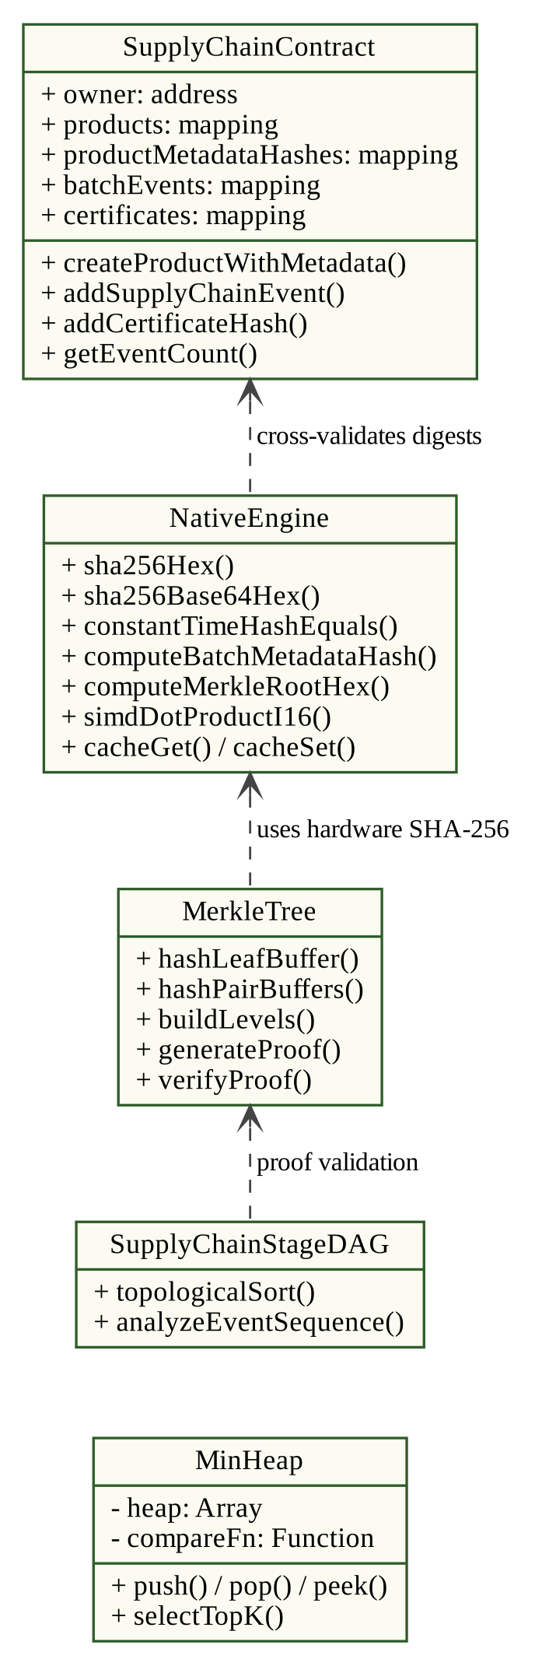
Figure 4.5: Class diagram of the contract and engine classes

4.3.3 Sequence Diagrams
Figure 4.6 shows batch creation. The server first checks that the batch identifier is unused, stores the record as PENDING, asks the native engine for the canonical metadata hash and, when a certificate is attached, for the certificate hash. It then sends the transactions to the contract and finally marks the record CONFIRMED with the transaction hash.
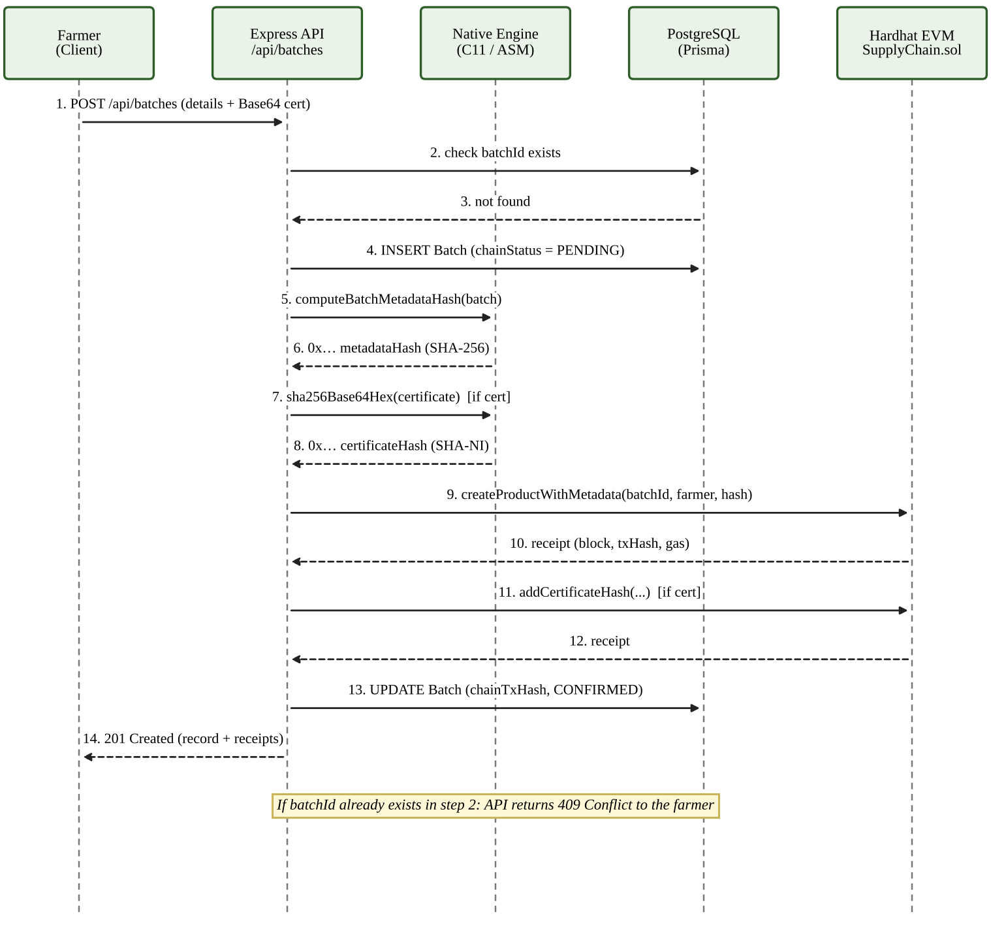
Figure 4.6: Sequence diagram: batch creation and anchoring
Figure 4.7 shows the public trace. A cache hit returns immediately from the off-heap cache. On a miss, the server loads the batch from PostgreSQL, reads the on-chain digests, recomputes and compares the metadata hash, builds the Merkle proof and the DAG report, stores the result in the cache for 30 seconds and returns it.
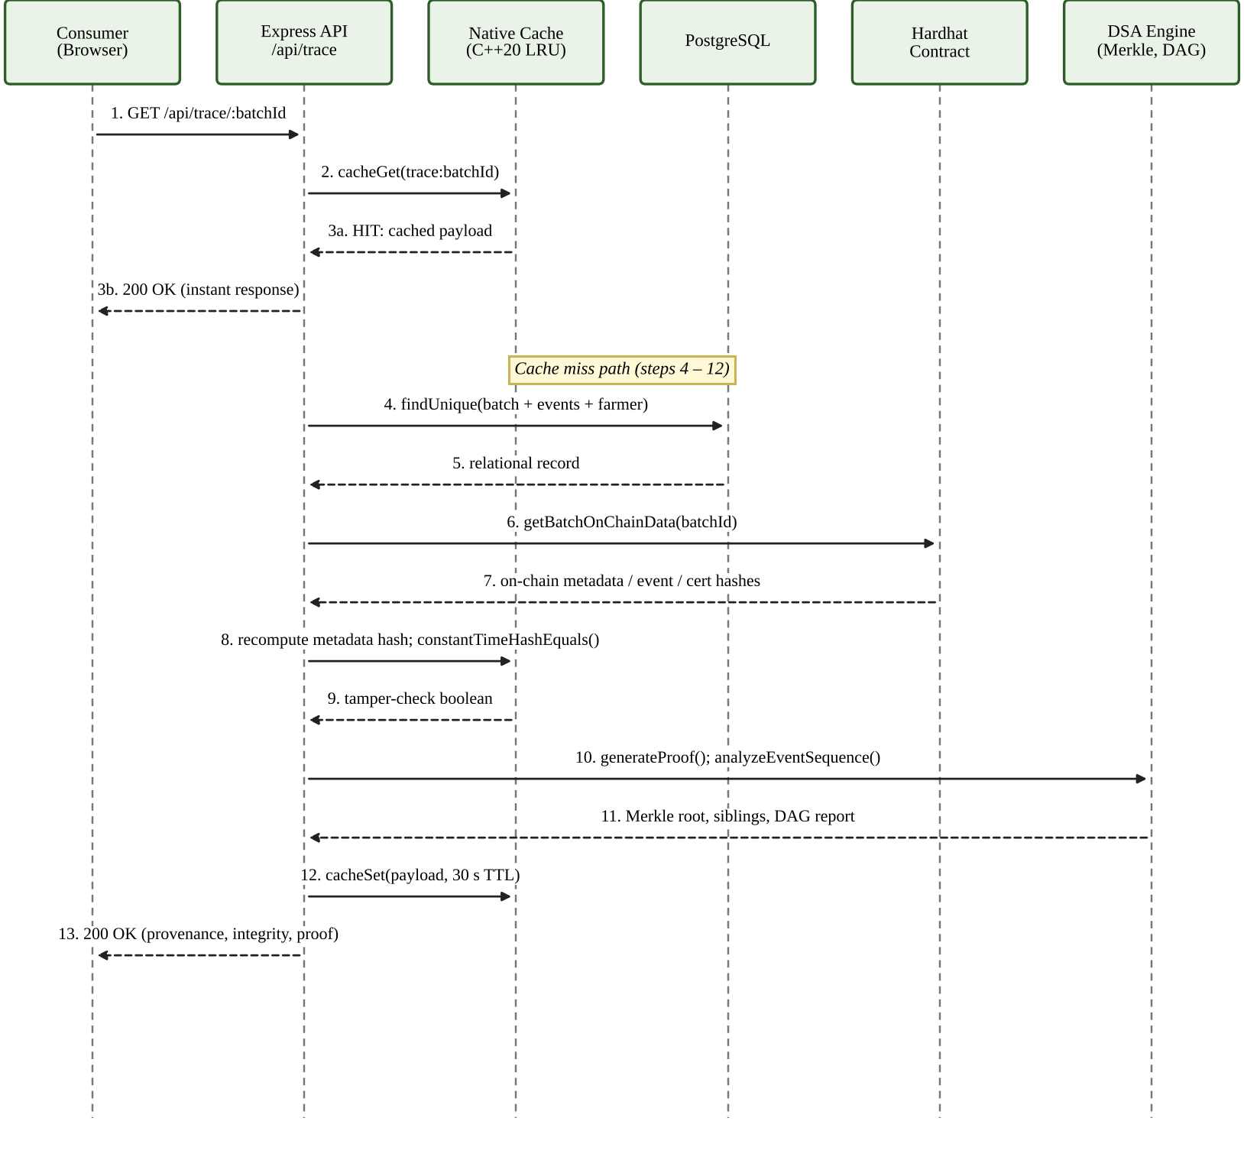
Figure 4.7: Sequence diagram: consumer QR trace and verification

4.4 Database Design
The relational schema is defined in schema.prisma and has eight models, shown in the entity-relationship diagram of Figure 4.8. A user owns many batches (as farmer), takes part in many events (as participant), saves many schemes and has at most one preference record. A batch has many events and many scheme links. Table 4.1 summarises keys, indexes and integrity rules.
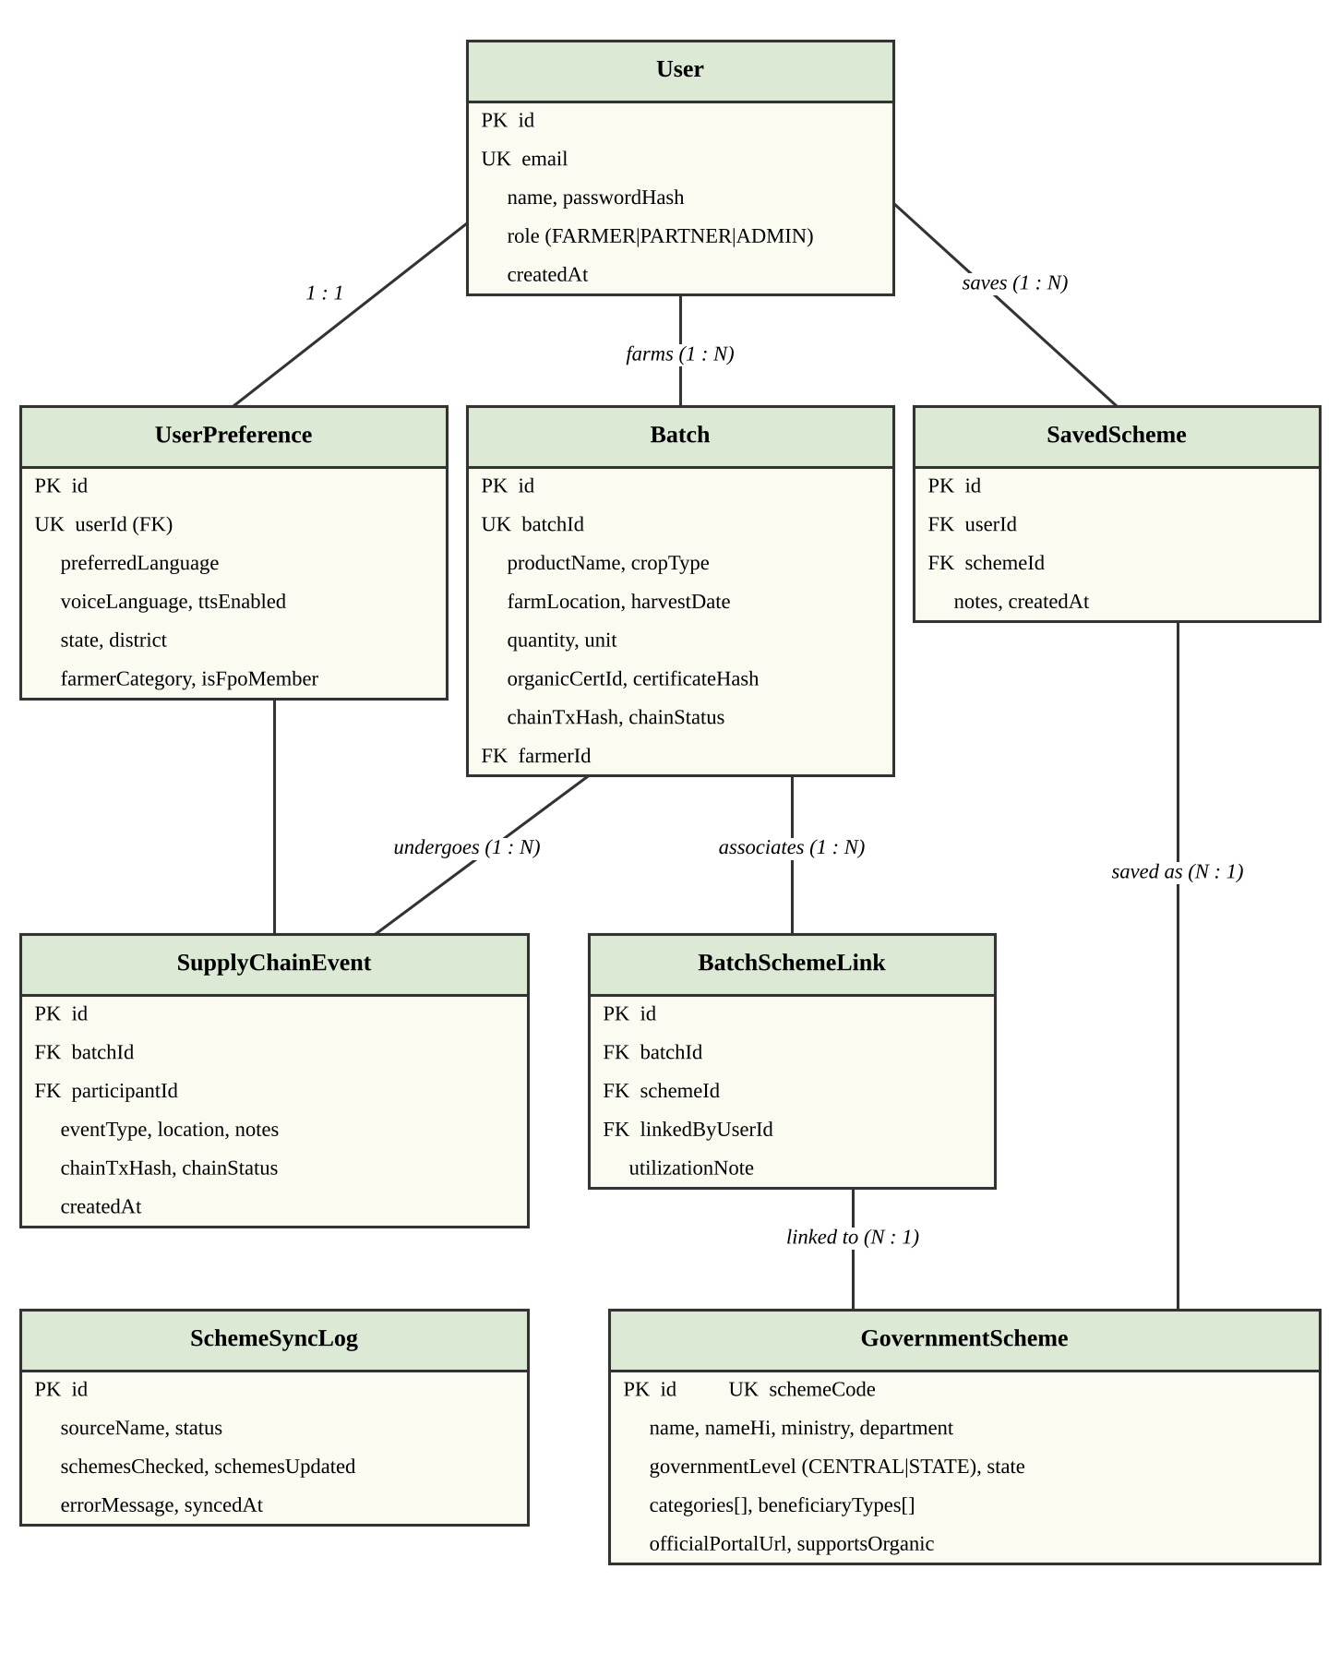
Figure 4.8: Entity-relationship diagram of the database
Table 4.1: Relational schema, keys and constraints
Table | Keys | Indexes | Integrity rules
User | id (PK), email (UK) | email | One-to-many with Batch, Event, SavedScheme, BatchSchemeLink
Batch | id (PK), batchId (UK) | farmerId, chainStatus | FK farmerId to User; one-to-many with events
SupplyChainEvent | id (PK) | batchId, createdAt | FK to Batch and User
GovernmentScheme | id (PK), schemeCode (UK) | level, state, status | One-to-many with SavedScheme and BatchSchemeLink
SavedScheme | id; unique [userId, schemeId] | userId, schemeId | Cascade delete with user or scheme
BatchSchemeLink | id; unique [batchId, schemeId] | batchId, schemeId | Cascade delete with batch or scheme
UserPreference | id; userId (UK) | userId | One-to-one with User; defaults: language en, speech on
SchemeSyncLog | id (PK) | syncedAt | Audit trail of portal synchronisation

4.5 Project Structure
Table 4.2 maps the main directories and files to their roles. The repository is a monorepo with separate packages for the contracts, the back end and the front end, plus a native source folder and the container definitions.
Table 4.2: Directory layout and file roles
Path | Purpose
contracts/contracts/SupplyChain.sol | Solidity 0.8.24 contract with inline assembly
contracts/scripts/deploy.js, contracts/test/ | Deployment script and Hardhat/Mocha/Chai tests
backend/prisma/schema.prisma, seed.js | Eight-model schema and demo data seeding
backend/src/index.js | Express bootstrap, middleware and error handling
backend/src/blockchain.js | ethers.js client, nonce locking and local hash-chain ledger
backend/src/hash.js | Bridge to the native engine with JavaScript fallback
backend/src/middleware/auth.js | JWT verification and role-based access control
backend/src/routes/ | auth, batches, events, trace, schemes, preferences, assistant
backend/src/services/ | Scheme synchronisation (SSRF checks) and LLM assistant
backend/src/utils/dsaEngine.js | MinHeap, PrefixTrie, InvertedIndex, MerkleTree, StageDAG, LRU
backend/src/native/ | addon.cpp, sha256_engine.c/.h, fast_asm.S
frontend/src/pages/ | Landing, dashboards, batch pages, Trace, GovernmentSchemes
frontend/src/locales/ | Dictionaries for 27 languages
frontend/src/utils/voiceCommand | Voice parser mapping utterances to actions
run.py, Dockerfile, docker-compose.yml | Launcher, multi-stage build and service definitions

4.6 Module-Wise Implementation

4.6.1 Smart Contract Module
The contract SupplyChain is compiled with Solidity 0.8.24 and the optimiser enabled. It keeps a products mapping, a productMetadataHashes mapping, an event array per batch and one certificate record per batch. Functions revert with a clear message if a batch already exists or does not exist. The listing below shows the creation function; the full source is given in Appendix A.
function createProductWithMetadata(string calldata batchId,
address farmer, bytes32 metadataHash) external {
require(!products[batchId].exists, "SupplyChain: batch already exists");
uint256 ts;
assembly { ts := timestamp() }
products[batchId] = Product({ batchId: batchId, farmer: farmer,
createdAt: ts, exists: true });
if (metadataHash != bytes32(0)) {
productMetadataHashes[batchId] = metadataHash;
emit ProductMetadataAnchored(batchId, metadataHash, ts);
}
emit ProductCreated(batchId, farmer, ts);
}

Listing 4.1: Batch creation with metadata anchoring

4.6.2 Back-End API and Authentication Module
The Express server exposes the REST API listed in Section 4.8. Passwords are hashed with bcrypt and sessions use signed JSON Web Tokens [26]. A middleware verifies the token on every protected route, loads the role and rejects expired or forged tokens. Request bodies are parsed with Zod schemas that reject unexpected fields, malformed dates and out-of-range quantities. Ownership checks ensure that a farmer can upload a certificate to, or change, only a batch whose farmerId equals the authenticated user. Helmet sets security headers and a rate limiter slows brute-force and flooding attempts, in line with common API security guidance [30].

4.6.3 Native Cryptographic Engine
The add-on has three parts. sha256_engine.c implements SHA-256 with the SHA-NI intrinsics and a CPUID check; for Base64 certificates it decodes 4 KB at a time on the stack and feeds each chunk to the compression function, so memory stays flat for files of several megabytes. fast_asm.S contains hand-written x86-64 routines: a SSSE3 pshufb hexadecimal encoder that turns 16 bytes into 32 ASCII characters at once, a branch-free constant-time equality test, an SSE4.2 CRC32C routine and a pmaddwd based 16-bit dot product. addon.cpp exports these functions through Node-API and also implements an LRU cache protected by std::shared_mutex, which allows many concurrent readers and one writer outside the garbage-collected JavaScript heap [22].
/* SHA-NI rounds 0-3 */
MSG = _mm_loadu_si128((const __m128i*)(ptr + 0));
MSG0 = _mm_shuffle_epi8(MSG, MASK);
MSG = _mm_add_epi32(MSG0, _mm_set_epi64x(0xE9B5DBA5B5C0FBCFULL,
0x71374491428A2F98ULL));
STATE1 = _mm_sha256rnds2_epu32(STATE1, STATE0, MSG);
MSG = _mm_shuffle_epi32(MSG, 0x0E);
STATE0 = _mm_sha256rnds2_epu32(STATE0, STATE1, MSG);

Listing 4.2: Hardware SHA-256 rounds using SHA-NI intrinsics
movdqu (%rdi), %xmm0 # load 16 input bytes
movdqa %xmm0, %xmm1
psrlw $4, %xmm1
pand %xmm6, %xmm1 # high nibbles
pand %xmm6, %xmm0 # low nibbles
movdqa %xmm1, %xmm2
punpcklbw %xmm0, %xmm1 # interleave nibbles 0..7
punpckhbw %xmm0, %xmm2 # interleave nibbles 8..15
pshufb %xmm1, %xmm3 # translate nibbles to ASCII hex

Listing 4.3: SSSE3 vectorised hexadecimal encoding
If the add-on cannot be loaded, or the processor lacks SHA-NI or is not x86-64, hash.js transparently falls back to the Node.js crypto module, so behaviour is identical and only speed differs.

4.6.4 Algorithms Engine
dsaEngine.js contains the algorithmic classes. The Merkle tree is built bottom-up: leaves are hashed, adjacent pairs are hashed together level by level, and an unpaired last node is paired with itself. A proof for leaf i lists, for every level, the sibling hash and whether it lies to the left or right. Figure 4.9 illustrates the proof for the third event of a four-event batch.
static buildLevels(leaves = []) {
const level0 = leaves.map((l) => MerkleTree.hashLeafBuffer(l));
const levels = [level0];
let current = level0;
while (current.length > 1) {
const next = [];
for (let i = 0; i < current.length; i += 2) {
const left = current[i];
const right = i + 1 < current.length ? current[i + 1] : current[i];
next.push(MerkleTree.hashPairBuffers(left, right));
}
levels.push(next);
current = next;
}
return levels;
}

Listing 4.4: Bottom-up construction of the Merkle tree levels
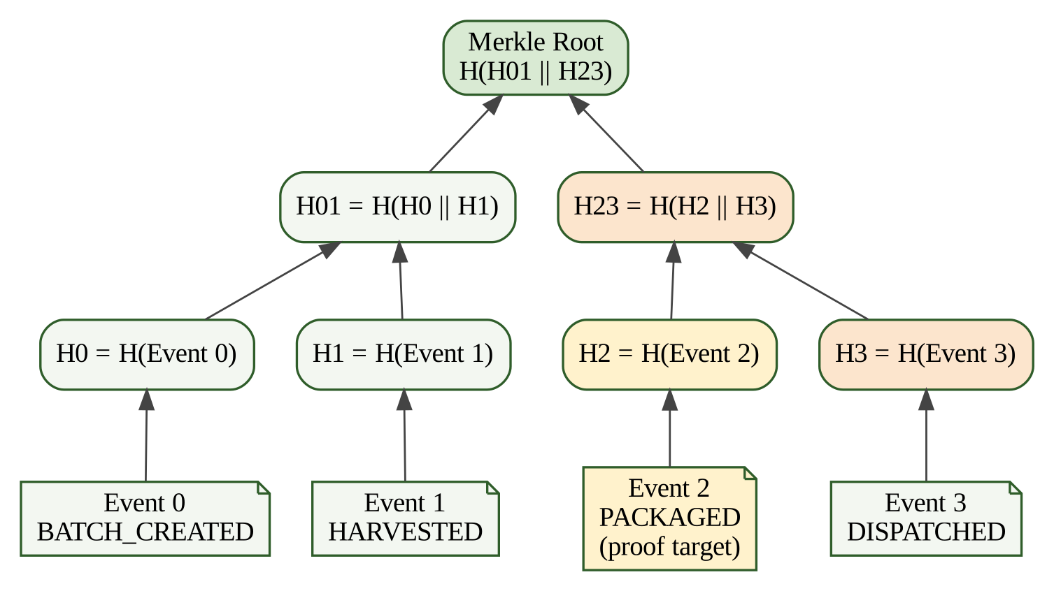
Figure 4.9: Merkle tree and inclusion proof for one event
Custody order is checked by SupplyChainStageDAG. The 15 stages, their ranks and permitted transitions are listed in Table 4.3 and drawn in Figure 4.10 (the figure shows transitions between consecutive ranks; Table 4.3 also permits forward skips). The class first runs Kahn’s algorithm to confirm the graph has no cycle. analyzeEventSequence then walks the events of a batch in time order, flags any event whose rank is lower than the previous one or whose transition is not permitted, and reports the completion percentage reached.
Table 4.3: Supply-chain stages, ranks and permitted transitions
Stage | Rank | Phase | Permitted next stages
BATCH_CREATED | 0 | Farm origin | HARVESTED, CERTIFICATE_UPLOADED, QUALITY_CHECK_PASSED
HARVESTED | 1 | Farm origin | CERTIFICATE_UPLOADED, QUALITY_CHECK_PASSED, RECEIVED_BY_PROCESSOR
CERTIFICATE_UPLOADED | 1 | Certification | QUALITY_CHECK_PASSED, RECEIVED_BY_PROCESSOR, PROCESSING_STARTED
QUALITY_CHECK_PASSED | 2 | Quality assurance | RECEIVED_BY_PROCESSOR, PROCESSING_STARTED, PACKAGED
RECEIVED_BY_PROCESSOR | 2 | Processing | PROCESSING_STARTED, PROCESSING_COMPLETED, PACKAGED
PROCESSING_STARTED | 3 | Processing | PROCESSING_COMPLETED, PACKAGED
PROCESSING_COMPLETED | 4 | Processing | PACKAGED, COLD_STORAGE_LOGGED, RECEIVED_BY_DISTRIBUTOR, DISPATCHED
PACKAGED | 5 | Packaging | COLD_STORAGE_LOGGED, RECEIVED_BY_DISTRIBUTOR, DISPATCHED, IN_TRANSIT
COLD_STORAGE_LOGGED | 5 | Storage | RECEIVED_BY_DISTRIBUTOR, DISPATCHED, IN_TRANSIT
RECEIVED_BY_DISTRIBUTOR | 6 | Logistics | DISPATCHED, IN_TRANSIT, DELIVERED_TO_RETAILER
DISPATCHED | 7 | Logistics | IN_TRANSIT, DELIVERED_TO_RETAILER, RECEIVED_BY_RETAILER
IN_TRANSIT | 8 | Logistics | DELIVERED_TO_RETAILER, RECEIVED_BY_RETAILER, AVAILABLE_FOR_SALE
DELIVERED_TO_RETAILER | 9 | Retail | RECEIVED_BY_RETAILER, AVAILABLE_FOR_SALE
RECEIVED_BY_RETAILER | 9 | Retail | AVAILABLE_FOR_SALE
AVAILABLE_FOR_SALE | 10 | Retail | (terminal stage)

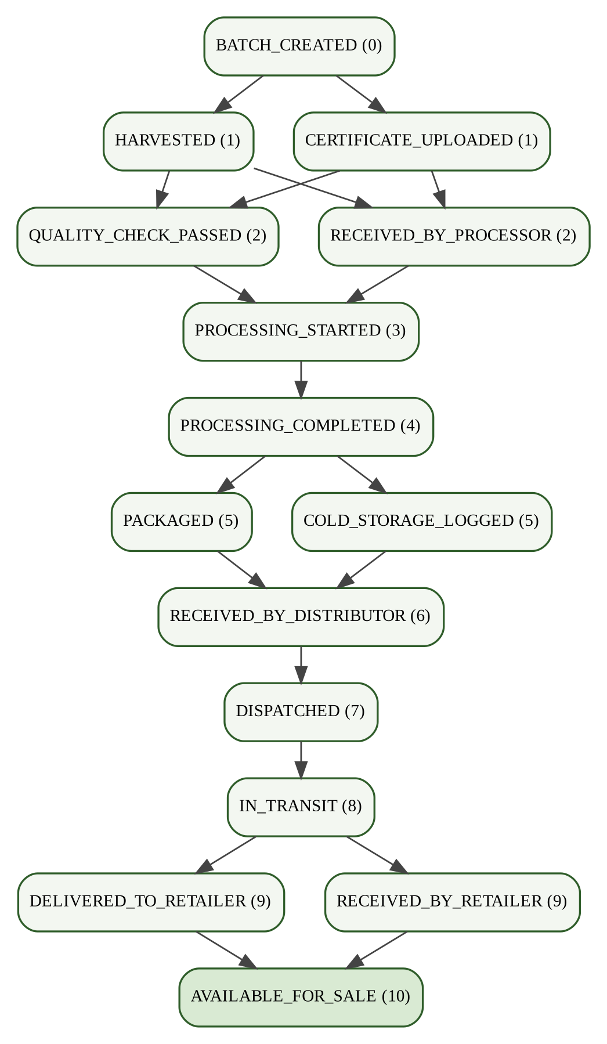
Figure 4.10: Supply-chain stage DAG (transitions between consecutive ranks)

4.6.5 Government Schemes Module
The schemes hub holds a curated dataset of more than 17 verified central and state programmes, including PKVY [31], PM-KISAN, the Agriculture Infrastructure Fund, PMKSY and state organic-farming incentives. Each record has a code, bilingual name and description, ministry, level, state, categories, beneficiary types, funding type, benefit summary, application status, official portal URL and an organic-support flag. At start-up the service builds an inverted index and a prefix trie over the text. A search query is tokenised with a Unicode-aware regular expression, looked up in the index, expanded through the trie for tokens of three or more letters, scored, and reduced to the best K with the min-heap. Recommendations additionally weigh the farmer’s state, land holding, category and interests. The synchronisation service checks each official portal with an HTTPS request but only after the URL passes isSafeOfficialUrl(), described in Section 4.10.

4.6.6 Localization and Voice Module
The user interface is available in 27 Indian languages, each with its own dictionary file; Table 4.4 lists a representative subset with their BCP-47 voice codes. Several regional languages without their own speech model, such as Haryanvi, Bhojpuri and Rajasthani, use the Hindi recogniser as fallback. The voice bar uses the browser’s Web Speech API [29]. A spoken sentence is first passed through sanitizeVoiceInput(), which strips markup, SQL keywords and shell punctuation, and is then mapped to an action such as opening a page, filtering schemes by state or tracing a batch. Unsafe input is rejected and never reaches the router.
Table 4.4: Representative supported languages and voice codes
Code | Language | Script | Voice code | Main region
en | English | Latin | en-IN | Pan-India
hi | Hindi | Devanagari | hi-IN | Northern and central India
bn | Bengali | Bengali | bn-IN | West Bengal, Tripura
te | Telugu | Telugu | te-IN | Andhra Pradesh, Telangana
mr | Marathi | Devanagari | mr-IN | Maharashtra
ta | Tamil | Tamil | ta-IN | Tamil Nadu, Puducherry
gu | Gujarati | Gujarati | gu-IN | Gujarat
kn | Kannada | Kannada | kn-IN | Karnataka
ml | Malayalam | Malayalam | ml-IN | Kerala
pa | Punjabi | Gurmukhi | pa-IN | Punjab, Haryana
or | Odia | Odia | or-IN | Odisha
bgc | Haryanvi | Devanagari | hi-IN (fallback) | Haryana, Delhi NCR
bho | Bhojpuri | Devanagari | hi-IN (fallback) | Bihar, eastern Uttar Pradesh
raj | Rajasthani | Devanagari | hi-IN (fallback) | Rajasthan

4.6.7 Optional AI Assistant
An optional assistant runs on a local Ollama server with the Llama 3.2 model [32]. The back end retrieves the most relevant scheme records and short descriptions of the application’s functions, places them in the prompt as context, and streams the answer to the browser over Server-Sent Events. The assistant is not required: the Docker stack starts without it, and the application shows a graceful offline message if the model is unavailable.

4.6.8 Front-End Module
The React application uses lazy-loaded routes and a theme provider for light and dark mode. The main views are the landing page with a batch search box, the farmer dashboard and batch creation form, the partner dashboard for logging events, the public trace page with the timeline, DAG progress and Merkle proof, the schemes hub with filters, and the floating voice bar. QR codes are generated in the browser with qrcode.react and can be downloaded as PNG files.

4.7 Algorithms Used

4.7.1 Min-Heap Top-K Selection
- Create an empty binary min-heap ordered by score, so the root holds the lowest score among the kept items.
- Insert the first K items, sifting each up in O(log K).
- For each remaining item, compare its score with the root. If it is higher, replace the root and sift down in O(log K); otherwise discard it.
- After all N items are processed, pop the heap and reverse the result to obtain the K best items in descending order.
The total time is O(N log K) and the extra space is O(K), which is better than sorting all N items in O(N log N) when K is small.

4.7.2 Inverted Index and Prefix Trie Search
- Normalise text to lower case and split it on every character that is not a Unicode letter, digit or hyphen.
- Insert each token into the prefix trie and add it to the inverted index as a posting with a weight (larger for names than for descriptions).
- For a query, look up each token in the index in O(1); if the token has at least three characters, also collect trie completions in O(L).
- Add up the weights per scheme and pass the scores to the min-heap to select the top results.

4.7.3 Custody Validation and Proof Generation
For custody validation, the DAG is built from the transition table, Kahn’s algorithm checks that it is acyclic, and the event list is checked rank by rank in O(E) for E events. For proof generation, the levels of the Merkle tree are built once per request and the sibling at each level is collected, giving ⌈log₂ N⌉ hashes for N events.

4.8 API Endpoints
Table 4.5 lists the REST endpoints. Routes marked Public need no token; others require a bearer JWT and, where shown, a specific role.
Table 4.5: REST API endpoint specification
Method | Endpoint | Access | Purpose
POST | /api/auth/register | Public | Create an account with a hashed password
POST | /api/auth/login | Public | Authenticate and return a signed JWT
POST | /api/auth/refresh | Public / JWT | Refresh the session token
GET | /api/auth/me | JWT | Return the current profile and role
GET | /api/batches | JWT | List batches with pagination
POST | /api/batches | Farmer / Admin | Create a batch, hash metadata, anchor on-chain
POST | /api/batches/sync-chain | JWT | Force synchronisation of database and blockchain
GET | /api/batches/:batchId | JWT | Batch details with on-chain verification
POST | /api/batches/:batchId/certificate | Farmer / Admin | Hash a Base64 certificate and anchor the digest
POST | /api/batches/:batchId/cert/verify | Public | Verify a document against the anchored hash
POST | /api/batches/:batchId/events | Partner / Admin | Append a custody event and anchor its hash
GET | /api/batches/:batchId/events | JWT | List events of a batch
GET | /api/trace/:batchId | Public | Public trace with Merkle proof and DAG report
GET | /api/schemes/meta | Public | Filter options and last synchronisation log
GET | /api/schemes | Public | Search, filter and paginate schemes
POST | /api/schemes/recommend | Public / JWT | Top-K personalised scheme recommendations
GET | /api/schemes/contextual/batch/:id | Public | Schemes matching a batch’s crop and location
GET / POST / DELETE | /api/schemes/:code/save | JWT | List, add or remove bookmarked schemes
POST / DELETE | /api/schemes/:code/link-batch | Farmer / Admin | Link or unlink a scheme and a batch
GET / PUT | /api/preferences | JWT | Read or update language and region settings
GET | /api/assistant/models | Public | List local LLM models
POST | /api/assistant/ask, /stream | Rate-limited | Grounded answer, plain or streamed (SSE)
GET | /api/health, /api/health/benchmark | Public | Status, telemetry and native microbenchmark

4.9 User Interface and User Flow
A typical flow is as follows. A farmer logs in, opens the dashboard and creates a batch; the system anchors it and shows an On-chain badge with a QR code. The farmer uploads the organic certificate, and only its SHA-256 hash is recorded. A processor or distributor logs in as a partner, opens the batch and records events such as RECEIVED_BY_PROCESSOR or DISPATCHED. The consumer scans the QR code and reaches the public trace page, which shows the product details, the timeline with an on-chain badge for each event, the custody progress and the proof of integrity. At any time, a farmer can open the schemes hub, filter by state or category, or simply say a command such as “show organic schemes in Haryana”. The actual screens are shown in Chapter 6.

4.10 Security, Validation and Error Handling
- Authentication. Passwords are salted and hashed with bcrypt; JWTs carry the user identifier and role, are signed with a server secret and are verified on every protected request.
- Object-level authorization. Ownership is checked before any change to a batch, which prevents BOLA and IDOR attacks [30].
- SSRF protection. isSafeOfficialUrl() accepts only HTTPS URLs whose host ends in .gov.in or .nic.in or belongs to a short list of approved official domains; every other URL is rejected before any request is made.
- Input validation. Zod schemas validate every request body and reject unknown fields, malformed ISO dates and out-of-range numbers.
- Constant-time comparison. Hash comparisons use the assembly routine asm_const_time_eq() or crypto.timingSafeEqual() so that timing does not reveal how many characters matched.
- Voice sanitization. Transcribed speech is stripped of markup, SQL keywords and shell characters before parsing.
- Privacy. No personal contact data, land records or documents are written to the blockchain, only digests.

CHAPTER 5
TESTING AND DEPLOYMENT

5.1 Testing Strategy
Testing was organised in four layers. Smart-contract tests use Hardhat, Mocha and Chai to check deployment, duplicate rejection, event counting and metadata anchoring. Algorithm and native tests run with the Node.js test runner and cover the min-heap, prefix trie, Merkle proofs, Kahn’s algorithm, the constant-time comparison and the native hashing path. Security tests try object-level authorization bypass, forged tokens, SSRF URLs and malformed payloads. Integration and concurrency tests send 40 parallel requests to the trace, scheme and benchmark endpoints. A separate suite checks the voice parser against both valid commands and injection attempts. Table 5.1 summarises the suites.
Table 5.1: Automated test suites
Test file | Framework | Target | Size
contracts/test/SupplyChain.test.js | Hardhat, Mocha, Chai | Solidity contract | 7 test cases
backend/test/schemesAndTrace.test.js | Node.js test runner | Back end, algorithms, native engine | 15 test suites, 70+ assertions
frontend/src/__tests__/voiceParser.test.js | Node.js test runner | Voice parser | 5 test suites

5.2 Test Cases
Table 5.2 lists representative test cases with their expected and observed results. All of them passed in the final run.
Table 5.2: Representative test cases
ID | Module | Input | Expected result | Result
TC-01 | Contract | Duplicate batchId | Revert: batch already exists | Pass
TC-02 | Contract | Event for unknown batch | Revert: batch does not exist | Pass
TC-03 | Contract | 32-byte metadata hash | ProductMetadataAnchored event emitted | Pass
TC-04 | SSRF validator | https://evil.com/fake-scheme | Rejected (false) | Pass
TC-05 | SSRF validator | https://pmkisan.gov.in/ | Accepted (true) | Pass
TC-06 | Authorization | Farmer B uploads certificate to Farmer A’s batch | HTTP 403 | Pass
TC-07 | JWT | Token signed with a wrong secret | HTTP 401 | Pass
TC-08 | Validation | harvestDate = not-a-valid-date | HTTP 400 with error | Pass
TC-09 | Native SHA-NI | 256 KB buffer, 40 iterations | Throughput above 1,000 MB/s | Pass (about 1,490 MB/s)
TC-10 | Constant-time equality | Two identical 64-character hashes | Returns 1 | Pass
TC-11 | Constant-time equality | Hashes differing in one bit | Returns 0 | Pass
TC-12 | Merkle tree | Proof for leaf 2 of 4 | Valid proof with correct sibling sides | Pass
TC-13 | Merkle tree | Proof checked against tampered root | Returns false | Pass
TC-14 | Stage DAG | Sequence BATCH_CREATED then PACKAGED then HARVESTED | Rank regression flagged | Pass
TC-15 | Min-heap | 50 scored schemes, K = 5 | Five items in descending order | Pass
TC-16 | Voice parser | Show organic schemes in Haryana | FILTER_SCHEMES with state Haryana | Pass
TC-17 | Voice parser | DROP TABLE GovernmentScheme; -- | REJECTED_UNSAFE, no route | Pass
TC-18 | Concurrency | 40 parallel HTTP requests | All succeed, latency under 100 ms | Pass

5.3 Defects Found and Fixed
Table 5.3 lists the main defects found during integration on Windows and Docker, their causes and the fixes. Most of them concern the development environment and not the traceability logic.
Table 5.3: Defects, root causes and fixes
ID | Component | Root cause | Fix
BUG-01 | run.py on Windows | node_modules/.bin held Unix shell scripts from a Linux build, so cmd.exe could not run npx | Added ensure_windows_shims() to generate .cmd shims and used direct node execution
BUG-02 | Port cleaning in run.py | free_port killed the process that Docker Desktop uses as port proxy, crashing the daemon | Added is_docker_pid() and stop the Compose service instead of killing the PID
BUG-03 | Docker dependencies | backend depended on ollama, so it refused to start without the AI service | Removed the dependency; the backend now starts and falls back gracefully
BUG-04 | nodemon watcher | Writes to localChainLedger.json triggered endless restarts | Added nodemon.json to ignore src/data, logs and the ledger file
BUG-05 | Vite on Windows host | Missing @rollup/rollup-win32-x64 native module | Default to the containerised stack where the Linux binary works

5.4 Deployment and Installation

5.4.1 Prerequisites
The following are needed: Docker Desktop with the WSL 2 backend on Windows [28], Python 3.10 or newer for the launcher, and Node.js 18 or newer only if the services are run directly on the host.

5.4.2 Environment Configuration
The template .env.example is copied to .env. The values below show the required variables. The private key and the secret must be replaced with the developer’s own values; the key used on a local Hardhat network is a publicly known test key and must never be used on a real network.
DATABASE_URL="postgresql://organic:<password>@localhost:5432/organic_trace"
JWT_SECRET="<long random string>"
PORT=5000
BLOCKCHAIN_RPC_URL="http://127.0.0.1:8545"
CONTRACT_ADDRESS="<address printed by the deploy script>"
PRIVATE_KEY="<Hardhat test account key>"
VITE_API_URL="http://localhost:5000"

Listing 5.1: Environment variables (placeholders)

5.4.3 Running and Stopping the Stack
python run.py # builds, deploys the contract, seeds the database
docker compose up -d --build postgres hardhat backend frontend
python run.py --status # health and port status
python run.py --stop # stop containers and free the ports

Listing 5.2: Launch and management commands

5.4.4 Containers and Continuous Integration
A multi-stage Dockerfile compiles the C, C++ and assembly sources, compiles the contract, generates the Prisma client and builds the front end, and the runtime images run as a non-root user. A GitHub Actions workflow runs on every push to the main branch: it executes the contract tests and the back-end algorithm suites and builds the Docker images for linux/amd64 and linux/arm64. On ARM the native add-on is not used and the JavaScript fallback takes over.

CHAPTER 6
ANALYSIS AND RESULTS

6.1 Working Output of the Features
This section shows the running application. The screenshots were taken from the system running on the local development stack, with demonstration data.
Figure 6.1 shows the landing page. A visitor can type a batch identifier such as ORG-BAS-001 and press Trace Product, or log in or register. The three cards below the search box explain the flow: the farmer registers a batch, partners add tamper-evident events, and a customer scans the QR code to see the verified history without logging in.
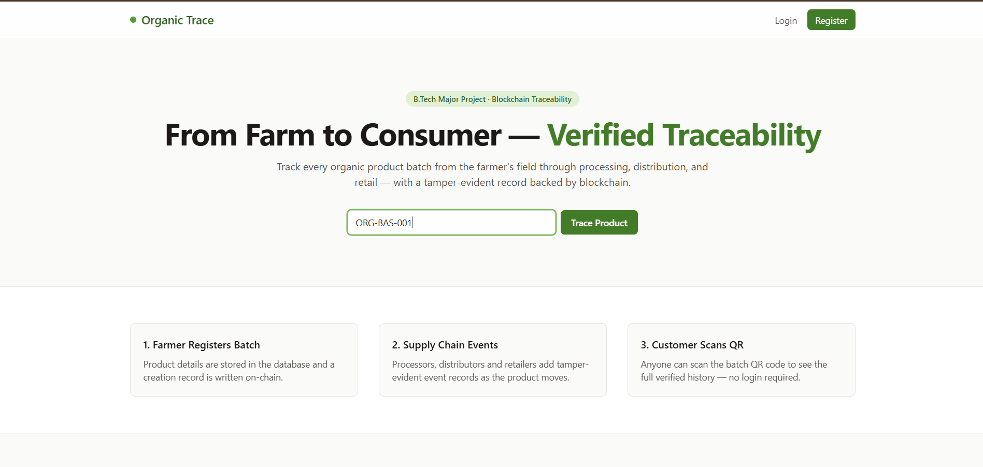
Figure 6.1: Landing page with the public batch search
Figure 6.2 shows the farmer’s dashboard, which lists the farmer’s batches together with an On-chain badge that shows that the creation record has been written to the blockchain, the batch identifier, the quantity and the number of recorded supply-chain events.
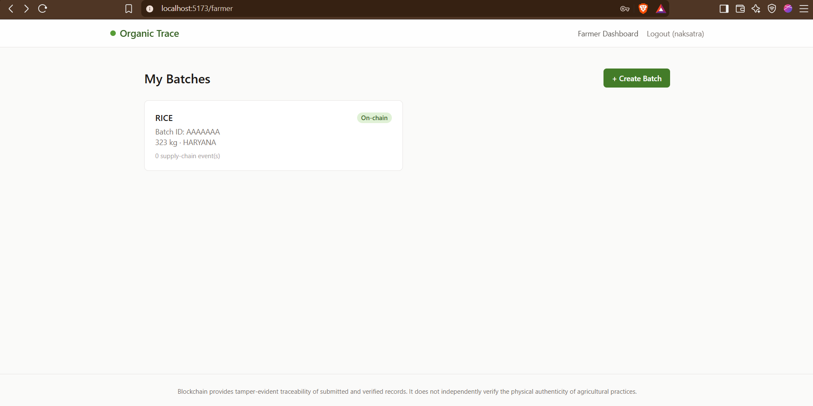
Figure 6.2: Farmer dashboard listing batches with on-chain status
Figure 6.3 shows the batch detail page of a farmer. It displays the crop, location, harvest date, quantity, organic certificate identifier, the certificate hash and the public trace link, with a downloadable QR code. The form below it hashes a chosen certificate file and records the hash; the page states that the document itself stays off-chain and only its SHA-256 hash is written to the blockchain.
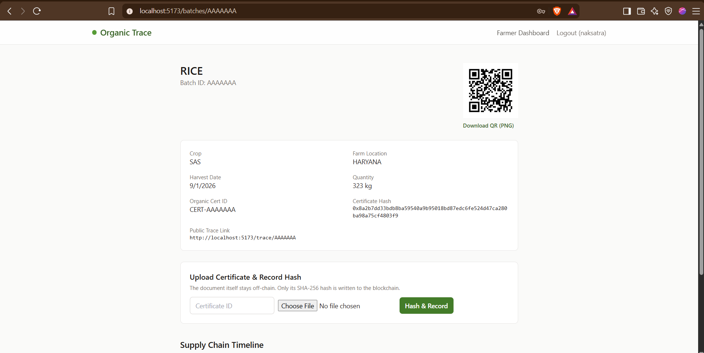
Figure 6.3: Batch details with QR code and certificate hash upload
Figure 6.4 shows the partner’s view. A partner sees all batches and can open any of them to record an event.
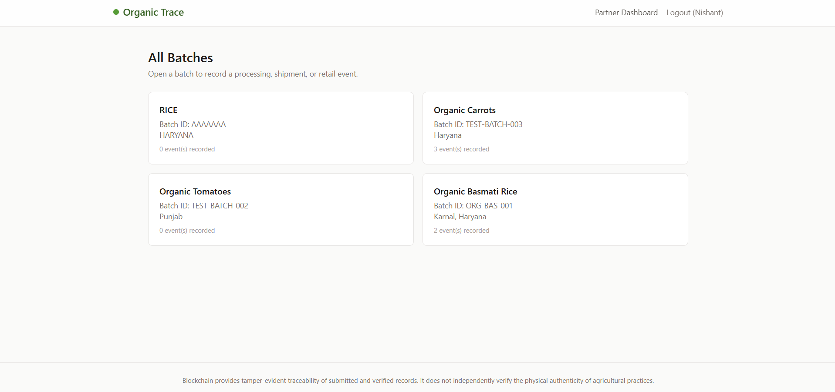
Figure 6.4: Partner view listing all batches
Figure 6.5 shows a batch page for a partner, with the QR code and the form for adding a supply-chain event. The partner chooses an event type such as Received by Processor, enters a location and optional notes, and presses Record Event.
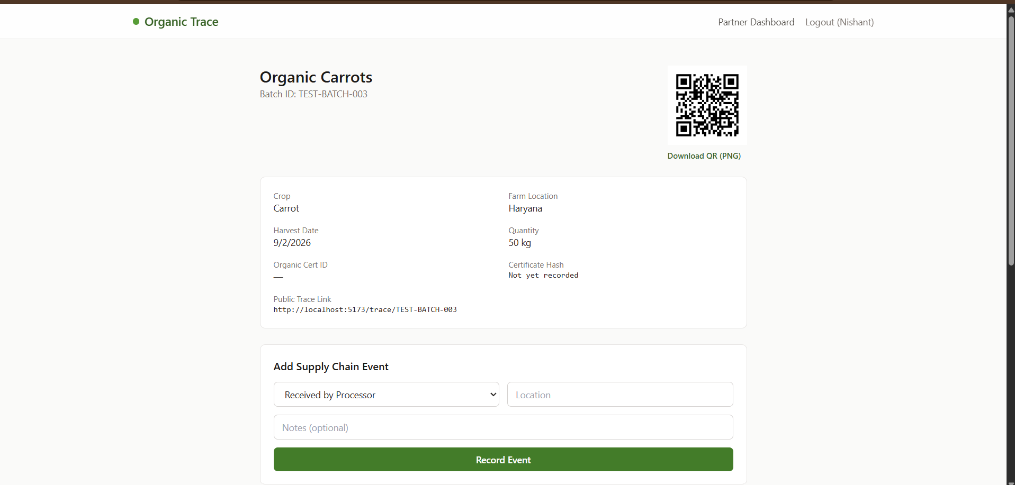
Figure 6.5: Partner form for recording a supply-chain event
Figure 6.6 shows the resulting timeline. Each event shows the event name, the participant, the place, the time and a Recorded on blockchain badge with the transaction hash.
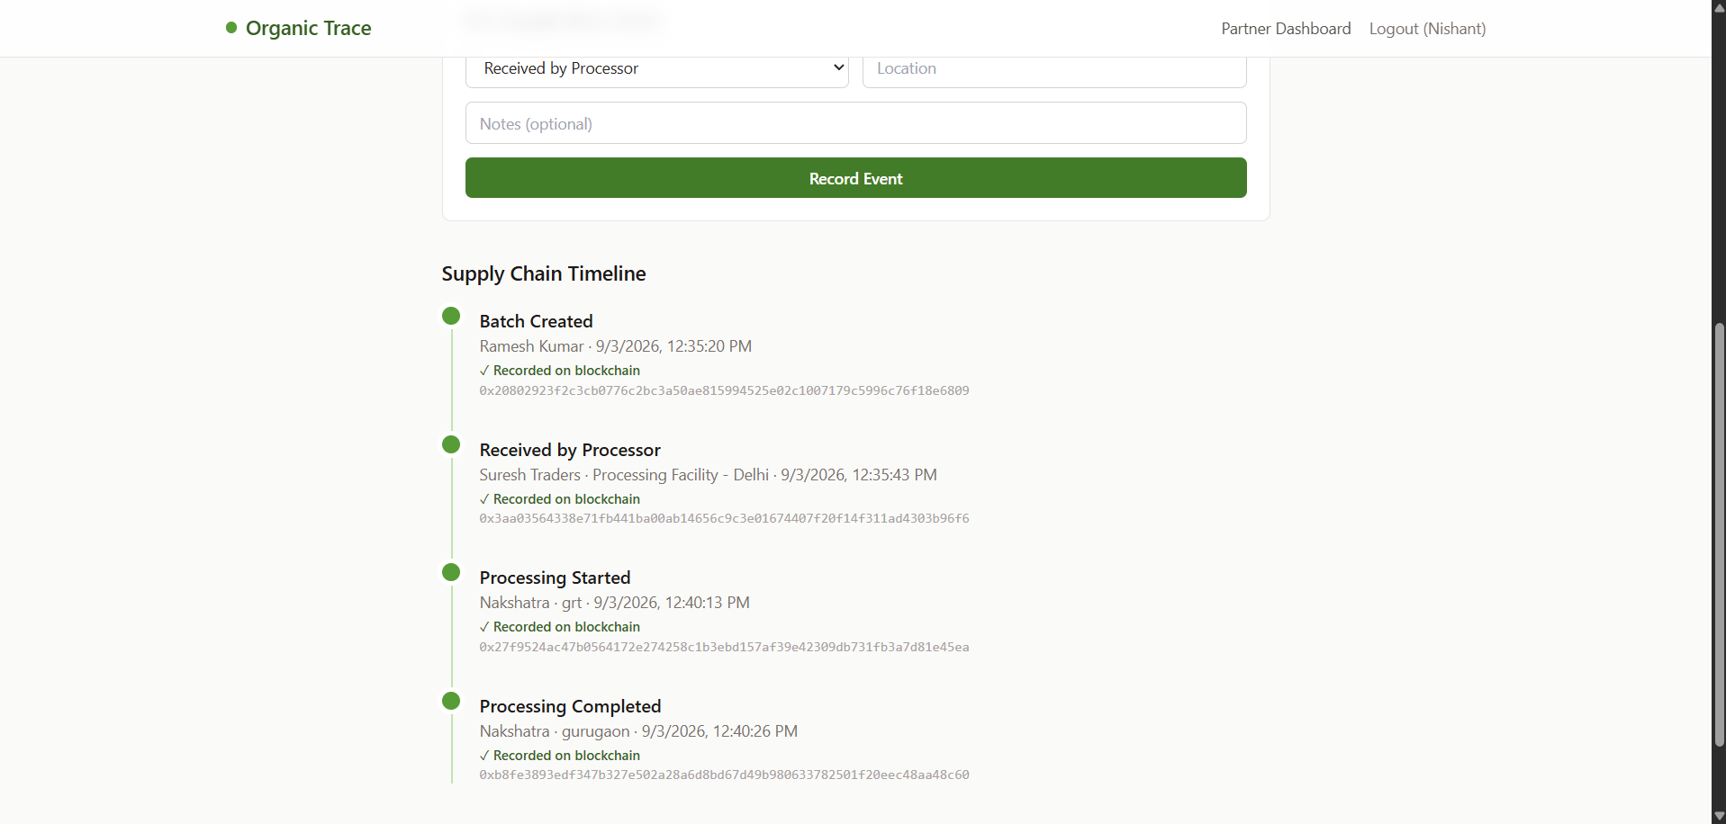
Figure 6.6: Supply-chain timeline with blockchain transaction hashes
Figure 6.7 shows the public trace page that a consumer reaches after scanning the QR code. It shows the product name and batch identifier, the crop, farm location, harvest date, quantity, farmer and certification status, followed by the supply-chain timeline. Events that have not yet been confirmed on the chain are marked with a clear warning instead of being hidden, so the consumer always sees the true verification state.
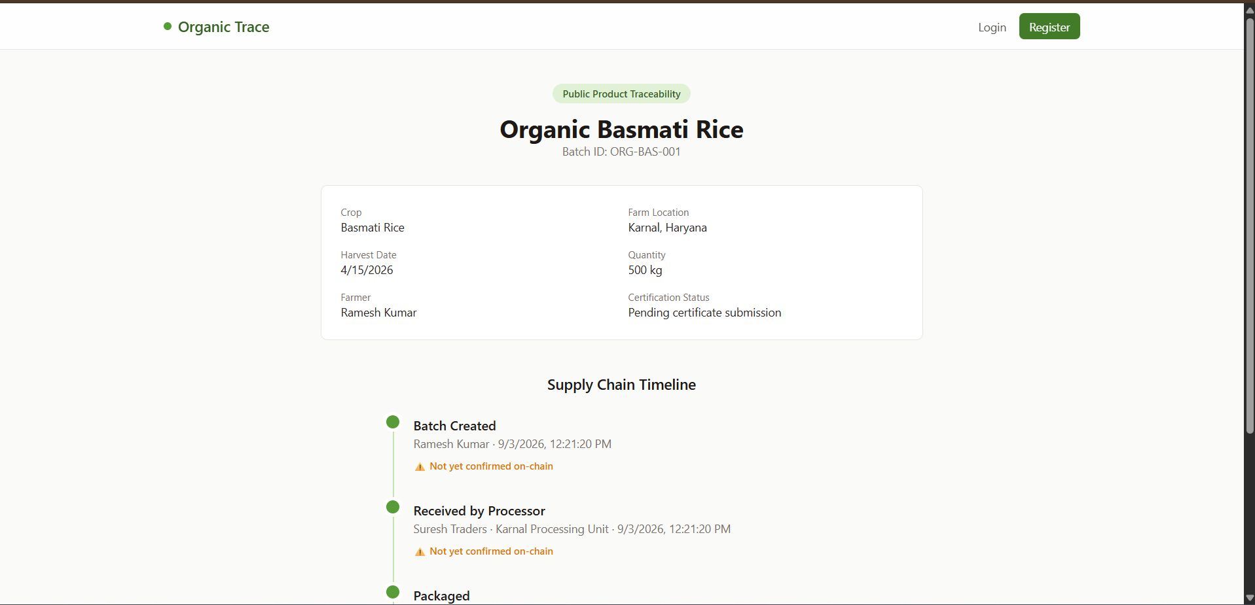
Figure 6.7: Public product traceability page seen by a consumer
The page footer of the application states that blockchain provides tamper-evident traceability of submitted and verified records and does not independently verify the physical authenticity of agricultural practices. This sentence reflects the design principle explained in Section 6.6.

6.1.1 Tamper Detection
When a trace is requested, the server recomputes the canonical metadata hash from the database record and compares it with the digest stored on the contract. If a database administrator changes a value after the batch was anchored, for example the quantity, the two digests differ and the trace page shows a tamper alert. Likewise, a certificate that has been edited produces a different SHA-256 digest and fails verification. Tests TC-10 to TC-13 in Chapter 5 confirm the comparison and the proof logic.

6.2 Performance Observations
Table 6.1 reports the figures produced by the project’s built-in benchmark and test run on the development machine, which has an x86-64 processor with SHA-NI. The numbers depend on the hardware and should be read as indicative, not as guarantees.
Table 6.1: Native accelerator benchmark results (development machine)
Operation | Subsystem | Result
SHA-256 with SHA-NI and SSSE3 hex encoding | C11 and x86-64 assembly | About 1,490 MB/s
SHA-256 with the Node.js crypto fallback | JavaScript runtime | About 220 MB/s
16-bit SIMD dot product (pmaddwd) | x86-64 assembly | Above 10,000 million operations per second
Merkle root over 16 leaf hashes | C11 engine | Well below one millisecond (about 0.6 microseconds reported)
Off-heap cache hit | C++20 with shared_mutex | A few microseconds
40 concurrent requests (trace, schemes, benchmark) | Whole stack | All succeeded, each under 100 ms

The hardware path is about 6.7 times faster than the JavaScript fallback, which matches the ratio of the two throughput figures. Because Base64 certificates are decoded in 4 KB stack chunks, memory use stays flat even for certificates of several megabytes.

6.3 Algorithmic Efficiency
Table 6.2: Complexity of the data structures and algorithms used
Structure or algorithm | Problem | Time | Space | Remark
Min-heap Top-K | Scheme score selection | O(N log K) | O(K) | Better than full sort O(N log N) for small K
Prefix trie | Autocomplete of search terms | O(L) | O(total characters) | L is the word length
Inverted index | Full-text scheme search | O(Q · P) | O(documents × terms) | Q query terms, P postings
Merkle inclusion proof | Event verification | O(log N) | O(log N) | Four steps for 16 events
Linear history scan | Naive audit comparison | O(N) | O(N) | Baseline for comparison
Kahn’s algorithm | Custody sequence analysis | O(V + E) | O(V + E) | 15 stages in this project

6.4 Results and Discussion
The results show that the hybrid design works as intended. Relational storage gives fast and flexible queries, and the blockchain adds an independent record that makes later changes visible. The native engine gives a clear speed-up for hashing and does not change behaviour, because the fallback is functionally identical. All automated tests pass, including the security tests for authorization, token forgery and SSRF, and the voice parser rejects injection attempts. The public trace page needs no login, which keeps the barrier for consumers as low as scanning a QR code.
The synopsis aimed at a prototype showing the journey Farmer, Processor, Distributor, Retailer, Consumer. The final system achieves this and goes further with Merkle proofs, custody-order validation, the schemes hub and voice navigation, as listed in Table 3.6.

6.5 Advantages
- Tamper evidence. Any later change to recorded metadata or a certificate causes a hash mismatch.
- Efficiency. Hardware hashing and the off-heap cache prevent the server from becoming a bottleneck.
- Accessibility. Voice navigation and 27 language dictionaries lower the barrier for rural users.
- Privacy. Only digests are written to the public ledger; no personal data or documents.
- Safe scheme links. Scheme links are validated against official domains, which protects farmers from phishing links.
- Low cost. The stack is open source and runs on a local network with no gas cost.

6.6 Limitations
- Physical-world trust. Blockchain protects the integrity of recorded data but cannot prove that the first entry was truthful, or stop a dishonest actor from putting ordinary produce into a crate with a genuine QR code. This is the well-known oracle problem [6]. Inspection and certification by trusted bodies remain necessary.
- Local network. The system targets a local Hardhat network. Deployment to a public network needs a Layer-2 network to keep fees low and needs key management and contract auditing.
- Merged roles. Processor, distributor and retailer share the partner role, so the platform cannot yet restrict an event type to one kind of partner.
- Hardware dependence. The fastest path needs an x86-64 processor with SHA-NI; other processors use the slower JavaScript path.
- Optional AI. The local language model needs disk space of about 2 GB and substantial memory, so it is optional.
- Benchmarks. The measurements were taken on one machine and should be repeated on target hardware.

CHAPTER 7
CONCLUSION AND FUTURE ENHANCEMENTS

7.1 Conclusion
This project designed and implemented Organic Trace, a blockchain-based platform for the traceability of organic agricultural products. A farmer registers a batch, supply-chain partners record custody events, and a consumer verifies the product history by scanning a QR code. A hybrid architecture was used: PostgreSQL stores application data, while a Solidity smart contract anchors SHA-256 digests of metadata, certificates and events. The integrity of a certificate or record can be checked at any time, and the presence of an event in a batch history can be proved with a Merkle proof. A directed acyclic graph of 15 stages checks the order of custody.
The project went beyond the planned prototype. A native C11, C++20 and assembly engine accelerates hashing by about 6.7 times on supporting hardware with a safe JavaScript fallback; a curated hub of government schemes, ranked by a min-heap, helps farmers find support; and multilingual voice navigation in 27 languages makes the application usable by people who are not comfortable with English-only interfaces. The automated test suites for the contract, algorithms, security and voice parser pass, which gives confidence in the correctness and the security of the system.
The work also made the limits of the technology clear. Blockchain makes recorded data tamper-evident, but it cannot confirm that the original data was true; trustworthy certification and inspection remain essential. The platform is therefore best seen as a way to make honest records verifiable and dishonest edits visible, not as a replacement for certification bodies.

7.2 Future Enhancements
- Layer-2 deployment. Move the contract from the local Hardhat network to an Ethereum Layer-2 network such as Polygon or Arbitrum for public test-net or main-net verification at low cost.
- Decentralised document storage. Store certificate files on IPFS and anchor the content identifier next to the existing SHA-256 hash.
- IoT integration. Connect GPS and temperature sensors through signed oracles so that events such as COLD_STORAGE_LOGGED and IN_TRANSIT can be created automatically, in line with the interest in combining blockchain with IoT reported in recent reviews [12].
- Government identity and records. Integrate DigiLocker or similar services to verify land records and certificates directly with the issuing authority.
- Fine-grained roles. Split the partner role into processor, distributor, retailer and certifier, and restrict event types to the matching role.
- Selective disclosure. Use zero-knowledge proofs to let a farmer prove a property of a certificate without revealing the whole document.
- Security audit and formal verification of the smart contract before any public deployment.
- Mobile application with offline capture and later synchronisation for areas with poor connectivity.

PROOF OF BROADER IMPACT
Evidence of broader impact (acceptance mail, certificate, or published paper) will be attached on this page.
[Attach the mail / certificate / published paper here]

CHAPTER 8
REFERENCES
[1] S. Nakamoto, "Bitcoin: A peer-to-peer electronic cash system," 2008. [Online]. Available: https://bitcoin.org/bitcoin.pdf
[2] V. Buterin, "A next-generation smart contract and decentralized application platform," Ethereum White Paper, 2014. [Online]. Available: https://ethereum.org/en/whitepaper/
[3] H. Feng, X. Wang, Y. Duan, J. Zhang, and X. Zhang, "Applying blockchain technology to improve agri-food traceability: A review of development methods, benefits and challenges," J. Cleaner Prod., vol. 260, Art. no. 121031, 2020.
[4] A. Pakseresht, S. Ahmadi Kaliji, and K. Hakelius, "Blockchain technology characteristics essential for the agri-food sector: A systematic review," Food Control, vol. 165, Art. no. 110661, 2024.
[5] Z. B. Tao and J. X. Chao, "The impact of a blockchain-based food traceability system on the online purchase intention of organic agricultural products," Innov. Food Sci. Emerg. Technol., vol. 92, Art. no. 103598, 2024.
[6] L. Pan, B. Huo, and X. Hong, "Blockchain traceability and agri-food appeal: A task-technology fit perspective," Food Qual. Prefer., Art. no. 105400, 2024.
[7] D. Prashar, N. Jha, S. Jha, Y. Lee, and G. P. Joshi, "Blockchain-based traceability and visibility for agricultural products: A decentralized way of ensuring food safety in India," Sustainability, vol. 12, no. 8, Art. no. 3497, 2020.
[8] G. Mirabelli and V. Solina, "Blockchain and agricultural supply chains traceability: Research trends and future challenges," Procedia Manuf., vol. 42, pp. 414–421, 2020.
[9] R. L. Rana, C. Tricase, and L. De Cesare, "Blockchain technology for a sustainable agri-food supply chain," Brit. Food J., vol. 123, no. 11, pp. 3471–3485, 2021.
[10] A. S. M. T. Hasan, S. Sabah, A. Daria, and R. U. Haque, "A peer-to-peer blockchain-based architecture for trusted and reliable agricultural product traceability," Decis. Anal. J., vol. 9, Art. no. 100363, 2023.
[11] M. Vasileiou, L. S. Kyrgiakos, C. Kleisiari, et al., "Digital transformation of food supply chain management using blockchain: A systematic literature review towards food safety and traceability," Bus. Inf. Syst. Eng., vol. 68, pp. 919–946, 2025.
[12] A. Rejeb, K. Rejeb, H. Treiblmaier, et al., "Blockchain technology for food supply chain traceability using a systematic literature review and co-word analysis," Discover Sustainability, 2026.
[13] Agricultural and Processed Food Products Export Development Authority (APEDA), "National Programme for Organic Production (NPOP)," Ministry of Commerce and Industry, Government of India. [Online]. Available: https://apeda.gov.in/
[14] Ministry of Agriculture and Farmers Welfare, Government of India, "PGS-India: Participatory Guarantee System for India." [Online]. Available: https://pgsindia-ncof.gov.in/
[15] Solidity Team, "Solidity documentation." [Online]. Available: https://docs.soliditylang.org/
[16] Nomic Foundation, "Hardhat documentation." [Online]. Available: https://hardhat.org/docs
[17] R. Moore, "ethers.js v6 documentation." [Online]. Available: https://docs.ethers.org/v6/
[18] National Institute of Standards and Technology, "Secure Hash Standard (SHS)," FIPS PUB 180-4, Gaithersburg, MD, USA, Aug. 2015. doi: 10.6028/NIST.FIPS.180-4.
[19] R. C. Merkle, "A digital signature based on a conventional encryption function," in Advances in Cryptology — CRYPTO '87. Berlin, Germany: Springer, 1988, pp. 369–378.
[20] A. B. Kahn, "Topological sorting of large networks," Commun. ACM, vol. 5, no. 11, pp. 558–562, Nov. 1962.
[21] Intel Corporation, "Intel 64 and IA-32 Architectures Software Developer's Manual, Volume 2: Instruction Set Reference," Santa Clara, CA, USA. [Online]. Available: https://www.intel.com/
[22] OpenJS Foundation, "Node-API," Node.js documentation. [Online]. Available: https://nodejs.org/api/n-api.html
[23] OpenJS Foundation, "Express — Node.js web application framework." [Online]. Available: https://expressjs.com/
[24] Prisma Data, Inc., "Prisma ORM documentation." [Online]. Available: https://www.prisma.io/docs
[25] PostgreSQL Global Development Group, "PostgreSQL 16 documentation." [Online]. Available: https://www.postgresql.org/docs/16/
[26] M. Jones, J. Bradley, and N. Sakimura, "JSON Web Token (JWT)," IETF RFC 7519, May 2015.
[27] Meta Platforms, Inc., "React documentation." [Online]. Available: https://react.dev/
[28] Docker, Inc., "Docker documentation." [Online]. Available: https://docs.docker.com/
[29] W3C Web Platform Incubator Community Group, "Web Speech API specification." [Online]. Available: https://webaudio.github.io/web-speech-api/
[30] OWASP Foundation, "OWASP API security top 10 — 2023." [Online]. Available: https://owasp.org/API-Security/
[31] Ministry of Agriculture and Farmers Welfare, Government of India, "Paramparagat Krishi Vikas Yojana (PKVY)." [Online]. Available: https://agricoop.nic.in/
[32] Ollama, "Ollama documentation." [Online]. Available: https://ollama.com/

APPENDIX A: Smart Contract Source Code
The listing shows the main parts of the contract SupplyChain.sol (Solidity 0.8.24). Long lines are wrapped for printing.
// SPDX-License-Identifier: MIT
pragma solidity ^0.8.24;

contract SupplyChain {
address public owner;
enum Status { PENDING, VERIFIED, REJECTED, EXPIRED }

struct Product { string batchId; address farmer;
uint256 createdAt; bool exists; }
struct SupplyChainEvent { string batchId; string eventType;
address participant; uint256 timestamp;
bytes32 dataHash; string location; }
struct Certificate { string batchId; string certificateId;
bytes32 certificateHash; address verifier;
uint256 timestamp; Status status; }

mapping(string => Product) public products;
mapping(string => bytes32) public productMetadataHashes;
mapping(string => SupplyChainEvent[]) public batchEvents;
mapping(string => Certificate) public certificates;

event ProductCreated(string indexed batchId,
address indexed farmer, uint256 timestamp);
event ProductMetadataAnchored(string indexed batchId,
bytes32 metadataHash, uint256 timestamp);
event SupplyChainEventAdded(string indexed batchId,
string eventType, address indexed participant, uint256 timestamp);
event CertificateHashAdded(string indexed batchId,
string certificateId, bytes32 certificateHash,
address indexed verifier);

constructor() { assembly { sstore(owner.slot, caller()) } }

function createProductWithMetadata(string calldata batchId,
address farmer, bytes32 metadataHash) external {
require(!products[batchId].exists,
"SupplyChain: batch already exists");
uint256 ts; assembly { ts := timestamp() }
products[batchId] = Product({ batchId: batchId, farmer: farmer,
createdAt: ts, exists: true });
if (metadataHash != bytes32(0)) {
productMetadataHashes[batchId] = metadataHash;
emit ProductMetadataAnchored(batchId, metadataHash, ts);
}
emit ProductCreated(batchId, farmer, ts);
}

function addSupplyChainEvent(string calldata batchId,
string calldata eventType, address participant,
bytes32 dataHash, string calldata location) external {
require(products[batchId].exists,
"SupplyChain: batch does not exist");
uint256 ts; assembly { ts := timestamp() }
batchEvents[batchId].push(SupplyChainEvent({
batchId: batchId, eventType: eventType, participant: participant,
timestamp: ts, dataHash: dataHash, location: location }));
emit SupplyChainEventAdded(batchId, eventType, participant, ts);
}

function addCertificateHash(string calldata batchId,
string calldata certificateId, bytes32 certificateHash,
address verifier) external {
require(products[batchId].exists,
"SupplyChain: batch does not exist");
uint256 ts; assembly { ts := timestamp() }
certificates[batchId] = Certificate({ batchId: batchId,
certificateId: certificateId, certificateHash: certificateHash,
verifier: verifier, timestamp: ts, status: Status.VERIFIED });
emit CertificateHashAdded(batchId, certificateId,
certificateHash, verifier);
}
}

APPENDIX B: Docker Multi-Stage Build Definition
The builder stage installs the toolchain and dependencies, compiles the native add-on, compiles the contract, generates the Prisma client and builds the front end.
FROM node:20-bookworm-slim AS builder
WORKDIR /app
RUN apt-get update && apt-get install -y --no-install-recommends \
build-essential gcc g++ make python3 openssl ca-certificates \
&& rm -rf /var/lib/apt/lists/*
COPY package.json ./
COPY contracts/package.json ./contracts/
COPY backend/package.json ./backend/
COPY frontend/package.json ./frontend/
RUN cd contracts && npm install --no-audit --no-fund \
&& cd ../backend && npm install --no-audit --no-fund \
&& cd ../frontend && npm install --no-audit --no-fund
COPY Makefile ./
COPY native ./native
COPY contracts ./contracts
COPY backend ./backend
COPY frontend ./frontend
RUN make clean && make all
RUN cd contracts && npx hardhat compile \
&& cd ../backend && npx prisma generate \
&& cd ../frontend && npm run build

