**WalmartDemoApp**

**Application Overview:** WalmartDemoApp is a web application where a user can login and performs CRUD operations on courses data. The user can also add courses to his favorites list and check the total credit hours.

**Technologies and Framework**: The application is built using angularjs framework for front end and Web API framework with C# as the core programming language for backend.

**Database**: The courses information is being stored in the SQL server database provided by Visual Studio 2017. However the student information is being stored as a session or in memory.

Note: Id is used as the primary key for Courses Table so that should be unique.

**How to run:** Please follow the below steps

1. Download the “WalmartDemoApp” project from the GitHub link.
2. Open the “WalmartDemoApp” solution with Visual Studio 2017
3. Build Solution then Go to Debug- Start without Debugging.
4. Add ‘index.html’ after ‘localhost:portnumber’

For the above steps I have already provided the sample database which is populated from “courses.text” file located at local folder.

**How to run**: If you wish to provide your own courses.txt file

1. Download the “WalmartDemoApp” project from the GitHub link.
2. Open the “WalmartDemoApp” solution with Visual Studio 2017
3. Go to Migrations/configuration.cs file and change the path of ‘course.text’ file
4. Under Migrations folder, delete the 201810230211258_initial.cs file
5. Now open Sql Server Object Explorer and delete dbo.Courses and dbo._MigrationHIstory
6. Go to View-> Other Windows-> Package manager console and type the commands “Add-Migration Initial ” and then “Update-Database”
7. Build Solution then Go to Debug- Start without Debugging
8. Add ‘index.html’ after ‘localhost:portnumber’

**Assumption**: We are assuming that the input file (courses.txt) will always be in the proper format (Each line represents a single course with information such as Id, name, length and subject separated by space). However I have applied a validation check while populating the database. The corrupt entries will not get stored in the database.

Please find screenshots below:

Delete file under Migration folder

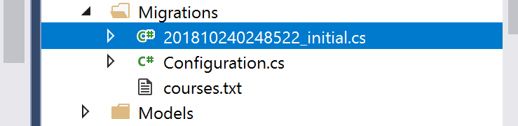

Delete dbo._MIgrationHistory and dbo.courses

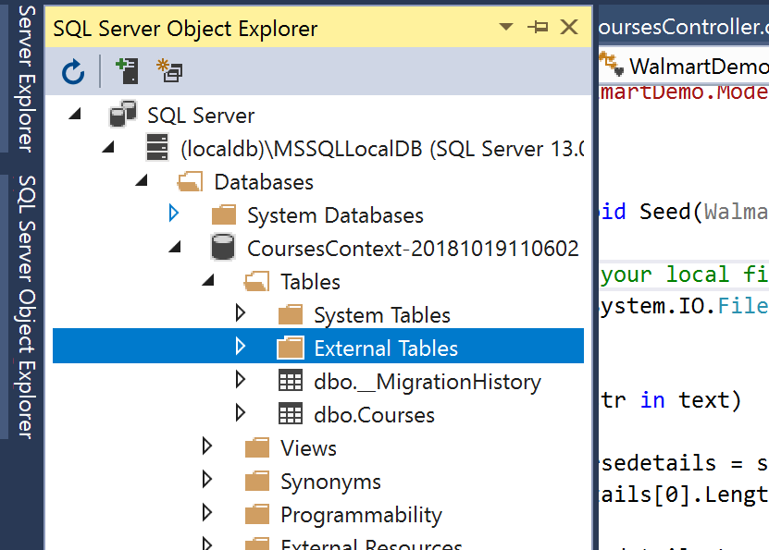

Open PMC and run commands here

