4)B) payroll system for with exception handling

import java.util.Scanner;
import java.util.Stack;
import java.util.InputMismatchException;
class Employee {
private int id;
private String name;
private double salary;

public Employee(int id, String name, double salary) {
this.id = id;
this.name = name;
this.salary = salary;
}
public int getId() {
return id;
}
public String getName() {
return name;
}
public double getSalary() {
return salary;
}
@Override
public String toString() {
return "ID: " + id + ", Name: " + name + ", Salary: " + salary;
}
}
class PayrollSystem {
private Stack<String> history = new Stack<>();
private Employee[] employees = new Employee[10];
private int count = 0;
public void addEmployee(int id, String name, double salary) {
if (id <= 0 || name.trim().isEmpty() || salary < 0) {
System.out.println("Invalid data. Employee not added.");
return;
}
if (count < employees.length) {
employees[count++] = new Employee(id, name, salary);
history.push("Added: " + name);
System.out.println("Employee " + name + " added.");
} else {
System.out.println("System is full.");
}
}
public void displayEmployees() {
if (count == 0) {
System.out.println("No employees to display.");
return;
}
System.out.println("Current Employees:");
for (int i = 0; i < count; i++) {
System.out.println(employees[i]);
}
history.push("Displayed employees.");
}
public void calculatePayroll() {
if (count == 0) {
System.out.println("No employees to process.");
return;
}
System.out.println("Calculating Payroll:");
for (int i = 0; i < count; i++) {
double netSalary = employees[i].getSalary() * 0.9;
System.out.println(employees[i].getName() + ": " + netSalary);
}
history.push("Calculated payroll.");
}
public void undoLast() {
if (history.isEmpty()) {
System.out.println("No operations to undo.");
return;
}
System.out.println("Undoing: " + history.pop());
}
public void showHistory() {
if (history.isEmpty()) {
System.out.println("History is empty.");
return;
}
System.out.println("Operation History:");
for (String op : history) {
System.out.println("- " + op);
}
}
}

public class ex4b {
public static void main(String[] args) {
Scanner s = new Scanner(System.in);
PayrollSystem p = new PayrollSystem();
while (true) {
System.out.println("\nPayroll System Menu:");
System.out.println("1. Add Employee");
System.out.println("2. Display Employees");
System.out.println("3. Calculate Payroll");
System.out.println("4. Undo Last Operation");
System.out.println("5. Show History");
System.out.println("6. Exit");
System.out.print("Enter your choice: ");
try {
int choice = s.nextInt();
s.nextLine();
switch (choice) {
case 1:
System.out.print("Enter employee ID: ");
int id = s.nextInt();
s.nextLine();
System.out.print("Enter employee name: ");
String name = s.nextLine();
System.out.print("Enter employee salary: ");
double salary = s.nextDouble();
s.nextLine();
p.addEmployee(id, name, salary);
break;
case 2:
p.displayEmployees();
break;
case 3:
p.calculatePayroll();
break;
case 4:
p.undoLast();
break;
case 5:
p.showHistory();
break;
case 6:
System.out.println("Exiting. Goodbye!");
s.close();
return;
default:
System.out.println("Invalid choice. Please try again.");
}
} catch (InputMismatchException e) {
System.out.println("Invalid input. Please enter a number for your choice.");
s.nextLine();
}
}
}
}

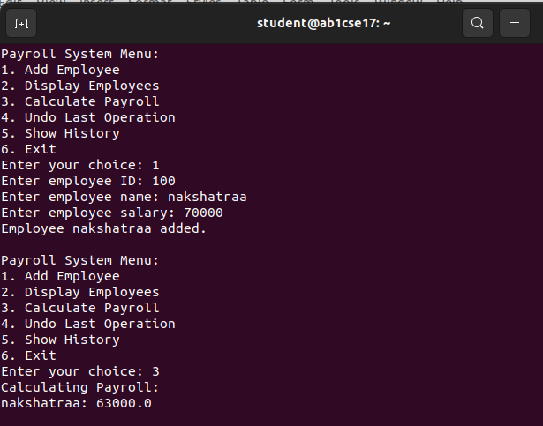
output:

