Name Naqi ahmad

ID G00332403

Email G00332403@gmit.ie

For this part of the lab you will write a program in C to solve the following problem:

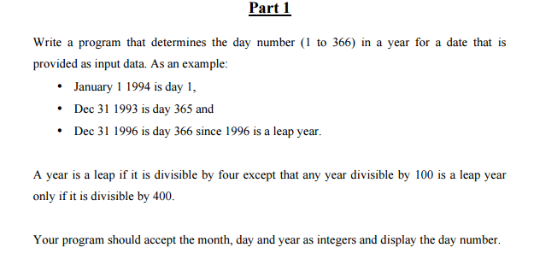

**Design**

**Inputs**

month, day, year – int

dayNumber, count – int

**Outputs**

allNum - int

**Algorithm**

1. Ask the user for the inputs and read the individual inputs.
2. Calculate if it’s a leap year.
3. Add up the months
4. Add up the day the month and if the leap year (allNum =count + dayNumber + day)
5. Output the results to the user.

**Code**

/*Name NAQI AHMAD

Calculate what day it is from the year*/

#include<stdio.h>

#include<conio.h>

void main()

{

//Declare Variables get the input from user

int month, day, year;

int dayNumber, allNum;

int count;

// get the input from user

printf("Enter the Day): ");

scanf("%d", &day);

printf("Enter the Month(number): ");

scanf("%d", &month);

printf("Enter the Year: ");

scanf("%d", &year);

// getting the leap year

if (year % 4 ==0 && !(year % 100 ==0))

{

dayNumber = 1;

}

else if(year % 4 == 0 && (year % 100 == 0) && year % 400)

{

dayNumber = 1;

}

else {

dayNumber = 0;

}

//add up the months

if (month == 1)

{

count = 0;

}

else if (month == 2)

{

count = 31;

}

else if (month == 3)

{

count = 59;

}

else if (month == 4)

{

count = 90;

}

else if (month == 5)

{

count = 120;

}

else if (month == 6)

{

count = 151;

}

else if (month == 7)

{

count = 181;

}

else if (month == 8)

{

count = 212;

}

else if (month == 9)

{

count = 243;

}

else if (month == 10)

{

count = 273;

}

else if (month == 11)

{

count = 304;

}

else if (month == 12)

{

count = 334;

}

//add up the month leap year and day number

allNum = (count + dayNumber + day);

//Output the results

printf("%d/%d/%d ", day, month, year);

printf("The Day number is: %d ", allNum);

getch();

}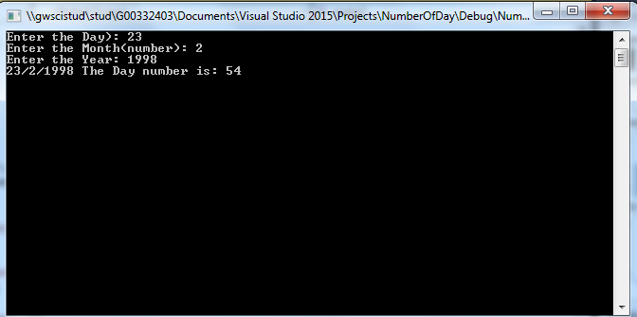

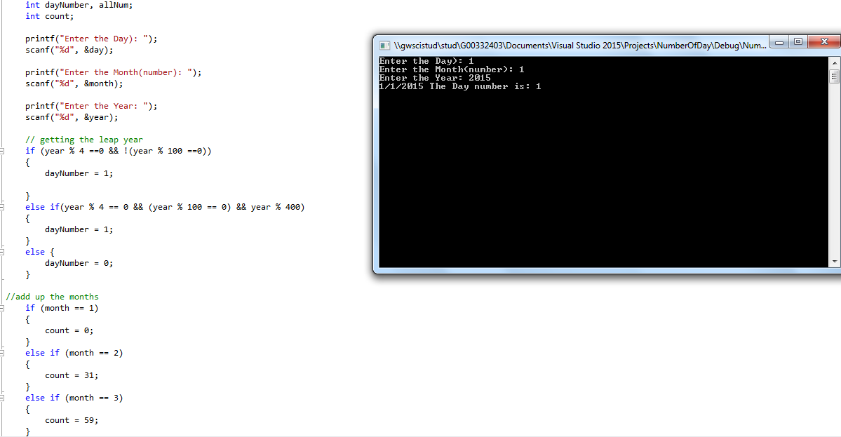

**Lab 3 Part 2**

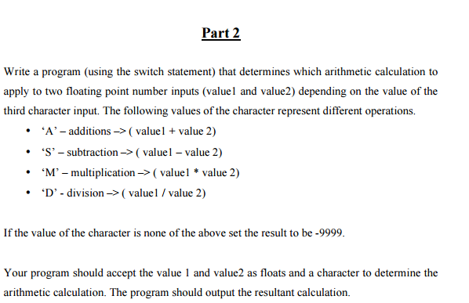

**Design**

**Inputs**

float value1, value2;

char ch;

**Outputs**

float sum;

**Algorithm**

1. Ask the user for the inputs and read the individual inputs.
2. Ask for what they would like to do i.e s/m/d/a.
3. According to the assignment they picked calculate the value.
4. Output the results to the user.

**Code**

/*Name NAQI AHMAD

Use switches to calculate the values

*/

#include<stdio.h>

#include<conio.h>

void main()

{

//Declare Variables

float value1, value2;

char ch;

float sum;

// get the input from user

printf("Enter Value 1): ");

scanf("%f", &value1);

printf("Enter Value 2): ");

scanf("%f", &value2);

printf("Enter The operoter you would like to use(A/S/M/D): ");

scanf(" %c", &ch);

// use switch to calculate the values

switch (ch) {

case 'A':

case 'a':

sum = value1 + value2;

// output the info

printf("The value is) %f: ", sum);

break;

case 'S':

case 's':

sum = value1 - value2;

printf("The value is) %f: ", sum);

break;

case 'M':

case 'm':

sum = value1 * value2;

printf("The value is) %f: ", sum);

break;

case 'D':

case 'd':

sum = value1 / value2;

printf("The value is) %f: ", sum);

break;

default:

// default

printf("-9999\n");

}

getch();

}

