Name Naqi Ahmad

ID G00332403

Email G00332403@gmit.ie

For this part of the lab you will write a program in C to solve the following problem:

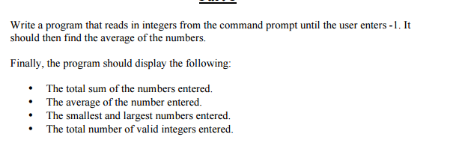

**Design**

**Inputs**

int number;

**Outputs**

int smallest, largest, sum, count;

float average;

**Algorithm**

1. Ask the user for the inputs and read the individual inputs.
2. Calculate the sum of the numbers.
3. Calculate the highest and lowest number.
4. Calculate the average.
5. Output the results to the user.

**Code**

/*Name NAQI AHMAD

Calculate the average of the sum and highest Number and Lowest Number and display

*/

#include<stdio.h>

#include<conio.h>

void main()

{

//Declare Variables

int number;

int smallest =0, largest=0, sum =0, count =0;

float average =0;

//prompt user

printf("Enter a Number: ");

scanf("%d", &number);

largest = number;

smallest = number;

while(number != -1)

{

// count for average

count++;

//add the numbers

sum += number;

//find highest And lowest number

if (number > largest)

{

largest = number;

}

if (number < smallest)

{

smallest = number;

}

printf("Enter a Number: ");

scanf("%d", &number);

}

//calculate the average

average = (float)sum / (float)count;

//display results

if (count != 0 ) {

printf("Total Sum of the Numbers Entered is: %d\n", sum);

printf("Average of the number entered is: %.1f\n", average);

printf("The smallest number entered is: %d\n", smallest);

printf("The largest number entered is: %d\n", largest);

printf("Valid Numbers: %d\n", count);

}

else {

printf("Not valid Data:%d \n ", number);

}

getch();

}

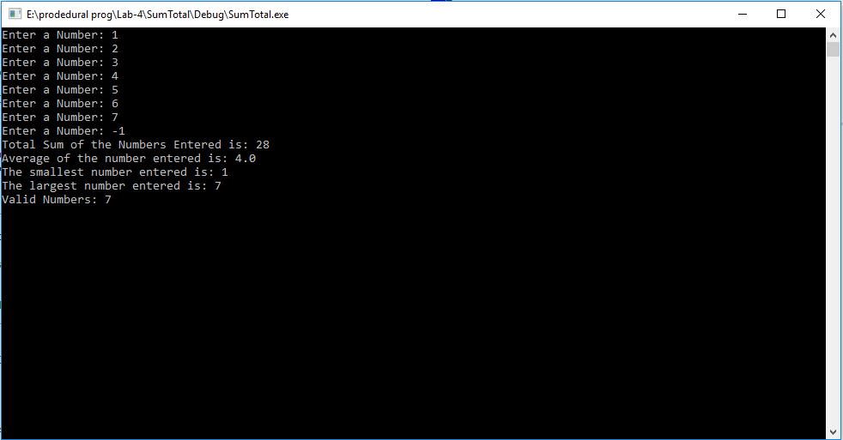

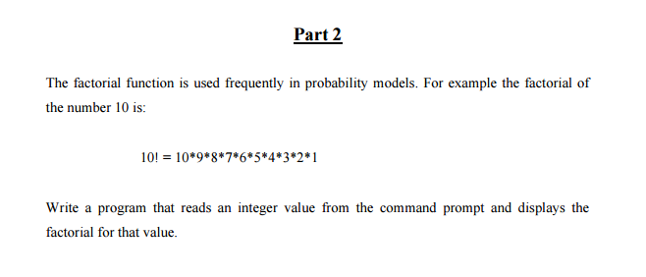

**Design**

**Inputs**

int i;

int n;

**Outputs**

int factorial;

**Algorithm**

1. Ask the user for the inputs and read the individual inputs.
2. Calculate the factorial of the number.
3. Output the results to the user.

**Code**

/*Name NAQI AHMAD

Calculate the factorial from input given

*/

#include<stdio.h>

#include<conio.h>

void main()

{

//Declare Variables

int factorial =1 ,i,n;

//prompt user for info

printf("Enter a Number: ");

scanf("%d", &n);

//for loop for factorial

for (i = 1; i <= n;++i)

{

factorial = factorial*i;

}

//output

printf("Number is %d\n", factorial);

getch();

}

