Name: Naqi Ahmad

ID: G00332403

Email: [G00332403@gmit.ie](mailto:G00332403@gmit.ie)

For this part of the lab i will write a program in C to solve the following problem:

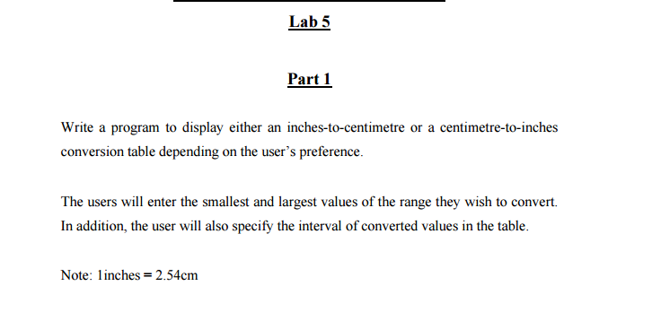

**Design**

**Inputs and variables**

char c;

float small, large, interval;

float inchesToCm = 2.54;

float cmToInches = 0.39370;

**Outputs**

float firstNum , currentNum;

**Algorithm**

1. Ask the user inches-to-centimetre(I) or centimetre-to-inches(C)
2. Ask the user for the inputs and read the individual inputs.
   1. Enter the smallest value / largest /interval
   2. Use if statement or switch
3. Calculate the inches to cm/cm to inches in the while loop inside the switch or if
4. Output the results to the user.
   1. Also output Choice is not I or C

**Code**

#ifdef _MSC_VER

#define _CRT_SECURE_NO_WARNINGS

#endif

/*Name NAQI AHMAD

Calculate cm to inches and inches to cms and use the interval and output display

*/

#include <stdio.h>

#include <conio.h>

void main()

{

//variables

float small, large, interval;

char c;

float inchesToCm = 2.54;

float cmToInches = 0.39370;

float firstNum = 0, currentNum = 0;

//prompt user

printf("inches-to-centimetre(I) or centimetre-to-inches(C): ");

scanf(" %c", &c);

printf("\n");

switch (c) {

case 'I':

case 'i':

//ask for the small number

printf("Enter the smallest value: ");

scanf("%f", &small);

//ask for the largest number

printf("Enter the largest value: ");

scanf("%f", &large);

//ask for a interval

printf("Enter the the Interval value: ");

scanf("%f", &interval);

printf("\n");

//prints out the choice

printf("Your choice is inches-to-centimetre: \n");

printf("\n");

firstNum = small;

while (firstNum <= large) {

currentNum = firstNum;

//printf("Before conversion: %0.2f \n", firstNum);

//calculations

currentNum *= inchesToCm;

printf("After conversion %0.0f inches are: %0.2f cms\n", firstNum, currentNum);

firstNum = firstNum + interval;

}

break;

case 'c':

case 'C':

//ask for the small number

printf("Enter the smallest value: ");

scanf("%f", &small);

//ask for the largest number

printf("Enter the the largest value: ");

scanf("%f", &large);

//ask for a interval

printf("Enter the the Interval value: ");

scanf("%f", &interval);

printf("Choice is Centimetres to Inches \n");

printf("\n");

firstNum = small;

while (firstNum <= large) {

currentNum = firstNum;

//calculations

currentNum *= cmToInches;

printf("After conversion %0.0f CMs are: %0.2f Inches\n", firstNum, currentNum);

firstNum = firstNum + interval;

}

break;

default:

//

printf("Choice is not I or C");

break;

}

getch();

}

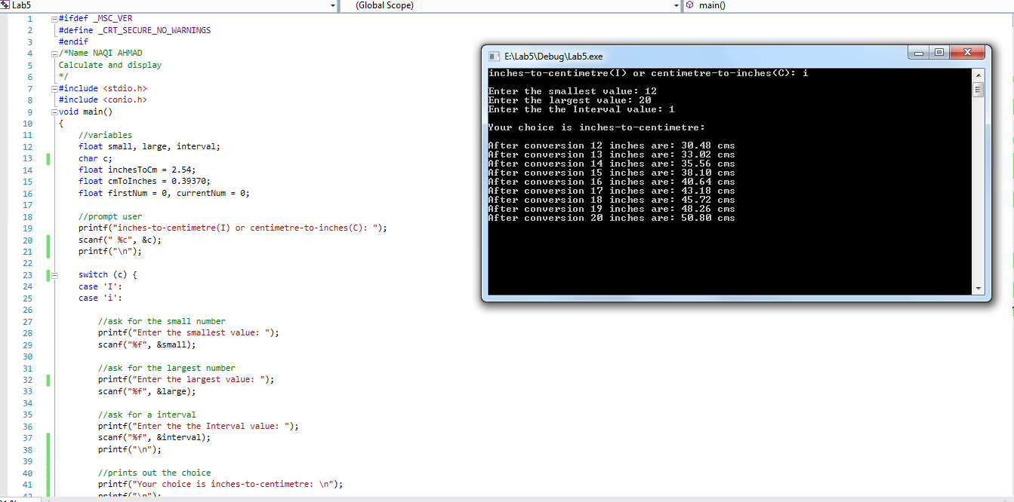

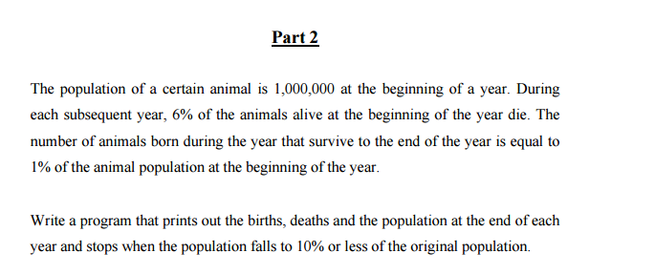

**Design**

**Inputs**

int population = 1000000;

const float death = 0.06;

const float alive = 0.01;

int end;

**Outputs**

int totalDeath, totalAlive, endPopulation;

int count =0;

**Algorithm**

1. Calculate the end of the while loop
2. Use the While to calculate
   1. totalDeath/ totalAlive/ endPopulation
3. Output the results to the user.

**Code**

#ifdef _MSC_VER

#define _CRT_SECURE_NO_WARNINGS

#endif

/*Name NAQI AHMAD

Calculate birth, death, population at the end of each year and output display

*/

#include <stdio.h>

#include <conio.h>

void main()

{

//variables

int population = 1000000;

const float death = 0.06;

const float alive = 0.01;

int totalDeath, totalAlive, endPopulation;

int count =0,end;

//calculate the end of the loop

end = 1000000 *0.1;

while(population > end)

{

//this for years

count++;

//calculations

totalDeath = (float)population * (float)0.06;

totalAlive = (float)population *(float)alive;

endPopulation = (float)population - ((float)totalDeath - (float)totalAlive);

//output the values

printf("Year %2d Total Death is: %5d Total Alive is: %5d Total Population is: %d\n", count, totalDeath, totalAlive, endPopulation);

//assingning new assignment to population

population = endPopulation;

}

getch();

}

