Name Naqi Ahmad

ID G00332403

Email g00332403@gmit.ie

For this part of the lab you will write a program in C to solve the following problem:

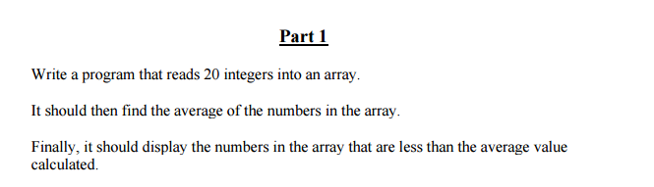

**Design**

**Inputs**

int array[20];

float sum;

int count;

int i;

**Outputs**

float average;

**Algorithm**

1. Ask the user for the inputs and read the individual inputs inside a for loop.
2. Add the sum in the for loop.
3. Calculate the average.
   1. average = sum/20.
4. Use a for loop and display all the values that are lower than the average.

**Code**

/*Name NAQI AHMAD

Run the loop for 20 times and fill the array with the values the user enters

*/

#include<stdio.h>

#include<conio.h>

void main()

{

//Declare Variables

int array[20];

float sum = 0;

float average;

int count = 0;

int i;

//for loop to display and ask the user for 20 array entries

for (int x = 0; x < 20;x++)

{

count++;

printf("Please Enter A number %d: \n", count);

scanf("%d", &array[x]);

sum = sum + array[x];

}

//calculate the average

average = sum / 20;

printf("\n");

//print the average

printf("Average is: %0.2f \n", average);

printf("\n");

//lower then the average

printf("All values lower then the average\n");

printf("\n");

// Print all the lower then the average values

for (i = 0; i < 20;i++)

{

if (array[i] < average) {

printf("Lowest is: %d \n", array[i]);

}

}

getch();

}

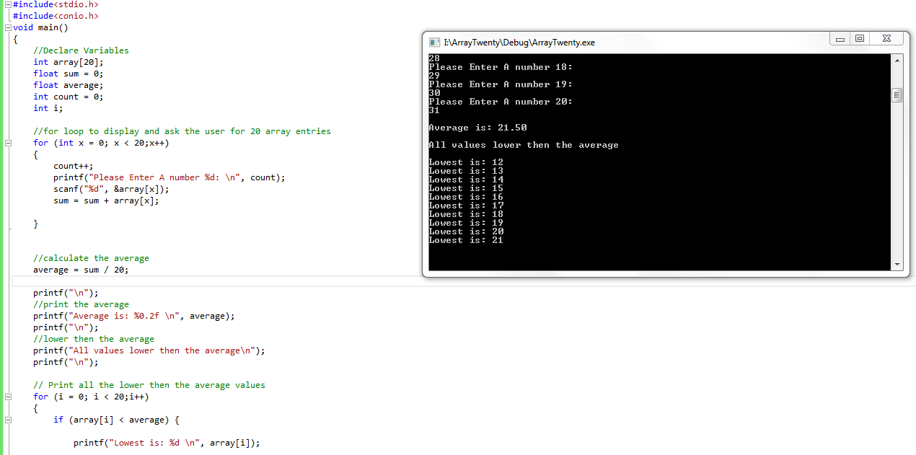

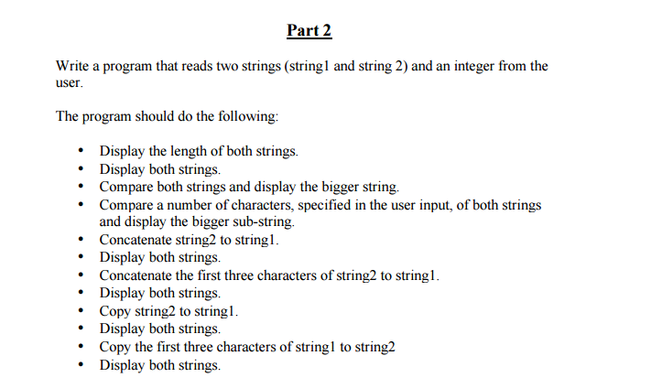

**Design**

**Inputs**

TotalWidth – float

TileWidth – float

**Outputs**

NoofTiles - int

Space – float

**Algorithm**

1. Ask the user for input and do the following
2. Display the length of both strings.
3. Display both strings.
4. Compare both strings and display the bigger string.
5. Compare a number of characters, specified in the user input, of both strings and display the bigger sub-string.
6. Concatenate string2 to string1.
7. Display both strings.
8. Concatenate the first three characters of string2 to string1.
9. Display both strings.
10. Copy string2 to string1.
11. Display both strings.
12. Copy the first three characters of string1 to string2 • Display both strings.
13. Calculate the number of full tiles that fit into the total width.

**Code**

/*Name NAQI AHMAD

Calculate the average of the marks and display grades and overall all percentage

*/

#include<stdio.h>

#include<conio.h>

void main()

{

char string1[100];

char string2[100];

int i;

int length,length1;

printf("Enter The First String: ");

scanf(" %s", string1);

printf("Enter The Second String: ");

scanf(" %s", string2);

printf("Enter The Integer: ");

scanf("%d", &i);

printf("\n");

//calculate the length of the strings

length = strlen(string1);

length1 = strlen(string2);

printf("Length of string One is: %d Length of string Two is: %d \n",length, length1);

//display the strings

printf("String one Is: %s String Two Is: %s \n", string1, string2);

printf("\n");

//Compare both strings and display the bigger string.

if (strncmp(string1, string2) == 1)

{

printf("Entered strings are equal.\n");

}

else if (strncmp(string1, string2) == 0)

{

printf("Entered string one is bigger. %s \n",string1);

}

else {

printf("Entered string Two is bigger. %s \n", string2);

}

printf("\n");

//Compare a number of characters, specified in the user input, of both strings and display the bigger sub - string.

if (length > length1)

{

printf("Characters of string one is bigger. %s \n", string1);

}

else if(length1 > length)

{

printf("Characters of string Two is bigger. %s \n", string2);

}

else

{

printf("Characters of strings are equal \n");

}

printf("\n");

//Concatenate the first three characters of string2 to string1.

printf("string2 %s to string1: %s \n", string2, string1);

printf("Concatenate the first three characters of string2 to string1: %s \n", strcat(string2, string1));

printf("\n");

//Copy the first three characters of string1 to string2

//strncpy(string1, string2,3);

printf("string2 %s to string1: %s \n", string2, string1);

printf("Copy the first three characters of string1 to string2 : %s %s\n", strncpy(string2, &string1, 3));

printf("\n");

//Copy string2 to string1.

printf("string1 is %s to string2 is: %s \n", string1, string2);

printf("\nCopy String1 to String2: %s", strcpy(string1, string2,3));

printf("\n");

getch();

}

