Name Naqi Ahmad

ID G00332403

Email G00332403@gmit.ie

For this part of the lab you will write a program in C to solve the following problem:

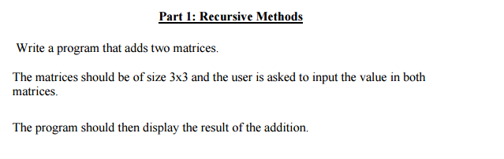

**Design**

**Algorithm**

1. Ask the user for the inputs and read the individual inputs.
2. Use the for loop.
3. Calculate.
4. Output the results to the user.

**Code**

#include<stdio.h>

#include<conio.h>

void main()

{

int array[3][3];

int arrayTwo[3][3];

int result[3][3];

int i =0;

int j=0;

int x;

int y;

//for loop

for (i = 0;i<3;i++)

{

for (j = 0;j < 3;j++)

{

printf("Please enter the value for Row: %d Column: %d\n", i, j);

scanf("%d", &array[i][j]);

}

}

printf("\n");

printf("The second Array\n\n");

for (x = 0;x <3;x++)

{

for (y = 0;y < 3;y++)

{

printf("Please enter the value for Row: %d Column: %d\n", x, y);

scanf("%d", &arrayTwo[x][y]);

}

}

for (i = 0;i < 3;i++)

{

for (j = 0;j < 3;j++)

{

//chart_result[i][j] = chart[i][j] + chart[i][j];

result[i][j] = array[i][j] + array[i][j];

}

}

printf("\nChart Result\n\n");

for (i = 0;i < 3;i++)

{

printf("Row %d: ", i);

for (j = 0;j < 3;j++)

{

///// Read the matrix......

printf("%d ", result[i][j]);

}

printf("\n");

}

getch();

}}

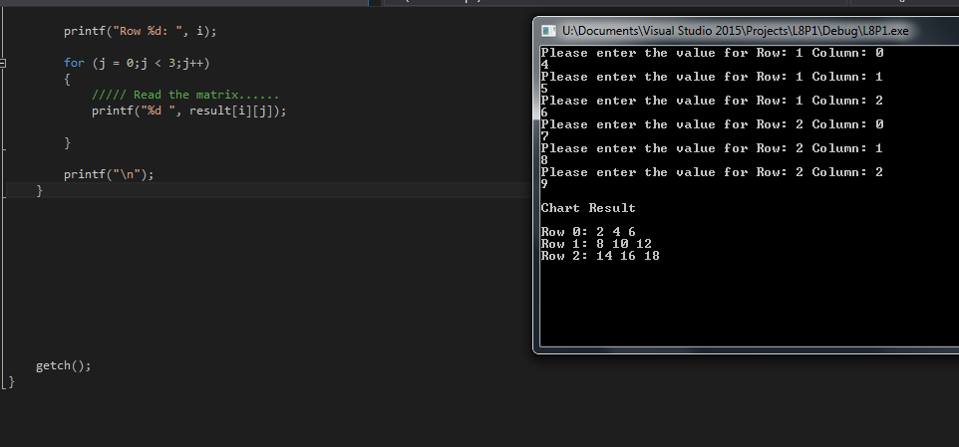

**Part 2**

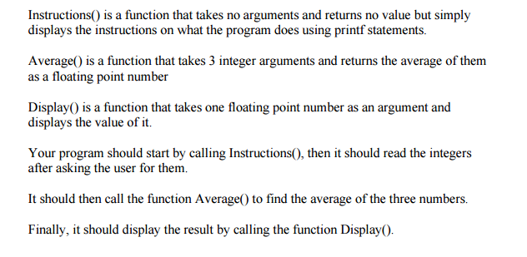

**Design**

**Algorithm**

1. Ask the user for the inputs and read the individual inputs.
2. Use the structures to do the calculation.
3. Calculate.
4. Output the results to the user.

#include<stdio.h>

#include<conio.h>

//naqi ahmad g00332403 lab 8 part 2

void Instructions();

float Average(int num1, int num2, int num3);

void Display(float av);

void main()

{

int num1, num2, num3;

float result;

Instructions();

scanf("%d %d %d", &num1, &num2, &num3);

result = Average(num1, num2, num3);

//call the structure Display which

Display(result);

getch();

}

void Instructions()

{

printf("Welcome to the program !!!!!!\n");

printf("Please enter 3 numbers seperated by a space and ending with a return\n");

}

float Average(int num1, int num2, int num3)

{

float av;

av = (float)(num1 + num2 + num3) / 3;

return av;

}

void Display(float average)

{

printf("Average Of 3 Numbers Is: %f\n", average);

}

