Name Naqi Ahmad

ID G00332403

Email G00332403@gmit.ie

For this part of the lab you will write a program in C to solve the following problem:

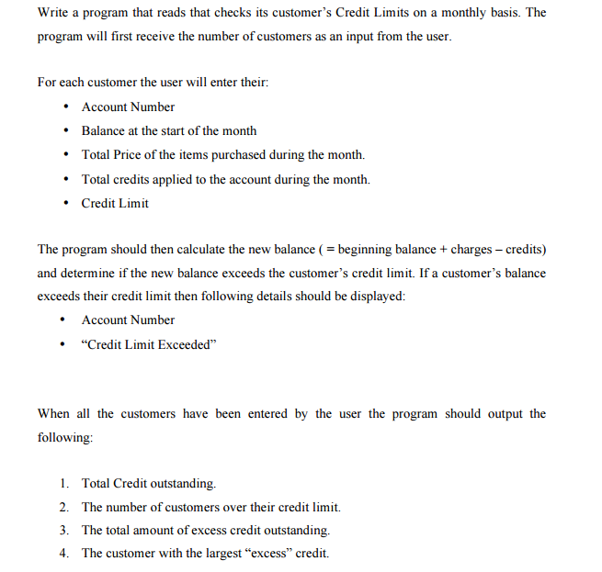

**Design**

**Variables**

int max,i;

int count = 0,countLimit=0;

int accountNumber = 0;

float balance, totalPrice, totalCredits, creditLimit;

float newBal=0;

float addBal=0;

float excessBal = 0;

float maxExcess=0, excessBal2=0;

int accountNumFind;

**Algorithm**

1. Ask the user for the inputs and read the individual inputs.
   1. asking the users for the number of customers
2. Use the constant for the for loop.
   1. Ask from the user he info of the customer.
3. Do the Calculations.
   1. Find the new balance/max excess and …
4. Output the results to the user.

**Code**

#ifdef _MSC_VER

#define _CRT_SECURE_NO_WARNINGS

#endif

// Naqi Ahmad - Lab7 G00332403

#include <conio.h>

#include <stdio.h>

void main()

{

//variables

int max,i;

int count = 0,countLimit=0;

int accountNumber = 0;

float balance, totalPrice, totalCredits, creditLimit;

float newBal=0;

float addBal=0;

float excessBal = 0;

float maxExcess=0, excessBal2=0;

int accountNumFind;

//asking the users for the number of customers i.e the number of time the loop //runs

printf("Enter the number of customers: ");

scanf("%d", &max);

printf("\n");

for (i = 0; i < max; i++)

{

count++;

printf("Enter the Account Number for customer %d: ",count);

scanf("%d", &accountNumber);

printf("Enter the previous balance for customer %d: ", count);

scanf("%f", &balance);

printf("Enter the total price for customer %d: ", count);

scanf("%f", &totalPrice);

printf("Enter total credits for customer %d: ", count);

scanf("%f", &totalCredits);

printf("Enter Credit Limit for customer %d: ", count);

scanf("%f", &creditLimit);

printf("\n");

//calculating the new balance

newBal = balance + totalPrice - totalCredits;

//calculating the total outstanding balance

addBal += newBal;

//calculating the excess credit

excessBal = newBal - creditLimit;

//calculating the total excess credit

excessBal2 += excessBal;

//this is to find if the newbal eceeds the credit limits

if (newBal > creditLimit)

{

//this just counts the time this if statement runs

countLimit++;

printf("The Account Number %d Exceeded his Credit Limit!! \n", accountNumber);

printf("\n");

}

//find the largest excess credit customer

if (excessBal >maxExcess)

{

//if excess balance is greater than the variable maxExcess then //maxExcess is going to have the value of excessBal

maxExcess = excessBal;

//this is just giving a new variable the value of the account //number of the customer with the highest excess balance

accountNumFind = accountNumber;

}

}

//Total Credit outstanding

printf("Total Credit outstanding: %0.2f\n", addBal);

printf("\n");

//The number of customers over their credit limit

printf("The number of customers over their credit limit: %d\n", countLimit);

printf("\n");

//The total amount of excess credit outstanding.

printf("The total amount of excess credit outstanding: %0.2f\n", excessBal2);

printf("\n");

//The customer with the largest “excess” credit

printf("The customer %d has the largest excess credit: %0.2f\n", accountNumFind, maxExcess);

getch();

}

