Name Naqi Ahmad

ID G00332404

Email G00332404@gmit.ie

For this part of the lab you will write a program in C to solve the following problem:

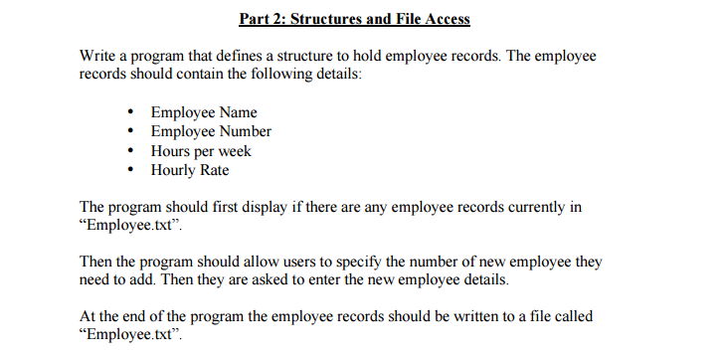

**Design**

**Algorithm**

1. Write to the file first and then read it.
2. Use for loop to get the user input of asked users.
3. Write to the text file.
4. Output the results to the user.
5. Read the file.

**Code**

#include<stdio.h>

#include<stdlib.h>

#include<conio.h>

//g00332403 Naqi Ahmad Lab 9 part 2 input and output files

typedef struct

{

//structure variables

char E_Name[20];

int E_Number;

int Hours_Week;

float H_Rate;

}employee_t;

void main()

{

FILE* Fileem;

//variable of structure

employee_t empl;

int result;

int em = 0;

int max;

int i=0;

//opening file to read

Fileem = fopen("employee.txt", "r");

if (Fileem == NULL)

{

//displays this message when the file is empty

printf("The file cannot be opened to read\n");

em = 1;

}

else {

while (!feof(Fileem))

{

//else it reads the file

result= fscanf(Fileem, "%s %d %d %f", empl.E_Name, &empl.E_Number, &empl.Hours_Week, &empl.H_Rate);

if (result>0)

//displays the file

printf("%s %d %d %0.2f\n\n", empl.E_Name, empl.E_Number, empl.Hours_Week, empl.H_Rate);

}

}

//close the file

fclose(Fileem);

//opens the file agian to append

Fileem = fopen("employee.txt", "a");

//ask the user for the number of employees

printf("Enter the Number Of emplyees: ");

scanf("%d", &max);

printf("\n");

// use the for loop to ask the user for the info of the employees and asked previously

for (i=0;i<max; i++)

{

//ask for info

printf("Please enter the Employee Name/Number/Hours/Hour Rate: ");

scanf("%s %d %d %f", empl.E_Name, &empl.E_Number, &empl.Hours_Week, &empl.H_Rate);

if (Fileem != NULL)

{

//printf("%s %d %d %f\n", empl.E_Name, empl.E_Number, empl.Hours_Week, empl.H_Rate);

//print it to the the file employee.txt

fprintf(Fileem, "%s %d %d %f\n", empl.E_Name,empl.E_Number,empl.Hours_Week,empl.H_Rate);

}

}

//close the file

if (Fileem != NULL)

fclose(Fileem);

getch();

}

