Subjective Analysis of News Articles
Semester Project Paper – Text Mining / NLP
Author: (fill in name) | Date: May 14, 2026
The goal of this paper is to design and implement a pipeline for acquiring Czech news articles, preprocessing them, and computing a metric of subjectivity/bias. The results are demonstrated on data from Seznam Zprávy, Deník N, and Parlamentní listy.

Motivation
News reporting often combines facts with commentary, evaluative wording, and emotionally loaded language. For analytical and educational purposes, it is useful to quantify the degree of subjectivity in a text and compare it across different sources.

Introduction
The project works with Czech articles: it automatically downloads them from the selected websites, cleans the text, and performs linguistic annotation (POS tagging, lemmatization). On top of this processed data, we compute topics (TF‑IDF), sentiment, and most importantly a custom subjectivity index based on the ratio of evaluative words.

Methodology

Data Collection (Web Scraping)
Articles are downloaded using the newspaper3k and BeautifulSoup libraries. In the sample run, 111 links were found on the initial source and 102 candidate articles remained after filtering.

Text Preprocessing
The text is tokenized, lowercased, punctuation is removed, and Czech stop words are filtered out. The output is the `cleaned_text` column, which serves as input to subsequent steps.

POS Tagging (Stanza)
To assign part-of-speech tags, we use a Czech Stanza model. The output is a list of (token, POS) pairs, which can be used for example to compute the ratio of adjectives and adverbs.

Lemmatization (UDPipe)
Lemmatization normalizes inflected word forms into their base form. The project uses `ufal.udpipe`. From lemmatized tokens, we can also build bigrams and refine TF‑IDF topics.

TF‑IDF and Topics
Using `TfidfVectorizer`, we identify keywords and n-grams for each article. This step helps with quick orientation in the article content and verifies that preprocessing works correctly.

Sentiment and Bias
Sentiment is estimated using a transformer model (HuggingFace). Beyond sentiment, we compute a custom subjectivity index and then a final bias score (0–10) that combines subjectivity with adjective polarization using Word2Vec and anchor words.

Implementation
The entire implementation is contained in a single Jupyter notebook. Data is stored in a pandas DataFrame where new columns are progressively added (`cleaned_text`, `pos_tags`, `lemmatized_text`, `subjectivity_index`, `refined_bias_corpus_score`).

Code Samples
1) Downloading and storing articles (simplified):
import newspaper
from bs4 import BeautifulSoup
# download and parse article text
article = newspaper.Article(url)
article.download(); article.parse()
text = article.text
2) Computing the bias score (simplified):
bias_score = (
subjectivity_index * adj_polarization_corpus * 10
).clip(0, 10)

Results

Number of Articles by Source
For the media comparison, the following numbers of articles were processed:
Source | Number of articles
DenikN | 8
ParlamentniListy | 20
SeznamZpravy | 13

Bias Score (0–10)
The aggregated bias score (a combination of subjectivity and adjective polarization) yields the following averages:
Source | Mean | Std. deviation | Count
DenikN | 1.9563 | 0.3445 | 6
ParlamentniListy | 1.7575 | 0.3941 | 20
SeznamZpravy | 1.7746 | 0.4427 | 16

Visualizations
Below are examples of charts generated during the analysis (exported from the notebook).
Figure: Subjectivity / bias comparison chart (049-01-import-matplotlib-pyplot-as-plt.png)
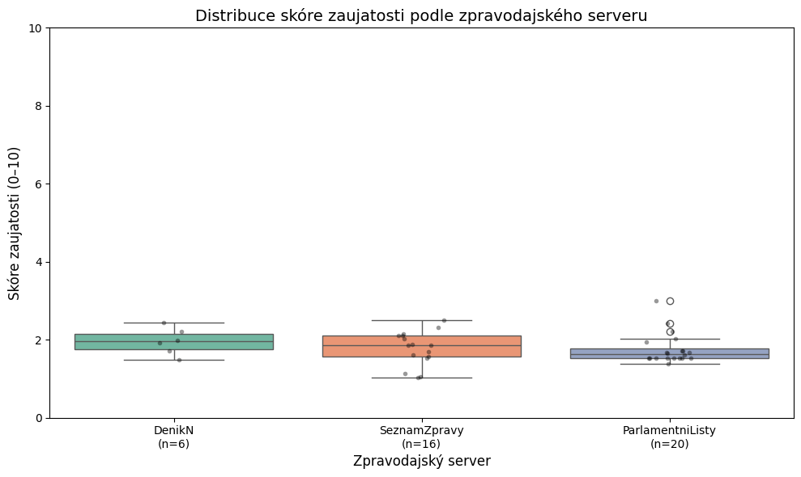
Figure: Dashboard scatter plot (cell 50) (plotly_cell_050.png)
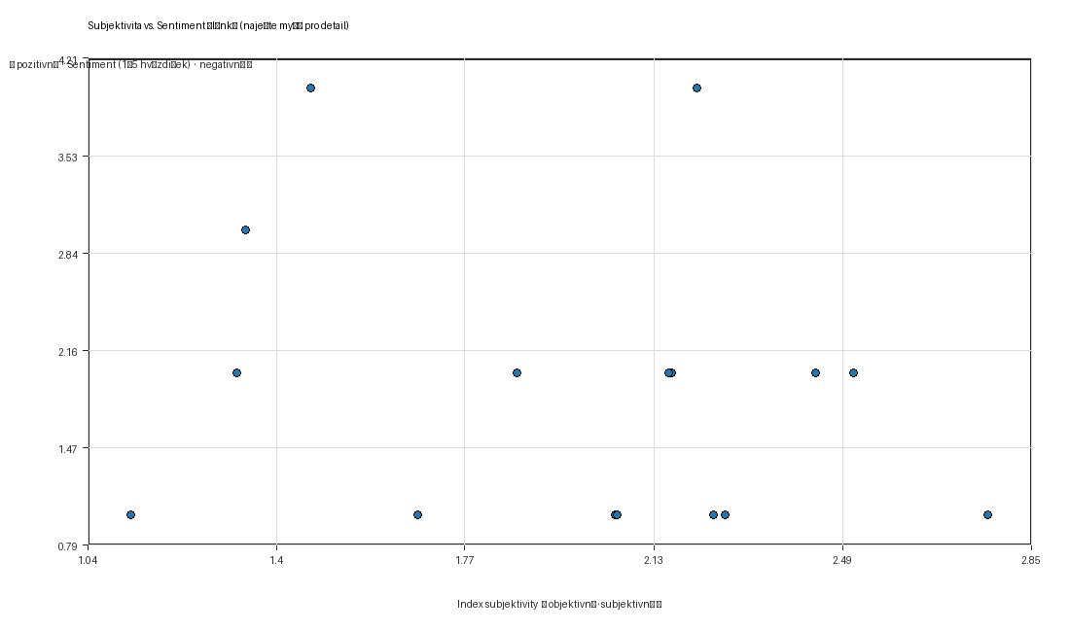
Figure: Dashboard scatter plot (cell 52) (plotly_cell_052.png)
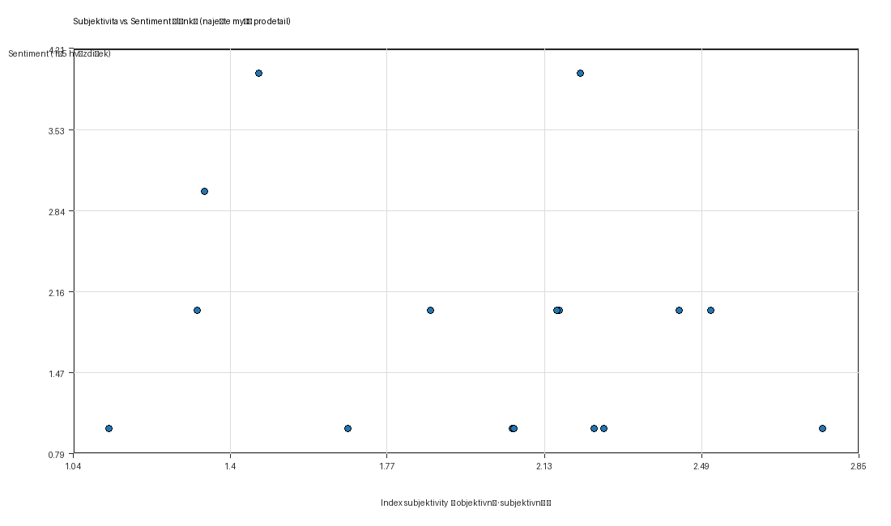

Conclusion
The notebook demonstrates a complete end-to-end pipeline from data collection to visualization and comparison of bias scores. The proposed score is an interpretable metric that can be further improved by extending the anchor-word lexicons, better detecting quotes and direct speech, or adding a manually annotated validation sample.

Reproducibility
To reproduce the experiment, run the notebook from top to bottom. In a local environment, you need to set the `HF_TOKEN` environment variable for the sentiment section (outside Google Colab).

