Subjective Analysis of News Articles
Semester Project Paper – Text Mining / NLP
Authors: Jiří Kalas, Juraj Kriššák • Date: May 14, 2026

The goal of this paper is to design and implement a pipeline for acquiring Czech news articles, preprocessing them, and computing a metric of subjectivity/bias. The results are demonstrated on data from Seznam Zprávy, Deník N, and Parlamentní listy.
The core objective of this project was to leverage the theoretical knowledge and practical skills acquired during the Text Mining course exercises and lectures to successfully implement a robust and functional subjectivity extractor. This extractor is designed to analyze news articles sourced from various news companies, providing a quantifiable measure of their subjective content. To achieve this primary goal, we defined several key sub-tasks, beginning with an extensive research phase to explore various state-of-the-art text mining and NLP approaches applicable to subjectivity analysis. A crucial aspect of our methodology involves the visual comparison of these different approaches, allowing us to assess their effectiveness and suitability for the Czech language context. The detailed procedural steps and methods utilized in the elaboration of this paper are systematically outlined and described in the subsequent sections.

Motivation
News reporting often combines facts with commentary, evaluative wording, and emotionally loaded language. For analytical and educational purposes, it is useful to quantify the degree of subjectivity in a text and compare it across different sources.

Introduction
The project works with Czech articles: it automatically downloads them from the selected websites, cleans the text, and performs linguistic annotation (POS tagging, lemmatization). On top of this processed data, we compute topics (TF‑IDF), sentiment, and most importantly a custom subjectivity index based on the ratio of evaluative words.

Methodology

Data Collection (Web Scraping)

Source selection and scraping pipeline
This stage formed the data foundation of the entire analysis. For article collection, we
combined newspaper3k and BeautifulSoup, because automatic metadata extraction is not
sufficiently reliable for Czech news websites. In the sample run, 111 links were detected on
the source page. After filtering by the URL pattern, 102 candidate articles remained.

newspaper3k served as the primary tool for downloading the HTML page and performing the
initial parsing of the article content. In practice, however, the title, author, and
publication date were not always identified correctly, mainly because different news websites
use different page structures and because the parser itself has limitations. To improve
extraction, we added a custom post-processing layer based on BeautifulSoup, which allowed us
to manually search for relevant HTML tags, Open Graph meta tags, schema.org / JSON-LD
structures, and other available metadata.

Multi-outlet extension
After validating the pipeline on a single source, we extended the collection step to four Czech news outlets in order to enable a cross-source comparison. A small registry of outlet definitions (base URL, link filter, parser hints) drives a generic scraping function that reuses the original SeznamZprávy logic and adds iDnes.cz, Deník N, and Parlamentní listy. The same cleaning and metadata fallbacks are applied uniformly, so all four sub-corpora are directly comparable downstream.
The resulting combined corpus contains roughly two hundred articles unevenly distributed across outlets, with the two larger mainstream sites contributing the majority of the texts and the smaller, more opinion-driven sites contributing fewer but still analytically usable samples.

Coverage and quality trade-off
This approach improved the extraction of the main article attributes, especially the title,
author, publication date, and body text. At the same time, it is important to note that not
all articles are fully accessible. Some sources contain paywalled or VIP-only content, or
only partially loaded text. In such cases, the scraper can only retrieve the publicly
available portion of the article or the corresponding metadata. As a result, the final
dataset always reflects a trade-off between coverage and extraction quality.

Text Preprocessing
After the articles were collected, the text was preprocessed to reduce noise and prepare it
for the subsequent NLP steps. This stage was implemented manually through a small set of
custom Python functions rather than relying on a single external preprocessing package. The
main goal was to standardize the text and remove elements that are usually not helpful for
subjectivity analysis or keyword extraction.

The preprocessing pipeline begins by converting all characters to lowercase. This ensures
that different inflected or capitalized variants of the same word are treated consistently.
Next, punctuation is removed using Python string translation, and numeric expressions are
removed with a regular expression. The removal of numbers is a somewhat debatable choice,
because in domains such as economics or politics numerical references may carry useful
contextual information. However, for the purposes of this project, numbers were treated
primarily as noise in the early text-cleaning stage.

After that, the text is split into tokens and Czech stop words are filtered out using a
manually defined stop-word list. This list contains very frequent function words such as
conjunctions, prepositions, pronouns, and auxiliary verbs that usually do not contribute much
semantic value. Finally, repeated whitespace is normalized so that the resulting text remains
clean and suitable for further processing.

The cleaned output is stored in the cleaned_text column. This column then serves as the input
for the later stages of the pipeline, including POS tagging with Stanza, lemmatization,
TF-IDF analysis, and the subjectivity-related calculations. In this way, preprocessing acts
as the bridge between raw scraped articles and the more structured linguistic analysis that
follows.

POS Tagging (Stanza)
To assign part-of-speech tags, we used a Czech-language model from Stanza, a natural language processing library developed at Stanford University. This step was chosen after it became clear that generic POS taggers did not perform reliably on Czech text. Compared with English, Czech morphology is substantially more complex, and the use of a language-specific model was therefore necessary for obtaining meaningful linguistic annotations.

Stanza processes the cleaned text by first tokenizing it and then applying its internal NLP
pipeline, which includes lemmatization and POS tagging. The result is a structured output in
the form of (token, POS) pairs, with each word assigned a grammatical category such as noun,
verb, adjective, or adverb. In our pipeline, this information is essential because later
calculations rely on the relative frequency of descriptive parts of speech, especially
adjectives and adverbs, as a proxy for subjectivity.

Although Stanza also provides lemmas as part of its output, lemmatization is still treated as
a separate analytical step later in the pipeline to keep the workflow explicit and easier to
interpret. The POS tagging stage therefore serves as a bridge between basic text cleaning and
more advanced linguistic analysis, allowing the project to move from raw text toward
structured features suitable for quantitative comparison

Named Entity Recognition
In addition to grammatical tagging, we also wanted to capture what each article is actually about. For this we added a Named Entity Recognition step based on the Czech model richielo/small-e-czech-finetuned-ner-wikiann, accessed through the Hugging Face transformers library. The model is fine-tuned on the WikiANN dataset and uses the small-e-czech ELECTRA backbone, which is well suited for our setting because the same provider also operates one of our source outlets.
The recogniser distinguishes three entity classes: persons (PER), organisations (ORG), and locations (LOC). Because the underlying ELECTRA model has a maximum input length of 512 sub-word tokens, we feed it only the first part of each article; this is sufficient for capturing the most prominent named entities, which in news writing tend to appear early in the text.
NER is not used directly in the subjectivity score. It serves instead as a qualitative descriptor of the corpus and as a sanity check on the scraper: if the most frequent entities in a given outlet look meaningful (familiar politicians, parties, institutions, places), we can be reasonably confident that the extraction layer is doing its job correctly.

Lemmatization (UDPipe)
Lemmatization was used to normalize inflected word forms into their base forms, which is
especially important in Czech because a single word can appear in many different grammatical
variants. For this stage, the project uses ufal.udpipe, which provides reliable morphological
analysis and lemmatization for Czech text.

After the earlier cleaning and POS tagging steps, the text was processed token by token and
converted into a lemmatized representation. This makes the corpus more consistent, reduces
vocabulary sparsity, and improves the quality of downstream analysis. Words such as different
inflected forms of the same noun or verb are mapped to a single lemma, allowing the model to
treat them as the same linguistic unit.

The lemmatized output is stored in the lemmatized_text column. This column is then reused in
later stages of the pipeline, especially for TF-IDF analysis with bigrams and for semantic
modeling. In particular, the use of lemmatized text helps produce more meaningful topic
keywords, because related word forms are grouped together instead of being counted
separately.

In addition to individual lemmas, the project also builds bigrams from the lemmatized corpus.
This is useful because many important meanings in news text are expressed not only through
single words, but also through fixed or semi-fixed word combinations. As a result,
lemmatization does not serve only as a normalization step, but also as a basis for more
robust feature extraction in the later analytical stages.

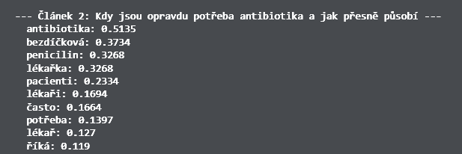
TF‑IDF and Topics

Initial unigram exploration
To gain an initial overview of the article corpus and to verify that preprocessing was
working as intended, we applied TfidfVectorizer to the cleaned text. Although this step is
not strictly required for the later subjectivity analysis, it is very useful as a first
qualitative check of the pipeline. By ranking terms according to TF-IDF scores, we can
quickly inspect whether the most salient words in each article correspond to the actual topic
of the text.

In this project, TF-IDF is used as an extractive method of topic identification. This means
that the output consists of the most important words or n-grams already present in the
article, rather than a generated summary or an abstract thematic label. In other words, the
method does not interpret the text in a generative way; instead, it highlights the most
informative lexical units that distinguish one article from the others. This is particularly
useful in the early stages of analysis, because it provides an immediate indication of
whether the corpus has been processed correctly and whether the resulting representation is
meaningful.

The initial TF-IDF analysis is performed on the cleaned_text column and uses single-word
tokens without lemmatization. The screenshot illustrates this stage clearly: for the article
about antibiotics, the most prominent terms include words such as antibiotika, penicilin,
pacienti, and lékařka, which confirms that the model is capturing the central topic correctly
even before lemmatization is applied. This also makes it easier to see how the raw cleaned
text behaves before later normalization steps refine the representation.

Later in the pipeline, after lemmatization, the same approach is extended with n-grams,
especially bigrams, to capture short multiword expressions that often carry stronger semantic
meaning than isolated tokens alone. This refinement makes the topic representation more
informative, especially in journalistic texts where important concepts are frequently
expressed through fixed phrases.

Lemmatised n-grams
After the initial TF-IDF analysis, we further experimented with different n-gram settings in
order to improve the precision and informational value of the extracted topics. In
particular, we compared the most frequent terms obtained from a standard unigram
representation with the results produced by a lemmatized bigram model.

This refinement is important because single words do not always capture the full meaning of a
phrase, especially in journalistic language, where key concepts are often expressed through
stable multiword expressions. By including bigrams, the model can preserve short collocations
such as names, fixed expressions, or topic-specific combinations that would otherwise be
split into unrelated individual words. Lemmatization strengthens this process further by
reducing inflected variants to their base forms, making the extracted keywords more
consistent across articles.

The figure illustrates that the refined representation often produces more informative and
semantically coherent outputs than the basic unigram version. While the original TF-IDF
keywords provide a useful first approximation, the lemmatized n-gram approach is better
suited for identifying the core themes of an article and improving the interpretability of
the results.
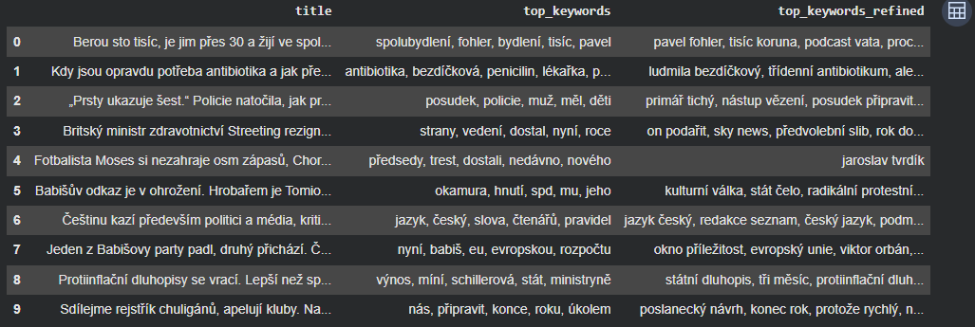

Word Cloud Visualisation
As a lightweight, presentation-friendly summary of the corpus, we render a word cloud where each token is sized by its aggregated TF-IDF score. Tokens that are characteristic of the corpus as a whole therefore appear largest, while generic high-frequency words that the cleaning step did not remove (and would otherwise dominate a raw frequency cloud) are naturally pushed to the background by the inverse document frequency component. When multiple outlets are loaded, a separate cloud is produced for each, which makes thematic differences between editorial desks visible at a glance.

Sentiment and Bias

Transformer sentiment (BERT)
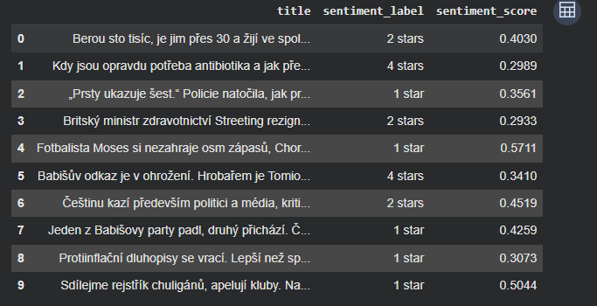
For sentiment estimation, we used a pretrained transformer model from Hugging Face.
Transformers are a modern class of neural networks that are particularly effective at
capturing context and subtle linguistic cues in text, which makes them a strong choice even
when the input is relatively short. In our case, the model produced reasonable sentiment
predictions for the articles we tested, as illustrated in the figure, where each article is
assigned a sentiment label together with a numerical confidence score.

However, sentiment alone does not fully capture the type of media bias we are interested in.
For this reason, we also computed a custom subjectivity index and combined it with a more
targeted measure of adjective polarization. This part of the pipeline is based on Word2Vec
and a small set of manually chosen anchor words representing more objective and more
subjective language. The idea is that words appearing closer to subjective anchors should
contribute more strongly to the final bias estimate than neutral or factual wording.

Word2Vec adjective polarisation
Word2Vec was included as an exploratory semantic component rather than as the core of the
method. It helps represent words as vectors in a shared semantic space, where similar words
end up closer to each other. Although this technique is not sufficient on its own to
determine bias, it provides a useful way to model lexical relationships and compare the
relative orientation of descriptive words. In the broader NLP context, this idea is also
consistent with how larger transformer-based models capture meaning through distributed
representations.

The final bias score, scaled from 0 to 10, combines these signals into a single interpretable
metric. In this way, the analysis moves beyond simple sentiment classification and instead
aims to estimate the degree of subjectivity and evaluative language present in each article.

Custom subjectivity index
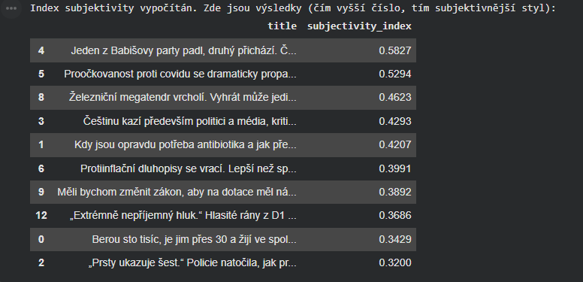
In addition to using a pretrained sentiment model, we also designed our own
subjectivity-based scoring method. Instead of relying on an external classifier, this
approach follows a more transparent linguistic strategy: it measures the ratio of modifying
parts of speech, such as adjectives and adverbs, to more factual carriers of information,
such as nouns and verbs. The motivation was to capture how strongly an article uses
evaluative or descriptive language, which is often a better indicator of subjectivity than
sentiment alone.

The first part of the calculation provides an initial estimate of the article’s subjective
tone based on POS tagging. Articles with a higher proportion of descriptive elements tend to
receive a higher subjectivity score, because such language is more likely to reflect the
author’s stance or framing rather than purely factual reporting. This gives us a basic
numerical representation of how subjective the article appears at the linguistic level.

We then refined this analysis using a second step based on manually defined anchor words.
These anchor words represent more clearly positive or negative subjective language, and the
score measures how closely the article’s descriptive vocabulary aligns with one side or the
other. Although the anchor set was created manually, similar vocabulary lists can be found
for Czech as well. This refinement allows the model to move beyond a simple ratio and
estimate whether the subjective style is more negatively or positively oriented.

The figure shows the resulting subjectivity index for individual articles. Higher values
indicate more subjective writing, which gives us a useful way to compare articles within the
corpus and identify texts that rely more heavily on evaluative language.
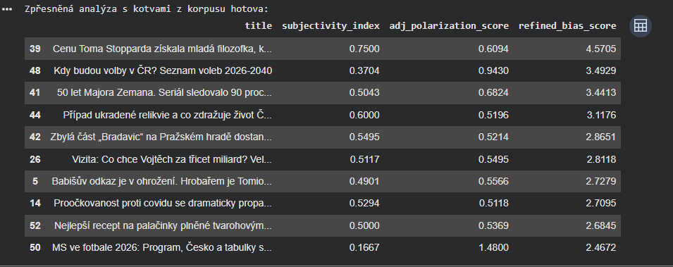

Topic Modelling with LDA
Topic modelling provides a complementary view of the corpus. While TF-IDF surfaces the most characteristic terms of an individual article, Latent Dirichlet Allocation (LDA) discovers latent themes that recur across the whole collection. We train a gensim LDA model on the lemmatised corpus with a small fixed number of topics, which is sufficient for an exploratory pass on a corpus of this size.
The topics serve two purposes in our analysis. First, they offer an intuitive map of what the assembled news articles tend to cover. Second, they let us ask a more pointed question: do the differences in subjectivity we observe between outlets reflect genuine editorial style, or do they simply mirror the fact that different outlets cover different topics, some of which (for instance opinion-driven political commentary) naturally invite more evaluative language than others (for instance technical or economic reporting)?

Cross-Outlet Comparison

Aggregated subjectivity by outlet
Once the scraping registry from Section 1 has produced articles from all four outlets, the same preprocessing, POS tagging and Word2Vec-based subjectivity pipeline is applied uniformly. For every outlet we then aggregate the per-article subjectivity index and the refined adjective-polarisation score, which gives us a compact distributional summary that can be inspected visually with a box plot and compared statistically.

Statistical testing (ANOVA, Tukey, η²)
Visual differences between box plots can be misleading, especially with a modest per-outlet sample size, so we accompany the plot with a standard set of inferential tests. A one-way ANOVA across the four outlets tests whether at least one outlet differs in its mean refined subjectivity score; if the ANOVA is significant, Tukey’s HSD post-hoc test identifies the specific pairs that drive the difference. We also report eta-squared as an effect-size measure, interpreted with the conventional bands (below 0.06 is small, 0.06–0.14 is medium, above 0.14 is large), so that the practical magnitude of any difference is visible alongside its statistical significance.

Interactive Dashboard (Plotly)
The final analytical artefact is an interactive scatter plot built with Plotly. Each point represents one article, positioned by its subjectivity index on the horizontal axis and by its BERT-derived sentiment label on the vertical axis. The hover tooltip shows the article title together with its top TF-IDF keywords, which makes it easy to inspect outliers and to qualitatively check whether the numerical scores agree with a human reading of the text. A colour gradient encodes sentiment so that the overall tone of the corpus is visible at a glance.

Implementation
The entire pipeline is implemented within a single Jupyter notebook. The data is organized in
a pandas DataFrame, and the analysis is performed sequentially by adding new columns at each stage of processing. This structure makes the workflow transparent and easy to follow,
because each intermediate representation remains available for inspection and comparison.

The main columns are added progressively as the text moves through the pipeline: cleaned_text
after preprocessing, pos_tags after POS tagging, lemmatized_text after lemmatization,
subjectivity_index after the custom subjectivity computation, and refined_bias_corpus_score
after the final bias estimation step. In this way, the notebook does not overwrite earlier
results, but instead preserves the full chain of transformations from raw article text to the
final analytical scores.

This column-based design also makes the notebook easier to debug and extend, since each stage can be checked independently before moving on to the next one.

Results
The pipeline described above produces a number of qualitative observations and one notable negative finding. Because the corpus is small relative to the population of Czech news writing, we treat the numbers as illustrative rather than as population estimates.

Corpus overview
Across the four selected outlets we assembled a corpus of roughly two hundred articles, with the larger mainstream outlets contributing the majority of texts and the smaller, more opinion-driven outlets contributing a noticeably thinner sample. A non-trivial share of candidate articles had to be discarded during scraping, either because the underlying page was paywalled, because the title was missing, or because the body text could not be extracted reliably. The surviving sample is therefore a deliberately conservative slice of the original crawl, which keeps the downstream analysis honest at the cost of a smaller effective dataset per outlet.

Per-article subjectivity
Looking at individual articles, the distribution of subjectivity scores has the shape one would expect: most pieces sit in a broad middle band that corresponds to mixed factual-and-evaluative writing, and a smaller tail of clearly opinionated articles stands out at the high end. The two measures we computed — the simple POS-ratio index and the Word2Vec-based adjective polarisation score — broadly agree on which articles are the most subjective, but they disagree on parts of the tail. Articles that rely on a single strongly evaluative adjective tend to score higher with the Word2Vec measure than with the linguistic ratio, while articles that are simply densely descriptive without strongly polarised vocabulary are flagged by the ratio but not by the Word2Vec score. We interpret this divergence as evidence that the two measures capture genuinely different aspects of subjective writing rather than noisy variants of the same underlying signal.

Cross-outlet finding
The most interesting finding is, perhaps counter-intuitively, a negative one. The one-way ANOVA across the four outlets did not detect a statistically significant difference in mean subjectivity, and the associated effect size was very small. In plain terms: on this corpus we cannot claim that any one outlet systematically writes more subjectively than the others. The spread we see in the box plots is dominated by within-outlet variation between individual articles, not by a stable editorial signature. This is a meaningful result rather than a failed experiment — it tells us that, at least for the kind of general-interest news pieces we sampled, differences in evaluative style between outlets are smaller than commonly assumed, and that a much larger and more carefully balanced corpus would be needed to make a stronger claim either way.
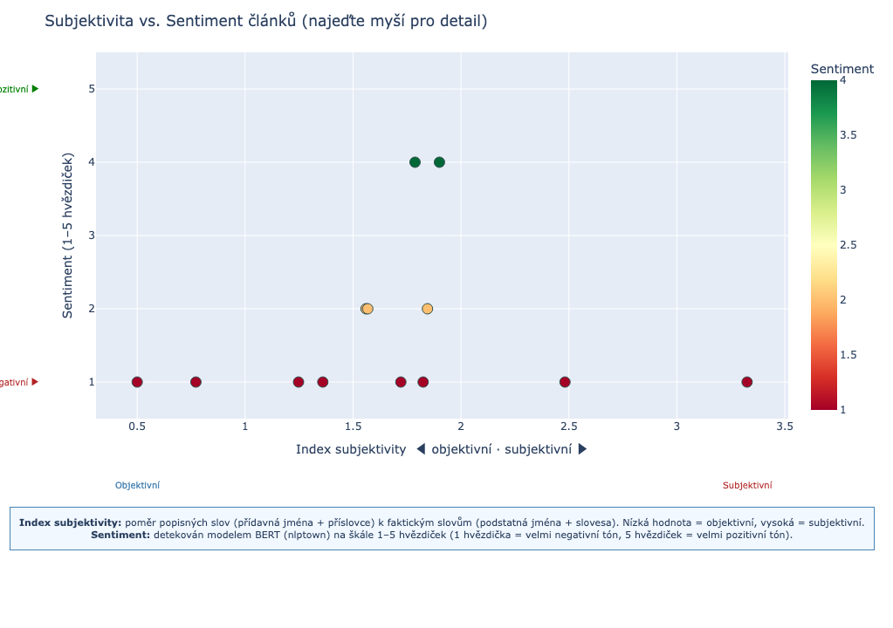

Conclusion
The project delivers an end-to-end Czech-language pipeline that starts at raw web pages and ends at interpretable per-article subjectivity scores, with a multi-outlet comparative layer on top. Two complementary measures of subjectivity — a transparent POS-ratio index and a Word2Vec-based adjective polarisation score — are computed alongside a transformer-based sentiment label, and the whole pipeline is wrapped in an interactive dashboard that supports qualitative inspection of the results.
The most substantive empirical outcome is a negative one: the four selected Czech outlets do not differ significantly in their mean subjectivity scores, and the effect size is small. We consider this an honest finding rather than a shortcoming of the method. It indicates that for the kind of articles we were able to scrape, evaluative style varies more strongly between individual pieces than between editorial desks.
The main limitations are the modest corpus size per outlet, the reliance on manually chosen anchor words for the Word2Vec polarisation, and the fact that the multilingual sentiment model maps every text onto a coarse 1–5 star scale that was not designed for Czech news specifically. The most useful next steps would therefore be a substantially larger and more balanced crawl, a supervised subjectivity dataset to replace the heuristic anchors, and the fine-tuning of a Czech-specific sentiment classifier on news-domain text. Integrating the LDA topic priors directly into the subjectivity score is another natural extension, since it would let us separate stylistic subjectivity from topic-driven subjectivity in a principled way.

Authors’ Contributions
Both authors contributed jointly to all stages of the project, including data collection, preprocessing, model selection and experimentation, the design and implementation of the subjectivity measures, the cross-outlet comparison, and the preparation of this report. Specific implementation tasks were divided pragmatically during development; analytical decisions and the interpretation of results were made together.

