**Nakuja Project**

**Preparation Procedure of Pyrotechnic Bolts *[Issue #1]***

**Definition**

Pyrotechnic bolts efficiently secure two objects and strategically explode when commanded to. They initiate a perfect failure at the point of interest, allowing the separation of bodies at the point where rapid structure separation is needed. They may look something like this:

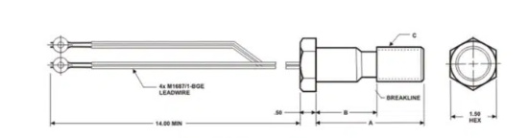

**Requirements**

|  |  |  |
| --- | --- | --- |
| **Item No** | **Name** | **Description** |
| 1 | M10-1.0x10 Bolts | * Length:10mm * Pitch: 1mm |
| 2 | Black powder | * Quantity to be determined during tests |
| 3 | Igniters | * Two on each bolt for redundancy |
| 4 | Epoxy glue |  |
| 5 | Heat shrinks tubing |  |
| **Tools** | | |
| 6 | Drill bits | 2mm, 3mm |
| 7 | Electric drill |  |
| 8 | Rubber gloves |  |
| 9 | Safety goggles |  |
| 10 | Wire cutters |  |
| 11 | Hacksaw |  |

**Manufacturing**

1. Put on your safety glasses.
2. Clamp the bolt vertically on a vise, with the hex side facing downwards
3. Using the 5mm drill bit, drill down in the middle of the bolt until you have opened a hole through the center of the bolt
4. Insert the igniters from the bottom side of the bolt (the bottom side is the hex side)
5. Using epoxy, glue the igniters at the point of entry to prevent the black powder from pouring. Make sure the igniter heads remain inside the cavity
6. Fill the cavity about ¾ full of black powder and ensure the powder is in full contact with the igniter heads.
7. Cover the top of the bolt with heat shrink tubing and pass slightly over a light flame to adhere the tubing to the bolt.

**Testing the bolts**

After manufacturing, we need a way to test the bolts

1. Make sure you are in an open space away from people, pets or buildings
2. Put on your safety googles
3. The cord connecting the igniters and the battery or the firing circuit **MUST** be long enough to prevent injuries.
4. Fire your bolts using the firing circuit. The bolt should explode with a small bang and a little bit of smoke and/or flame.
5. Examine your pyro bolt
6. Repeat tests until satisfied. You can modify the manufacturing process to suit your needs.

**Installation and Operation**

Once your brand of the bolt is performing properly, it’s time for installation. You need two things for this:

1. A secure point of installation between the two mating surfaces
2. A source of ignition for the internal igniter, for our case we use a firing circuit located on the avionics bay

To install:

1. For our application, drill a hole big enough on the piston to fit the shank of the bolt
2. Insert the bolt into this hole and secure with epoxy glue. Igniter wires will be on the outside of the piston.
3. Allow to dry.