**ICS 4U: Design Document**

**Purpose**

This project will try to predict stock prices with the use of different machine learning algorithms and neural networks. Currently, many large hedge funds and insurance companies are investing heavily in “Quants”, the “rocket scientists of Wall Street”. These analysts apply secretive, predictive machine learning algorithms in attempts of giving their firms “upper hands” to the market. The purpose of this project is to mimic the production of a quant, and produce a unique predictive algorithm.

Currently, (larger) firms are investing in quants for the following reasons:

1. Rapid growth of hedge funds and automated trading systems
2. Increasing complexity of both liquid and illiquid securities
3. Need to give traders, accountants and sales reps access to pricing and risk models
4. Ongoing search for market-neutral investment strategies.

Overall, while I will be learning from pre-existing algorithms, the final project will aim to create a mainstream desktop application for the purpose of financial tracking and analysis.

**User Interface**

The user should be able to search stock and find predictive modelling as well as allow for basic portfolio management. The following must also be a part of the UI:

1. Interface should be intuitive.
2. User must be able to (easily) locate stock info and analysis.
3. User must be able to change the location of any button, as well as it’s ID.

(A basic outline is attached on the next page).

**Functionality**

The application must be able to analyze and display the predictions of any given stock. As well, a variety of algorithms must be used, with a final decision made based on a “correction” check.

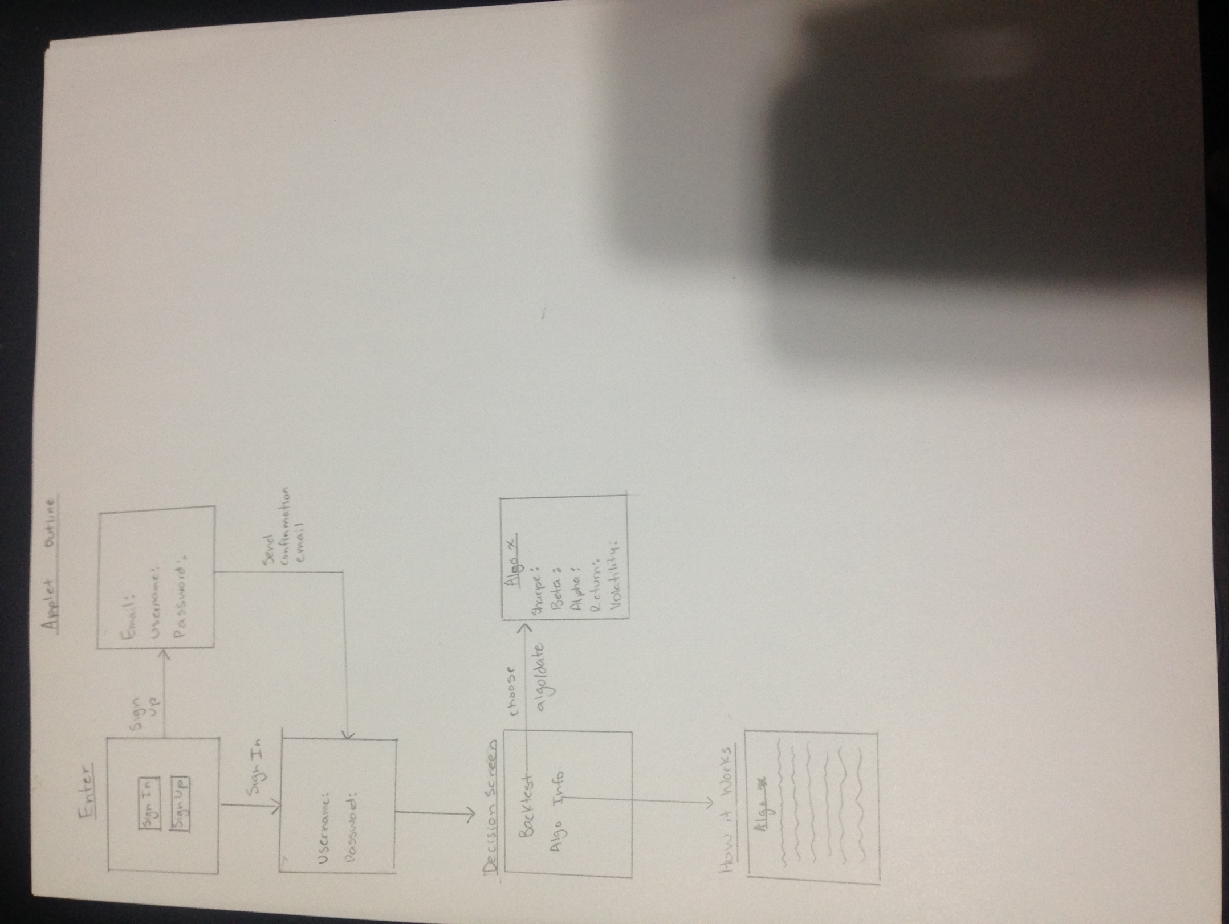A Basic Outline: