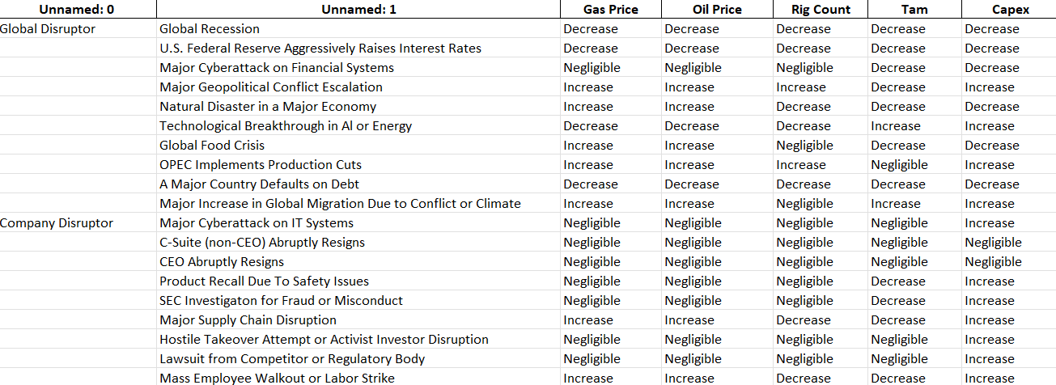

This is the research work regarding impact of disruptors over 5 params.

Questions
1 – First of all please verify whether these changes are valid and correct so that we can work on implementation part.
2 – Almost all the disruptors have to follow a binary pattern like for example- if we consider CEO Abruptly resign so this have to be in format of either yes (say 1) or no (say 0). So the question arises how these binary values can consider a relation with the parms.
Here 0 is like nothing happened that means values should be independent of that disruptor and if 1 then only we need to consider that right?
3 – How we are supposed to give the inputs to the NN of disruptors so that it can impact predicted values?

