

**Hotel/Restaurant Automation System**

**Group 9**

**DAIICT**

**Instructor: - Prof. Jayprakash Lalchandani**

**Mentor TA: - Mahir**

**Date: - 27/03/2022**

**Id Name**

**201901043 Nakul Patel**

**201901224 Shrey Mavani**

**201901259 Divyesh Patel**

**201901274 Soham Patel**

**DFD Modeling**

**DFD Level 0: -**

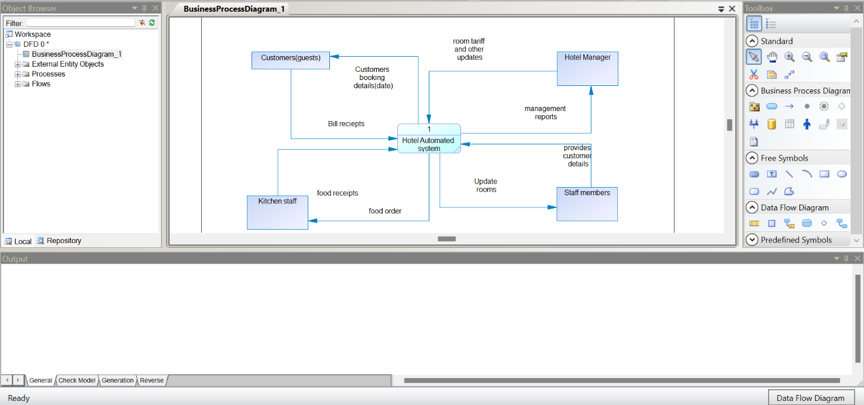

**DFD Level 1: -**

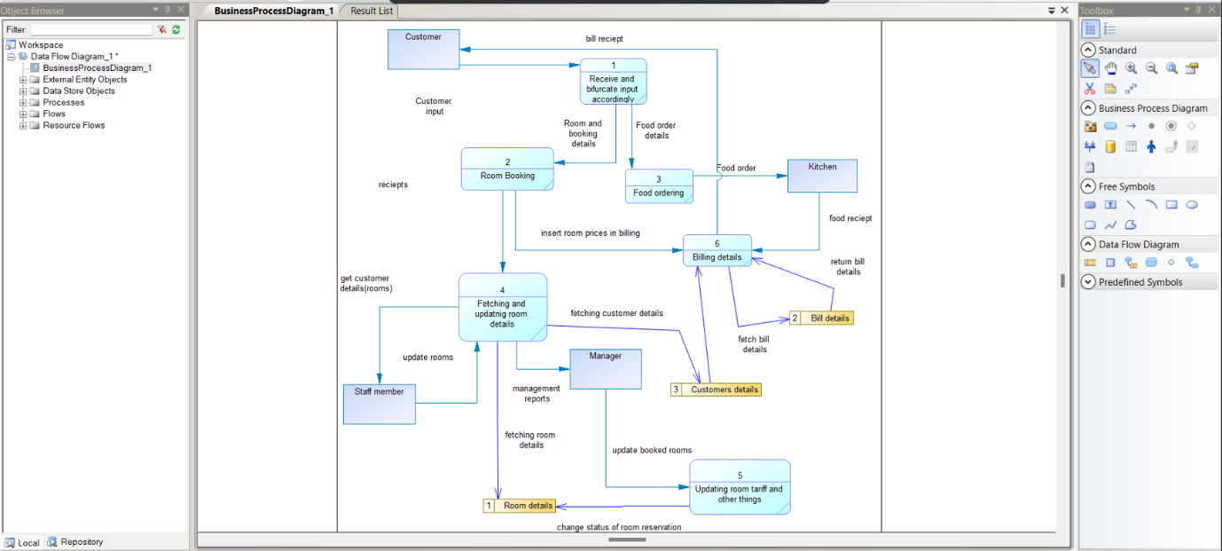

**DFD Level 2: -**

**Process 1: -**

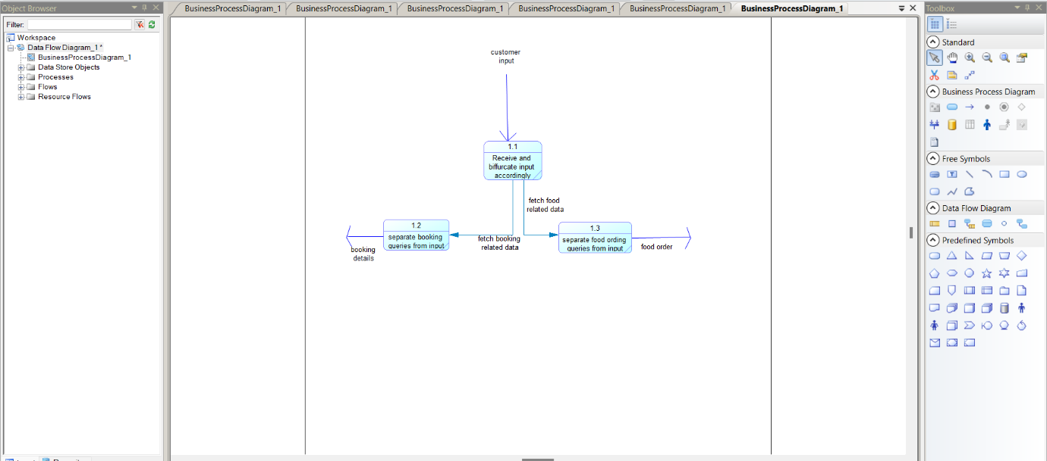

**Process 2: -**

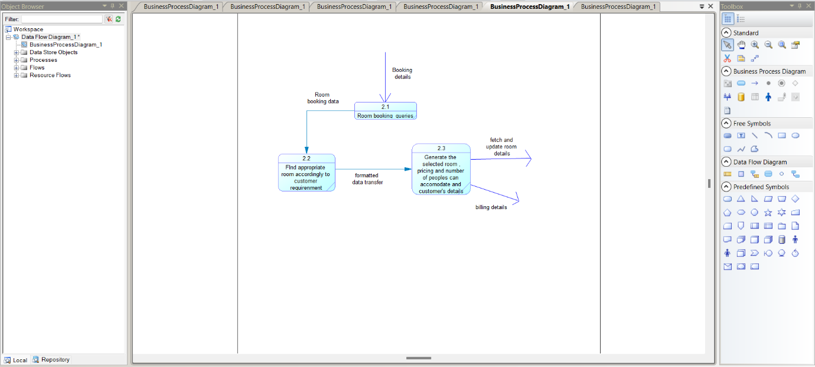

**Process 3: -**

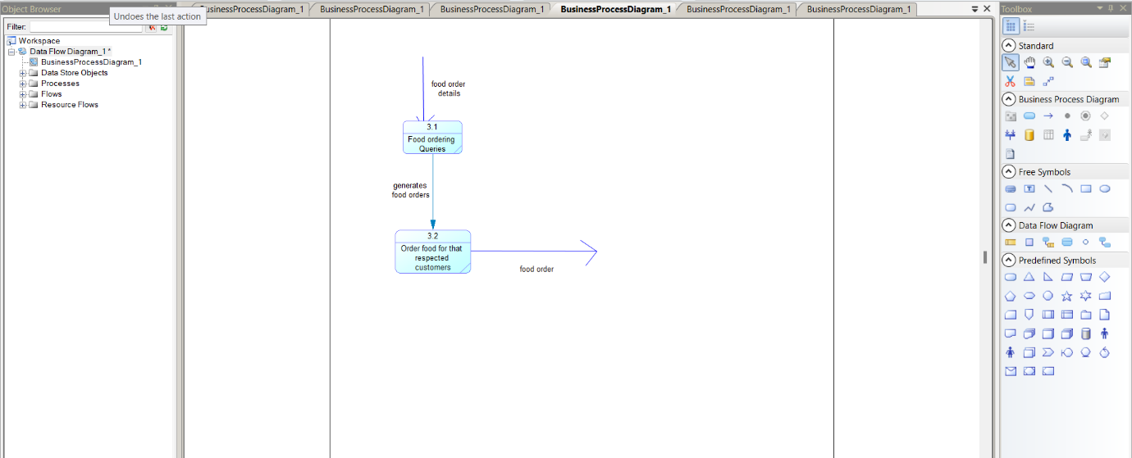

**Process 4: -**

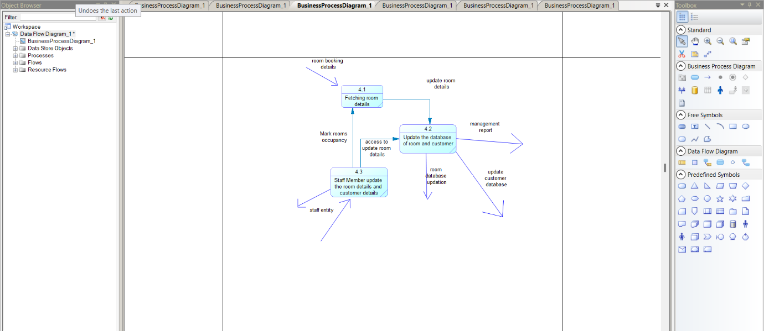

**Process 5: -**

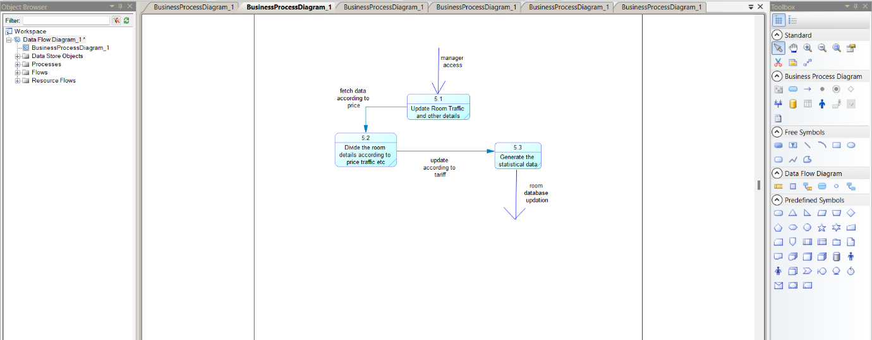

**Process 6: -**

