

**Hotel/Restaurant Automation System**

**Group 9**

**DAIICT**

**Instructor: - Prof. Jayprakash Lalchandani**

**Mentor TA: - Mahir**

**Date: - 25/04/2022**

**Id Name**

**201901043 Nakul Patel**

**201901224 Shrey Mavani**

**201901259 Divyesh Patel**

**201901274 Soham Patel**

1. **You need to make all the design pages of your web-application project using Figma tool, upload a .pdf file containing the screenshots of the designs. And show prototyping between those pages.**

**Home Page: -**

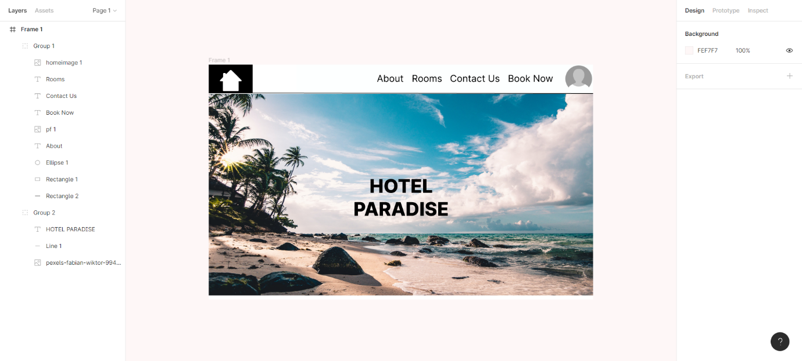

**Login Page: -**

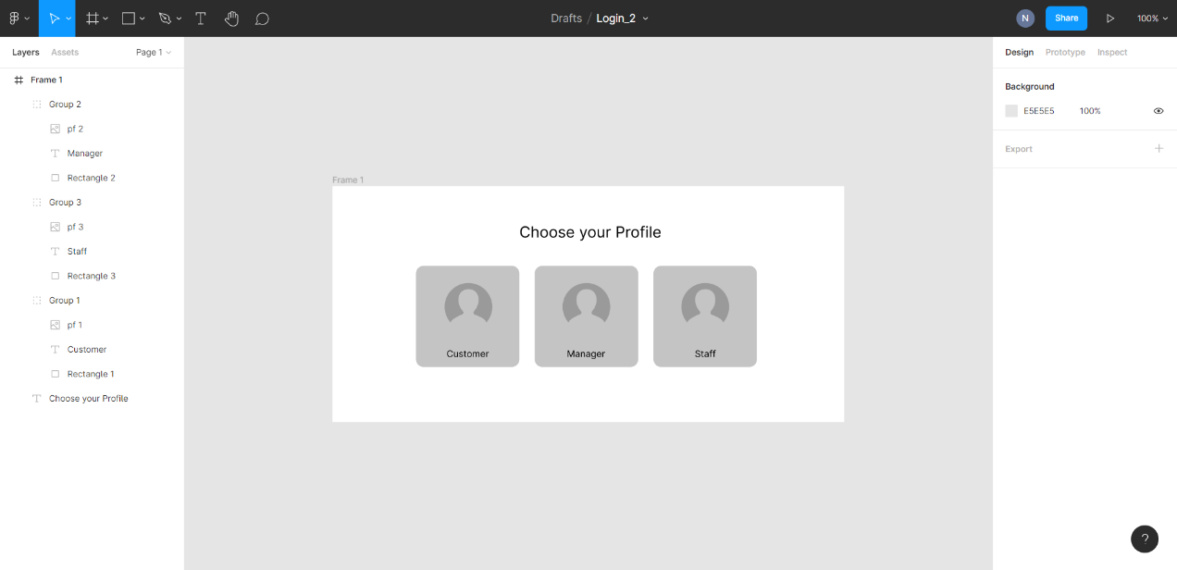

**Sign-in Page: -**

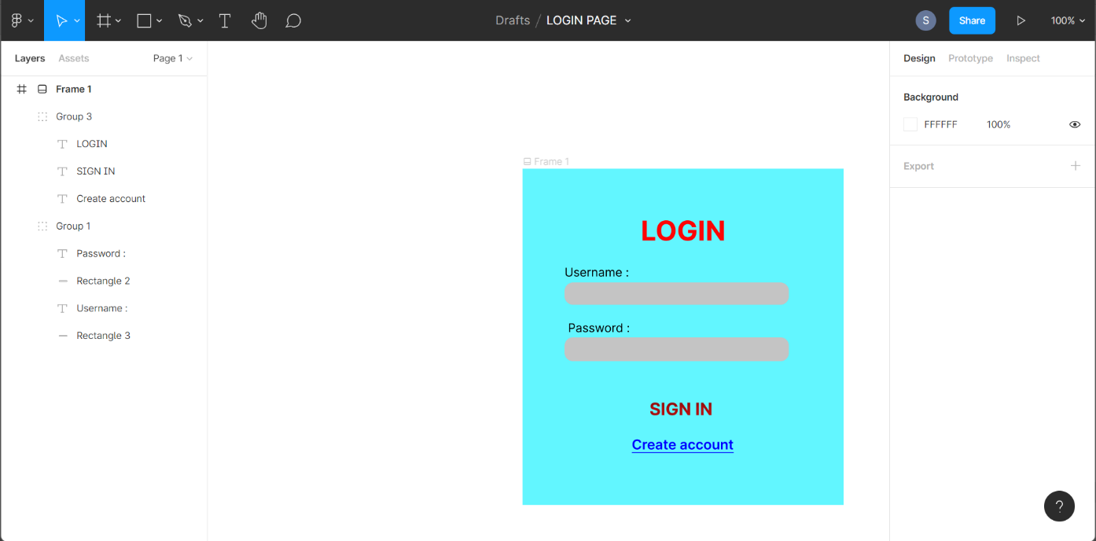

**Staff member Page: -**

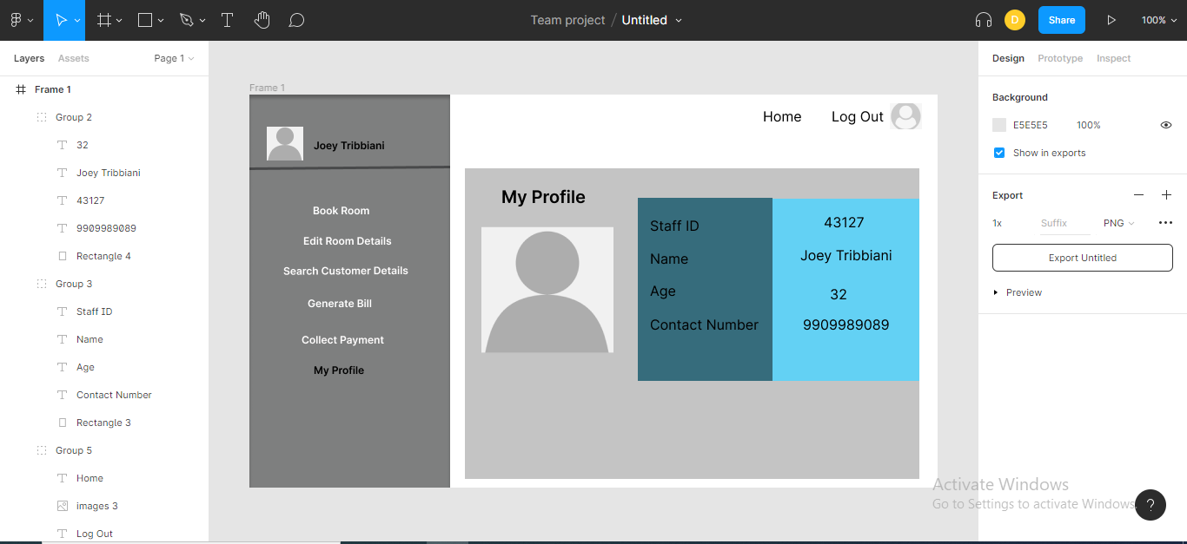

**Customer Page: -**

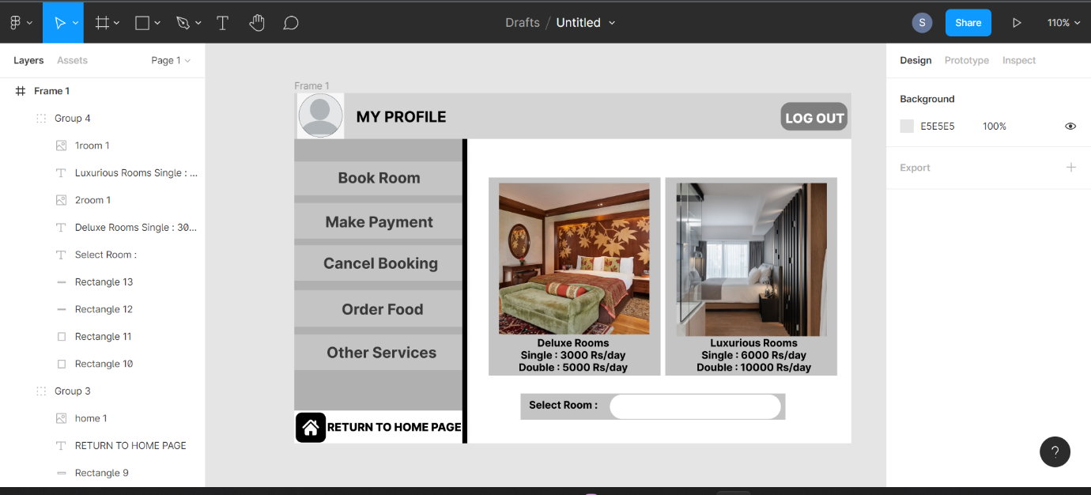

**Manager Page: -**

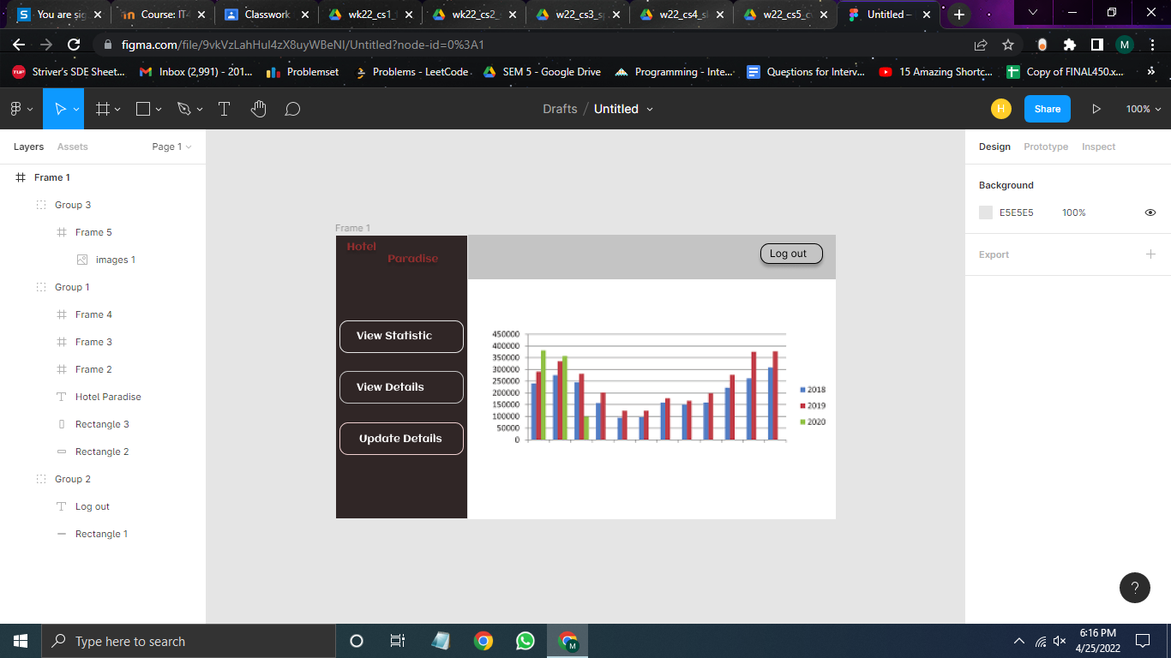

1. **Describe what is the working of that particular page. And explain the flow of pages.**

**Home page: -**

When any user visits our website, this is the first page which he will came across. The Home page show the basic functionalities of our website like booking the room and view room of our hotel. Home page all contains the “About Us” section which also gives information about our hotel and Contact details are also provided at the end of the home page.

**Login Page: -**

But in order to view all functionalities user must login to our system. User can login to our system with three different profiles. If Manager of hotel wants to change the tariff of the rooms and also want to change other details, he can login as Manager and provide his respective credentials to the sign up-page. Similarly, when new customer enters to our system, he can login as customer and create a new account he didn’t have any previously.

**Sign-in Page: -**

After user decide as under which profile, he wants to login to our system, user will redirect to the sign-in page which is shown above, where he has to enter required credentials in order to login and he can also create new account in case he didn’t have any.

**Staff Member: -**

When user select staff members as his login profile then he will be redirect to the Staff-member page as show above. In this page the staff member details like his/her name, ID, contact number etc. are shown. And the other functionalities of the staff member like he/she can book the room for customer offline and change the occupancy status of the room, also he can change the basic room details like occupancy status of the room, any complain from any room etc. He can also generate the bill of the customer and collect the payment i.e., Receptionist. User can also log out and go to the home page from the home option which is shown in the panel above.

**Customer Page: -**

When user select customer as his login profile and after providing required credentials, he/she will be redirect to the Customer page as shown above. Here the user can go to an of functionalities like booking room, canceling room, ordering food and making the payment. In figure the room booking service is shown, like which type of room he wants to book and how many rooms he wants to book and he can also cancel the room etc. And he can also log out and navigate to home page of website through return to home page option.

**Manager Page: -**

When user select the manager as his/her login profile and after providing required credentials, he/she will be redirect to the Manager page as shown above in the figure. Manager can visit to his/her functionalities like view statistic of the profit gained of our hotel, and he can also see the details of the customer like which customer is residing in which room etc., he also has access to change the tariff of the room and other details and services setting. And manager can also log out and navigate to home page of website through return to home page option.

1. **Explain all the pages what you have added, which grouped you have formed etc.**
2. **Home Page –**

* **About –** This contains the information of the hotel, location and photos of hotel.
* **Rooms** **–** This contains room available.
* **Contact Us –** Thiscontains details to contact the hotel reception.
* **Book Now –** Final booking of the room.
* **Groups formed**
  + **Group 1 –** Login, contact us, about, room booking and homepage are included in top panel.
  + **Group 2 –** Main background box containing background image and hotel name.

1. **Login Page 1-**

**Gives options to choose profile to login in the system.**

* **Customer –** This is the login page for user customer.
* **Manager –** Thisis the login page for user Manager.
* **Staff –** This is the login page for user staff.

**After Selecting any of the profile, user will enter his/her username and password to login in the system, and also there is create new account option too for new user’s.**

* **Groups formed**
  + **Group 1 –** Contains customers profile image and name.
  + **Group 2 –** Contains managers profile image and name.
  + **Group 3 –** Contains staff profile image and name.

1. **Login Page 2-**

* **Username**.
* **Password.**
* **Groups Formed**
  + **Group 1** – Main background box containing all details.
  + **Group 2** – Username, Password and place to fill it are included in it.

1. **Staff Member Page –**

* Shows user name on the left
* Shows all the functionalities staff members can do on the left panel.
  + **Book Room –** To book room’s offline from the reception.
  + **Edit Room Details –** To edit room details like customer information, number of customers staying in the room etc.
  + **Search Customer Details –** To verify customer details while checking in.
  + **Generate Bill** – To generate the bill of the customer while customer is checking out.
  + **Collect Payment –** To collect bill on the billing counter.
  + **My Profile** – Contains the details of the staff member.
* **Groups Formed**
  + **Group 1 –** Left Panel.
  + **Group 2** – Right box which contains the details name (e.g., Joey Tribbiani), age.
  + **Group 3 –** Is the left box which contains parameter of name, age and contact number.
  + **Group 4 –** Isthe box in which, group 2, group 3 and profile photo resides.
  + **Group 5 –** Is the top panel contains return to home button and log out option.

1. **Customer Page –**

* Shows user name on the left
* Shows all the functionalities customer can do on the left panel.
  + **Book Room –** To book room online.
  + **Make Payment –** To do the final payment to book room.
  + **Cancel Booking –** To cancel the booked room.
  + **Order Food** – To order food online from the website.
  + **Other Services –** To book and use other services like taxi service.
  + **Return to Home Page –** To go back to home page.
* Middle screen contains the options to book room in two different categories.
* Top right corner has an option to log out from the website.
* **Groups Formed**
  + **Group 1 –** Upper Panel containing logout button, profile button and profile option.
  + **Group 2** – Left panel having options to all features like Book Room, make payment, Cancel Booking, Order Food and Other Services.
  + **Group 3 –** Return to home page and its button.
  + **Group 4 –** Center page having the detailed view of the feature selected.

1. **Manager Page –**

* Shows all the functionalities manager can do on the left panel.
* Shows all the functionalities customer can do on the left panel.
  + **View Statistics –** Show statistics of profits of the hotel.
  + **View Details –** Manager can view details of the customer, staff members and room’s details.
  + **Update Details –** Toupdate the details of room tariff.
* **Groups Formed**
  + **Group 1 –** Left panel contains functionality of manager like view statistics, view details etc.
  + **Group 2** – Upper panel contains logout button.
  + **Group 3 –** Contains the statistical details.

1. **Importance of UI/UX in Software Products.**

**Importance of UI/UX in software products.**

* The primary goal of any business is to increase its sales and increase the growth of the business. UX/UI design plays an essential role in achieving this goal. The UX/UI design of the application improves the user experience and customer satisfaction that ultimately helps increase the number of users of the specific application.
* The UI and UX design help to win the consumers’ confidence and make them use your application or website providing them what they are looking for. The number of consumers you are getting on your application can measure the success of the great UI and UX.
* For a start-up or a small venture, the importance of UI and UX design becomes even more crucial as the first impression lasts long and using UI and UX designing can make or break the brand recognition