

**Hotel/Restaurant Automation System**

**Group 9**

**DAIICT**

**Instructor: - Prof. Jayprakash Lalchandani**

**Mentor TA: - Mahir**

**Date: - 17/04/2022**

**Id Name**

**201901043 Nakul Patel**

**201901224 Shrey Mavani**

**201901259 Divyesh Patel**

**201901274 Soham Patel**

**Behavioral Diagram**

**State Machine Diagram**

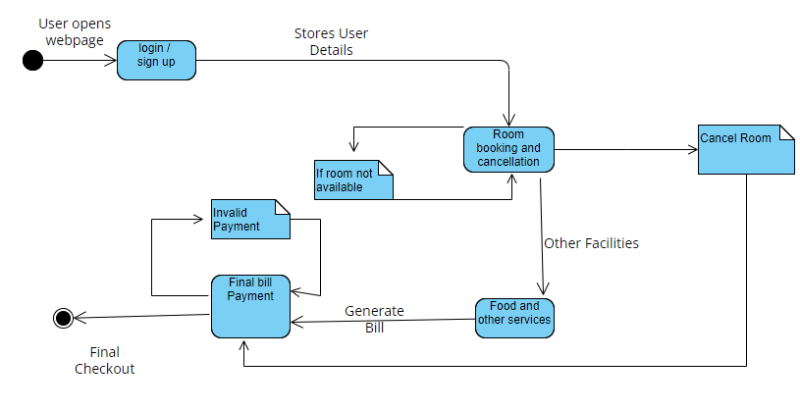

**Communication Diagram**

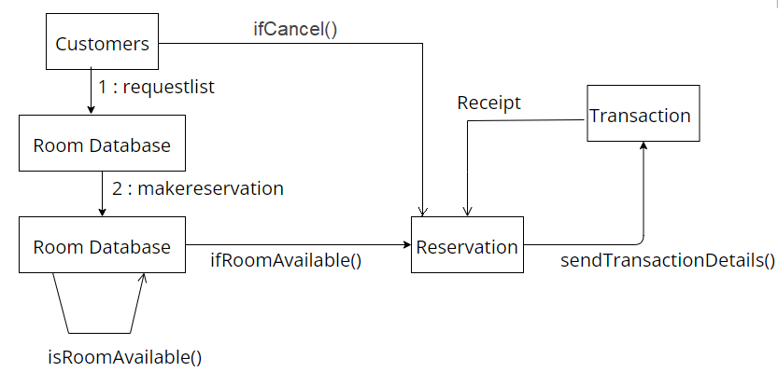

**Use-Case Diagram**

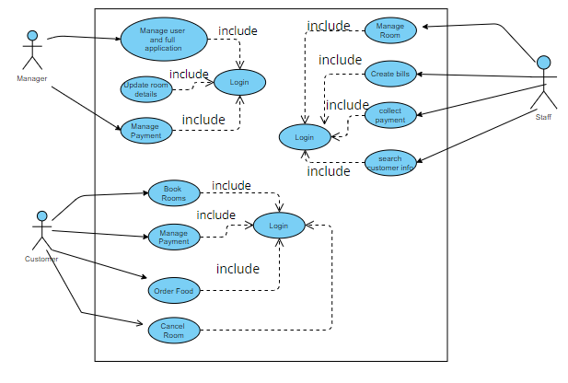

**Activity Diagram**

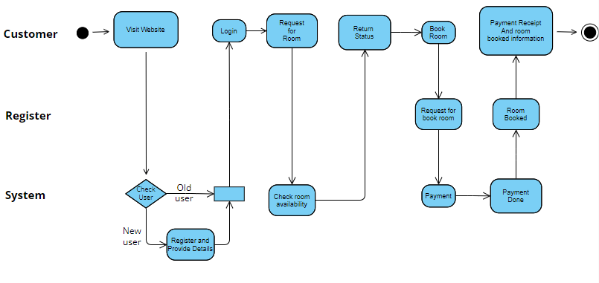

**Sequence Diagram**

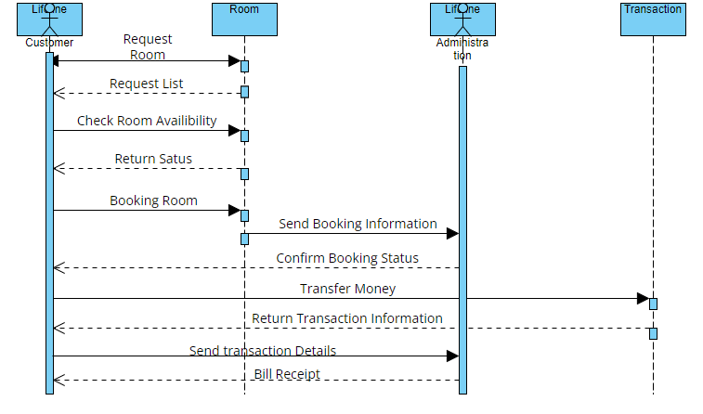

**Timing Diagram**

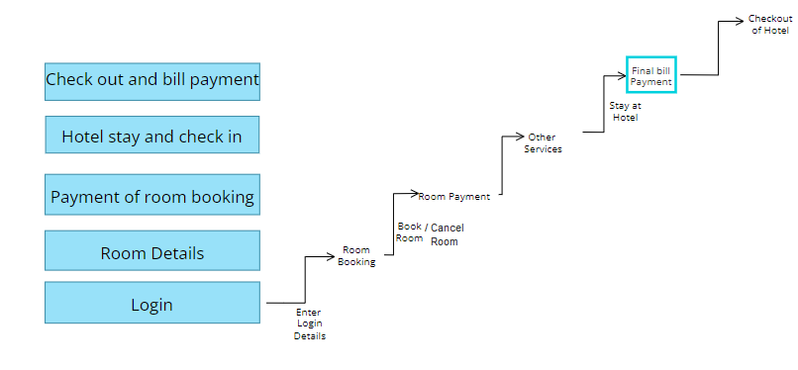

**Interaction overview Diagram**

