DynamoDB

## Step 1: Open the AWS Management Console

Log in to the AWS Management Console. In the search bar, type 'DynamoDB' and select it from the results to open the DynamoDB dashboard.

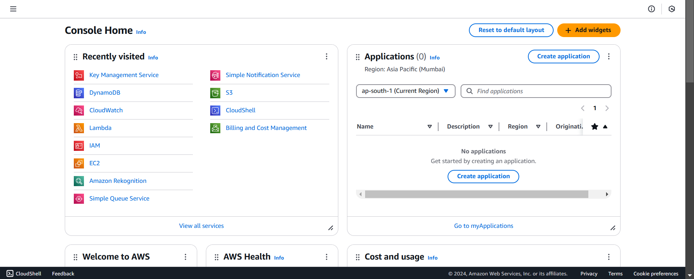

## Step 2: Create a New Table

On the DynamoDB dashboard, click on the 'Create table' button to begin the table creation process.

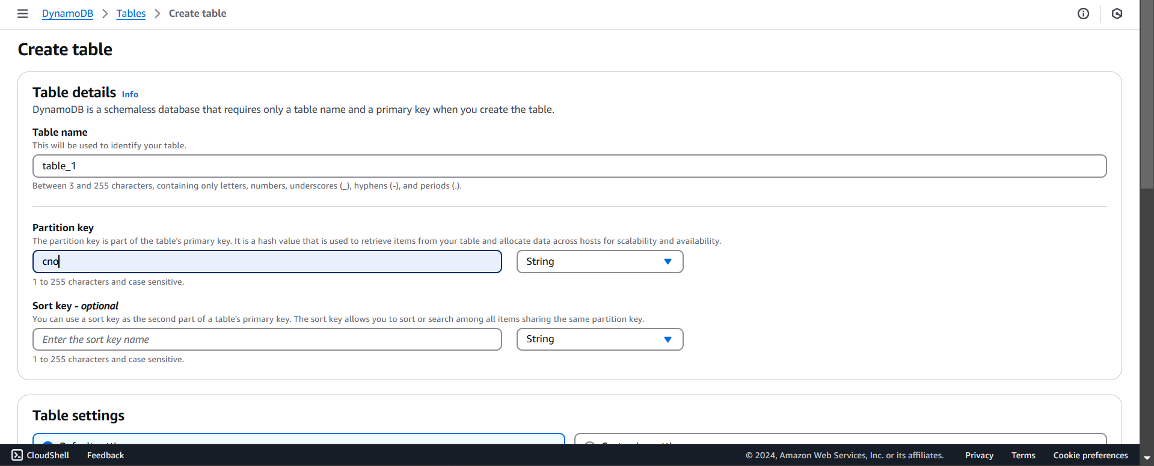

## Step 3: Define Table Details

Provide a name for your table in the 'Table name' field and specify the primary key attributes. For example, enter 'id' as the partition key.

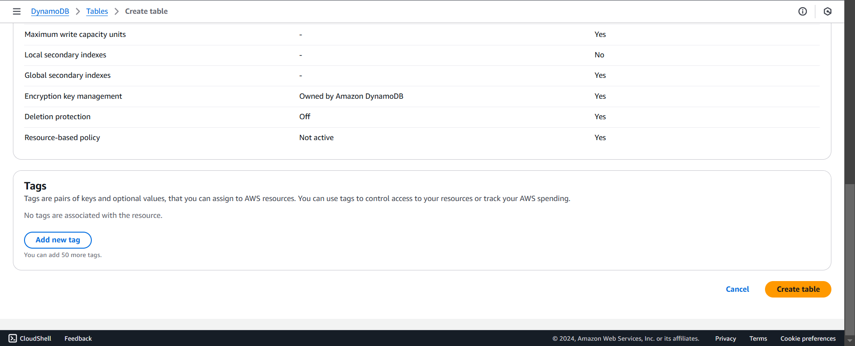

## Step 4: Configure Additional Settings (Optional)

If needed, adjust the default settings such as table capacity mode, encryption, and secondary indexes. Once done, proceed by clicking 'Create table'.

## Step 5: Verify Table Creation

After the table is created, it will appear in the list of tables on the DynamoDB dashboard. Verify its status is 'Active' to ensure it’s ready to use.

