**Creating IAM**

Step1: First of all login to AWS Console and search the IAM on search bar then select the IAM Services from the result.

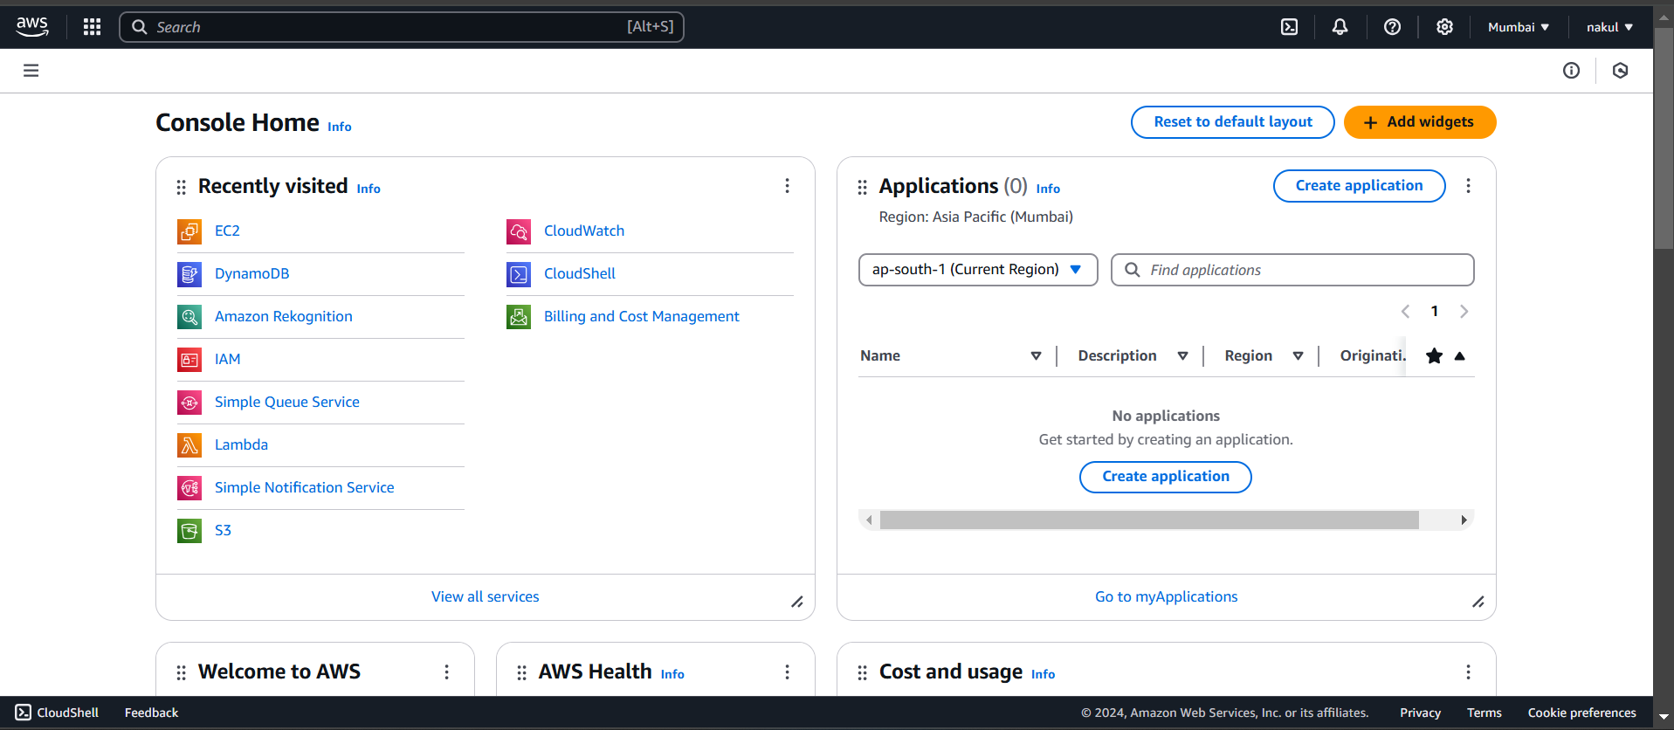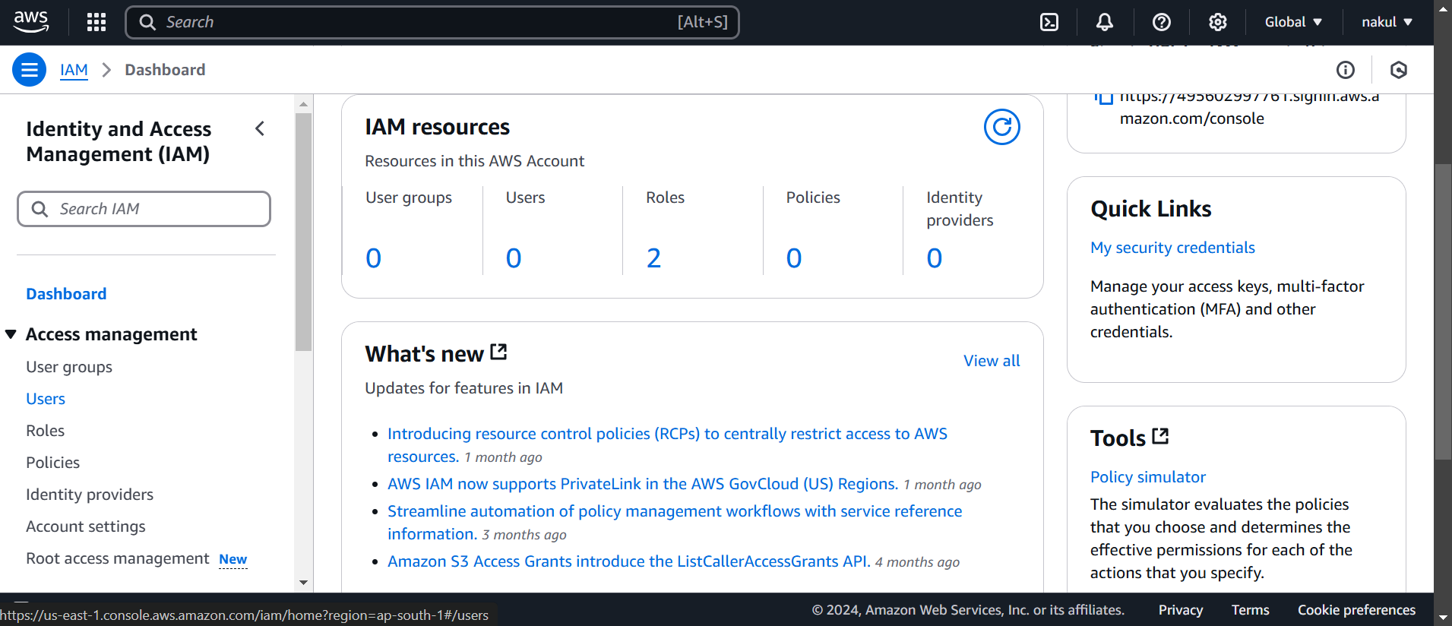

Step2: In the IAM dashboard, click on **"Users"** in the left-side menu, then click to the create user.

Step3: Now click on the create user.

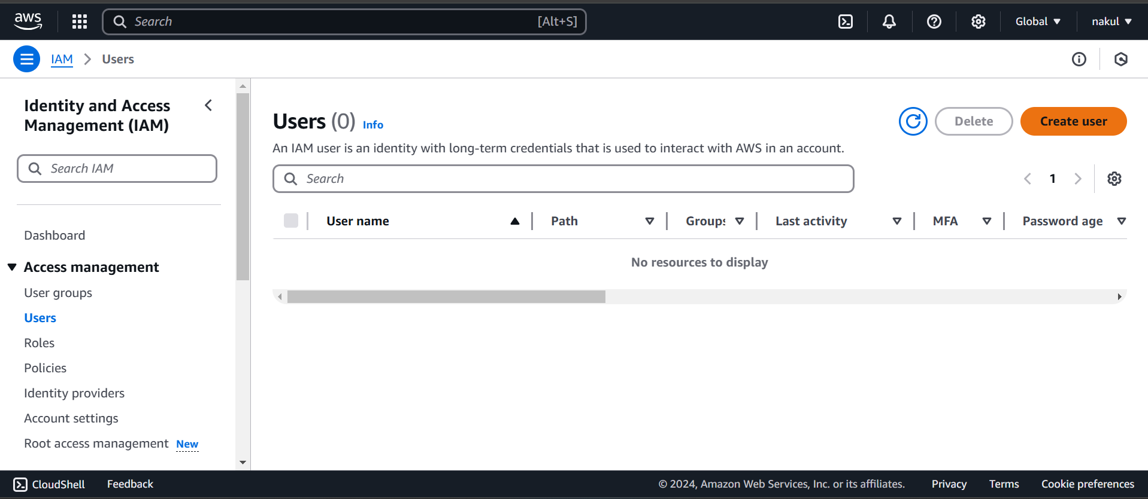

Step4: Now we have to take more steps on creating user, firstly enter a unique name.

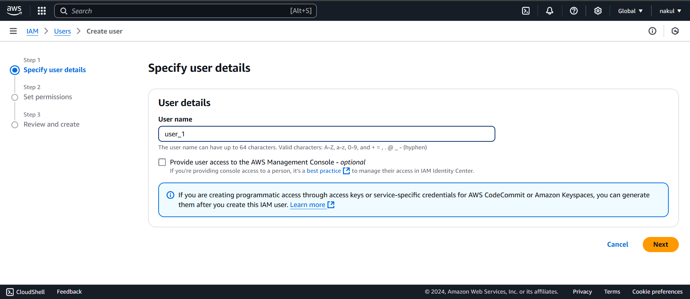

Step5: Now we have to set permissions, there is three option to set this, like add to user, and one is we can copy permissions from already user which is exist and last one is directly attached polices.

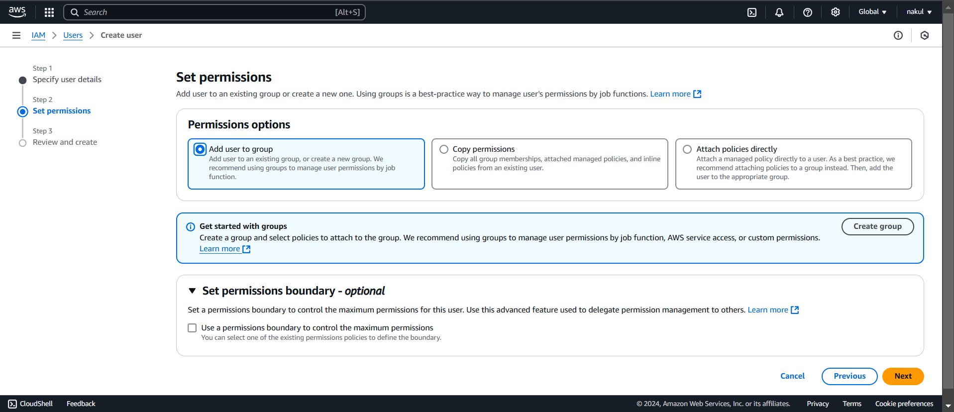

Step6: Last review all things are setup, then click on the create user button.

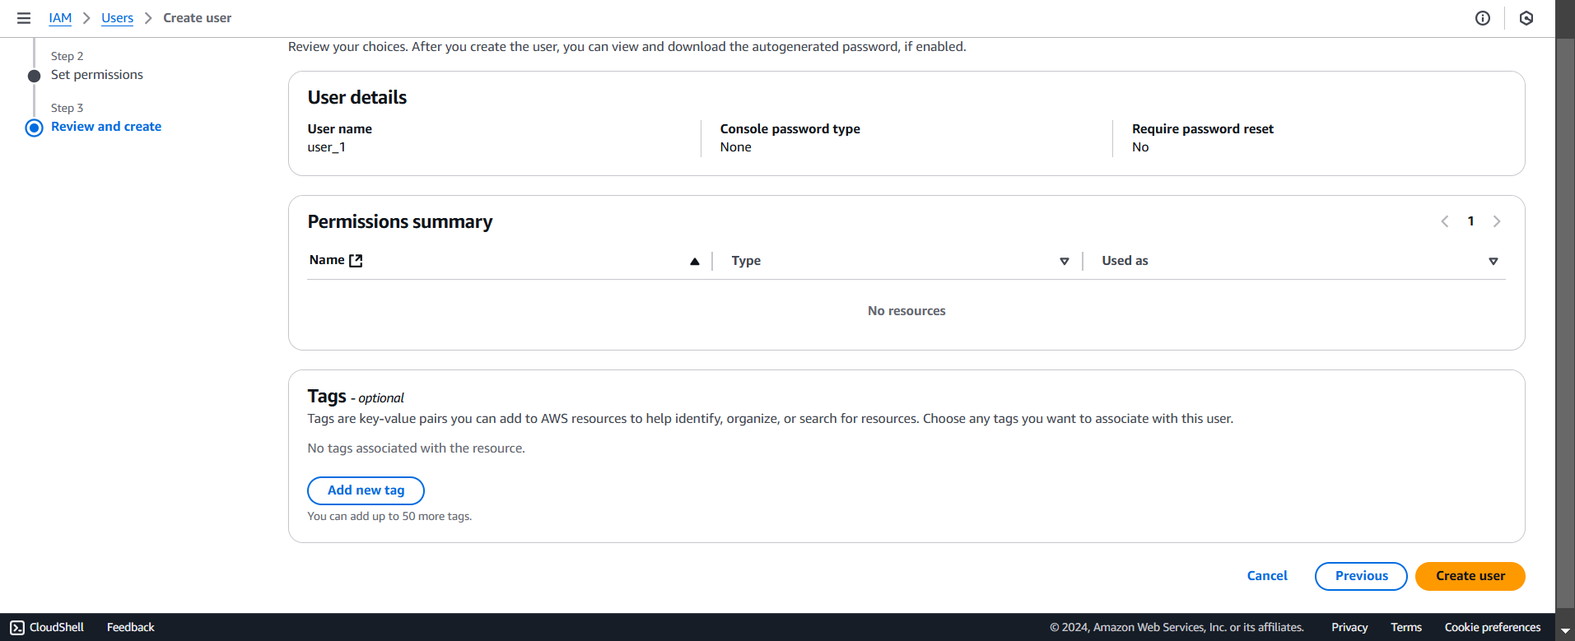

Step7: Successfully created used…

