Lambda

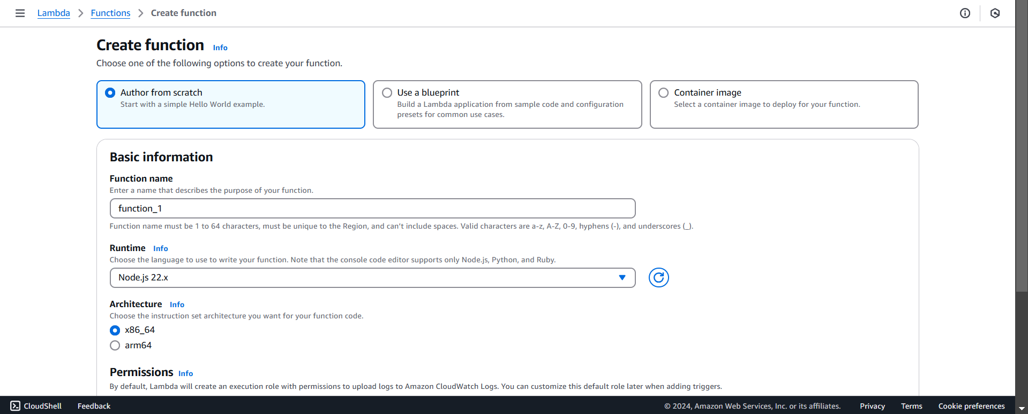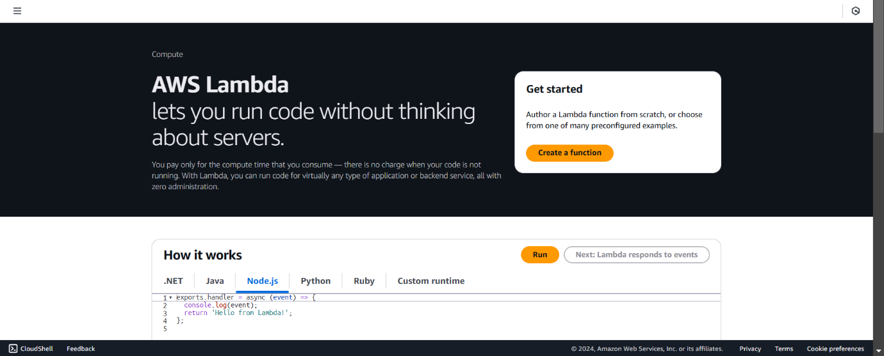

Step2: Select from 3 options like, author from scratch, use as blueprint, container image, and enter the basic function details like function name, runtime usually use python, and last one fill architecture and scroll down then click on the create function.

**Step1: Open the Lambda Service:** Search for **"Lambda"** in the search bar and select the **Lambda** service

Step3: Then successfully created lambda function.

