Simple Notification Service

Step1 - Go to AWS Console → Search for **SNS**.

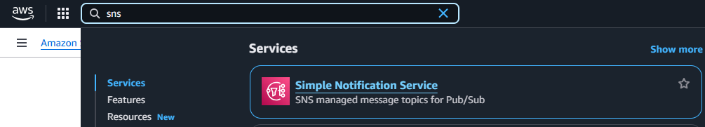

Step2 - Click **Topics** → **Create Topic**.

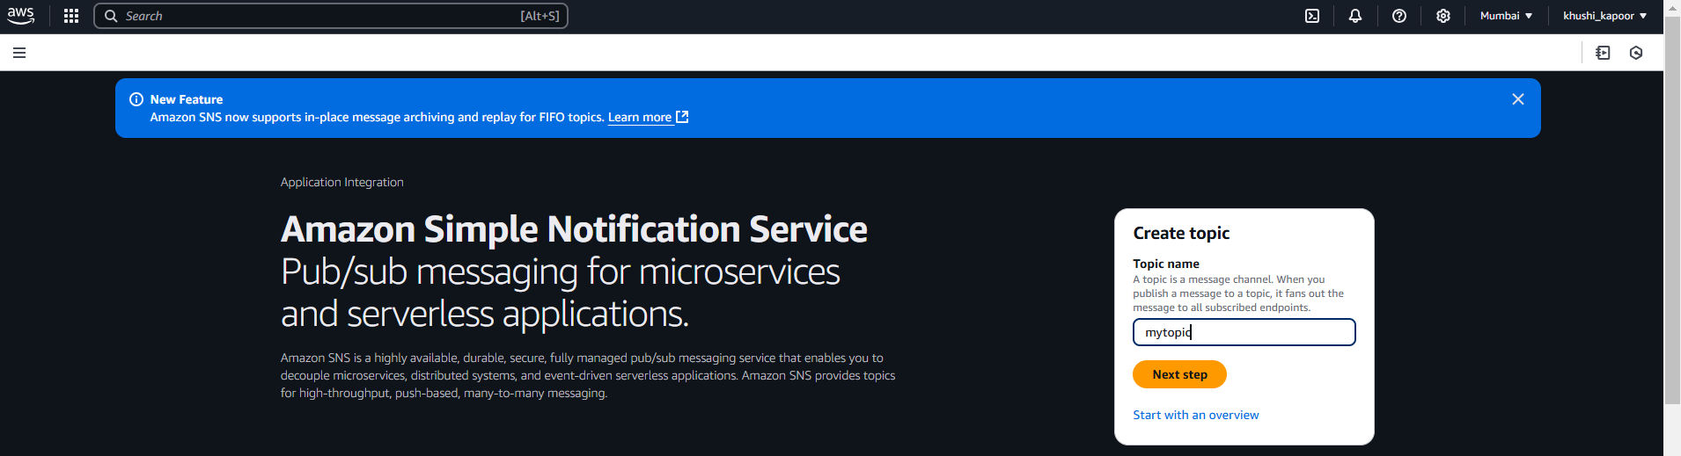

Step3 - Choose the type: Standard or FIFO (use Standard for most cases).

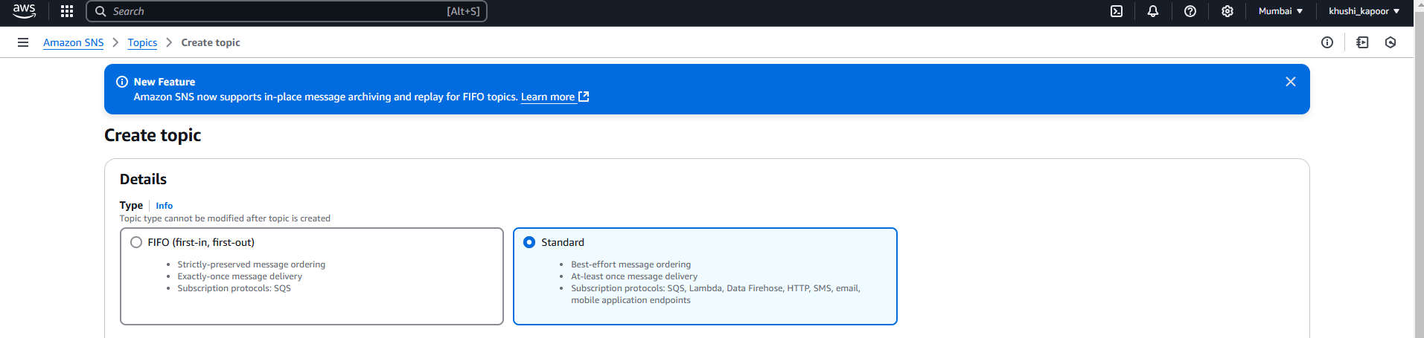

Step4 – Create Topic

