**Simple Queue Service**

Step1 - Go to AWS Console → Search for **SQS**.

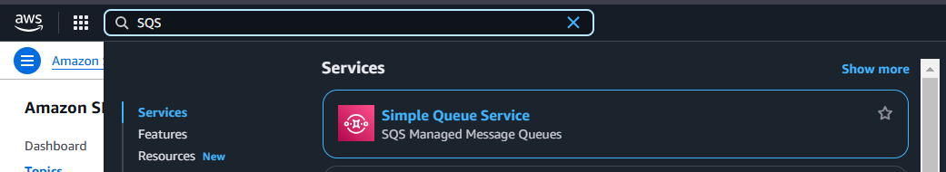

Step2 - **Create Queue**.

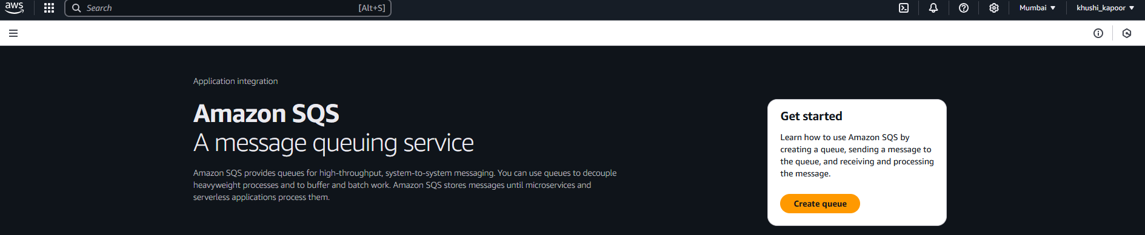

Step3 - Choose a type:

* **Standard**: Best-effort ordering (most use cases).
* **FIFO**: First-In-First-Out for order-sensitive tasks.

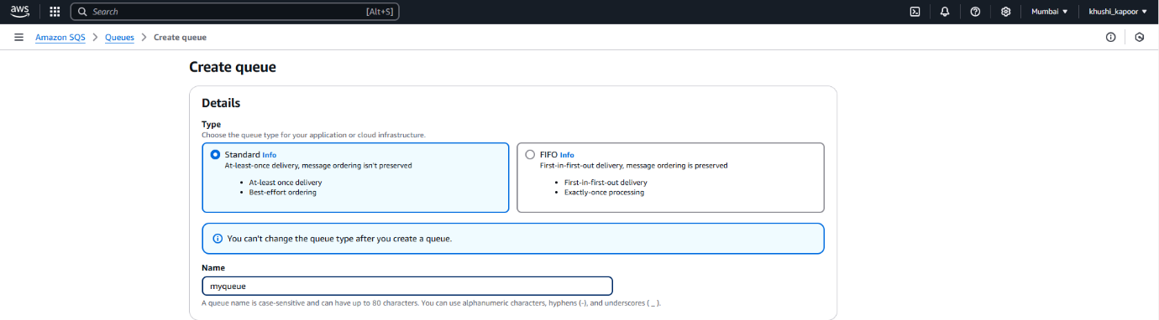

Step5 - Enter a **Queue Name** and create queue

