**Virtual Private Cloud**

Step1 - Go to AWS Console → Search for **VPC**.

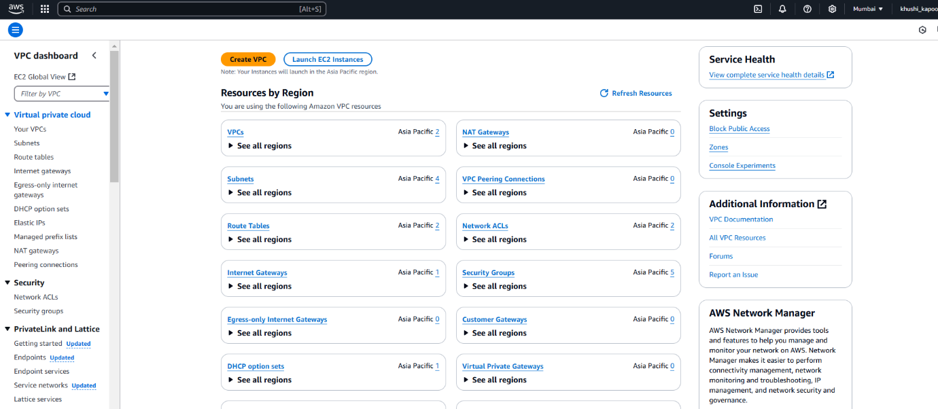

Step2 - **Create VPC**.

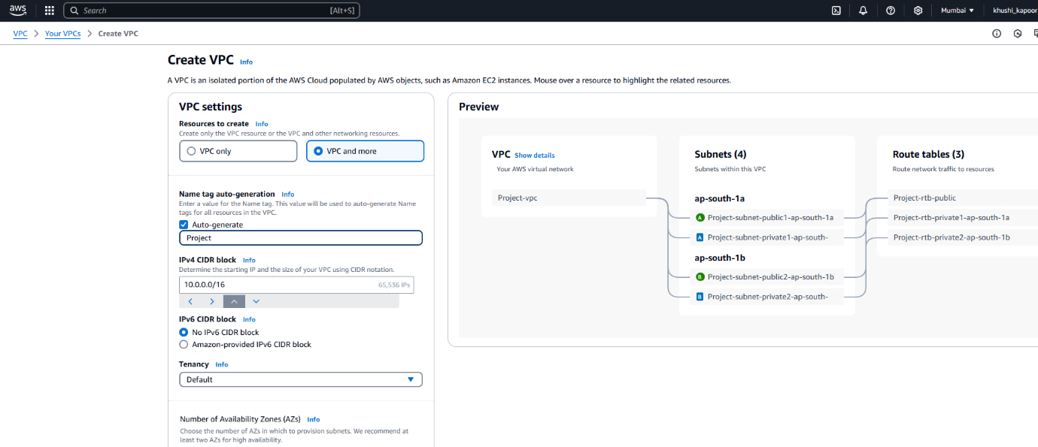

Step3 - **Create VPC**

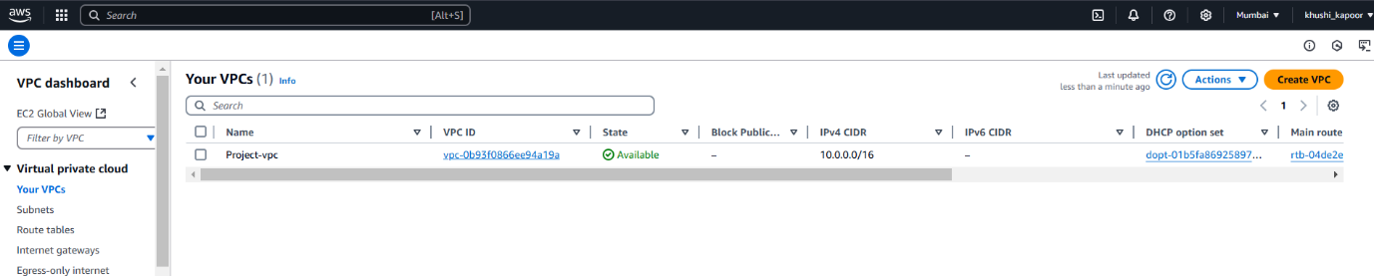

Step4 – Go to **VPC Dashboard** → **Subnets** → **Create Subnet**.

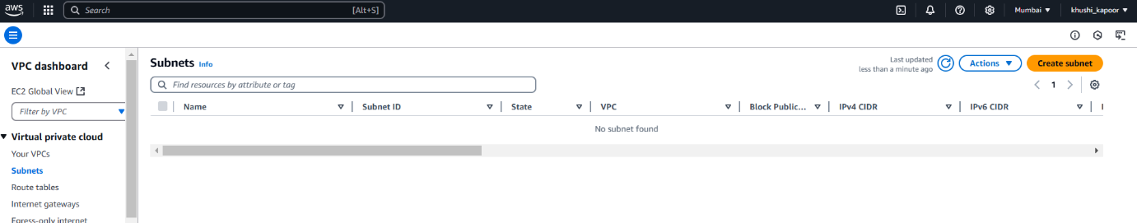

Step5 - Select your **VPC**.

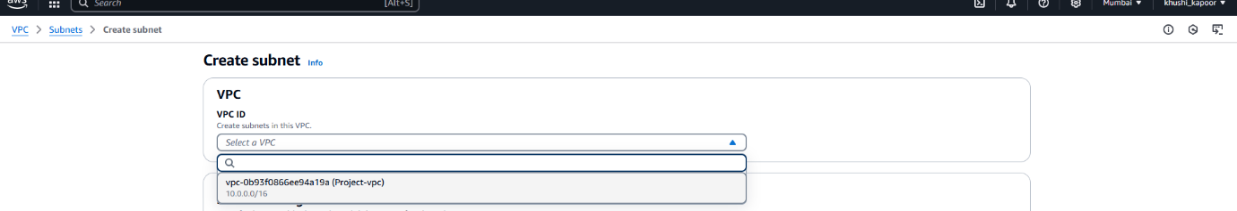

Step6 - Define details for each subnet:

* Name Tag: Friendly name (e.g., Public-Subnet).
* Availability Zone: Choose a zone (e.g., us-east-1a).
* IPv4 CIDR Block: A range within the VPC’s block (e.g., 10.0.1.0/24).

