# Vegetation-Classification-based-on-Leaf-Pattern

How to run the Project in your system

First download the zip file and then extract the zip folder

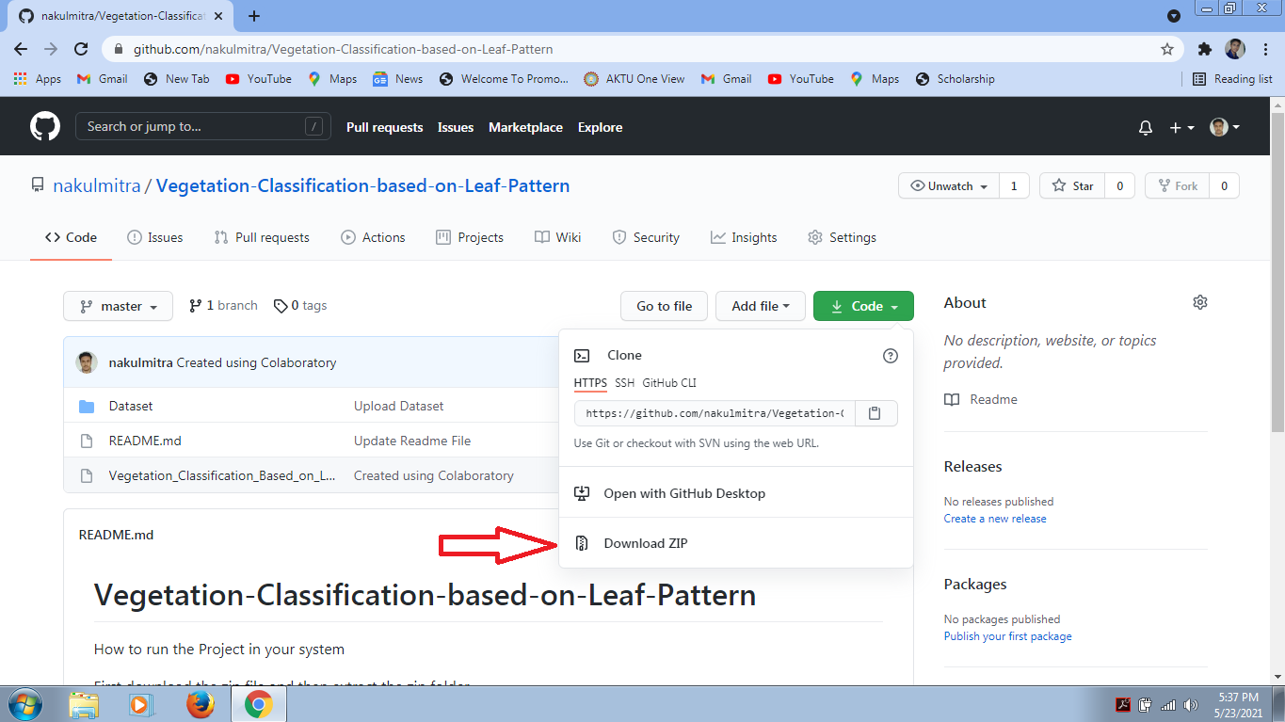

Convert the Dataset folder into zip file

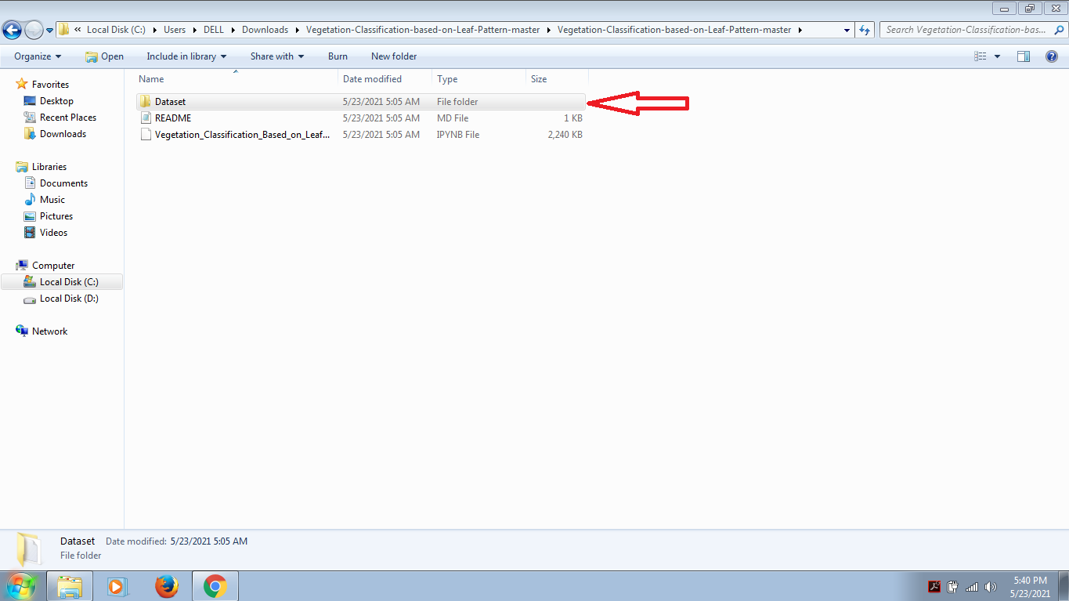

Upload the .ipynb and Dataset zip file into your Google Drive

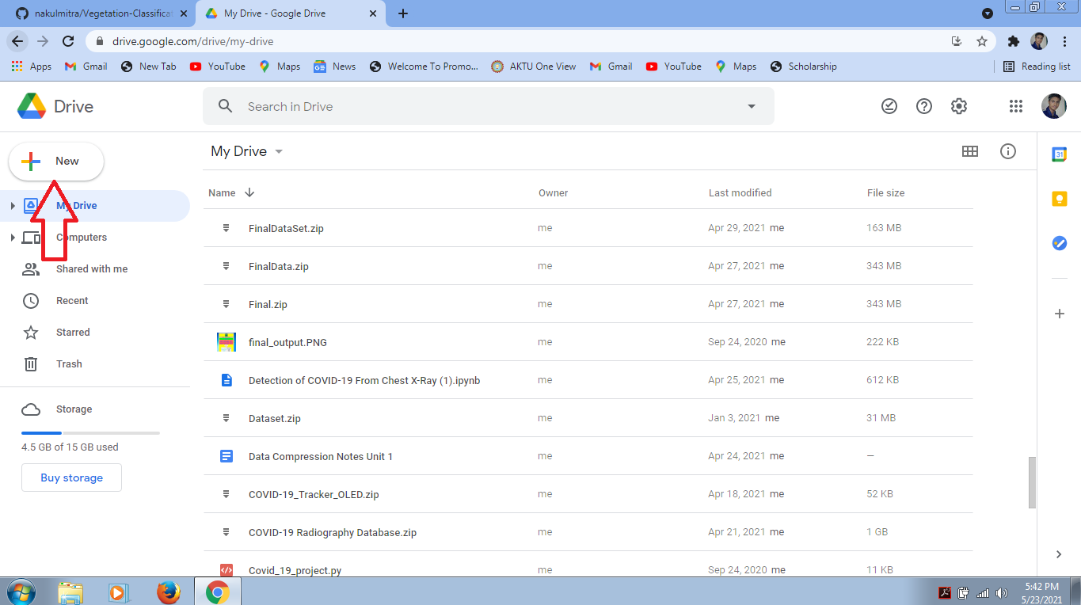

Double Click on .ipynb file. It will ask you to open with Google Colaboratory. Click on it. If there is no option of Google Colaboratory in your drive then you need to install Google Colaboratory

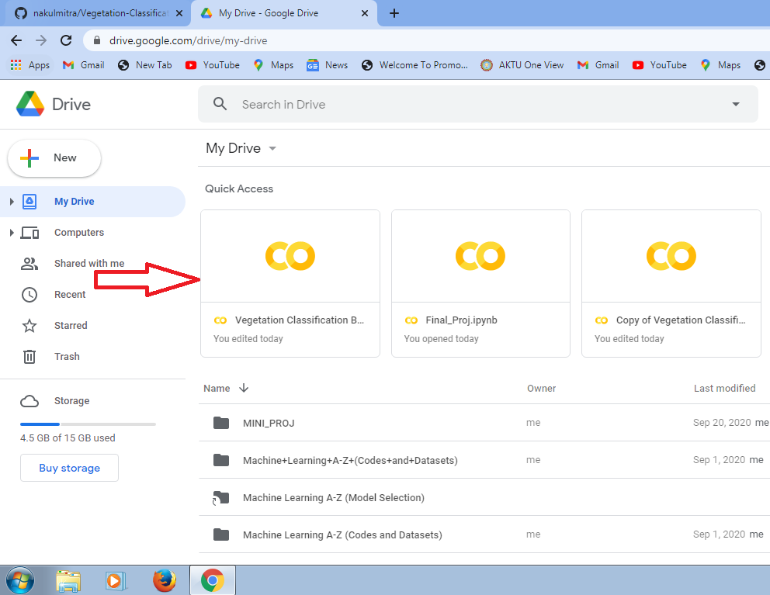

After you open the .ipynb file in Google Colaboratory then you first need to click on connect button

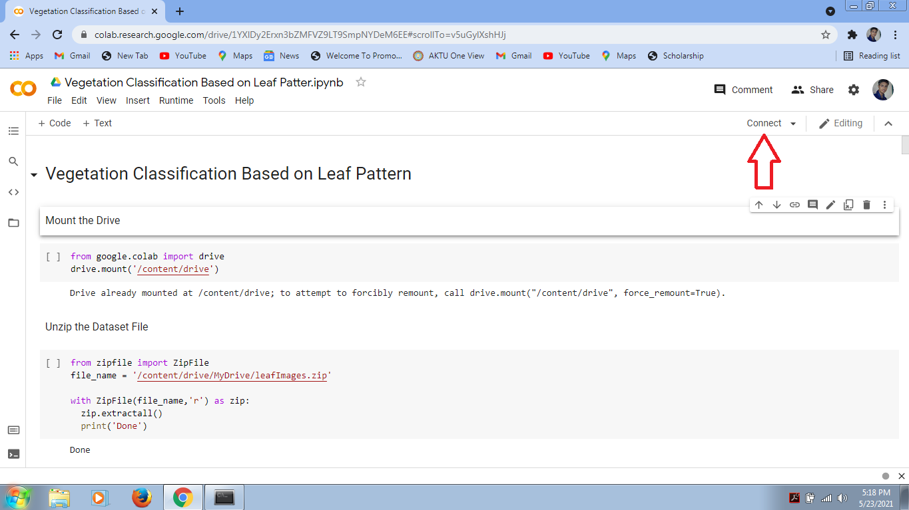

Click on the Runtime button there is a option of run all, click on it

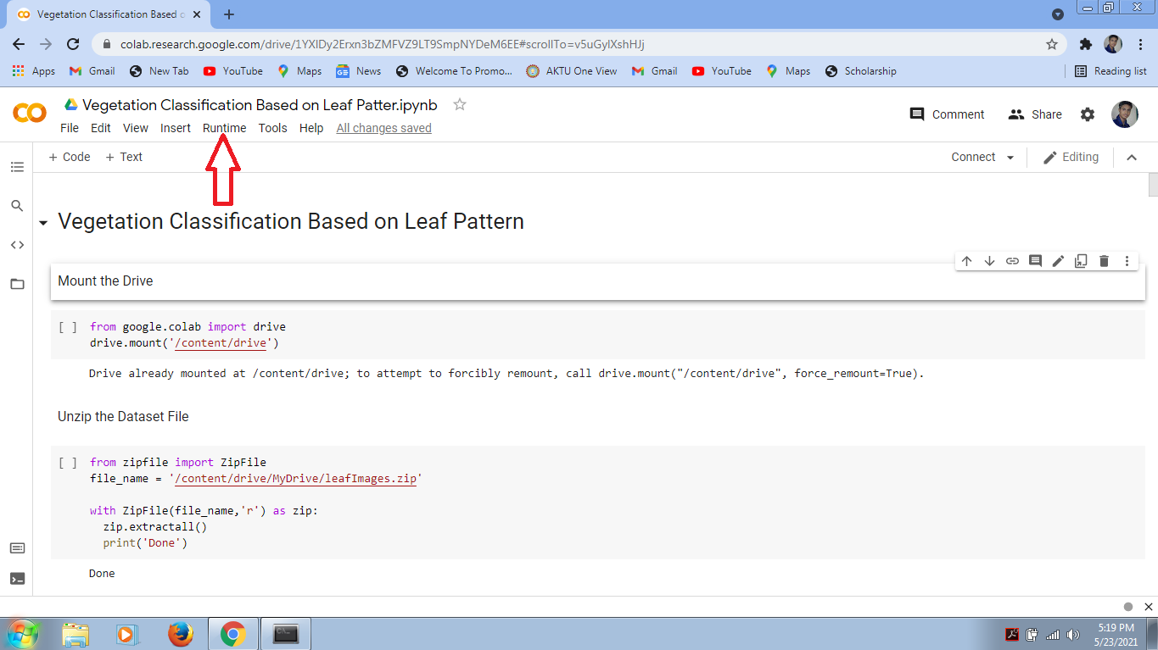

Code and Observation will be uploaded soon.