# Part 1: Bollinger Band Strategy

stock_symbol = 'IBM'

start_date = '2007-12-31'

end_date = '2009-12-31'

start_val = 10000

### Result

Data Range: 2007-12-31 to 2009-12-31

Sharpe Ratio of Fund: 0.977668660132

Sharpe Ratio of $SPX: -0.21996865409

Cumulative Return of Fund: 0.3615

Cumulative Return of $SPX: -0.240581328829

Standard Deviation of Fund: 0.0108802895522

Standard Deviation of $SPX: 0.0219524869863

Average Daily Return of Fund: 0.000670088055509

Average Daily Return of $SPX: -0.000304189525556

Final Portfolio Value: 13615.0

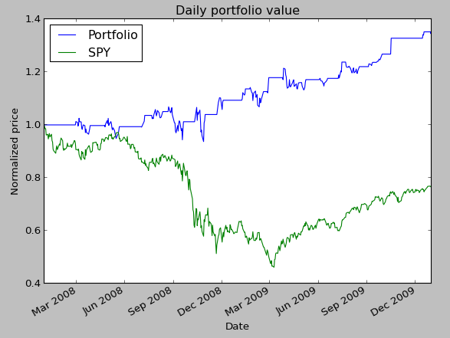

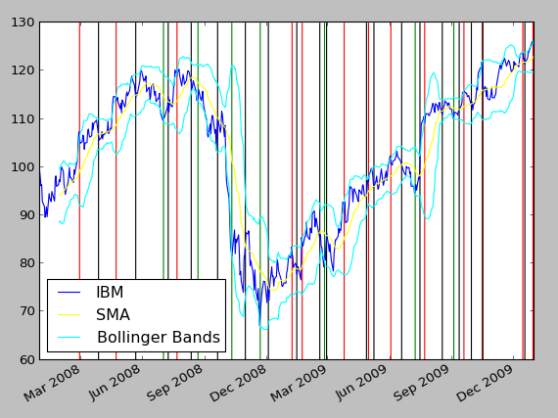

# Part 2: My Strategy

My strategy is similar to basic Bollinger Band strategy, with small alteration which I believe makes it much safer and also outperforms the basic Bollinger Band strategy.

Thought is that a lot of time with Basic Bollinger band strategy, after entering short/long position the exit signal usually takes long time to come. And in the mean time before the stock price crosses Simple Moving Average (SMA); exit point; it oscillates multiple times between the Bollinger Band and SMA. These would all be trading opportunities missed. We need more frequently occurring exit points.

But more than missing trading opportunities to make more money, in my opinion it is more important for strategy to be safe. Basic Bollinger strategy performs poorly with stocks that are rising or dipping over time. For example, AAPL consistently grew over past years. Bollinger Band strategy would lose money in this case because after coming down from upper band it would short the stock, and then the exit position would not come for many months since the stock is rising. And when exit position finally comes the stock price will have risen a lot making you lose money. This is another reason for having shorter and more frequently occurring exit points.

My strategy entry exit points as below:

20 Day Simple Moving Average (SMA)

Upper Band = SMA + 20 day standard deviation.

Upper Band 2 = SMA + 2 * 20 day standard deviation.

Lower Band = SMA - 20 day standard deviation.

Lower Band 2 = SMA - 2 * 20 day standard deviation.

There are two potential entries, long and short. The long entry is made when the price transitions from below the Lower Band 2 to above the Lower Band 2. This indicates that the stock price has moved substantially away from the moving average, but is now moving back towards the moving average. When this entry signal criteria is met, buy the stock and hold it until the exit. The exit signal occurs when the price moves from below the Lower Band to above it.

The short entry and exit are mirrors of the long entry and exit: The short entry is made when the price transitions from above the Upper Band 2 to below the Upper Band 2. This indicates that the stock price has moved substantially away from the moving average, but is now moving back towards the moving average. When this entry signal criteria is met, short the stock and hold it until the exit. The exit signal occurs when the price moves from above the Upper Band to below it.

##### My strategy is able to outperform with IBM 2008-2009 by taking advantage of price oscillation between traditional Bollinger Band and SMA.

stock_symbol = 'IBM'

start_date = '2007-12-31'

end_date = '2009-12-31'

start_val = 10000

### Result

Data Range: 2007-12-31 to 2009-12-31

Sharpe Ratio of Fund: 1.7535739339

Sharpe Ratio of $SPX: -0.21996865409

Cumulative Return of Fund: 0.386

Cumulative Return of $SPX: -0.240581328829

Standard Deviation of Fund: 0.00601537988286

Standard Deviation of $SPX: 0.0219524869863

Average Daily Return of Fund: 0.000664487583103

Average Daily Return of $SPX: -0.000304189525556

Final Portfolio Value: 13860.0

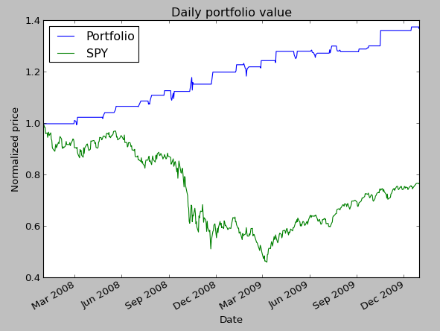

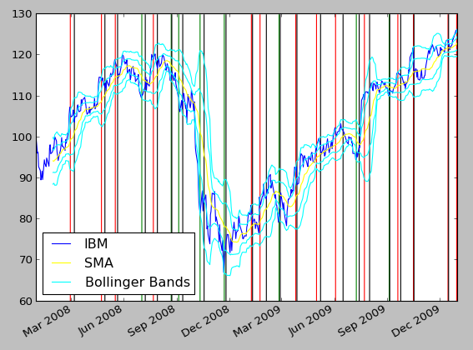

## Test using AAPL

##### Here is an example of how my strategy is safer than basic Bollinger Band strategy in the case where the stock is rising or dipping over time. This situation is bound to make you lose lots of money using basic Bollinger Band strategy.

##### Here is example using AAPL:

start_date = '2007-12-31'

end_date = '2009-12-31'

start_val = 10000

#### Bollinger Band Strategy:

Data Range: 2007-12-31 to 2009-12-31

Sharpe Ratio of Fund: -0.54976902235

Sharpe Ratio of $SPX: -0.21996865409

Cumulative Return of Fund: -0.4938

Cumulative Return of $SPX: -0.240581328829

Standard Deviation of Fund: 0.0278530657376

Standard Deviation of $SPX: 0.0219524869863

Average Daily Return of Fund: -0.000964612752024

Average Daily Return of $SPX: -0.000304189525556

Final Portfolio Value: 5062.0

My Strategy:  
Data Range: 2007-12-31 to 2009-12-31

Sharpe Ratio of Fund: -0.295198266208

Sharpe Ratio of $SPX: -0.21996865409

Cumulative Return of Fund: -0.2587

Cumulative Return of $SPX: -0.240581328829

Standard Deviation of Fund: 0.0205723989585

Standard Deviation of $SPX: 0.0219524869863

Average Daily Return of Fund: -0.000382559040909

Average Daily Return of $SPX: -0.000304189525556

Final Portfolio Value: 7413.0

##### In this case, because of the more frequently occurring exit points we do not lose nearly as much money as basic Bollinger Band strategy making my strategy much safer.

##### From the below charts you will notice that with basic Bollinger Band strategy, most of the money is lost by entering a short position at March 19, 2008 and not being able to exit until May 21, 2008 because the stock was rising causing us to lose a lot of money. And same with the short position at March 19, 2009 which it exits on May 12, 2009.

##### In these scenarios, my strategy is able to outperform basic Bollinger Band strategy by utilizing shorter exit intervals to get out of bad positions quickly.

### Bollinger Band Strategy, AAPL:

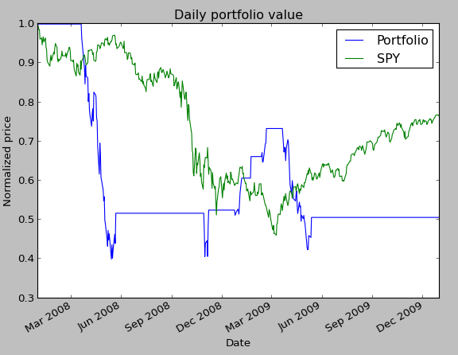

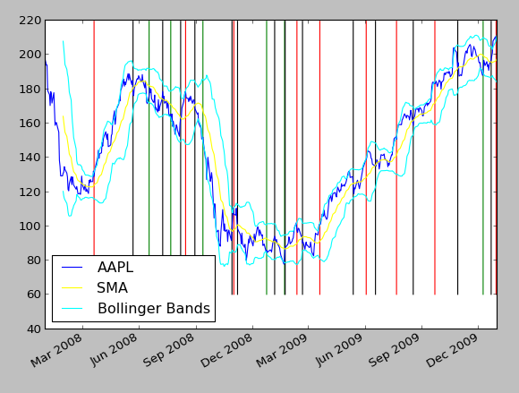

### My Strategy, AAPL:

