# Strategy

**Technical Indicators Used**

Values for all indicators range from -1.0 to 1.0.  
 **Bollinger Value**: is calculated using Bollinger band calculation done in previous project. The formula used to calculate the Bollinger value  
*bb\_value[t] = (price[t] - SMA[t])/(2 \* stdev[t])*

**Momentum**: The formula used to calculate the momentum  
*momentum[t] = (price[t]/price[t-N]) - 1*

**Volatility**: The formula used to calculate the volatility  
*normed[t] = (mean - value[t])/stdev[t]*

**Y – Value**

**Y:** Represents future 5 day return. The formula used to calculate Y  
*Y[t] = (price[t+5]/price[t]) - 1.0*

**Trading Strategy**

For my strategy, I have used KNN learner without bagging to train my model using k=5. For the Bollinger Value technical indicator I have used 10 days for simple moving average instead of default 20 days.

I have used similar constraints as previous projects, as far as number of stocks to buy and number of positions to hold at any given time. My trading strategy will hold at most 1 position at any time and will only buy or sell 100 stocks at a time.

My strategy will long 100 stocks when price is predicted to go up by 1% and hold for at least 5 days. After 5 days, it will exit on a day when price in following 5 days is not predicted to go up by 1% more. At the minimum the strategy will hold the position for 5 days. There is no maximum limit for number of days to hold a position.

Similar strategy as above for short position.

Charts below are generated using starting portfolio value of 10000.

# ML4T-399: In-Sample

**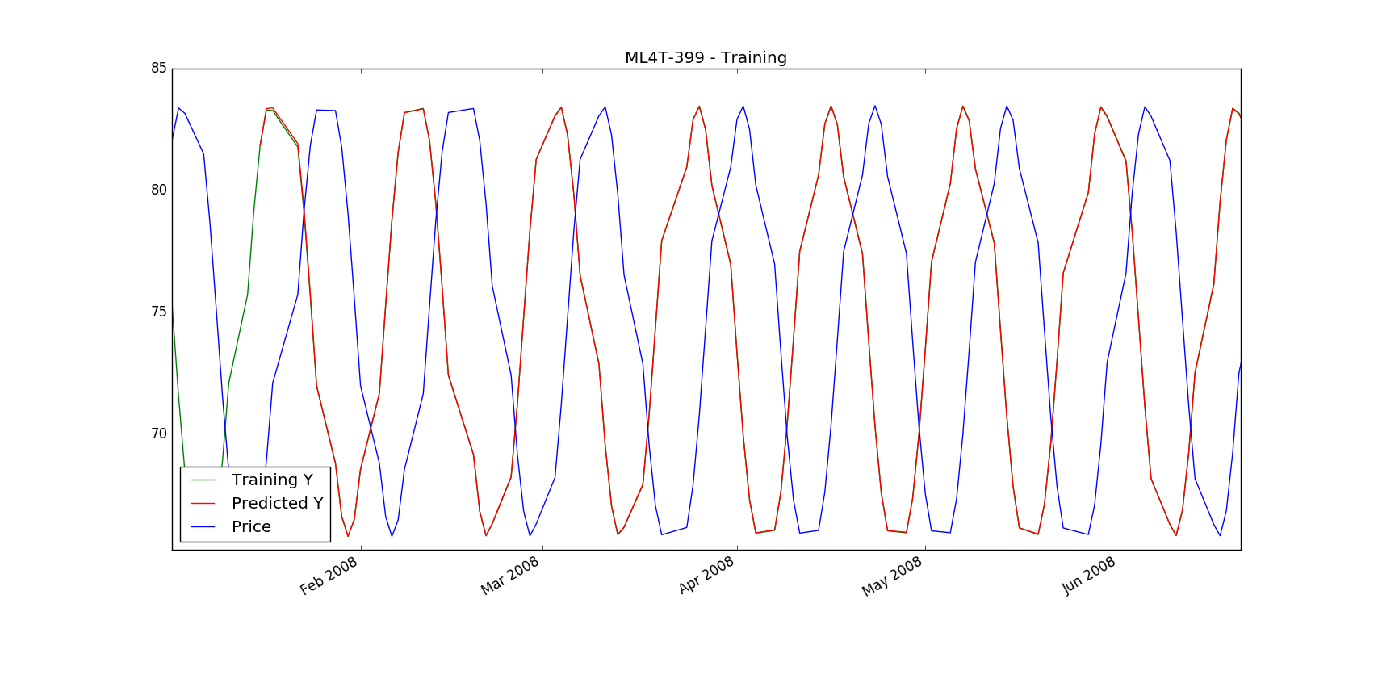**

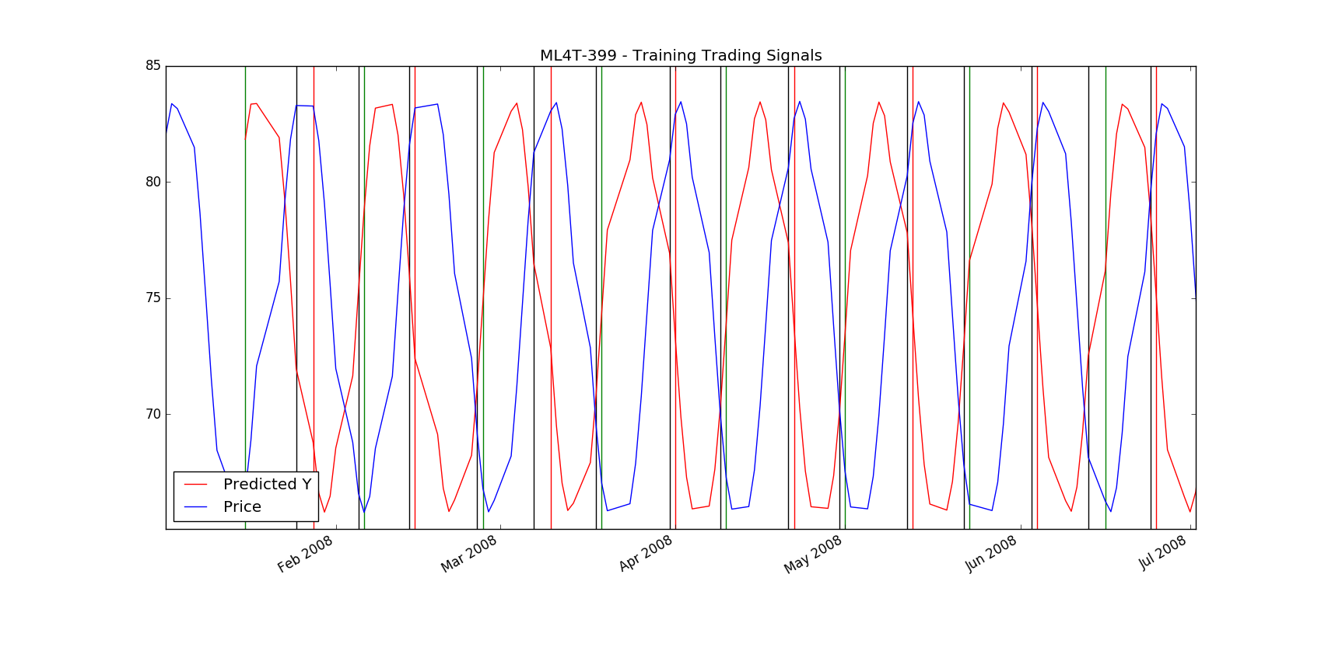Green vertical lines indicate to enter long position, red vertical lines indicate to enter short position and black vertical lines indicate to exit position.

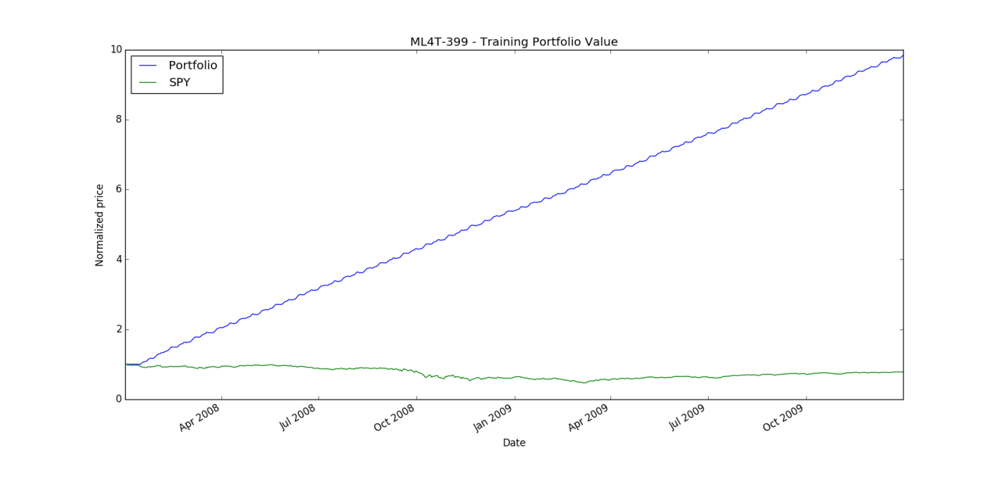

**ML4T-399: In-Sample Portfolio Statistics**

Data Range: 2008-01-01 to 2009-12-31

Sharpe Ratio of Fund: 11.8635094751

Sharpe Ratio of $SPX: -0.199573937554

Cumulative Return of Fund: 8.83781098

Cumulative Return of $SPX: -0.229456314437

Standard Deviation of Fund: 0.00610825781853

Standard Deviation of $SPX: 0.0219652414615

Average Daily Return of Fund: 0.00456488951444

Average Daily Return of $SPX: -0.0002761464963

Final Portfolio Value: 98378.1098

# ML4T-399: Out of Sample

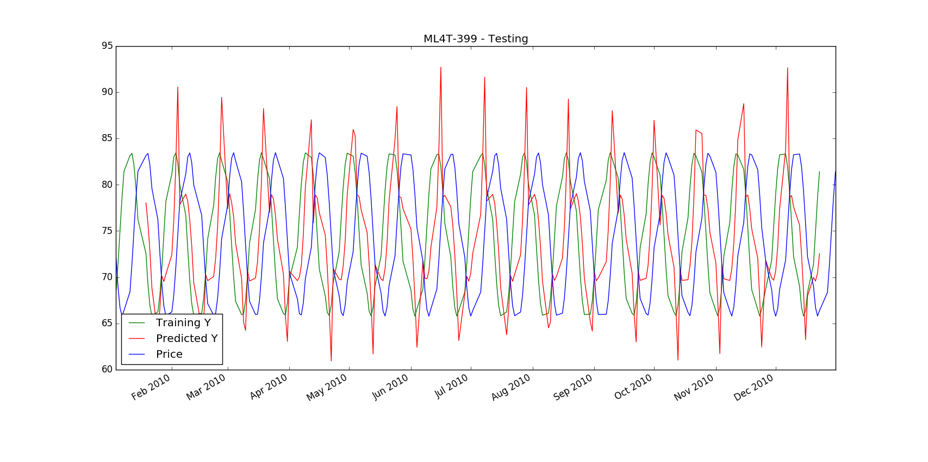

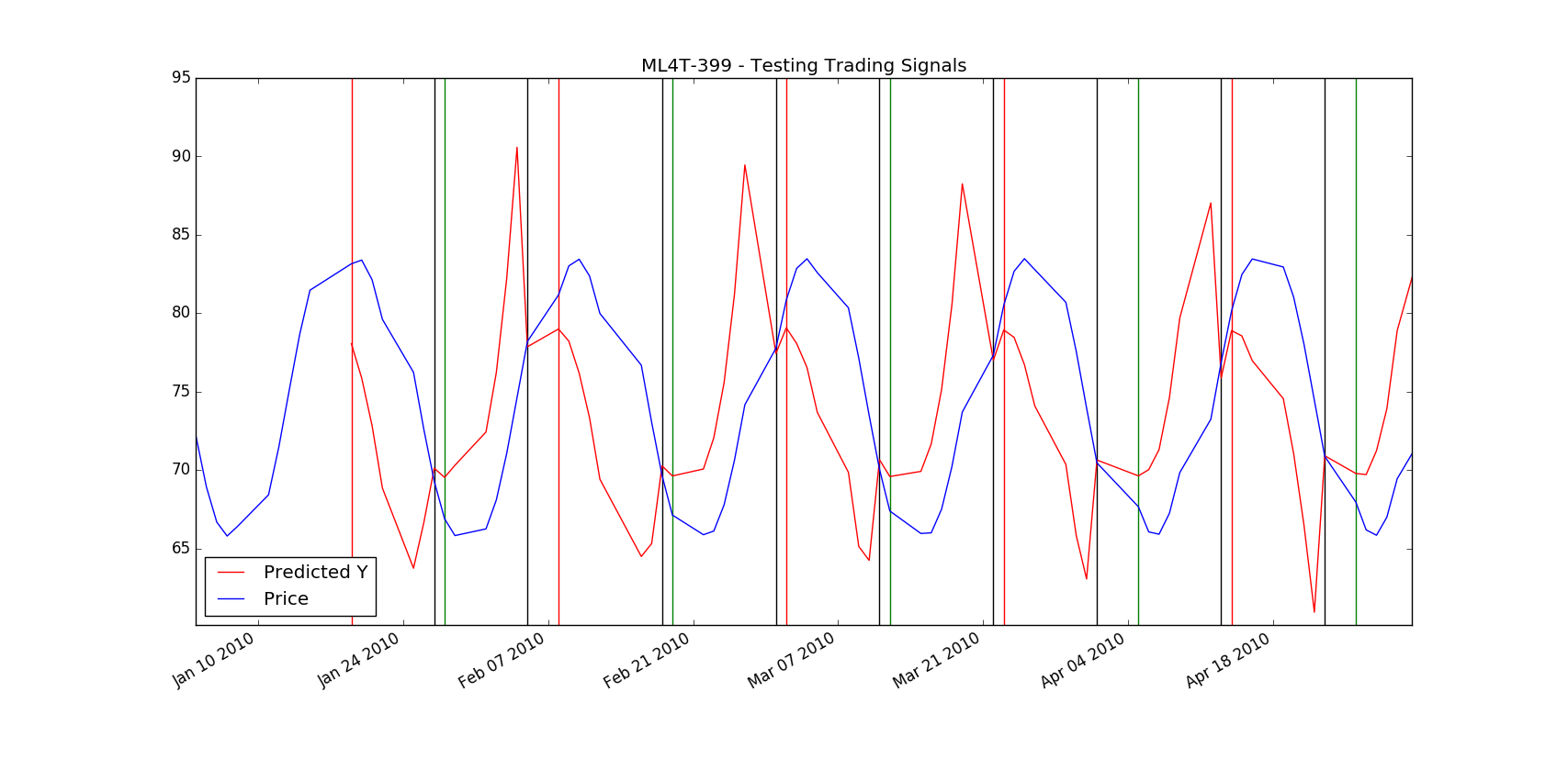

Green vertical lines indicate to enter long position, red vertical lines indicate to enter short position and black vertical lines indicate to exit position.

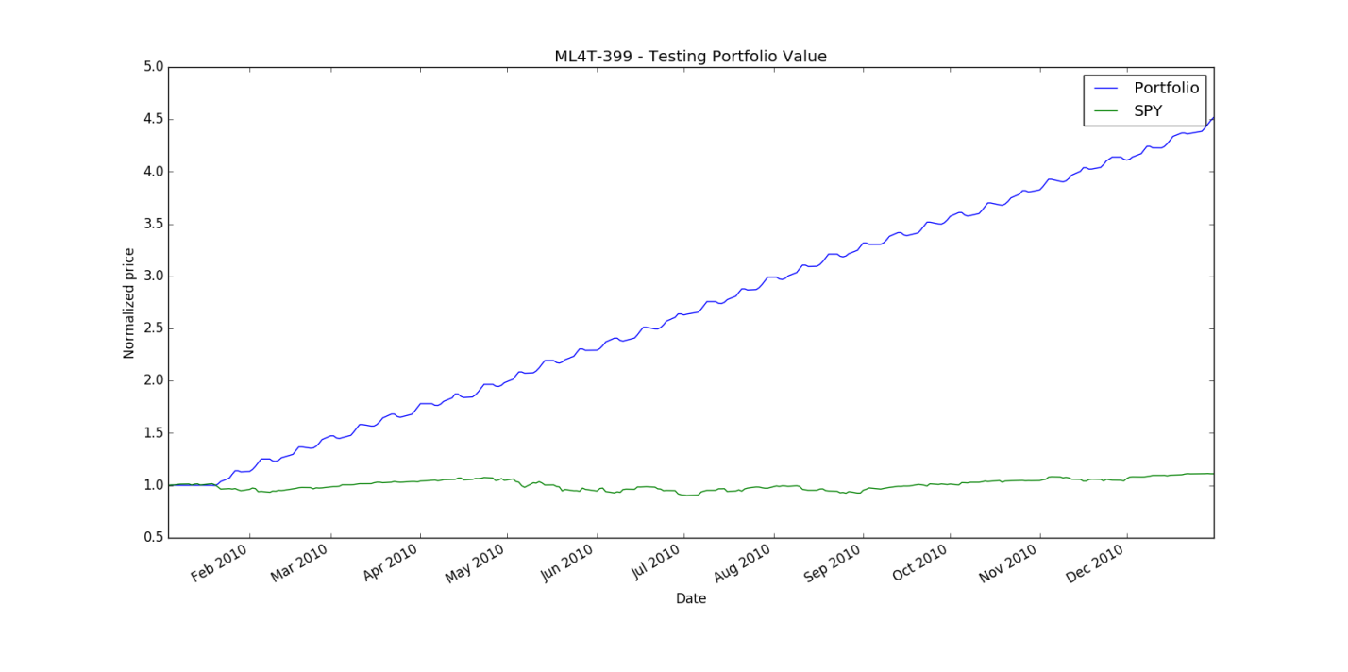

**ML4T-399: Out of Sample Portfolio Statistics**

Data Range: 2010-01-01 to 2010-12-31

Sharpe Ratio of Fund: 10.5510539559

Sharpe Ratio of $SPX: 0.671461673758

Cumulative Return of Fund: 3.51639646

Cumulative Return of $SPX: 0.110018623289

Standard Deviation of Fund: 0.00912657370732

Standard Deviation of $SPX: 0.0113518252015

Average Daily Return of Fund: 0.00606601303356

Average Daily Return of $SPX: 0.00048016074666

Final Portfolio Value: 45163.9646

# IBM: In-Sample C:\Users\Nakul\Desktop\knnlearner\IBM\figure_1-1.png

Green vertical lines indicate to enter long position, red vertical lines indicate to enter short position and black vertical lines indicate to exit position.

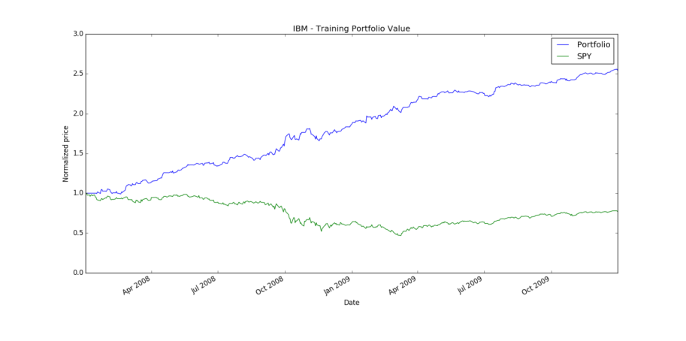

**IBM: In-Sample Portfolio Statistics**

Data Range: 2008-01-01 to 2009-12-31

Sharpe Ratio of Fund: 3.0885116042

Sharpe Ratio of $SPX: -0.199573937554

Cumulative Return of Fund: 1.5445

Cumulative Return of $SPX: -0.229456314437

Standard Deviation of Fund: 0.00977695735215

Standard Deviation of $SPX: 0.0219652414615

Average Daily Return of Fund: 0.0019021847159

Average Daily Return of $SPX: -0.0002761464963

Final Portfolio Value: 25445.0

# IBM: Out of Sample

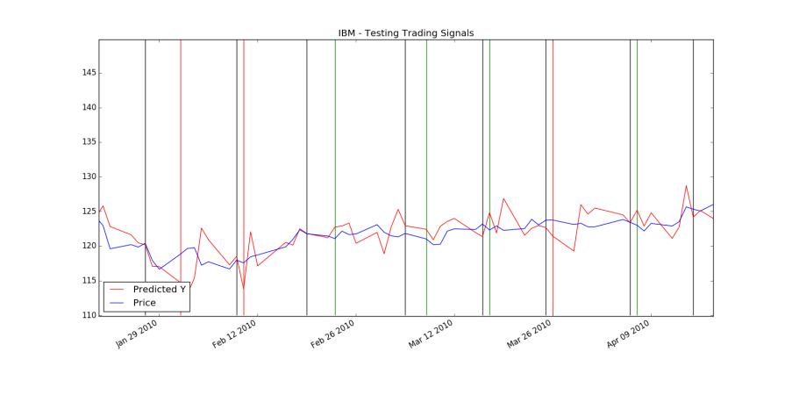

Green vertical lines indicate to enter long position, red vertical lines indicate to enter short position and black vertical lines indicate to exit position.

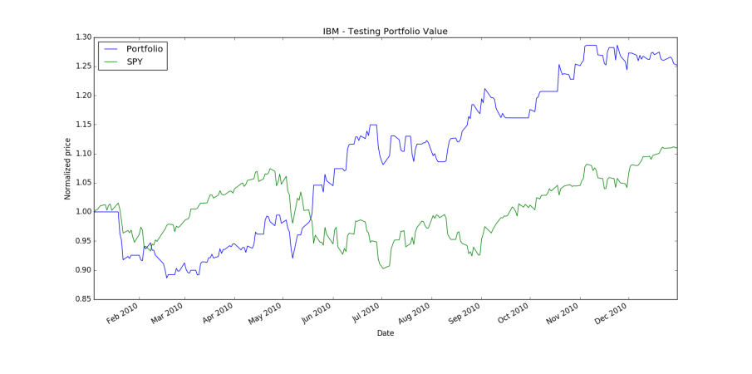

**IBM: Out of Sample Portfolio Statistics**

Data Range: 2010-01-01 to 2010-12-31

Sharpe Ratio of Fund: 1.33707231791

Sharpe Ratio of $SPX: 0.671461673758

Cumulative Return of Fund: 0.2524

Cumulative Return of $SPX: 0.110018623289

Standard Deviation of Fund: 0.0114169145017

Standard Deviation of $SPX: 0.0113518252015

Average Daily Return of Fund: 0.00096161975317

Average Daily Return of $SPX: 0.00048016074666

Final Portfolio Value: 12524.0

**Did it work well?**

My strategy did work, but I do not believe it will work in all situations with any stock. As you can see that even with IBM, the strategy did poorly for first two months before doing extremely well.

**Why?**

I believe there is more than just particular stock history that matters when predicting future. Other factors such as how the particular industry is doing, how its competitors are doing, how its resources (for example oil price for airline company) are doing matter as well.

**What would you do differently?**

However, I think the results can be improved by adding other indicators and also by using multiple learning methods. I think it would be a good idea to use multiple learning techniques and using mode of the returned predictions.