# Investment Risks for Change Financial

**HMDA Home Loans Report**

The data received by HMDA on the Home loans, was used to generate the following trends which could help Change Financial to calculate and analyse its risks of entering into the “Home Loans” market.

The following tables show theTotal number of loans and the Total amount of loan (in dollars) that was lent by the financial institutions in DC and the nearby states for the consecutive years from 2012 to 2014. The numbers received are quite dissapointing unlike what was expected.

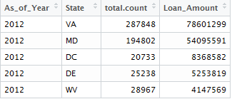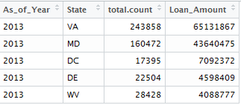

Figure 1: Sum and count of loans in 2012 Figure 2: Sum and count of loans in 2013

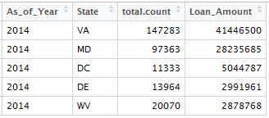

Figure 3: Sum and count of loans in 2014

From the insights created using data provided by HMDA, the financial institutions experienced a decline in loan originations from $8.3 billions in 2012 to $5.0 billions in 2014, a decline of 39.72% . Nearly a fall of 40% within two years shows the residential real estate market doesn’t seem to be on its peak and there are high chances that it may fall further in the coming years.

There is a similar case with the institutions in the nearby state which show a decline in the Total loan origination as well to a great extent. In fact, DC is somewhat in the mid range where as the other state like Virginia which had the max amount of Loan origination had a drop of 47.27% from 2012 through 2014 that is nearly fifty percent.

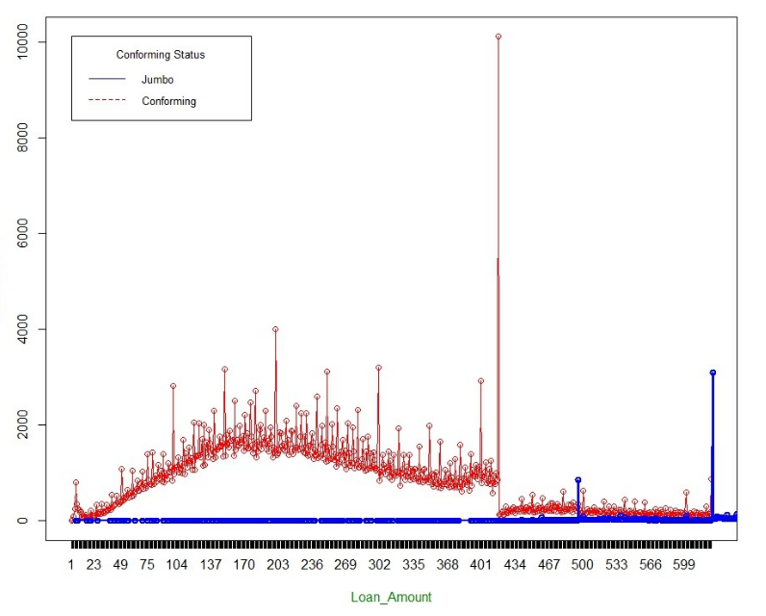

Figure 4: Conforming and Jumbo loans for ’12-‘14

Each year, the FHFA sets "loan limits" which provide the maximum loan size for a loan to be "Conforming", if a loan is greater than this limit, it is said to be "Jumbo".

The above data shows the trend of number of conforming and jumbo loans that was lent by the banks in the market. As per the data, Conforming limit is $417,000. So, the number of loans around that amount seems to be at the peak as compared to the rest which is kind of risky since the lenders are usually less confident in their ability to resell this type of mortgage and hence end up charging higher interest rates to the borrowers.

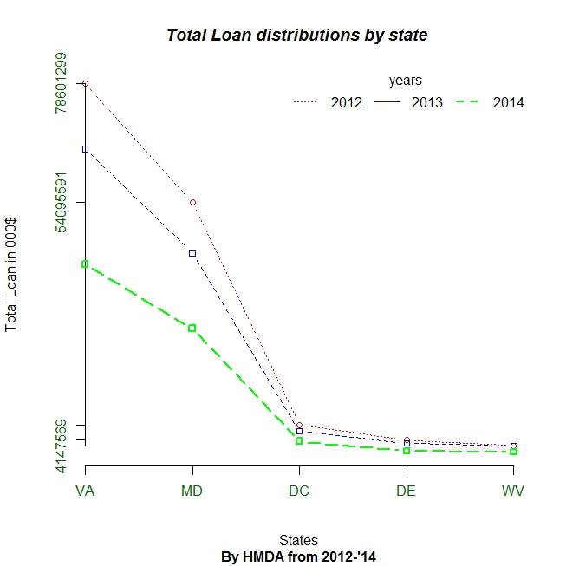

Figure 5

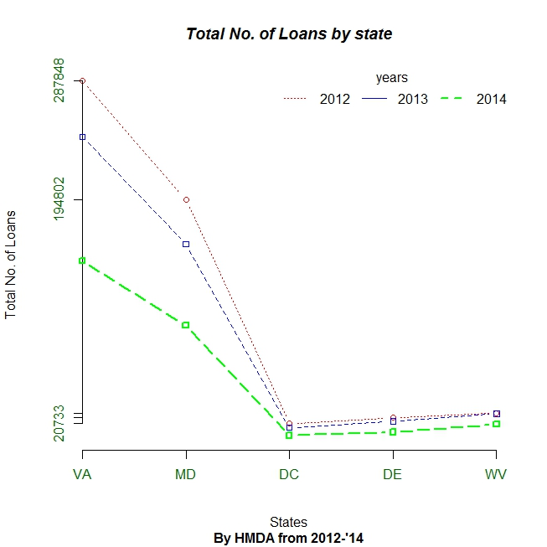

Figure 6

The Residential real estate has experienced a dramatic deterioration in past years (Figure 5 and 6). The market study shows that the small regional banks such as Change Financial hold a pretty small percentage of the market RRE market but can be risky for a novice.

Hence, investing in it at this point of time wouldn’t be a good decision for the company.