OPERATING SYSTEMS AND SYSTEM ENGINEERING
WEEK-1
TASK-1
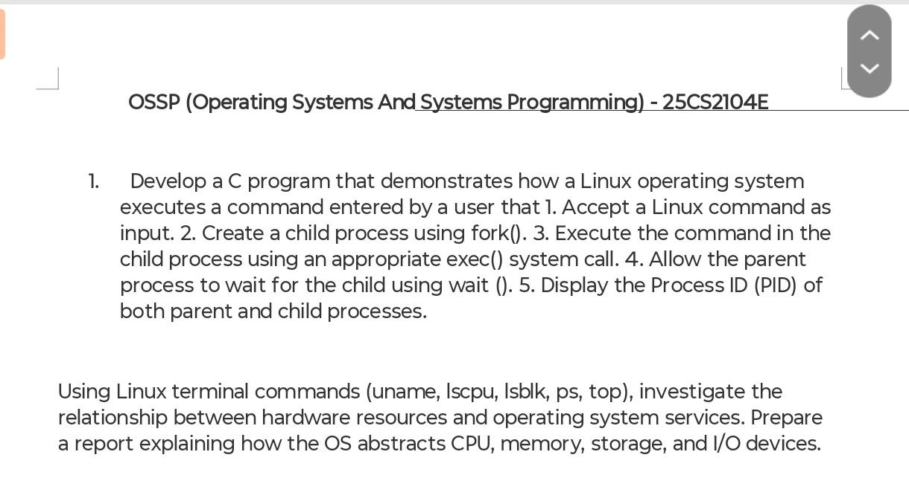

Aim: To develop a C program that demonstrates how the Linux operating system executes a command entered by the user using the fork(), exec(), and wait() system calls. The program also displays the Process IDs (PIDs) of the parent and child processes.
Objective:
- To understand process creation using fork().
- To execute Linux commands using the exec() system call.
- To synchronize parent and child processes using wait().
- To display the Process IDs (PIDs) of both parent and child processes.

Software Requirements:
- Ubuntu Linux / Linux Operating System
- GCC Compiler
- Terminal

System Calls Used:
1. fork()
Creates a new child process.
2. execvp()
Replaces the child process with the command entered by the user.
3. wait()
Makes the parent process wait until the child process finishes execution.
4. getpid()
Returns the Process ID (PID) of the current process.

Algorithm:
- Start the program.
- Read a Linux command from the user.
- Create a child process using fork().
- If the process is the child:
  - Display the Child PID.
  - Execute the entered command using execvp().
- If the process is the parent:
  - Display the Parent PID.
  - Wait for the child process using wait().
- Display that the child process has completed.
- Stop the program.

CODE:
#include <stdio.h>
#include <stdlib.h>
#include <unistd.h>
#include <string.h>
#include <sys/wait.h>
int main()
{
char command[100];
char *args[20];
int i = 0;
printf("Enter Linux Command: ");
fgets(command, sizeof(command), stdin);
command[strcspn(command, "\n")] = '\0';
char *token = strtok(command, " ");
while(token != NULL)
{
args[i++] = token;
token = strtok(NULL, " ");
}
args[i] = NULL;
pid_t pid = fork();
if(pid < 0)
{
printf("Fork Failed\n");
return 1;
}
else if(pid == 0)
{
printf("\nChild Process\n");
printf("Child PID : %d\n", getpid());
execvp(args[0], args);
printf("Command Execution Failed\n");
}
else
{
printf("\nParent Process\n");
printf("Parent PID : %d\n", getpid());
wait(NULL);
printf("Child Process Completed.\n");
}
return 0;
}

OUTPUT:
