**Friend List Assignment**

1. According to the assignment description, once you run index.html, the application front end will look like this

***User List***

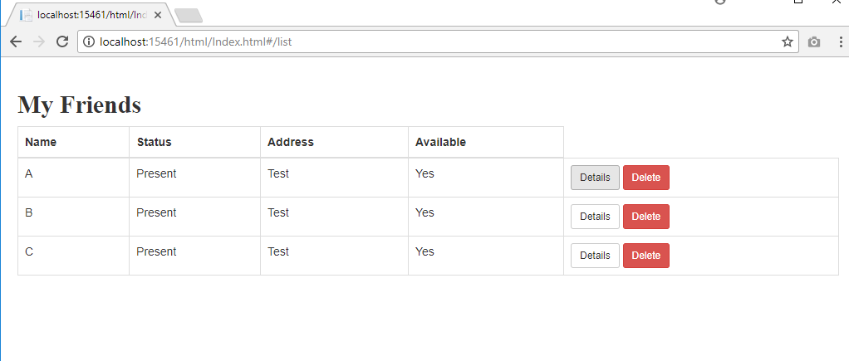

***Detail User***

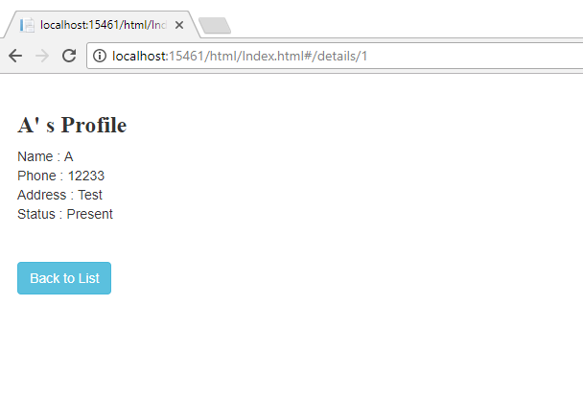

***And User can be deleted by pressing delete button.***

1. Main important design pattern used here due to Angular usage is MVVM

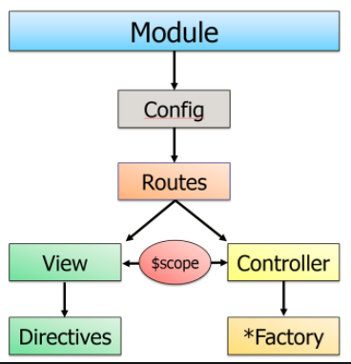

In this assignment, **$scope** object acts as the viewmodel where communication between view and controller bridges to each other. **FriendService.js** acts as the factory.For the **detail.html** and **list.html** views , **detailscontroller.js** and **friendlistcontroller.js** are available. Configurations and routes are done using theFriend.js. Main module is called as theFriend.

Dependency injection pattern in angular is in charge of creating components, resolving their dependencies, and providing them to other components as required.

Ex: **$scope, $routeParams, $routeProvider are some of the objects that are injected as necessary during the creation controllers, configurations etc**

1. For the data access layer, code first approach is used with entity framework. (Used MSSQL)