Simple Application Deployment

**Project Overview**

Create a simple Node.js application and package it into a Docker container for easy deployment.

**Requirements**

* Node.js installed on your machine
* Docker installed on your machine
* A Docker Hub account (for pushing the image)

**Implementation**

**Step 1: Create the Node.js Application**

**Initialize a Node.js Project:🡪**

**npm init -y**

This will create a **package.json** file with default settings.

Install Express lib using

**npm install express**

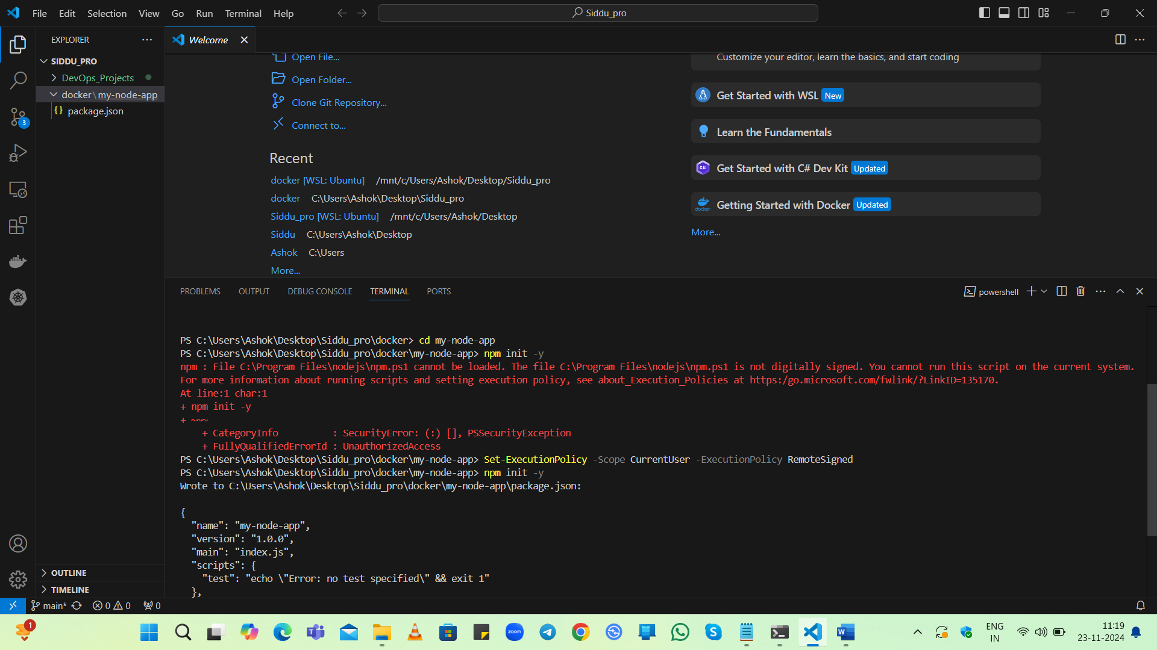

**To resolve the above error 🡪**

**Ref:**

**https://stackoverflow.com/questions/58880139/electron-node-js-ng-file-path-ng-ps1-cannot-be-loaded-because-running-scri**

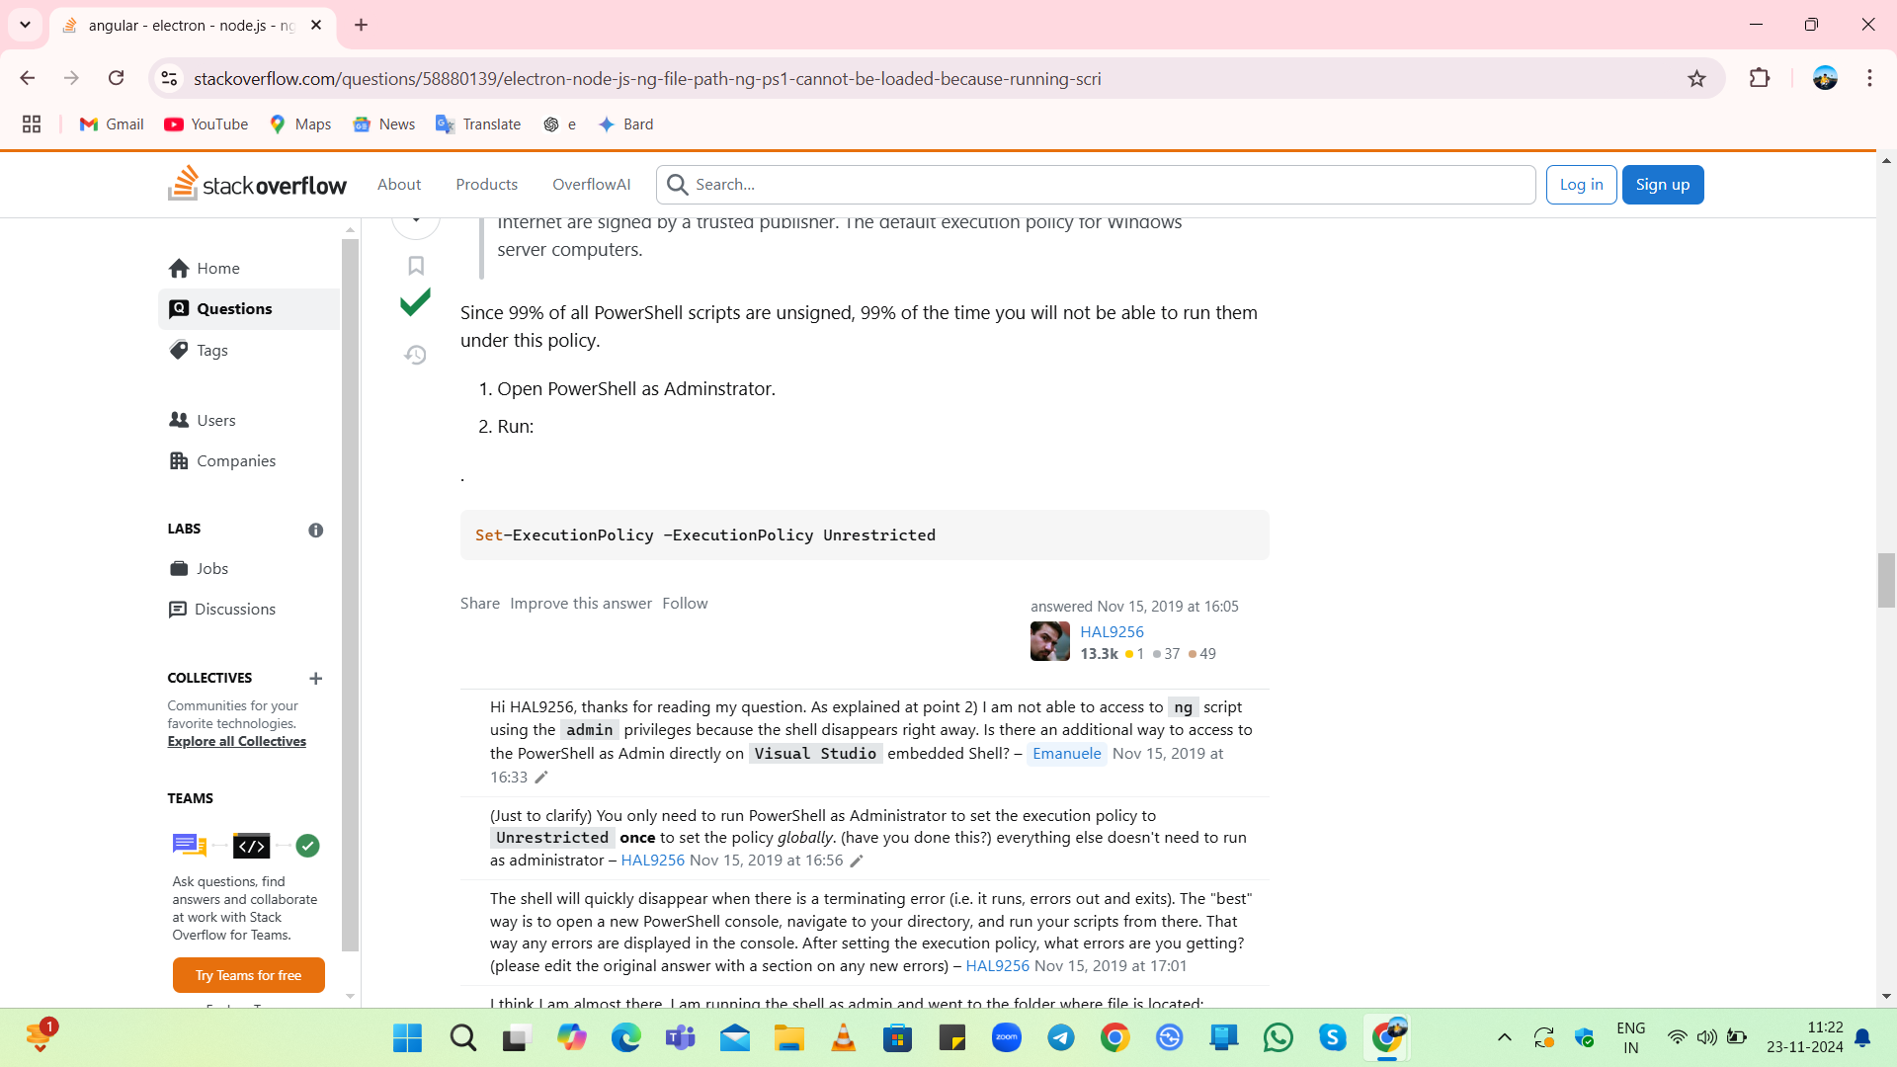

**npm install express**

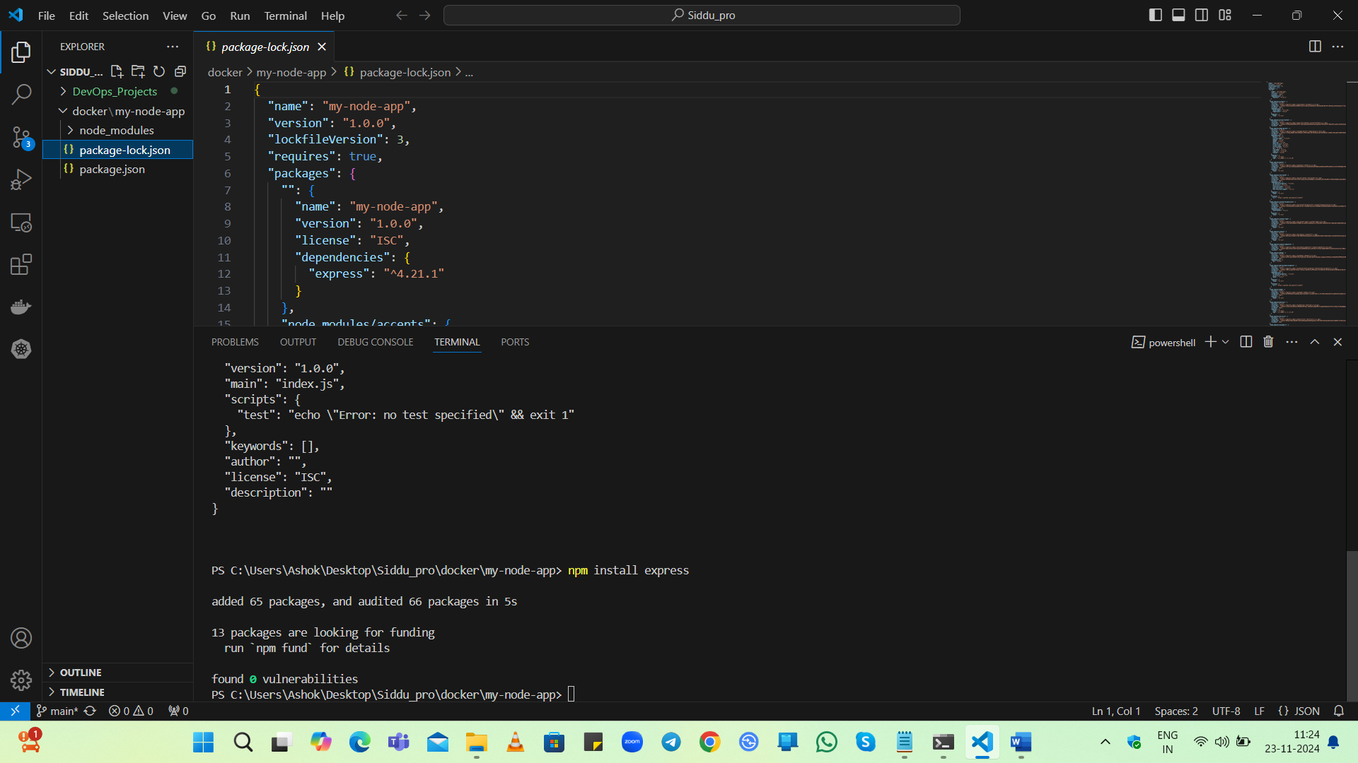

**Create application file as app.js**

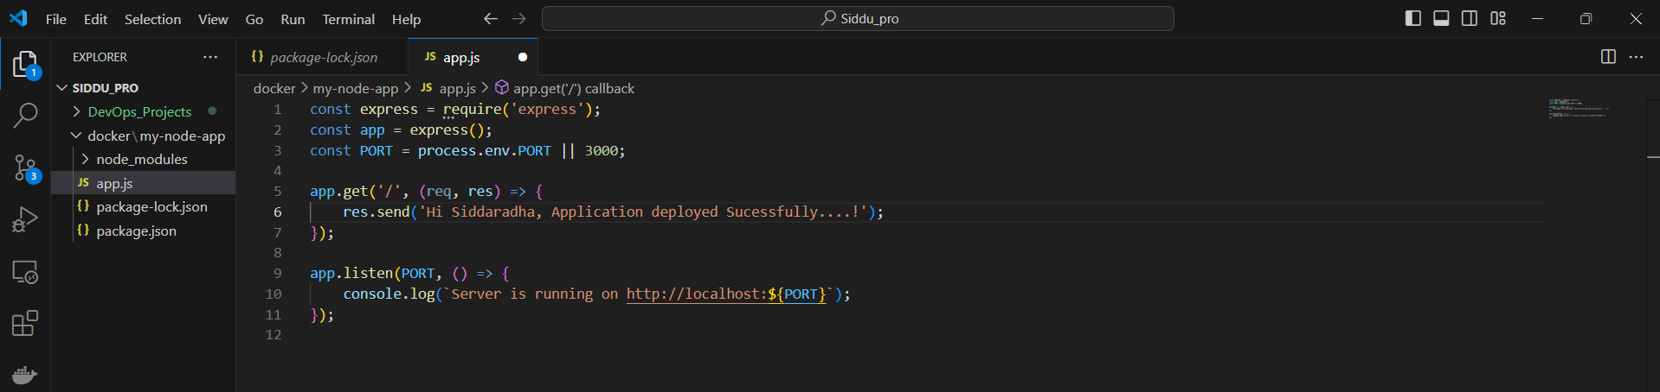

**Step 2: Write the Dockerfile**

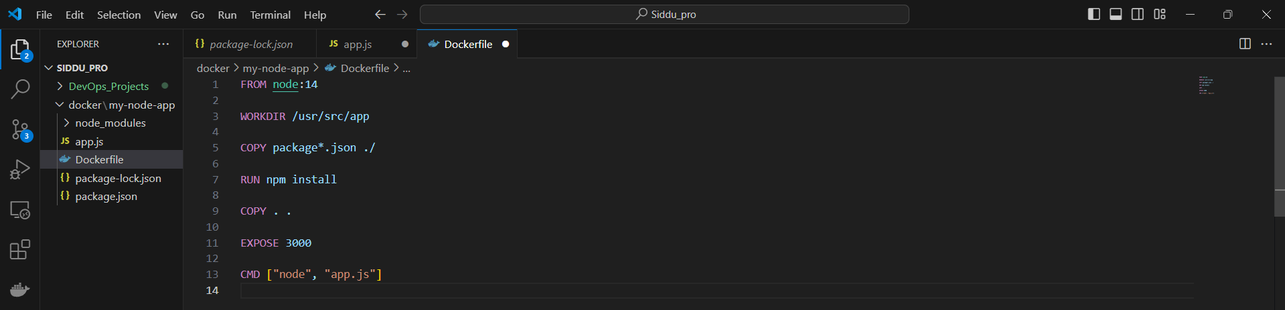

**Step 3: Build the Container Image**

**Build the Docker Image🡪 docker build -t my-node-app .**

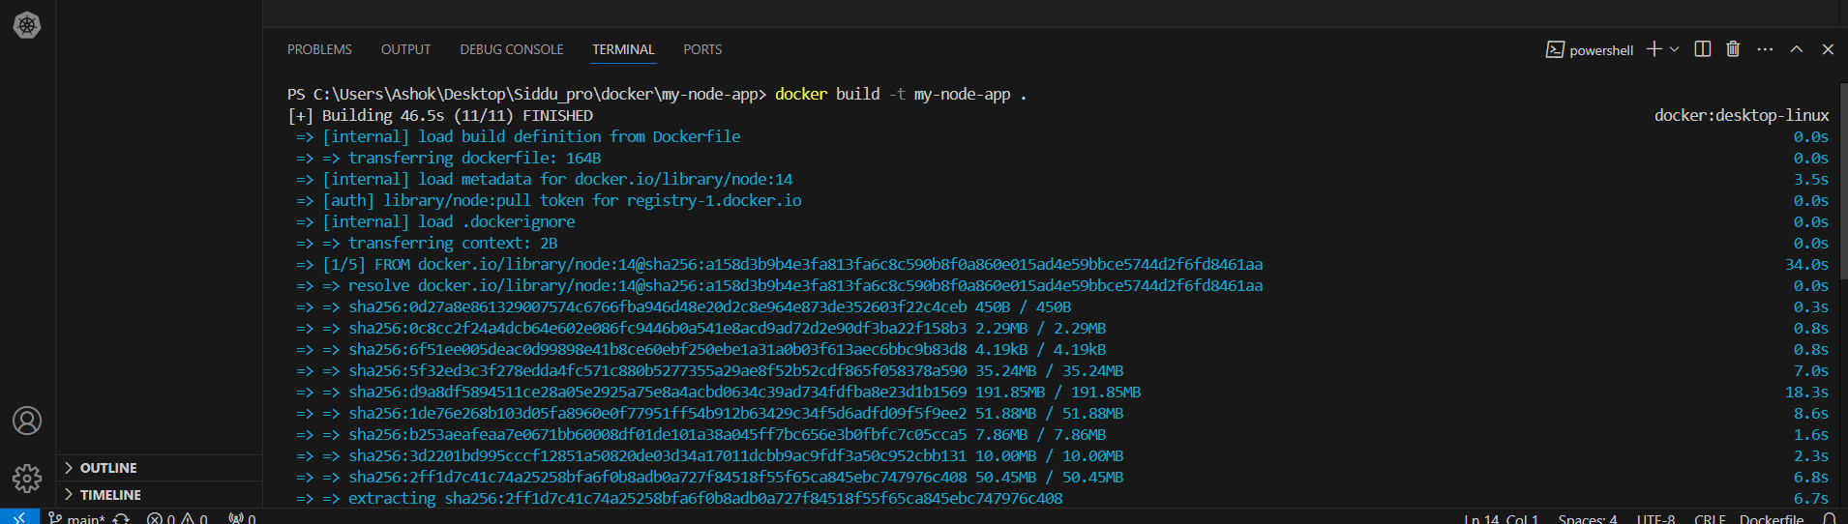

Docker images



**Step 4: Run the Container**

docker run -p 3001:3000 my-node-app



docker run 🡪To create and start a container form a images

-p 🡪 Port

3001 🡪Machine port

3000 🡪Container port

**Access the Application 🡪** <http://localhost:3001>

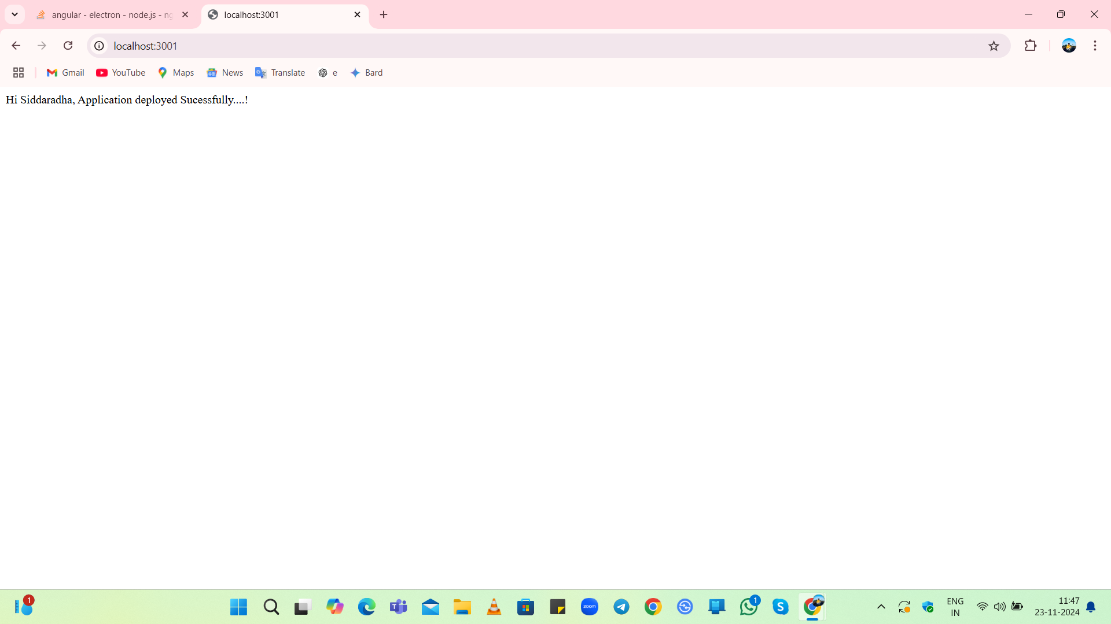

**Step 5: Push the Image to Docker Hub Private Registry**

**Log in to Docker Hub 🡪 docker login**



**Tag the Image 🡪 docker tag my-node-app siddusah/project-1:v1**

**Push the Image to Docker Hub 🡪 docker push siddusah/project-1:v1**

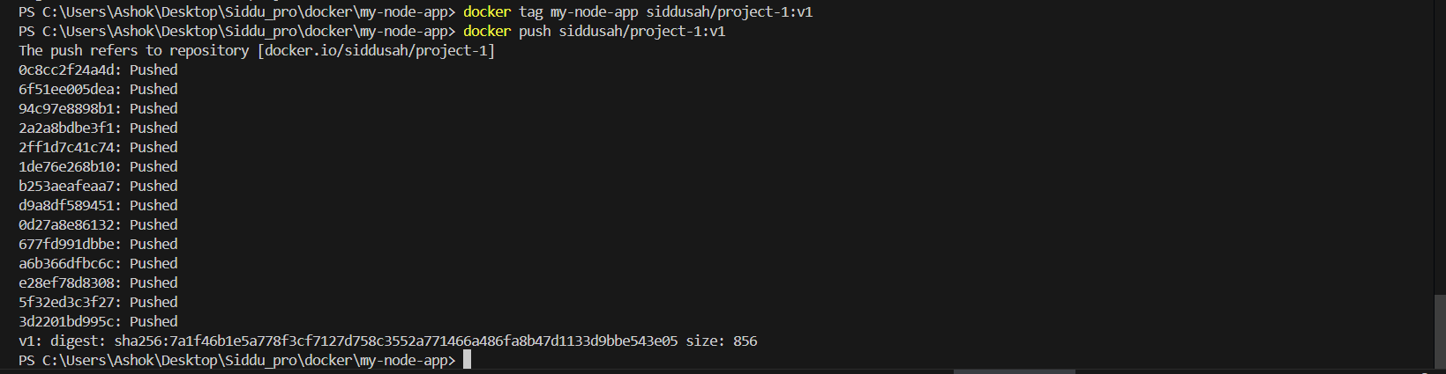

**Finally:**

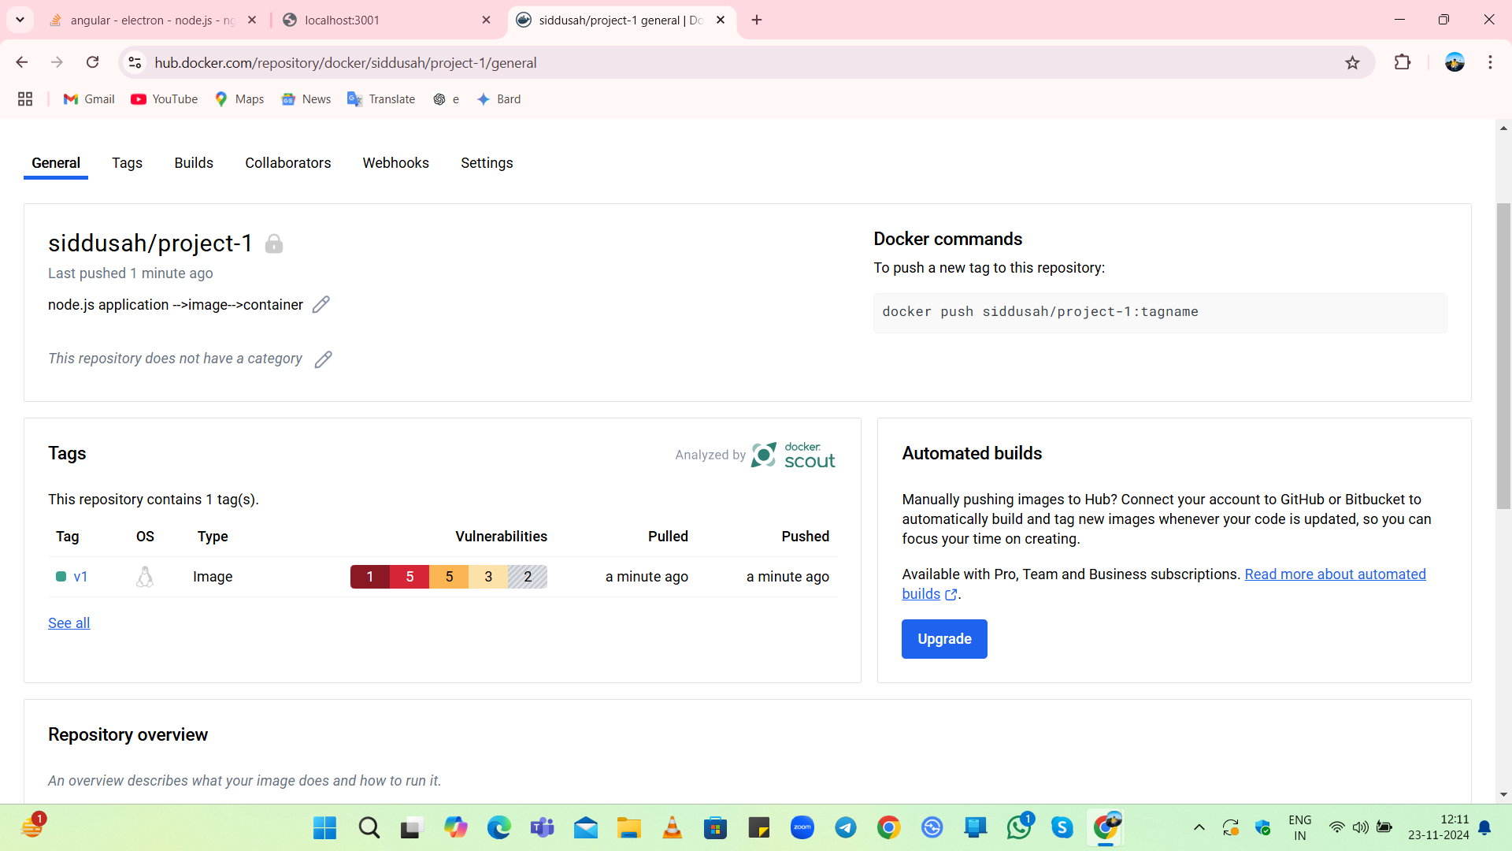

**Conclusion**

I have successfully created a simple Node.js application, packaged it into a Docker container, and pushed the image to your Docker Hub private registry.